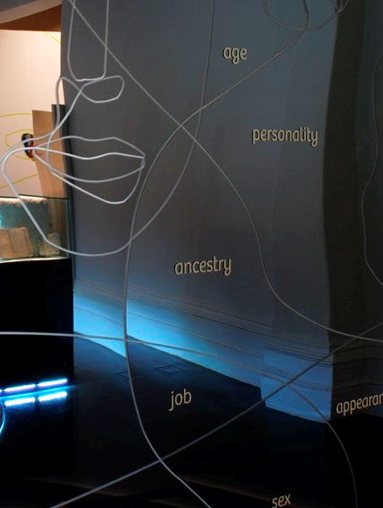
Identity: Yours, Mine, Ours
Exhibition Research Project
evaluation report
Funded through the australian research council 2012-2015


Identity: Yours, Mine, Ours
Exhibition Evaluation Report
Published by: Museum Victoria
First printed: April 2016
This research evaluation was funded by an Australian Research Council Linkage Grant (LP120100080)
The research was conducted through Deakin University within the Alfred Deakin Institute for Citizenship and Globalisation, and included researchers at the University of Melbourne. The following are partner organisations on this project: Museum Victoria (Immigration Museum and Melbourne Museum) and the Victorian Health Promotion Foundation.

Research Evaluation Team
Dr Jessica Walton (Research Fellow, Deakin University)
Prof Yin Paradies (CIA, Deakin University)

Deakin University –  Prof Emma Kowal  Prof Fethi Mansouri | University of Melbourne –  Prof Margaret Kelaher  Australian National University –  Dr Naomi Priest | Museum Victoria –  Dr Moya McFadzean  Ms Carolyn Meehan  Ms Jan Molloy  Ms Linda Sproul

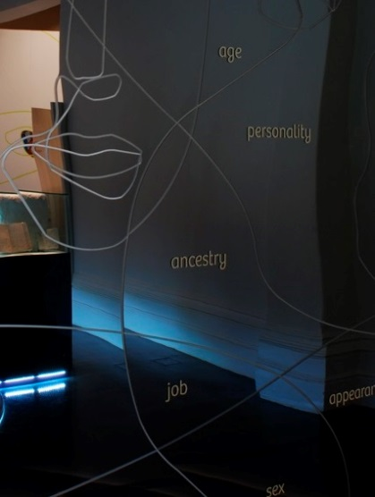
Research Assistance
Ms Melinda Herron
Ms Hannah Reich
Dr Philipp Schorch

Recommended Citation
Walton, J., Paradies, Y., McFadzean, M., Molloy, J., Sproul, L., Priest, N., Kowal, E., Mansouri, F., Kelaher, M., Meehan, C. 2016. Identity: Yours, Mine, Ours Exhibition Research Project Evaluation Report. Museum Victoria, Melbourne, Victoria.

Cover Image
First Impressions Mirror

Identity: Yours, Mine, Ours Exhibition
Source – Museum Victoria
Table of Contents
Acknowledgements 6
Executive Summary 7
About the exhibition 7
About the evaluation 7
Participants and methods 7
Key research findings 8
Impacts on students and teachers 11
Summary of learnings from thematic research data 13
Anticipating IYMO 13
Encountering IYMO 13
Feeling IYMO 13
Living IYMO 14
Talking Identity 14
Activating IYMO 14
Teaching IYMO 15
Impacts of IYMO 15
Report recommendations 16
1. Exhibition description 18
1.1 Background 18
1.2 Exhibition aims 21
2. The Evaluation 23
2.1 About the evaluation 23
2.2 School recruitment and Data collection 25
2.3 Participants 26
2.4 Evaluation methods 28
2.4.1 Student focus groups 28
2.4.2 Student narrative interviews 29
2.4.3 Student video diaries 29
2.4.4 Key informant interviews/focus group 30
2.4.5 Surveys 30
2.5 Data analysis 30
2.5.1 Qualitative analysis 30
2.5.2 Survey analysis 31
3. Summary of Research Themes 32
4. Research Theme 1: Anticipating IYMO 32
4.1 Students’ perspectives 32
4.2 Teachers’ perspectives 34
4.3 Introducing IYMO 36
4.4 What did we learn? 37

5. Research Theme 2: Encountering IYMO 38
5.1 First impressions, challenging stereotypes 38
5.1.1 ‘Welcome’ Video Installation: 38
5.1.2 ‘First Impressions’ Touch Table 42
5.1.3 Challenging stereotypes about Muslims 45
5.2 Deepening interpersonal encounters 47
5.3 What did we learn? 51
6. Research Theme 3: Feeling IYMO 51
6.1 An affective entrance 52
6.2 Feeling racism 55
6.2.1 Shock and surprise 55
6.2.2 Sadness and anger 58
6.2.4 Guilt and embarrassment 61
6.3 What did we learn? 65
7. Research Theme 4: Living IYMO 67
7.1 Experiences of belonging: Family, friends, social acceptance 67
7.2 Difficulties for belonging: Racism 68
7.2.1 Prevalence of racism 68
7.2.2 Racism from the targets’ perspectives 70
7.2.3 Vicarious racism 73
7.3 What did we learn? 76
8. Research Theme 5: Talking identity 77
8.1 ‘Having’ ethnicity or culture 77
8.2 Contested identities 80
8.3 What did we learn? 85
9. Research Theme 6: Activating IYMO 86
9.1 Identifying racism 86
9.2 Bystander anti-racism 87
9.3 What did we learn? 91
10. Research Theme 7: Teaching IYMO 912
10.1 Teachers’ experiences at IYMO 92
10.2 Teaching and learning practice in the classroom 95
10.3 School support for talking about cultural diversity and racism 99
10.3.1 Student demographics 99
10.3.2 Whole school support 101
10.3.3 Curriculum and resources 104
10.3 What did we learn? 105
11. Impacts of IYMO 106
11.1 Survey background 106
11.2 A discussion of survey findings in relation to qualitative findings 108
11.4 Discussion of IYMO impacts 110
11.4 Discussion of IYMO impacts 110
11.4.1 Knowledge acquisition 111
11.4.2 Challenging assumptions 113
11.4.3 Reflexivity 117
11.4.4 Behavioural change 122
11.5 What did we learn? 127
12. School Exhibition Feedback: Highlights and Improvements 129
12.1 Format 129
12.2 Educational approach 133
12.3 Content 135
12.4 Suggested Exhibition Improvements 136
13. Appendices 139
Appendix 1 Qualitative Methods (schedules and prompts): 139
1. Student focus group schedule 139
2. Student narrative interview prompts: 144
3. Student video diary prompt: 145
4. Teacher interview schedule: 145
5. Principal interview schedule: 149
6. Museum staff interview/focus group schedule: 150
Appendix 2: IYMO Survey items by construct 152
14. References 155

List of Tables
Table 1 Types of research participation by participant group 25
Table 2: Summary of total students participating in the qualitative evaluation components (2013-2014) 27
Table 3: Summary of total staff participating in the qualitative evaluation components (2013-2014) 27
Table 4: Summary of total student survey participation (2013-2014) 27

Acknowledgements

The research evaluation team wishes to express its gratitude to the students, teachers and principals who generously offered their time to talk about their experiences and provided valuable insights into issues relating to identity, belonging and racism. Without the schools’ support, this research evaluation would not have been possible. We acknowledge Museum Victoria staff who supported the school recruitment process, provided curatorial, education and evaluation advice in relation to the IYMO exhibition, participated in focus group discussions about the IYMO exhibition and the contemporary role of museums in general, and contributed to the development of this report.

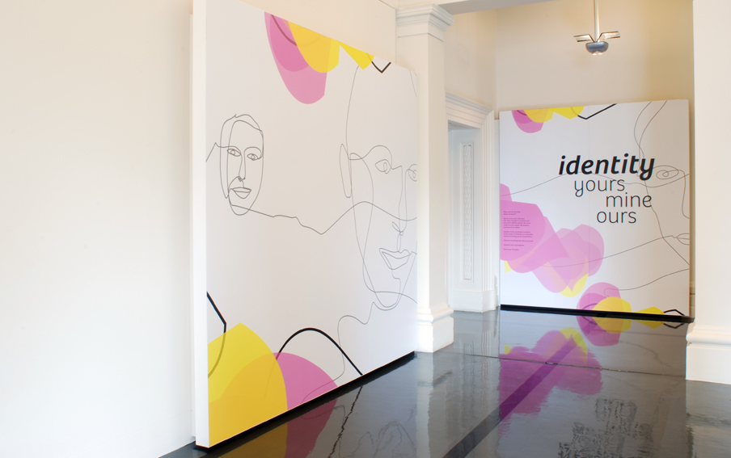
Our thanks also go to Ms Melinda Herron, Ms Hannah Reich and Dr Philipp Schorch, who provided research assistance during data collection at schools and the Immigration Museum.
Exhibition Entrance
Identity: Yours, Mine, Ours Exhibition
Source – Museum Victoria

Executive Summary

About the exhibition
In 2011, Museum Victoria launched the Identity: Yours, Mine, Ours (IYMO) exhibition at the Immigration Museum in Melbourne. This major long-term exhibition targeted secondary school students as a primary audience, its key themes addressing curriculum units relating to identity, belonging and ethnicity. The exhibition’s core aims were to provide a dynamic participatory environment that encouraged reflection, challenged assumptions and compelled visitors to think about ways they could effect positive change in their everyday lives.

About the evaluation
In 2012, an Australian Research Council Linkage Grant (#LP120100080) was awarded to evaluate the exhibition. This evaluation project involved a multi-disciplinary and multi-institutional team, including universities, a museum and a government agency. The overall aim was to understand the public role of museums in countering racism and promoting positive attitudes and acceptance toward people from diverse racial, ethnic and cultural groups. Specifically, this study aimed to examine the appropriateness, feasibility, acceptability and effectiveness of the IYMO exhibition in reducing racism and increasing acceptance of racial, ethnic, and cultural diversity among secondary school students in Years 10-12 and teachers.
The research questions included:
- How appropriate, feasible and acceptable is the IYMO exhibition as an intervention for promoting positive attitudes toward cultural diversity and a critical understanding of racism among Victorian students in Years 10-12?
- What is the effect of the IYMO exhibition on the attitudes, emotions, beliefs and behaviours of Victorian students in Years 10-12 in relation to racism, cultural diversity and racial and ethnic identity?
A pre-post study design was used to examine the effects of IYMO on students. A combination of survey, interview, focus group and video diary methods were used in this research to assess these changes over time resulting from a school visit to IYMO.

Participants and methods
A total of seven schools, which included ten classes, participated in the project. Six of the seven schools took part in the majority of the evaluation components (surveys, video diaries, focus groups, narrative interviews). In terms of survey participation, five of the seven schools completed baseline surveys. There were 80 students who participated across the qualitative evaluation components and 46 students who completed the survey across all three time points (Time 1 – before the exhibition visit, Time 2 – two weeks post-visit, and Time 3 – three months post-visit). Individual interviews were completed with seven school staff and a focus group/interview was completed with six museum staff. All ethics approvals were received by April 2013. All data collection was completed by December 2014.

Key research findings
Overall, the qualitative data demonstrate that the museum exhibition helped to challenge previous assumptions about cultural diversity, to develop a heightened awareness about the students’ sense of identity and belonging and to foster a more critical understanding of racism. It also raises some significant yet subtle issues relating to understandings (or not) about ethnicity and the social construction of ‘whiteness’ as a normal or neutral identity. The following provides a brief summary of key findings highlighted in the report:

The IYMO exhibition created an affective and intimate atmosphere that unsettled, confronted, affirmed and broadened students’ understanding of identity, belonging and racism. Importantly, the exhibition’s affective dimension provided an entry point through which students could connect to the individual people and their stories. In this way, the exhibition material became more than just a series of stories, objects and facts. The exhibition was enlivened by the interaction between students’ emotions, personal experiences and perspectives and the audio-visual presentation of people’s stories, which were brought to life through their individual voices and expressions.

IYMO is a successful example of the effectiveness of exhibitions which are both multi-sensory and multi-modal in the ways information and experiences can be presented. In particular in IYMO, the combination of interactive audiovisual displays that directly and tangibly engaged students along with the practical everyday content helped make the material accessible to the students. This provided a familiar connection to the exhibition through which they could begin to challenge their thinking and for some, to become more aware of their behaviours in terms of how they interact with people from different backgrounds in their everyday lives. The qualitative findings illustrate the subjective impact the experience in the exhibition had on the students and the ways through which the immersive and interpersonal approach of the exhibition helped to facilitate this.

For the teachers, the exhibition’s focus on diverse stories of people’s experience enlivened their teaching practice because it provided depth to the abstract concepts of identity and belonging they had been discussing in the classroom. The IYMO exhibition was used mainly as a resource to refer to when discussing topics in the curriculum. Teachers explained that the shared experience in the exhibition provided concrete examples that they could draw on to illustrate key concepts.

The IYMO exhibition helped the students to critically think about racism and strategies to counter racism in everyday life. The tram simulation was central to the students’ discussions because the video helped them to think about racism from multiple different perspectives.
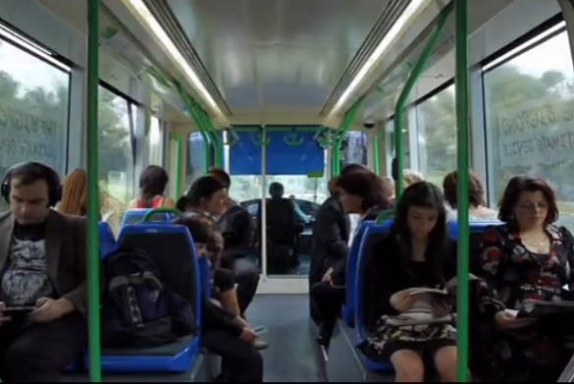
Tram simulation video
Identity: Yours, Mine, Ours Exhibition
Source – Museum Victoria

They then connected these perspectives to their own experiences at school and around their neighbourhood. The tram simulation as well as other exhibition content about the history of racism as well as anti-racism efforts in Australia stimulated the students’ reflection on these issues. In particular, students talked in-depth about bystander anti-racism in relation to their experiences and discussed conditions that influenced whether or not they took action when witnessing interpersonal racism.

For some students who identified as ‘white Anglo,’ the IYMO exhibition was disproportionately focused on white people’s identity as racist and lacked diverse representations. Although there are issues with the students’ uncritical understanding of how ‘whiteness’ is normalised at a systemic level and, in this sense, how these ‘invisible’ white perspectives are overrepresented in Australian society, it does draw attention to the need for a more nuanced understanding of cultural identities, inter-ethnic tensions, the potential for othering or racist perspectives from people from diverse ethnic/racial backgrounds and a more rigorous critique of how ‘visible’ racial, ethnic and cultural differences become essentialised in popular discourse about multiculturalism.
Those teachers who, whether consciously or unconsciously, conflated notions of ‘Anglo-Australian’ ethnicity and ‘Australian identity’, found the IYMO exhibition difficult to engage with. The report has revealed how an insensibility about ‘white privilege’ and/or non-recognition of an ‘Anglo ethnicity’ by teachers can impact upon teacher-learner interaction, and thus limit the ways in which issues about discrimination, multiculturalism and identity can be discussed in schools. As a consequence of this perspective, where ‘ethnicity’ is not associated with an ‘Anglo’ heritage that is seen to be normal/neutral, the idea of ‘othering’ can prevent teachers from being able to interpret the IYMO exhibition as fundamentally about them and their identity as ‘Australian’.

Not all students recognise that they have an ethnic or cultural background or if they do, do not necessarily view themselves in terms of ‘having an identity’. Students from ethnic minority backgrounds also emphasised that they are more than just their ‘ethnic identity’. Comparatively, most white and Anglo students did not think they had an ethnic or cultural identity and viewed themselves as ‘cultureless’. This is consistent with international research about the normativity and invisibility of whiteness and demonstrates the IYMO exhibition’s potential to open up dialogue and develop awareness of self in relation to concepts of ‘whiteness’ positionality and privilege.

Impacts on students and teachers
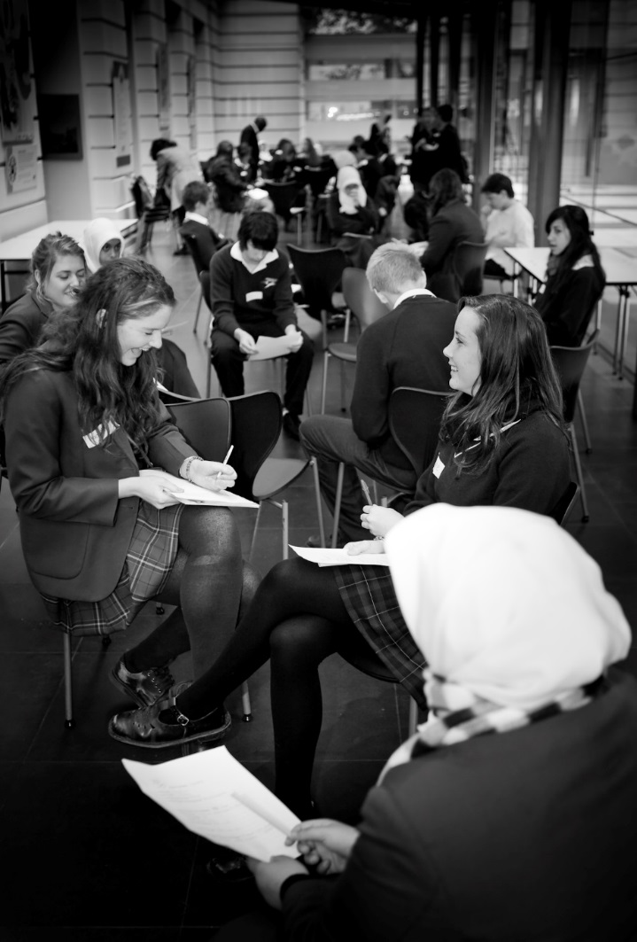
The multi-method qualitative research approach that this evaluation used was able to capture rich data about what the students experienced in the exhibition and the impact it had on them. As evidenced by the students’ experiences, the museum exhibition was not simply an informational exercise to increase literacy and comprehension levels. In addition to the new knowledge that the students acquired, it was also an affective experience which brought up memories, lived experiences and emotions about a range of issues raised in the exhibition. The audio-visual experiences and the interactive elements (e.g., ‘welcome’ video corridor, tram simulation, audio handsets, touch table) created a subjective and at times, intersubjective experience through which the students personally connected with the people whose stories they read, heard and felt. In addition to the impacts described above (e.g., challenging assumptions through perspective-taking and empathy, and reflexivity), the students also identified incremental but significant changes in their behaviours and attitudes toward people who may be perceived to be different to them.
Students at the Immigration Museum
Source – Museum Victoria

The following provides a brief summary of key impacts on students and teachers highlighted in the report:

Enhanced understanding of what it means to live in a multicultural society: At one level, students, particularly international students, talked about the visit as a ‘useful’ place where they could acquire information about people from different cultural backgrounds. For students who were already familiar with the idea of Australia as a multicultural society, the depth of knowledge that they acquired in the museum provided a critical layer that they previously had not considered or been exposed to.

Challenging assumptions: The in-depth knowledge and personal stories the students acquired at the exhibition helped provide a starting point to begin challenging their assumptions. In terms of developing intercultural understanding, acquiring knowledge is necessary but not sufficient to address prejudice.

Perspective-taking and reflexivity: There was some indication of reflexivity, particularly by students who took the time to critically reflect on what they learnt in relation to their own experiences, either at the exhibition or in their own time. For some students, it stopped at learning about other people whereas for other students, perspective-taking and empathy moved toward reflexivity. This tended to happen when there was a personal and felt connection to the people’s stories in the exhibition as well as meaning-making about how those stories relate to their own lives in terms of similarities or differences.

Heightened awareness and understanding of racism: Another key issue that students highlighted repeatedly was the heightened awareness and deeper understanding they had about racism. On a conceptual level, most of them knew that racism exists in Australia. However, for people who had never experienced racism, either as a target, perpetrator or bystander, the exhibition, particularly the tram simulation, offered the opportunity to experience a realistic scenario.

Summary of learnings from thematic research data
The following are the key learnings extracted from the detailed research data analysis outlined in sections 4-11:

Anticipating IYMO
Teachers and students:
1) Value museum experiences that engage with significant contemporary social issues.
2) Appreciate how museum experiences have the potential to deepen their understanding of topics and issues they have discussed in the classroom.
3) Respond positively to exhibitions which challenge preconceived ideas about museum experiences (i.e., static, not interactive) and their potential for active engagement.

Encountering IYMO
Providing elements of ‘surprise’ in exhibitions (e.g., ‘Welcome’ video installation and the ‘First Impressions’ touch table) worked to:
- Unsettle the students in a way that evokes curiosity. Although the students were prepared in terms of learning about key concepts around identity and belonging at school, their first encounter with the ‘Welcome’ video installation immediately confronted the students’ assumptions about who someone is and their sense of belonging, which set the scene for the rest of the exhibition.
- Challenge the students’ expectations of a museum experience. For example, the ‘First Impressions’ touch table creates an introspective environment where they were encouraged to deepen their understanding and disrupt stereotypes about people based on physical appearance.

Feeling IYMO
The multi-sensory storytelling medium provides opportunities for:
- Direct engagement with personal stories, artefacts and images which invite students to confront and reflect on their own feelings about identity, belonging and racism.
- Physical interaction with the displays, such as picking up an audio handset and hearing someone on the other end talk about what happened to them and how those experiences made them feel. The students did not just read about people, they felt connected to real people by hearing and seeing people from diverse backgrounds talk about their experiences growing up in Australia.
- Deeper connections that enabled a sense of civic responsibility. The intimate and interactive nature of this engagement ‘got under their skin’ and, through a familiar connection (e.g. talking on an audio handset), they could also begin to go a bit deeper by becoming open to the other person’s experience.

Living IYMO
In-body, interactive exhibition experiences which focus on race-based discrimination, encourage students to:
- Find affirmation in shared experiences of loneliness and alienation and realise that these experiences are not unique to them.
- Engage in deep discussions and self-reflection about issues and experiences of racism (as victims and bystanders), particularly via the presentation of multiple perspectives which provoke empathetic responses.

Talking Identity
Presenting an exhibition on complex and challenging concepts such as ‘personal identity’ pushes students and teachers to:
- Engage with their assumptions about their own identity (or perceived lack thereof) and attempt to articulate their reflections of either lived experience or through relational observations.
- Reflect on conventional understandings (whether spoken or unspoken) of identity ‘hybridity’, demonstrating the importance of legitimising individual expressions of identity, whether singular or multiple.
- Encounter the perceived absence of personal identification of ‘Anglo’ as an ethnicity when considering cultural diversity in Australia.

Activating IYMO
Presenting a variety of forms of racism (both subtle and overt) and ways to experience that racism in exhibitions provokes students to:
- Explore conflicting responses in discussions about what constitutes a racist artefact or act.
- Place themselves in a real-life situation and challenge themselves as to how they might act (or not) as an anti-racism bystander.
- Question what might be appropriate action to take as an anti-racism bystander.

Teaching IYMO
Taking a complex, cross-disciplinary topic and presenting it through both personal stories and real-life simulations (both in-gallery and online) provides teachers with:
- Ways to reflect on their own previously unrecognized or unspoken personal experiences relating to identity and racism, as well as those of their students.
- Opportunities for affective immersion in scenarios only formerly understood in a conceptual or intellectual way.
- Space to encounter representations of identity, and how this impacts on what they bring to teaching topics relating to identity and diversity.
- An invaluable value-adding resource for existing lesson plans that has lasting use post-exhibition visit, particularly due to strong online materials.
- A series of valuable shared experiences with students (personal stories and ‘real-life scenarios’) for ongoing class discussion on various curricular themes.
- A heightened awareness of social and cultural issues needing discussion in their schools (by teachers and students) not previously considered relevant or necessary.
- A boost to their acknowledged professional understanding, capability and confidence to teach complex subjects.

Impacts of IYMO
Acknowledging the limitations of the survey findings (due to the small sample size), the richness of the qualitative data, and the breadth and degree of exhibition impact on students, it can be concluded that:
- Exhibition experiences offering strong immersive and interpersonal opportunities can build knowledge, challenge assumptions and heighten personal awareness through self-reflection.
- The contracted nature of school visits require exhibitions to provide high-impact affective moments of interaction (such as the ‘Welcome’ video installation, ‘First Impressions’ touch table and Tram simulation) to deliver the key content – and that museum experiences can trigger this alliance within the student between the cognitive and affective learning domains.
- These high impact moments of interaction seem especially engaging to students who have little to no meaningful interactions with culturally and socially diverse people, and/or direct experiences of racism.
- Student and teacher learnings from exhibitions can range from a more detached, ‘educational’ experience, to more practical, ‘lived’ understandings through simulated and human interactions.
- It is the ‘felt’ affective experience that primarily remains with students and teachers (immersion, emotional stories), enabling a degree of reflexivity, and/or moments of painful recognition.

Report recommendations
The following summary recommendations are centred on teaching practice, museology and further academic and industry research, including some thoughts on future directions for research on young people’s experiences of racism and cultural diversity and the potential for museums to play a key role in providing spaces to combat racism and support further conversations about these issues in communities.

Recommendations specific to improving the IYMO exhibition can be found near the conclusion of the report.

Teaching practice:
In relation to teaching practice, the findings from this research identified:
- A need to explore ‘Whiteness’ as a social construction that requires understanding and insight as to how it can impact teacher practice in Australian classrooms. A visit to the IYMO exhibition elicited responses from teachers that indicated an often unacknowledged conflation of ‘Australian Identity’ and ‘Anglo ethnicity’.
- A gap between the exhibition experience and classroom practice in terms of continuing to build on the interactive learning approaches used in the exhibition. Teachers commented that while the exhibition experience helped to enliven classroom discussions and they felt more capable teaching about topics on ethnicity, identity and belonging in the curriculum, they did not have the time or resources to develop the exhibition learnings further. Schools would benefit from an updated resource package that includes comprehensive teaching resources/package about racism and diversity that teachers can immediately apply in their teaching practice, supported by extended Professional Learning that allowed for personal exploration and deeper understanding of ‘visible and invisible’ identities within Australia.

Museology:
In terms of museum policy and practice, this evaluation demonstrated that:
- An immersive, interactive and affective approach, that is ‘the embodied process of learning,’ to engaging with racism and experiences of identity and belonging, is critical to developing a more diverse and deeper understanding of these issues. While knowledge acquisition is important, simply learning about racial, ethnic and cultural diversity is not enough.
- The audio-visual and interactive approaches (multi-modal experiences) used in the museum exhibition facilitated this more reflexive and empathetic understanding of racism and diversity that simply reading about these contemporary issues could not evoke.
- An understanding of the importance of the ‘constructed’ experience and the role of learning in the ‘affective’ register affords social and ethical engagement that can activate the learners’ ethical and political imaginations and make space for social justice.

Research:
Finally, in terms of recommendations for research:
- Further research is needed to investigate the role of ‘embodied processes of learning’.
- Further longitudinal research is needed to better understand long-term impacts from museum experiences on students' attitudes and behaviours. This includes the impact of public learning institutions such as museums and the subsequent implementation of evidence-based teaching materials in classrooms that build on those initial museum experiences.
- Future studies could explore new ways to measure types of reflexive and affective shifts quantitatively, as has been recently undertaken by some researchers (Paradies, Franklin, & Kowal, 2013).

1. Exhibition description

1.1 Background
Museums as socially responsible institutions
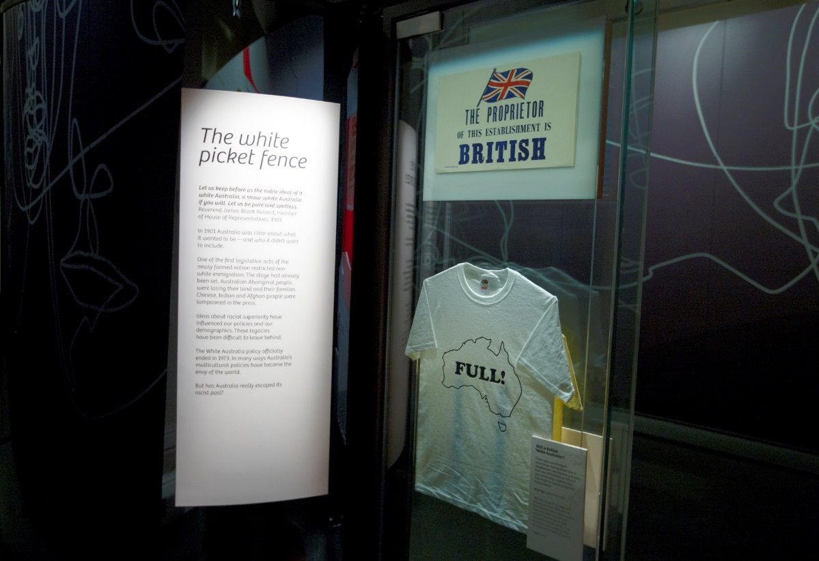
Museums are powerful sites of knowledge with the ability to present and represent particular worldviews. The way knowledge is selected, edited and displayed is always ‘partial’ (Clifford, 2010); however, because museums are positioned as authoritative institutions, this knowledge can be interpreted as presenting indisputable facts or ‘Truth’. In response to this and coinciding with a postmodern turn in the late 1980s and 1990s, there have been numerous sociological and anthropological critiques within museum studies that highlight how museums, through this authoritative position, work to privilege one reality over another in ways that may perpetuate static, limited and racist representations of cultural diversity. These critiques challenge fixed cultural representations and the production of knowledge and call for more reflexive and partial approaches (Marcus & Fischer, 1999). Since then, there has been a conceptual shift within museum studies toward developing museums and exhibitions that deliberately engage with contemporary social issues (Sandell, 2007). This has involved a re-conceptualisation of the role of museums and a critical assessment of their social positioning as well as their social impact as an authoritative, albeit partial, voice in society.
‘White Australia ‘ Display Case
Identity: Yours, Mine, Ours Exhibition
Source – Museum Victoria

More recently, there has been increased focus on audience engagement within museum spaces rather than on knowledge production and representation (Sandell, 2007). A focus on audience engagement recognises the agency of people who visit museums and the interpretive work that they perform while interacting with displays. This operates on the premise that people are not simply empty vessels absorbing knowledge that stays with them after they leave the museum. They bring their own stories, experiences and expectations, which influence how they interpret what is encountered in the museum. Thus, the same space and the same exhibition can resonate with people in different ways depending on their own social, cultural and political positioning. As such, the museum space has the potential to foster social dialogues between visitors and the exhibition material that reflect current social concerns and contribute to broader debates.

Museums in Australia: Fostering critical dialogue about cultural diversity and racism
In Australia, museums such as the Immigration Museum in Melbourne (opened 1998) and the Migration Museum in Adelaide (opened 1986) have been pioneers in their own right as they have sought to open up space for engaging with a complicated Australian history of migration and how this is represented in museum spaces (Witcomb, 2009; Szekeres, 2002).

Since the Immigration Museum opened, it has focused on exploring Australia’s immigration history with explicit attention to personal narratives of migration and settlement. In 2008, staff at the Immigration Museum began reflecting on the museum’s ten-year history and considering how the museum would like to position itself for the future.
‘We were all keen to start shifting the museum away from focusing on primarily migration narratives, if you like, through into a more contemporary space that was more about social activism, contemporary issues and looking at beyond migration and settlement to what contemporary Australia is today and how issues around cultural diversity and difference have impacted upon Australian society’ (MV staff focus group).
To mark this shift, museum staff began exploring ideas for an exhibition that would engage these issues about what it means to belong or not belong in Australia with an explicit focus on highlighting issues of racism as well as calling for individual and social action against racism. Rather than focusing primarily on the history of migration through individual narratives, the new exhibition was intended to explore how subsequent generations experience issues of identity and belonging from their personal perspectives that go beyond the processes of migration and settlement.

The working title for the exhibition was Personal Identity in Contemporary Australia. However, the name did not quite capture the interactive and interpersonal experience that the exhibition hoped to evoke, which was to encourage dialogue and self-reflection. It was decided that the final name would be Identity: Yours, Mine, Ours. Combined with the provocative marketing campaign slogan, I Belong, Do You?, the exhibition placed itself at the centre of contemporary debate about identity and belonging. This approach also supported the museum’s desire ‘to become contemporary and relevant and engage in … and potentially lead discussions around personal identity and how it contributes to diversity…[as well as] the more challenging issues … of racism that are happening around us.’ (Museum staff)

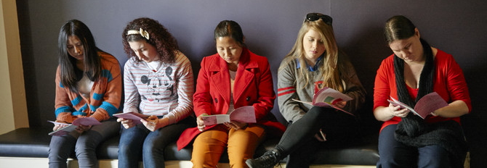
At the centre of this is the museum leadership’s view that the Immigration Museum plays a vital social and educational role ‘as a cultural organisation, as a participant, a leader and a contributor to the discourse around migration, identity, diversity and its challenges in many forms’ (Museum staff). The Immigration Museum’s vision is part of a broader trend that views museums as socially responsible institutions. As Sandell (2002) points out, this is not in itself a new concept, but it does place museums in a position that requires them to not only acknowledge their social role but also to understand ‘their impact on society [and to] seek to shape that impact through practice that is based on contemporary values and a commitment to social equality’ (p. 21). This research evaluation of the Immigration Museum’s Identity exhibition is part of this call to examine the social impact of museums.
Students at Identity: yours, mine, ours Exhibition
Source – Museum Victoria

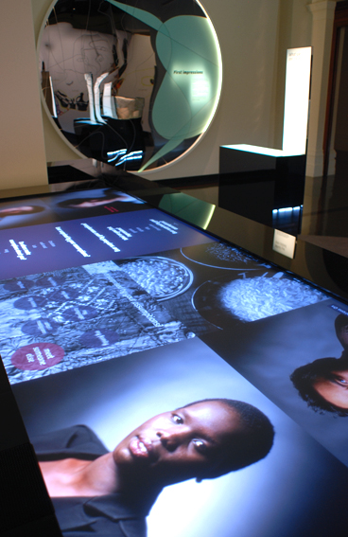
1.2 Exhibition aims
In the original concept brief for the IYMO exhibition, the vision statement clearly outlines the purpose of the exhibition, which is to provide a space that facilitates a ‘participatory exhibition experience’ where visitors are able to ‘open their minds and take an unforgettable emotional journey during which assumptions will be challenged, subconscious prejudices exposed, and personal experiences of self-identification acknowledged and legitimised.’ (PICA, 2009) From the outset, the exhibition was intended to provide an experience that encouraged visitors to think deeply about issues of identity, belonging and racism in relation to themselves, others and the broader Australian society in which they live. In this sense, the exhibition does more than simply use the individual stories to remind and inform visitors that Australia is a multicultural country. While the stories do provide evidence of Australia’s ethnic and cultural diversity, the exhibition also reaches out to visitors to create a space for a more active interpersonal experience. This is achieved through audio-visual displays, interactive features such as audio handsets and touchscreens, and provocative questions that gently push the visitor beyond their comfort zone to think more deeply about their own identity and sense of belonging. For example, in the context of challenging assumptions, visitors are asked to reflect on, ‘How well do we really know ourselves?’ and in the whiteness and racism section, visitors are asked to compare historical racism in Australia to the present day with the question, ‘But has Australia really escaped its racist past?’
‘First Impressions’ Touch Table
Identity: Yours, Mine, Ours Exhibition
Source – Museum Victoria

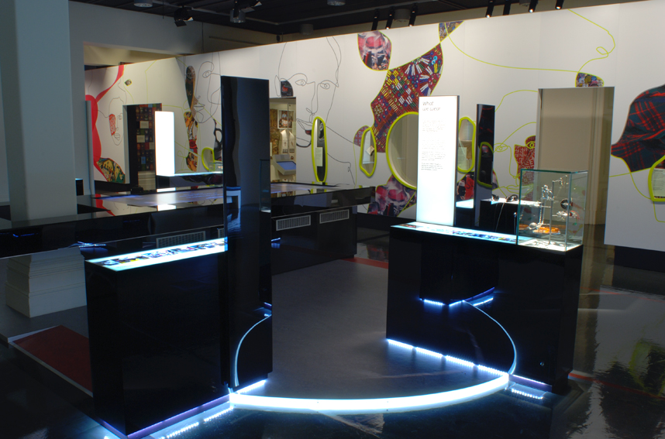
In addition to the interactive elements, the exhibition also aimed to provide a space for quiet reflection where visitors might read a story that reminded them of something in their own lives. Rather than remaining on the surface of cognitive learning, the intention was to provide a deeper, more intimate and emotional experience.
‘First Impressions’ Gallery
Identity: Yours, Mine, Ours Exhibition
Source – Museum Victoria

Source – Museum Victoria

‘As you go through the exhibition, the exhibition poses a lot of questions and I think those questions are important 'cause if you go somewhere and you're just reading facts and figures and information, or even reading a person's story, you're reading that story, whereas if you pose a question then you're ... maybe you have no choice but to stop and think a bit, and I think that's a dimension of that exhibition that's different to the others.’ (Museum staff)

Finally, the exhibition not only encouraged reflection and introspection, it also aimed to facilitate discussion, debate and social action in the community. For example, in the tram simulation section, there is a clear call for bystander anti-racism. By watching and listening to different perspectives about a racist experience on a tram, the visitor is invited to think about whether or not they might act against racism in a similar situation and what they might say or do. Accompanying prompts on a nearby wall facilitate further reflection about bystander action. Moreover, through a combination of interactive displays, audio-visual material, provocative questions about identity and belonging, and an historical timeline mapping issues of multiculturalism and racism in Australia, the exhibition aimed to instigate attitudinal shifts toward increased acceptance of cultural diversity and critical reflection on complex issues of identity, belonging and racism.
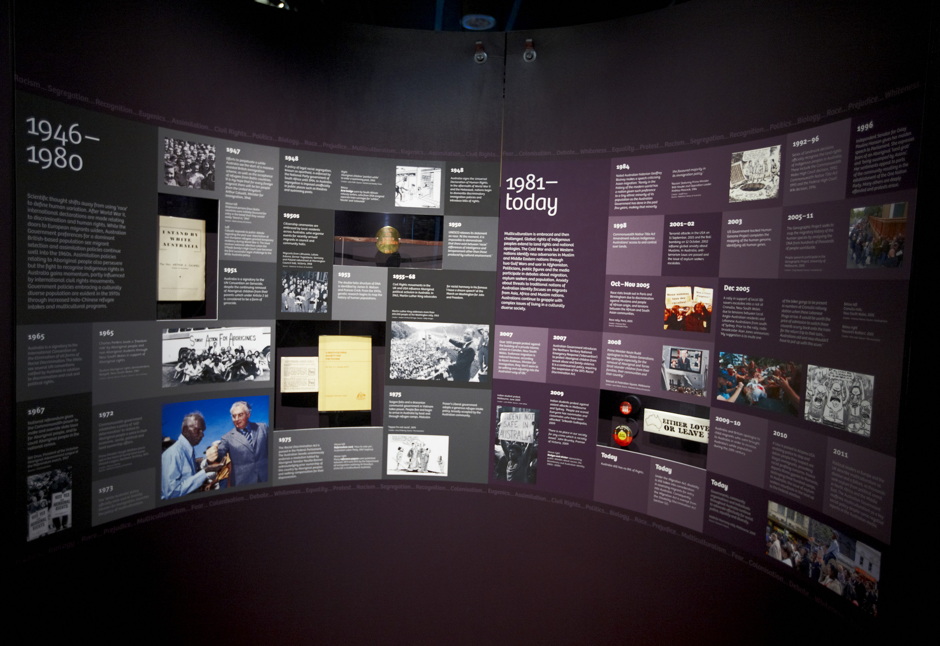
Historical Timeline within Identity: Yours, Mine, Ours Exhibition
Source – Museum Victoria

2. The Evaluation

2.1 About the evaluation
In 2012, an Australian Research Council Linkage Grant (#LP120100080) was awarded to evaluate the exhibition. This evaluation project involved a multi-disciplinary and multi-institutional team in partnership with Museum Victoria. The overall aim was to understand the role of museums in countering racism and promoting positive attitudes and acceptance toward people from diverse racial, ethnic and cultural groups. Specifically, this study aimed to examine the appropriateness, feasibility, acceptability and effectiveness of the IYMO exhibition in reducing racism and increasing acceptance of racial, ethnic, and cultural diversity among secondary school students in Years 10-12 and teachers.
The research questions included:
- How appropriate, feasible and acceptable is the IYMO exhibition as an intervention for promoting positive attitudes toward cultural diversity and a critical understanding of racism among Victorian students in Years 10-12?
- What is the effect of the IYMO exhibition on the attitudes, emotions, beliefs and behaviours of Victorian students in Years 10-12 in relation to racism, cultural diversity and racial and ethnic identity?
A pre-post study design was used to examine the effects of IYMO on students. A combination of survey, interview, focus group and video diary methods were used in this research to assess these changes over time resulting from a school visit to IYMO. Surveys were conducted in three waves: approximately two weeks before the IYMO visit (T1), approximately two weeks after the IYMO visit (T2) and approximately three months after the IYMO visit (T3). This provided baseline data (T1) in order to analyse any short-term attitudinal changes (T2) and any longer-term attitudinal changes (T3) among students. During the exhibition visit, some of the students were asked to record video diaries on mini iPads. These provided a more immediate glimpse into students’ experiences as they interacted with different parts of the exhibition. Narrative interviews and focus groups were conducted with the students twice after their visit to the exhibition (T2 and T3). These were conducted as a way to understand how students experienced the exhibition: what resonated with their own experiences, what they liked, what they did not like, what they found compelling, challenging and surprising, and what stirred their emotions. The interviews and focus groups conducted three months later gave a sense of what ‘stuck’ with them over a longer period of time. It also helped to gauge the extent to which they were still engaging with, living with or being confronted by the issues presented in the exhibition about identity, belonging and racism.
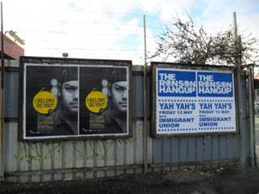
In addition to the student data, one-off individual interviews were conducted with teachers and principals to understand the relevance of IYMO in relation to teaching practice, teacher perceptions of students’ experiences, teachers’ experiences at IYMO, and the broader school context. Finally, a focus group and interviews were conducted with museum staff to understand the exhibition background in terms of its curation, production and educational outreach, and in relation to a broader Australian context. Table 1 provides a summary of the various types of research participation. Additional detail about each of the research methods is provided in Section 2.
Street promotion of Identity: Yours, Mine, Ours Exhibition
Source – Museum Victoria

Participant groups |  | Surveys | Narrative Interviews | Focus groups | Video Diaries | Semi-structured interviews
1 | Years 10-12 students | T1, T2 & T3 | T2 & T3 | T2 & T3 | -- | During IYMO visit
2 | Teachers | -- | -- | -- | -- | Once (T2 or T3)
3 | Principals | -- | -- | -- | Once (T2 or T3) | --
4 | Museum staff | -- | -- | 1 focus group | 1 interview | --
Table 1 Types of research participation by participant group

2.2 School recruitment and Data collection
We received all ethics approvals by April 2013 from the Deakin University Human Research Ethics Committee (HREC 2013-008), the University of Melbourne HREC (#1339536), the Victorian Department of Education and Early Childhood Development (#2013_001878) as well as the Catholic Education Office (#1880).
School recruitment commenced mid-April 2013. In order to recruit schools that were attending the exhibition to the research evaluation project, a coordinated process was implemented between the Museum Victoria booking team and the research team. When a teacher rang to book a school visit to the exhibition, a booking team member also informed the teacher that that they had the option to take part in a research evaluation project as part of their visit to the exhibition. They were told that it was completely voluntary and that they could still visit the exhibition without taking part in the research project. If the teacher showed interest in the research, they were asked if their contact details and booking information could be passed on so that a researcher could follow-up to invite them to participate in the study. The project manager then made initial contact by calling the principal to seek school support for the project. Contact was then made with the teacher to explain the project and to invite them to participate.
In 2013, contact was attempted at fourteen schools. Eight schools were originally recruited but due to school circumstances, only four schools participated (Harford, Bayside, Kensington, Lakeland). One of the four schools only completed a student video diary during their IYMO visit (Lakeland). The other three schools took part in the core evaluation components (surveys, focus groups, narrative interviews, video diaries) during two follow-up visits after attending the IYMO exhibition (T2, T3). Phase 2 of school recruitment continued in 2014. Fourteen schools were contacted resulting in three additional participating schools (Woodlane, Wellview, Hartville). All of these schools completed the core evaluation components. Additionally, a second class at Harford College participated in 2014. Overall, five schools (Harford, Kensington, Woodlane, Wellview, Hartville) completed baseline surveys prior to attending the exhibition (T1).

2.3 Participants
The schools were predominantly from the government sector and located in outer metropolitan suburbs. There were two schools located in provincial areas and one non-government school. Across the seven schools, there were 10 classes. Most were Year 12 classes with only one Year 11 and one Year 10 class. The total number of participants for each of the evaluation components is summarised in the tables below.

Table 2: Summary of total students participating in the qualitative evaluation components (2013-2014)
 | T2 Focus Groups (n=55) | T3 Focus Groups (n=44) | T2 Narrative Interviews (n=16) | T3 Narrative Interviews (n=11) | Video diaries (n=18)
Students* | Female: 36 | Female: 30 | Female: 8 | Female: 5 | Female: 10
Students* | Male: 19 | Male: 14 | Male: 8 | Male: 6 | Male: 8
*Total of 80 students (duplicates removed) across the qualitative evaluation components.

Table 3: Summary of total staff participating in the qualitative evaluation components (2013-2014)
 | Interviews | Focus group
Teachers | 5 (includes 1 joint interview) | N/A
Principals | 2 | N/A
Museum staff | 1 | 5 (1 focus group)

Table 4: Summary of total student survey participation (2013-2014)
 | Time 1  (pre-visit) | Time 2  (about 2 weeks post-visit) | Time 3  (about 3 months post-visit)
Students | n=80 | n=98 | n=85
In terms of the students who completed the survey, there were 46 students who completed the survey across all three time points. Among the 46 students, 23 were girls and 23 were boys and the mean age was 17 years old.

2.4 Evaluation methods
The evaluation used a combination of quantitative and qualitative methods to examine both changes in students’ attitudes (surveys) and the ways students experienced the exhibition in relation to their own lives at school and at home in their community (focus groups, narrative interviews, video diaries) (Schorch, Walton, Priest, & Paradies, 2015). Interviews were also conducted with teachers, principals and museum staff, including one museum staff focus group.
All student focus groups and narrative interviews were conducted in a separate room at the school so that the students could speak more freely than if a teacher were present in the room (MacDougall & Baum, 1997). All other interviews with the teachers, principals and museum staff were also conducted in separate rooms at the school or museum, respectively.

2.4.1 Student focus groups
Student focus groups were conducted at the school approximately two weeks after attending the exhibition (T2) and three months later (T3). A focus group schedule was developed that centred on themes gathered from the different IYMO exhibition sections. These themes were based on exhibition content available on the IYMO website given that the majority of the content is available on-line (see Museum Victoria, 2015b). Focus group questions centred on themes including: first impressions (stereotypes), belonging and identity, citizenship, racism and bystander anti-racism (see Appendix 1 for full focus group guide). Each focus group typically involved about six students per class and lasted between 30 minutes to one hour. An exception was Harford College with two focus groups conducted for one class (2013) after the teacher requested that all of the students who consented to a focus group be involved.
The focus groups were used to stimulate group discussion about key themes from the IYMO exhibition centred on identity, belonging and racism. As a method, the focus groups facilitated a process through which peer consensus was established or opinions diverged (Rabiee, 2004). Interestingly, compared to classroom discussions which are often teacher-led, the semi-structured approach to the focus group allowed more flexibility for the students to contribute and debate ideas even though the questions were initially prompted by the researcher. It also provided a space in which students could gauge how their peers experienced the exhibition and how their peers’ perspectives related to their own in ways that affirmed, extended and in some ways challenged their pre-conceptions. Finally, the students’ individual perspectives also related to broader public views (Willis, Green, Daly, Williamson, & Bandyopadhyay, 2009) that fostered conversations about social debates on topics that built on the exhibition themes, such as media representations of asylum seekers and refugees and more nuanced discussions about everyday racism (Essed, 1991).

2.4.2 Student narrative interviews
Narrative interviews were conducted with two students from each class with the aim to include one girl and one boy. Each interview lasted between 10-30 minutes depending on how long the student wanted to talk about their experiences. A narrative approach (Wengraf, 2001) was used to understand students’ experiences of the exhibition without being prompted by topics of interest to the research evaluation. Each interview began by asking the student to tell the interviewer about their experience of the exhibition by beginning with whatever they wished to discuss. The students were also asked to talk a bit about themselves. Based on what the students talked about, the interviewer provided further prompts. This iterative process allowed the students more flexibility to guide the discussion and to highlight aspects of the exhibition that resonated with them (Schorch, 2014, in press). The narrative interviews also provided in-depth insight into the students’ lives in relation to topics in the exhibition about racism, cultural diversity, identity and belonging that was captured to a lesser extent in the focus groups.

2.4.3 Student video diaries
Students were also invited to record a video diary during their exhibition visit. This method was used to provide a more intimate and immediate account of the students’ experiences as they moved through the exhibition. Two students from each class who consented were asked to complete the video diaries. We aimed to include one boy and one girl from each class. Students were briefed to record their thoughts and feelings about what they saw and heard in the exhibition, including what they liked or didn’t like. They were also encouraged to talk about past experiences or stories that might relate to objects, stories or people they encountered in the exhibition. The students were given mini iPads in order to use the in-built video recording function.
Overall, the video diaries were used to capture the students’ sensory and affective experiences during their time in the exhibition (Bates, 2013). As a visual method, the video diaries provided an affective layer and another lens through which we could understand students’ experiences in the exhibition that also enriched the data from the focus groups and narrative interviews. The video diaries also provided an informal medium through which young people could express themselves, which is particularly useful when understanding complex issues (Guillemin & Drew, 2010).

2.4.4 Key informant interviews/focus group
Semi-structured interviews were conducted with teachers, principals and museum staff as well as one museum staff focus group. Interviews were conducted with teachers to understand both the teachers’ experiences at the exhibition and how the exhibition can support teaching practice. A few interviews were conducted with principals to situate issues raised in the exhibition about racism and belonging in the context of broader school policy and practice. Finally, a focus group and interview were conducted with six museum staff to understand the broader context of the exhibition, including the development and production of the exhibition, curatorial and educational approaches and future directions.

2.4.5 Surveys
A pre-post survey design was used to understand changes in students’ attitudes toward cultural diversity as a result of engaging with the IYMO exhibition. Baseline surveys were conducted approximately two weeks before the exhibition visit (T1). Due to school time constraints and availability, some of the surveys were conducted on the day of the exhibition visit immediately before engagement with the exhibition. Post-visit surveys were conducted with the students during two follow-up school visits, approximately two weeks later (T2) and three months after the exhibition visit (T3), to measure both short- and long-term changes.

2.5 Data analysis

2.5.1 Qualitative analysis
All qualitative data were collected by four researchers on the project: the research fellow and three research assistants. All focus group and interviews were audio-recorded and transcribed verbatim by either one of the researchers or an external transcription service. The video diaries were audio-recorded by the students and transcribed verbatim by one of the researchers on the project. Descriptions of what the student was recording as well as noticeable speech markers such as changes in intonation, stress/emphasis and pitch were also documented. These speech markers often accompanied expressions of emotions such as anger, sadness, happiness and surprise.
A grounded theory approach was used to analyse the focus groups, narrative interviews and video diaries (Charmaz, 1996, 2014). Upon receiving the transcripts, the project manager quality checked each transcript against the audio recording to further immerse herself in the data and to correct any transcription errors. A second reading of the transcription involved line-by-line coding using an initial coding framework that was based on the research questions and themes from the focus group schedule. These themes were informed by the topics covered in the different sections of the exhibition about identity, belonging, racism, anti-racism and cultural diversity. Nvivo 10 was used in order to manage the large project dataset that included data gathered from multiple methods. In the process of coding the data, new major themes and sub-themes emerged through an inductive analysis of the data. Some of the a priori themes that were initially used as a starting point were revised or omitted.
After the initial coding process, summative memos were written for each focus group, narrative interview and video diary describing the key points raised by the participants. Notes were also made to begin comparative analysis for each student across the two time points and between students at different schools. A third reading of the data was conducted in order to fine-tune the coding framework and to develop a more in-depth understanding of the themes.
Queries were run in Nvivo in order to assist with comparing and contrasting themes across schools and individuals (e.g., students, teachers) and by various attributes (e.g., gender, age). This helped to locate particular data in one document. For example, if we wanted to know if the ways students talked about racism differed across schools, we could run a query based on those conditions that only included data from specific sub-themes. The queries also assisted with comparing and contrasting students’ and teachers’ responses across themes at each time point and across the two post-visit time points. For example, one of the focus group questions asked if the students felt they did anything, or thought, differently after attending the exhibition. In order to assemble the data in one document, we could run a query focused on impact sub-themes (e.g., challenging assumptions, change in behaviour, heightened awareness) for each school across the two time points. Since Nvivo is primarily an organisational tool rather than an analytical tool, this process helped to compile the data in one place so that it could be analysed in a more manageable way.

2.5.2 Survey analysis
Bivariate analyses were conducted using paired t-tests to examine changes in key outcomes between time points. As there was no evidence of difference between pre and post measures further multivariate analysis was not conducted. It is plausible that this ‘null’ finding is due to the small sample size limiting statistical power to detect meaningful differences. However, it is not possible to rule out that there were no differences in outcomes across time points in the study population.

3. Summary of Research Themes
The following sections are organised by the over-arching research themes from these data. For Sections 4 to 10, we have used headings that evoke experience as lived and ‘in process’ to highlight the interactive and interpersonal encounters, emotions and challenges that the students and teachers experienced during their time in the exhibition. The sections also reflect the exhibition’s core aims, which were to provide a dynamic participatory environment that encouraged reflection, challenged assumptions and compelled visitors to think about ways they could effect positive change in their everyday lives. Section 11 discusses the impacts of the exhibition by drawing primarily on students’ and teachers’ perceived impacts from the qualitative data. Finally, Section 12 includes students’ and teachers’ perspectives about what they liked most about the exhibition in terms of the content, format and environment; as well as their views on what did not work as well and suggested improvement to the exhibit and educational materials. Sections 4-11 also include a ‘what did we learn?’ segment which provide short reflections on learnings from the data for education through museum exhibitions.

4. Research Theme 1: Anticipating IYMO

4.1 Students’ perspectives
Students were asked why they thought their teacher decided to take them to the exhibition. Most made an explicit reference to the exhibition’s relevance to their coursework. Students at three of the schools were doing Year 12 Sociology and the exhibition material fit well with their ‘Ethnicities’ unit. Moreover, the students felt that the exhibition was a way to go beyond just reading about cultural diversity in the classroom.

‘So that it’ll help us with our studies and so that we know more about it, like not just with classroom stuff.’ (Harford ClassB T2FG)

‘…being able to see the different identities instead of just looking at it on the computer. That’s why I think our teacher took us to Melbourne to see it, because instead of us just looking at a website of different identities, we actually physically got to see it like moving pictures and different like items and stuff and different identities.’ (Woodlane T2FG)

Others added that it was also to help them understand racism, challenge their assumptions and learn more about people from other cultural backgrounds.

‘Cause it's really related with our studies and plus maybe it'll change our perspective towards other people. I think like maybe she thinks that um racism in Australia is kind of high, so by going there it might reduce the amount of racism in Australia by changing our perspective and become more broad and see other people as equal as us.’ (Kensington Yr11T2FG)

‘Cause racism is a big thing.’ (Wellview Class AT2FG)

‘To learn more about other cultures and immigration and why people immigrate to other countries.’ (Harford ClassB T2FG)

In terms of expectations, most of the students knew that it was relevant to their studies but did not have high expectations about the exhibition itself. Many said that they expected it to be ‘boring’, but found it to be quite interesting.
‘I thought it was going to be really boring. And it wasn’t.’ (Harford, ClassB T2FG)

‘I wasn’t actually expecting, like I heard about it but it wasn’t as bad as I was expecting. It was actually really cool. I just wanted to just sit there and see what was happening all day.’ (Woodlane, ClassB T2FG)

‘Yeah just like your basic sort of paintings or I don’t know, some sort of just two dimensional, flat on the ground something to look at. A lot of reading and writing, whereas this … it was more interactive than I thought and I really like that so yeah. I’ve been to the museum before and that part wasn’t there. So when we were going I kind of expected what I had already seen and yeah it was different, it was good.’ (Laura, Harford T2NarrIntv)

In terms of the students’ perspectives of IYMO’s value, they felt that the exhibition added value to their schoolwork by enlivening topics about identity and belonging through an interactive exhibition experience.

4.2 Teachers’ perspectives
All of the teachers agreed that IYMO is highly relevant to the curriculum content that they teach, particularly for English, Sociology, History and Literacy. This was one of the main reasons they decided to take their students to the exhibition.
‘If you have someone who’s teaching the subject I think it’s a useful resource, I think it’s a useful tool for teaching and implementing that unit and I have spoken to some other teachers who have been to the immigration museum during this exhibit and have thought it wonderful.’ (Brett, Harford Teacher Interview)

I went online and then noticed that there was one specific for ethnicity and immigration so I thought expose the students a little bit more. (Helen, Bayside Teacher Interview)

‘The reason why we took our kids there was, because part of our coursework we’re doing a unit on identity and belonging and we wanted our students to explore that.’ (Mandy, Kensington Teacher Interview)

‘I think for VCAL it’s great, it’s really, really good because it gives us that applied information.’ (Annette, Wellview Teacher Interview)

Despite already having ‘buy-in’ based on the exhibition’s connection to the curriculum, like the students, some teachers were surprised at how interactive the on-site exhibition actually was when they walked through it. This is illustrated by Mandy’s reflection:
‘I was just assuming okay, there’s ... going to have a few displays and we’ll be able to walk through but I was really pleasantly surprised as to how interactive the displays were and how thorough and diverse the actual stories and different sections were and the experience was really beneficial for the kids and even for myself it was an eye-opener too and I really enjoyed a lot of the yeah, the interactive displays, which made the experience that more enjoyable. And interesting.’ (Mandy, Kensington Teacher Interview)

From the teachers’ perspectives, the exhibition’s interactive format supported through audio-visual content as well as diverse personal stories provided the students with a ‘hands-on’ experience that enriched and extended what they were learning at school. For the teachers, this was the core value of the exhibition.
‘I think that sort of stuff makes it stick in their minds a little bit more as well…it just brings it a bit more hands-on for them.’ (Helen, Bayside Teacher Interview)

‘I like to think I’m pretty conscientious and engaging but I mean I’m just a guy standing up there, banging on about multiculturalism and immigration and ethnicity, but to have them go there and have the tangible artefacts and, you know, to view the case studies and to see … you know, to have the sort of experience of standing there on the bus [tram simulation], those are the things that we can’t do in class.’ (Brett, Harford Teacher Interview)

In the classroom if I say, ‘Okay, who are you? Tell me, you know, tell me about yourself. Tell me about your background, you know, where do you belong? Or tell me a little bit about the country where you’re from. What do you think about or what’s your first impressions of you know life in Australia or how have you been treated by people here? It’s just ... it’s not a practical application. But with the exhibit we were able to apply it practically.’ (Annette, Wellview Teacher Interview)

Back in the classroom, the teachers found that they could enliven topics about belonging and identity by drawing on their shared experiences at the exhibition in a way that was more concrete and practical compared to their previous classroom discussions. As Brett explained, ‘It adds a sort of … another layer of understanding…that we can all talk about. We were all there. We all did it. We all saw it. So, it comes up pretty regularly.’ (Harford Teacher Interview)
Overall, teachers understood the relevance of IYMO for the units they were teaching and could easily identify the value of visiting the exhibition in terms of the ways it enhanced what the students were learning in the classroom. Section 9 explores teaching practice in more detail by providing examples of activities teachers used that related to the themes highlighted in the exhibition. The section will also examine the relationship between teachers’ experiences of IYMO and teaching practice.

4.3 Introducing IYMO
All of the classes who participated in this evaluation booked staff-led sessions because of their relevance to what they were studying. For example, some groups were studying VCE Sociology (Ethnicity unit) and others were studying VCE English (Identity and Belonging unit) or VCAL Personal Development (Identity strand). The sociology classes experienced a classroom activity facilitated by a museum educator and contextualized their visit with an in-depth investigation, using a hands-on interpretation of migration suitcase stories. This 45-minute session preceded their time in the IYMO exhibition. VCE English and VCAL students did not have the 45-minute migration history lesson. Their staff led introduction took place in the IYMO exhibition education space, took 15 minutes and consisted of a facilitated conversation regarding Australia’s migration history. During all sessions, the students were asked to reflect on their own migration history by asking them to raise their hands if their parents came from another country, grandparents, great-grandparents and so on. The conclusion was that the majority of students had a migration story within their family history.
After their staff led session/introduction, the students were given booklets that focused specifically on the IYMO exhibition and were asked to complete activities as they went through the exhibition. The booklet is divided into sections that reflect the different sections of the exhibition: ‘Welcome hallway’, ‘First impressions’, ‘People like me’ and ‘People like them’. Each section has questions designed to prompt the students to think more deeply about identity and belonging. Importantly, these booklets were designed after consultations with teachers after the exhibition had opened to ensure it had relevance to the curriculum and suited the needs of teachers.

4.4 What did we learn?
Teachers and students:
1) Value museum experiences that engage with significant social issues.
2) Appreciate how museum experiences have the potential to deepen their understanding of topics and issues they have discussed in the classroom.
3) Respond positively to exhibitions which challenge preconceived ideas about museum experiences and their potential for active engagement.
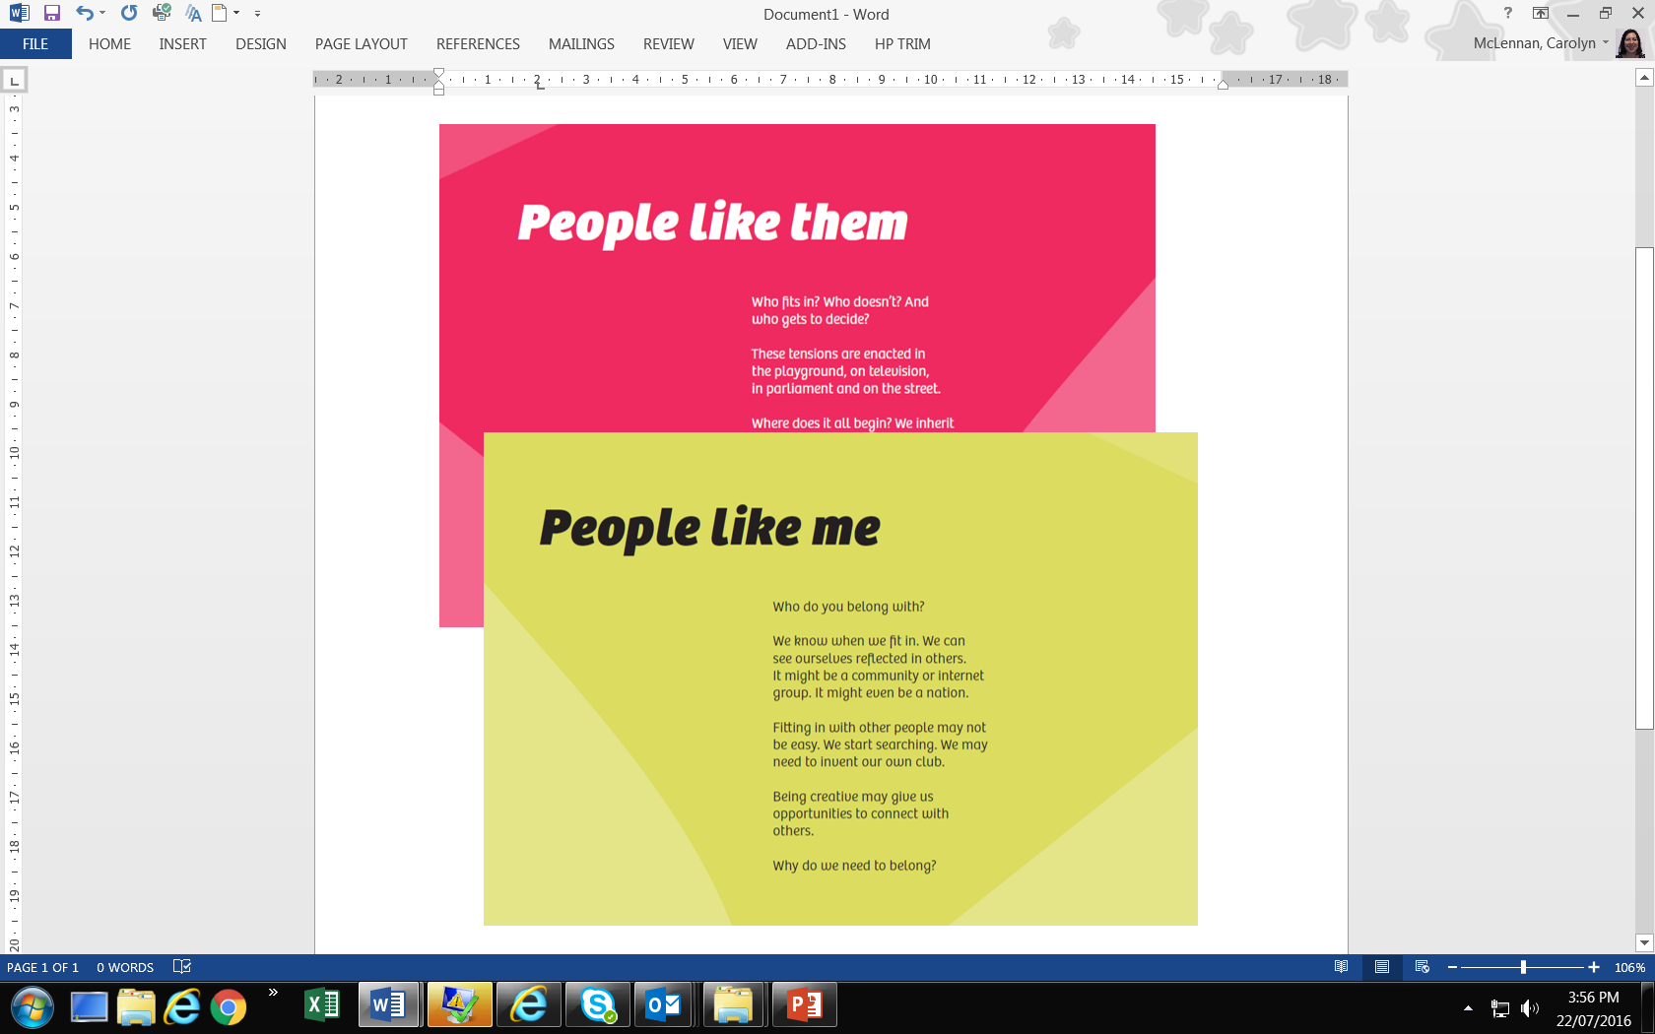
‘Difference’ and ‘Belonging’ Text Panels
Identity: Yours, Mine, Ours Exhibition
Source – Museum Victoria

5. Research Theme 2: Encountering IYMO
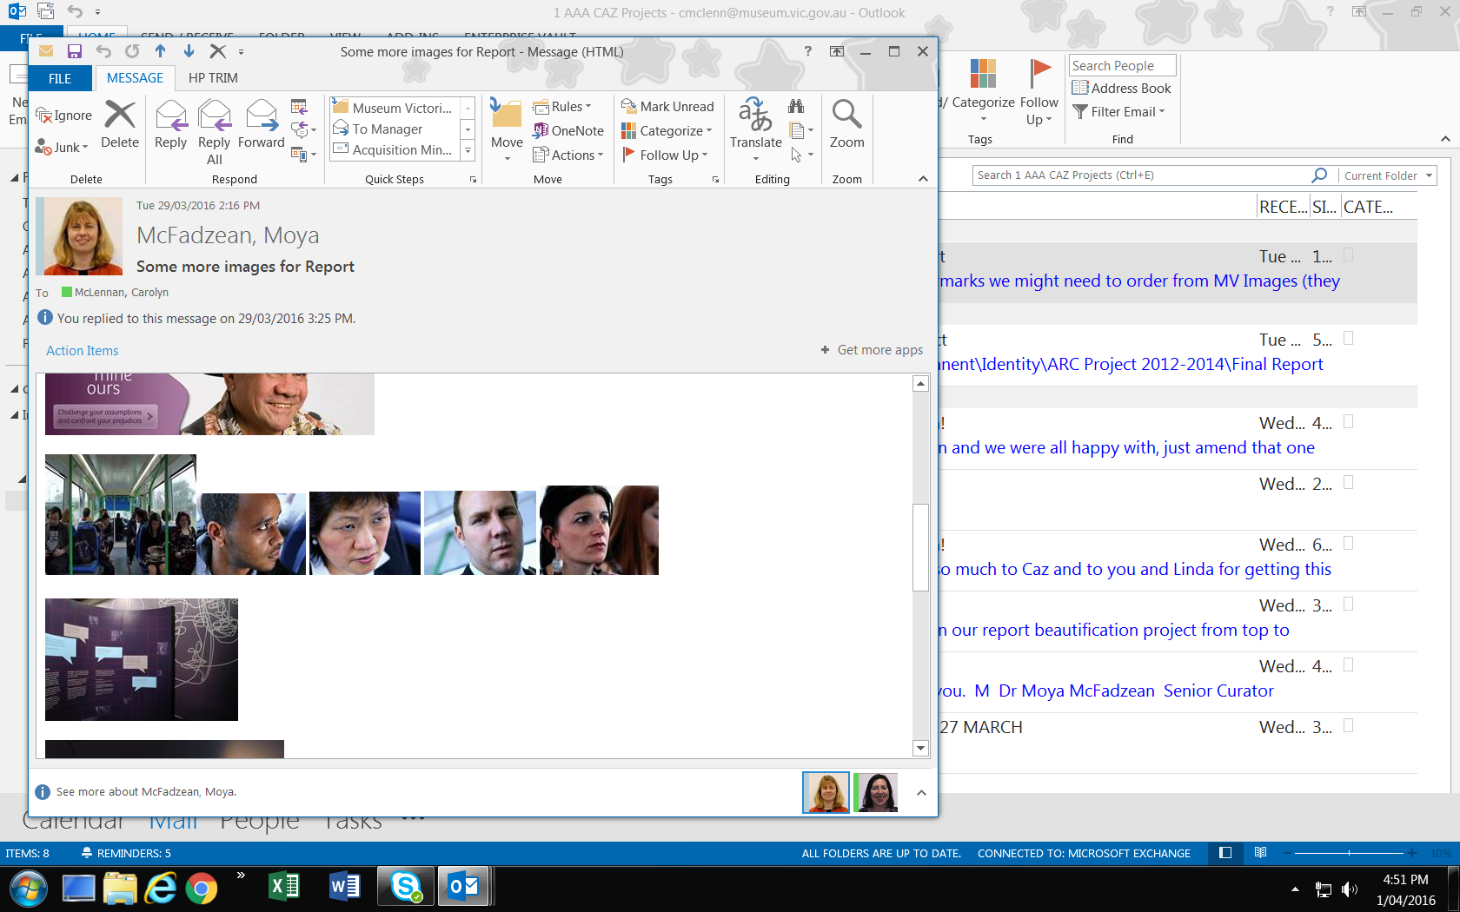
This section describes how the students engaged with and reflected on people’s stories in relation to their own lives or people they know. In some of their encounters, the students seemed to interact with the actual people, not just their stories. This tended to happen with the audio-visual displays, which more readily facilitated a feeling of talking to or seeing someone face-to-face. The sections that facilitated these more ‘life-like’ interpersonal encounters were the ‘Welcome Video Installation’ and the ‘First Impressions Touch Table’. These will be discussed in Section 4.1 in terms of first impressions and challenging stereotypes. Then, Section 4.2 will describe more intimate encounters that the students experienced, which included using perspective-taking to reflect on personal stories as well as making connections to their own stories, and even creating imagined stories about the people they were reading about. The ways in which the technology facilitated these encounters is also discussed. Finally, some students also talked about their general lack of experience with people from different ethnic or cultural backgrounds. For these students, their interpersonal encounters at the exhibition were some of the only such encounters they had had with people perceived to be different to them, particularly those from different ethnic or cultural backgrounds.
Identity: Yours, Mine, Ours Exhibition
Source – Museum Victoria

5.1 First impressions, challenging stereotypes

5.1.1 ‘Welcome’ Video Installation:
In order to enter the exhibition, the visitor walks down a dimly lit narrow corridor where all they can see is a video display of life-sized people projected onto the back wall. The video display is outlined with a doorframe to give the impression that this is the entrance to the exhibit (even though it is actually to the right of this). Each group of one to nine people included in ‘Welcome’ are presented in both a negative light (e.g., unwelcoming body language) and a positive light (e.g., welcoming body language) without any dialogue or audio of any kind. This display is the first encounter that the visitor has with the exhibition.
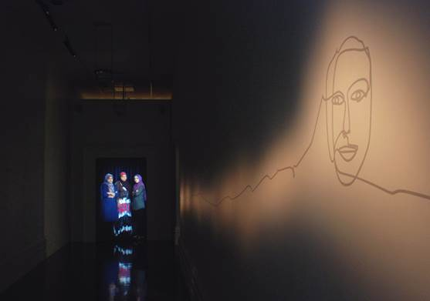
‘Welcome’ entry experience
Identity: Yours, Mine, Ours Exhibition
Source – Museum Victoria

The interactive displays create a space for visitors to reflect on their own assumptions about the people they are listening to and reading about as well as consider their own sense of identity and belonging. In some of the displays, particularly ‘Welcome’, it can feel like the people in the video are reaching out beyond the screen, thus inviting the visitor to move from being a passive observer to an active participant.
At first, the students were not quite sure what they were looking at and their initial reactions were of surprise and shock. As they stood there for a longer period of time, they began to understand that body language has a significant impact on how they perceive people and also upon reflection, how others might perceive them.
Student 1: ‘It’s trying to achieve like the way that the first way we perceive people and how like our body language and how we can create stereotypes around body language because I guess you know if you do see someone whose kind of leaning back and they’ve got their arms crossed and stuff, you kind of go, they’re not very friendly.’

Student 2: ‘And you don’t want to approach them as much as someone who have their arms open to you.’

Student 1: ‘Like embrace you and stuff.’ (Woodlane, T2FG)
Students who stayed long enough to see both negative and positive behaviour of a particular group of people were surprised how their feelings toward the same people changed. The students agreed that ‘Welcome’ was meant to challenge stereotypes. In many instances, they described how it helped them to reflect on their own assumptions.
M: ‘It breaks down stereotypes as well like that opening … what was it called? That … was that the mirror thing?

I: ‘Yeah, that welcome thing …
M: ‘Yeah, how like …

I: ‘… where they were like ..?

M: ‘Yeah, and then it shows them happy and then it shows like the stereotype and stuff. I guess that breaks down stereotypes.’ (Harford ClassA T3FG1)

Male student: ‘It was … yeah, just that really that change of what you assumed those type of people what assumed from that, just, and it was really a fantastic experience for me to go through that.’ (Bayside T3FG)

Additionally, a student at Harford College commented that ‘Welcome’ challenged many different assumptions that were not just about ethnicity:
Female student: ‘Well when we went there it wasn’t just about ethnic groups, it was about people like that tattoo guy and all that. So it wasn’t about just that. So I think it was like the way that they looked at you and how you thought about them. And when we were there, you know that tattoo guy, he was all nice and stuff. That’s what he was trying to do, but not just from an ethnic thing.’ (Harford ClassB T2FG)

Importantly, because ‘Welcome’ included a diverse range of images of people by gender, class, age, racial, ethnic, cultural and religious backgrounds, as well as personal clothing and hairstyles, the students could all interact with the images on a variety of levels.

During the focus groups, the interviewer prompted the students to discuss whether particular parts of the exhibition, such as ‘Welcome’ reminded them of any particular experiences they’ve had or people they know have had. Referring back to the image of a middle-aged man with visible tattoos, the same female student said it reminded her of her dad.
‘Well, my dad’s covered in tattoos and he’s like [unclear] and stuff and he looks really like (chuckling) … yeah, he looks like he’s … just came out of jail, but people just assume he’s a bad guy, but once they get to know him he’s not too bad. But people just assume that because he looks anyway, you know, but that type of thing.’ (Harford ClassB T2FG)

Another image presented people of Pacific Islander backgrounds. The image that the student refers to is the one that displayed unwelcoming body language:
Male student: ‘Yeah. When the … that guy was looking angry and it was like I’ve got friends from the islands and stuff that you just sort of…they look scary at us, but they’re like soft as.’

I: ‘Which guy are you talking about?’

Male student: ‘The one … he was like kind of dark skinned and he was just looking at you angry. The one I think they said they felt anxious about them looking at them. It was just like, yeah, some people look scary but I suppose they might not be scary.’ (Harford ClassB T2FG)

At the same school, another student talked about an image of a man and woman wearing alternative fashion, which they perceived to be pushing gender norms particularly for the man with pink hair and whose body language appeared more effeminate.
‘The guy with the pink hair, my boyfriend used to have pink hair and he had very colourful, different hairstyles and he was judged quite a bit. And it was quite upsetting sometimes because a lot of people would yell out from cars. They’d say things like ‘Fag, get a haircut. Kill yourself.’… They yell out that kind of stuff to people, you know, a lot of bogans mainly. But, yeah, it was really like upsetting, just because of how he looked. I know it was an eccentric look but he was going through a phase; he grew out of it. But he was just finding himself and he wasn’t, you know, gay or anything, but they assumed that straight away, and were just saying things like … really mean things all the time and you have these 40-year old men who look kind of scary and they’d come up and yell in his face and stuff. And then it was frightening just ‘cause of how he looked, and that reminded me when I saw the couple … the two people who had different, unique looks, I was like that reminded me of that.’ (Harford ClassB T2FG)

A few of the students’ reactions to ‘Welcome’ seemed to reinforce some stereotypes while challenging other stereotypes. For example, while recording his video diary, Adam from Lakeland College kept referring to the man with pink hair as ‘gay’. When the first positive image was displayed, he said, ‘He looks gay and she…I don’t know’. When the same positive image was displayed again a few minutes later, he repeated, ‘He’s the biggest gay dude, I reckon’. Finally, at the end of his video diary clip for ‘Welcome’, a negative image of the man with pink hair was displayed. He focused on him and said, ‘The gay dude, he still looks the same regardless if he’s sad or happy or whatever, whatevs’ (Adam, Lakeland, Video Diary). Comparatively, when Adam saw a negative image of Collingwood supporters, he said, ‘Yeah these people look a bit rough. They look a bit rough. Wouldn’t want to mess with them. She looks a bit evil’. Later he saw a positive image of them and was surprised how his feelings changed. He commented, ‘Ah! She looks a bit happier now than she did before. She actually looks like a nice lady. She looked grumpy before’.

5.1.2 ‘First Impressions’ Touch Table
After ‘Welcome’, the exhibition opens out into a spacious room. In the centre of the room is a large touch table with four audio-visual touchscreens. Similar to ‘Welcome’, the touch table invites the students to think about their assumptions. However, this is done more explicitly than ‘Welcome’. Each screen shows a person’s face and features their personal story. Floating around each person’s face are roaming thought bubbles with text that asks the visitor to think about their assumptions about the person in relation to: ‘My food’, ‘My clothes’, ‘My name’, ‘Who I really am’, ‘My family’, ‘My look’, and ‘My language’. The visitor is meant reflect on what they think that person eats or what they wear and then to touch the bubble to listen to the person tell them the truth of their story.

The students seemed to think more deeply about their assumptions while using the touch table. Comparatively, the rotating images in the ‘Welcome’ installation seemed to elicit more immediate impressions and emotions rather than more introspective thoughts about their stories. After the exhibition visit, the students were able to reflect on their experiences interacting with ‘Welcome’ in the focus groups and narrative interviews. However, during their visit, their experiences were much more reactive. This is discussed in Section 5 in relation to the students’ affective experiences. With the touch table, the students could choose what they wanted to learn about the person and could compare the person’s actual story with their perception of the person.

Some of the stories challenged what country they thought the person was from:
Female student: ‘The one I clicked on was like this guy and he looked … he didn’t look very Australian but when you … like he was and he well hadn’t been born anywhere else and that really caught me off guard. He was like a hip-hop artist or something.’ (Harford ClassB T2FG)

Speaking from the experience of someone who has had assumptions made about their cultural background, a few students at Kensington College explained:
‘Sometimes I kind of get offended when people ask, like, are you from Africa or are you from Bangaldesh or… when they don't even know us, like that's, like the assumption is too quick. I don't really like that kind of idea, and going through that room [with the touch table], I feel like humans are not books, you can't just see, like you can't just add up one and one is two, it's not like that. You shouldn't define people just the way they look.’ (Kensington Year 11 T2FG)

‘To all the people like when they look at us, they think that we are Asian but then sometime they assume that I am Chinese and stuff. I mean Chinese or whatever, they ask me, ‘Are you Chinese?’ They never ask, ‘Are you Vietnamese?’ That’s like yeah how they show our identity.’ (Tuyen, Kensington T2NarrIntv)

One of the Anglo-Australian students from Wellview College talked about his assumptions about someone’s racial background and the kind of name he assumed that person would have was also challenged. In response to the screen showing, Vera, an Asian Australian woman with a South African name, he said:
‘There was an Asian girl and she was talking about her name and she was like oh, my name’s this and that and then out of the blue, I didn’t know she was going to say this, but her name is actually from South African, I don’t know, culture or ... yeah, and I was like surprised, I was like are you serious and then I asked the ... sorry, the girl was like oh, my father named me after one of his friends or something like that from another country…So I was like oh, that’s ... I never knew that.’ (Wellview ClassA T2FG)

Another student gave a story about another student that she used to be friends with whose name was the basis of exclusion. She said, ‘I used to be friends with this Indian chick that everyone hated and she was actually really nice. I think people just saw her and like her name was really long, I can’t even remember it now, but people wouldn’t talk to her ’cause of it’ (Wellview Class A T2FG)
Students at Bayside College were mainly white Anglo and did not feel that people made assumptions about people based on race at their school due to the lack of racial and ethnic diversity. However, they could relate to assumptions people make about each other based on personality traits and other individual factors.
F: ‘It’s like that girl in our class, [female student], and she doesn’t talk or anything but and like you just kind of assume that she doesn’t want to talk to anyone but then when we went to that thing she was my partner and she actually talked a lot.
F: Yeah, she just… yeah, once you start talking to her she talks heaps.
F: You assume like she’s shy, she’s really …
F: Yeah, you assume that she’s really shy but she’s not.
F: … yeah.
F: I just thought she hated us.
F: She doesn’t actually know any of us so.
F: Yeah.
F: We make her nervous, as well.’ (Bayside T2FG)
The students demonstrated some perspective taking by talking about their initial impressions of their ‘quiet’ peer and how their behaviour or demeanour might have affected her.

5.1.3 Challenging stereotypes about Muslims
Many of the students discussed stereotypes or experiences of racism in relation to Muslims and people from Middle Eastern backgrounds. In the ‘Mapping Social Cohesion’ Report (Markus, 2013), Australians reported higher negative feelings toward people from Middle Eastern (25%) and Asian (14%) immigrant backgrounds compared to people from English-speaking countries and Europe (both at 3%). These findings are reflected in the students’ discussions about negative feelings they’ve had toward Muslims and stereotypes that Muslim students have experienced.
One of the Muslim students at Harford College gave an example of assumptions that people have made about her. As a Serbian Muslim, she found that people constantly assume she is from a Middle Eastern country. She explained:
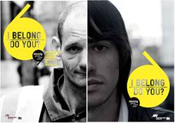
I think assumptions like, ‘I’m from the Middle East’ just because I wear a scarf and I’m a Muslim when actually my ... I was born here but my family are from Europe, so I always get those ... that she’s from the Middle East or something … And they think that only the people in the Middle East are only Muslim, in reality they’re not. (Harford ClassA T2FG2)
Graphic - Identity: Yours, Mine, Ours Exhibition
Source – Museum Victoria

Fahim, who identifies as Turkish and Muslim and was born in Australia explained that he doesn’t experience racism very often, except if he speaks Turkish, because as someone who is racially white with an Australian accent, he can bring out an ‘Australian boy sort of vibe’ (Hartville T2NarrIntv). Comparatively, he talked about the negative responses that Muslim women in his family experience. While recording their joint video diary during the exhibition visit, Cezmi and Fahim filmed a display of a hijab designed in the red and black colours of the Essendon Australian Football League (AFL) team. This prompted Fahim to talk about his experiences as an Essendon supporter and as a Turkish Muslim:
‘Again we feel it looks like a familiar sight to us. A person with a scarf on, wearing Essendon colours. That’s the way. I’m an Essendon bombers supporter. I don’t know, just looks like a really familiar sight to me as our family members wear the scarves, the women in the family…But when people [who] are outside of our family look at the people in my family wearing scarves, they give them like dirty looks and I don’t know it just turns sour after then.’ (Cezmi and Fahim, Hartville Video Diary)

Fahim compared his feelings of familiarity and comfort when seeing a hijab with how other people who are not Muslim have reacted toward family members who wear hijabs.
Comparatively, the Essendon hijab surprised many students from non-Muslim backgrounds. For example, one white student at Wellview said he liked the ‘fashion part of the museum’ the most. He explained:
‘I’ve never seen a Muslim girl ever play football and I was really surprised and then they just … I just remembered she was on, I think it was the Today Show or something. And she was talking about how more girls, even though you might be Muslim or something, get involved with sport and that even though you might wear a … I think it’s like a buka (sic) (burqa) or something? Yeah, what they wear? On top of their head? Like, still play football.’ (Wellview ClassA T3FG).

This student could not distinguish different religious head coverings used by some Muslim women. However, the significance of the Essendon hijab was that he saw something he shared with someone he previously considered very different, perhaps irreconcilably different to him. He never thought that people who are Muslim, and especially women, would also enjoy playing AFL.
A lack of familiarity combined with negative stereotypes, perpetuated by the media, also contributed to other students’ perceptions of students from Middle Eastern countries. This was discussed amongst white students at Bayside College during a focus group three months after their museum visit. They explained that when they first found out that a student from Iraq was an asylum seeker, they felt ‘a bit apprehensive’ and ‘a bit wary’. One student said that she made a decision to ‘give him a chance’ and after she got to know him a bit better, she realised that her initial thinking needed to be re-evaluated. Another student chipped in saying the experience challenged her stereotype of asylum seekers and refugees and prompted her to want to know more about why they are fleeing. She said, ‘I don’t know why people do it…but it makes you think about other situations like why are they coming here?’ She surmised that they were fleeing ‘wars and poverty and stuff’ but she wanted to know more about what it was really like for them (Bayside T3FG). Samin, a student at Harford, talked about her background as a Muslim Hazara refugee and what she hears people say about Muslims in everyday life and in the media. She explained that people need to not view terrorist acts committed by a few people as reflective of ‘a whole group of people’. She said that people need to be seen as ‘a person not as a nation or as a person presenting a whole religion’ (Samin, Harford T2 Narr Intv).

5.2 Deepening interpersonal encounters
The students also went beyond just challenging stereotypes. They engaged in deep reflexive thinking and began to empathise with the people they encountered in the exhibition. The students at Wellview College explained how ‘Welcome’ made them want to know more about the people they were meeting:
F: ‘Look if someone…felt sad or bad …
M: You just want to know ‘why are you feeling sad’.
F: Yeah you want to ask them why but you can’t.
F: And then if they’re like really excited you’re just like, whoa what’s happened to make you this excited?’ (Wellview, ClassB T2FG)

During one of the focus groups at Harford College in 2013, one of the students explained that the exhibition helped to ‘break down stereotypes’. Then, another student built on this and explained that it also helped them to ‘go deeper into the situation’ because she didn’t feel someone could really understand something by ‘just seeing’.
M: ‘Yeah, and then it shows them happy and then it shows like the stereotype and stuff. I guess that breaks down stereotypes.

F: Kind of like … I don’t know you know about racism and stuff before you went to it but then yeah, you just kind of … especially with the bus thing like I watched all of them and I’m like okay, you could see all … everyone’s opinion and what they were thinking or how they were feeling. So it was just … I don’t know, it was just more understanding like you go deeper into the situation. So instead of just seeing … I don’t know, I don’t know how to explain it but practically what [another student] said, yeah.

I: Cool. What were you going to say?

F: Sometimes you don’t put yourself in someone else’s shoes like another ethnicity or whatever it was just like (all chuckling) …

F: It’s easier to empathise.

F: Yeah, I put myself in another person’s shoes like someone that’s not my race and stuff. Some people cop racism all the time and … just by their looks and stuff. It opens up your eyes, yeah, it really opens up your eyes.’ Harford ClassA T3FG1)
For these students, the exhibition not only provided a visual representation that challenged their assumptions; it also provided a space in which they could take a step forward into someone else’s story and begin to not only understand but to feel where the other person was coming from.
In order to engage with the other person’s story, some of the students created stories about the other person as a way to understand how it might feel to be that person or to understand how they imagined the person was feeling just by watching their expressions and body language (e.g., ‘Welcome’). For Laura, being stared at and judged by the negative images in ‘Welcome’ made her think about what it might be like to not feel welcome and to be actively rejected despite efforts to find a sense of belonging.
‘One of them, there was a group of, I can’t really say what they were but they looked Hispanic maybe and one projection of them they were smiling and laughing as if they were friends and then there was another projection where they were staring to a … back at me as if I’m unfamiliar and I’m not welcome and what are you doing, why are you here. It didn’t look like they were coming to our … to look at for me, as in they didn’t come … they weren’t coming into Australia where I lived, it looked more like if I was going into where they lived and I think it was trying to show me that how I’d feel maybe if I went to another country. ‘Cause a lot of people that would go to the museum like me who’s never been to another country before, we don’t really know how it would feel. So we would just think, it’s not really that big of a deal but in actual fact, the projection showed me it actually would be a big deal ‘cause that’s only three people and I feel scared and there’s millions of them.’ (Laura, Harford T2NarrIntv)

She also recalled an image of three men with Asian backgrounds. One of the men had a visible disability. She created a story about the men who she felt looked like ‘university students [or] academics’, while acknowledging that even that was an assumption that she made about them. Nevertheless, she used her imagined story to consider the difficulties someone with a disability might face:
‘They look like a nice bunch of people but I was just thinking about how many people would come and think, ‘Oh look at this guy. He probably doesn’t know much and he probably doesn’t have anyone else to hang with. They’re all a bunch of nerds or something’ and in actual fact, it made me feel bad for them. For him especially because I thought, how many people are going to think that of him when in actual fact he just looks like an average sort of guy doing his own thing. So there was some times when I thought of assumptions and there was other times where I thought of assumptions that would be made.’ (Laura, Harford T2NarrIntv)

At Bayside College, the students primarily focused on rumours that people make about each other at their school. Because the school is mainly Anglo-Australian, they felt that people were judged more on the basis of personality or other factors rather than having a different racial, ethnic or cultural background. However, April used her understanding of the damage that rumours can do by thinking about what it might be like to be discriminated against because of someone’s ethnic background. She reflected on one of the ‘Welcome’ images that showed a group of schoolgirls whispering amongst themselves:
‘This one I find kind of sad because it’s school kids that are whispering and looking really unaccepting of people coming into the country like it just looks nasty. Like you can imagine standing here, being someone of a different ethnicity, wanting to come into this country and this is the reaction that people are giving you.’ (April, Bayside Video Diary)

For many of these students, particularly those who grew up in mostly Anglo-Australian suburbs, the exhibition challenged them to think about some of the difficulties people from different racial or ethnic backgrounds might encounter that went beyond the stereotypical portrayals in the media.
‘I’ve never really spoken to someone about their journey or anything like that ‘cause you don’t really talk about that in everyday life so I’ve never really had the experience to see what other people go through ‘cause it’s kind of when you think about it it’s quite selfish that everyone just lives their own lives and they don’t really understand what other people go through and you can pass them every day in the street and you don’t realise what they go through or what they’ve been through. So it was a really good experience to be able to see that, ‘cause as I said, the school just doesn’t … apart from this class especially sociology, no-one’s really shown what it’s like apart from this class, the school doesn’t really understand.’ (Sandra, Bayside T2NarrIntv)

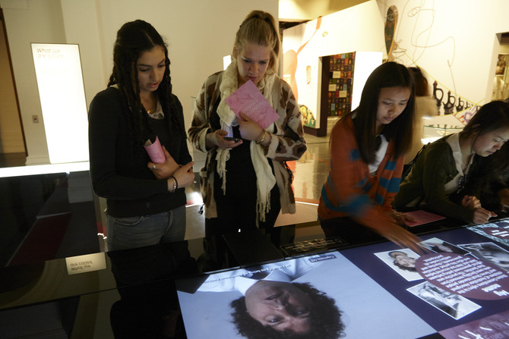
For students who had not experienced the kinds of difficulties some of the people’s stories in the exhibition described, especially experiences of racism, the parts of the exhibition evoked strong emotions. The next section explores the affective dimension of the exhibition in more depth.
TAFE students at Identity: yours, mine, ours Exhibition
Source – Museum Victoria

5.3 What did we learn?
Providing elements of ‘surprise’ in exhibitions (e.g., ‘Welcome’ video installation and the ‘First Impressions’ touch table) worked to:

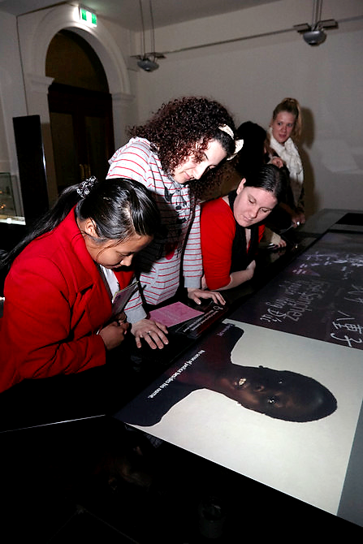
- Unsettle the students in a way that evokes curiosity. Although the students were prepared in terms of learning about key concepts around identity and belonging at school, their first encounter with the ‘Welcome’ video installation immediately confronted the students’ assumptions about who someone is and their sense of belonging, which set the scene for the rest of the exhibition.
- Challenge the students’ expectations of a museum experience. For example, the ‘First Impressions’ touch table creates an introspective environment where they were encouraged to deepen their understanding and disrupt stereotypes about people based on physical appearance.
Students at Identity: yours, mine, ours Exhibition
Source – Museum Victoria

6. Research Theme 3: Feeling IYMO

The IYMO exhibition creates an affective and intimate atmosphere that unsettles, confronts, accentuates and at times escalates emotions. For the students who participated in this evaluation, emotions ranged from feeling uncomfortable, sad and guilty to shocked, surprised and angry. This section describes how the exhibition’s affective dimension created an entry point through which students could connect to the individual people and their stories. In this way, the exhibition material became more than just a series of stories, objects and facts. The exhibition was enlivened by the interaction between students’ emotions, personal experiences and perspectives and the audio-visual presentation of people’s stories, which were brought to life through their voices and expressions.

6.1 An affective entrance
From the outset, the students’ first contact with the exhibition is a disquieting experience. They enter a liminal space that instantly transports them from the bright, noisy and lively activity area outside the exhibition through a doorway and into a narrow dark corridor. Their eyes are forced to adjust to the dim light when they suddenly become aware of people gesturing toward them on a video screen at the end of the corridor. Here, they are confronted with life-sized images of ordinary people who are displaying a whole range of emotions from banal indifference to enthusiastic inclusivity to distrust and aggression.
Rationally, after a moment or two, the students knew that the people in the video were not actually there and could not physically impact them. Nevertheless, the emotions the people in the video displayed, which were directed and projected out of the screen to the viewer, produced a bodily reaction so that their presence was actually felt by the students. Tuyen described the range of emotions she was feeling as she walked toward the screen and watched the changing images:
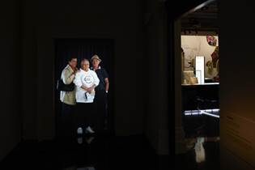
‘Welcome’ video installation
Identity: yours, mine, ours Exhibition
Source – Museum Victoria

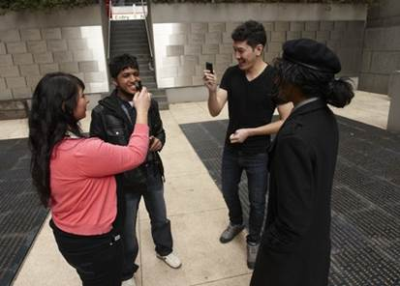
‘You know the whole way when I walked in, there’s expression of so many people here. And then when I first walked in here I was freaked out... that looked really like a horror movie you know when you’re in the dark hole, I was oh and it was like ‘oh my god’ and then ... because there were people smiling and laughing as well you know but everyone ... when I walked in people were staring at me and then you know that picture like seemed like they don’t like me you know so it looks so real and then ‘oh my god’ and then ... and then yeah and it was cool.’ (Kensington T2NarrIntv)
Video Story Making at the Immigration Museum
Source – Museum Victoria

Two weeks after the exhibition visit, students could still remember what it felt to stand there and be both the viewing subject and the viewed object. Two students at Bayside College reflected on this:
F1: I don’t think … I found … I don’t know I felt insulted but that’s silly ‘cause it’s like a video recording but I don’t know, you’re looking at it and you’re like, ‘Oh, I don’t really like this. This is uncomfortable ‘cause they’re staring at me’ and then when they got happy … it was like, ‘Oh’ (sound of relief) …’

F2: ‘It was still uncomfortable when they were happier, you know? Kind of like yeah (all chuckling).’ (Bayside T2FG)

At Harford College, students were asked what they felt while watching the screen. One female student explained that she ‘felt a bit uncomfortable watching it…’cause of the different, such strong emotions they were all giving off’. Another student agreed saying ‘It made you feel uncomfortable standing there’ (Harford T2FG 2014).
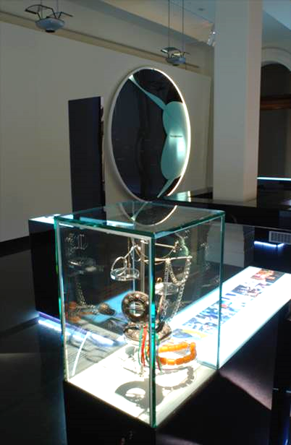
After being unsettled by ‘Welcome’, they enter a space with interactive displays and cultural artefacts that invite them to explore, to engage and to consider their own feelings and sense of belonging. This immersion has the effect of momentarily suspending time and providing space to absorb and reflect, that is, until their teacher reminds them that their time is limited and they need to move on to the next excursion activity. However, during this period of time in the exhibition, the students’ worldviews have the potential to shift in ways that may alter their perceptions of the world around them and challenge their preconceptions about cultural diversity, racism, history and their own sense of place within that social and cultural context.
‘What We Wear’ - Display Case
Identity: yours, mine, ours Exhibition
Source – Museum Victoria

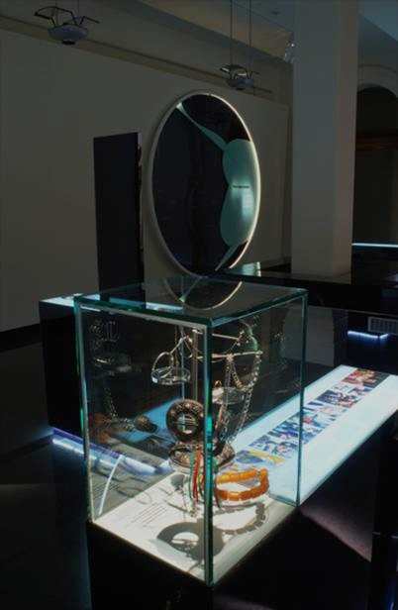

6.2 Feeling racism

6.2.1 Shock and surprise
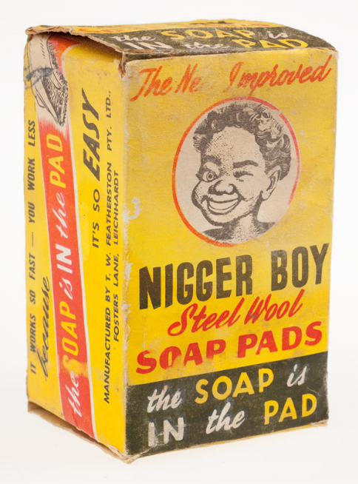
Emotions were particularly high when learning about historical racism and interacting with people whose stories described experiences of racism. Students were mainly shocked or surprised by historical facts that they weren’t aware of. This shock was primarily directed at the ‘nigger boy steel wool soap pads’, the racism behind the common nursery rhyme ‘eenie, meenie, miney, mo’, the White Australia Policy and the systematic social exclusion of Aboriginal people despite their status as Australian citizens, and, before the Australia nation was formed, a citizen of the British empire (Chesterman & Galligan, 1997).
The students were all shocked by the use of the word ‘nigger’ in commercial products. When the students at Bayside were asked three months after they visited the exhibition what was most memorable, they said the ‘nigger soap’. They all agreed it was ‘shocking’. (Bayside T3FG). Similarly, Amber from Harford College was filming her video diary when she abruptly stopped talking and exclaimed in disbelief, ‘Nigger boy…wow…’ when she saw the soap (Video Diary 2013).
Packet of Nigger Boy Steel Wool Soap Pads, 1950s
Identity: Yours, Mine, Ours Exhibition
Source: Museum Victoria
The steel wool pads are a common household cleaning product. The ‘nigger boy’ pads were manufactured in Leichardt, New South Wales by the company, TW Featherstone in the 1950s (Museum Victoria, 2015d). This blatantly racist everyday object points to the systematic racism that had become normalised at all levels of society. The White Australia Policy was in full force and Aboriginal people faced systematic social and political exclusion, including not being counted the Census (Chesterman & Galligan, 1997).
Today, while words like ‘nigger’ do not appear on mainstream commercial products, racism persists in more covert forms with the same social weight and vicious impacts (e.g., a 13 year old girl calling Adam Goodes, an Aboriginal Australian Football League player and 2014 Australian of the Year, an ‘ape’ (Crawford, 2013)). Racism continues to be normalised to the extent that people who speak out about it are labelled too sensitive or too politically correct or even accused of being a ‘reverse racist’ as if white people are being victimised and marginalised. When faced with more contemporary products such as ‘Creole cream’ biscuits previously issued by Coles (a chocolate biscuit with white filling) and Golliwogs (a black doll with exaggerated minstrel features), some of the students reacted defensively saying that it was too politically correct to call it racist. During her video diary, Karen panned over the food products and commented, ‘I guess there is a lot of like um what is it called? Um, political correctness now but then you look at some of these [Arnott’s Golliwog chocolate biscuits, Allen’s Retro gummies, and a glass with a black woman saying ‘Hello, I’m Co-coa, the flavour’] and they’re just so racist’. She added, ‘If you were to walk through the supermarket and you saw something racist on the shelf and it was racist against your culture and everything that you love. You would be like are you serious? What am I supposed to do about that?’ (Woodlane Video Diary). Conversely, April felt that the inclusion of some of the food products as racist was not warranted:
‘So this one is kind of looking at stuff that is again being taken as too politically incorrect like stuff just like Coles…chocolate biscuits [even though it says Creole creams] like they’re considered to be racist because they’re black which kind of seems silly because they’re just chocolate biscuits but I don’t know. It’s silly. And like having ‘Oriental teriyaki biscuits’. I don’t know, I like this one because it kind of shows how silly people are being with their food.’
Without a deeper understanding of the historical meaning behind words such as ‘Creole’ and ‘Oriental’, April could not understand why the products would be associated with racism.
For some students, the White Australia Policy was new knowledge and the fact that there was a t-shirt with a picture of Australia and the word ‘Full!’ from 2009 was surprising.
‘And I never really understood or knew how it was back then, here in Australia 'cause I just never really studied it. This is really the first time that I've really gone in-depth with the studying of Australian history and when the history of the first Aboriginals and the treatment. So to see something like that was ... I knew it was happening at other parts around the world but I didn't know it was ... that it happened in Australia. That's what kind of caught me off guard and surprised me.’ (Jordan, Harford T3Narr Intv 2013)

‘I was just looking at this t-shirt which is a picture of Australia and it says ‘full’ and I just think that this is unbelievable that people are actually wearing this in a year as recent as 2009 [zooms in on the placard displaying the date]….I just thought that we were much more evolved then that but I guess it’s just me.’ (Melissa, Wellview Video Diary)

Even events such as the Cronulla riots surprised some of the students that they were so recent.
Female 1: ‘There was a thing that surprised me, there was a t-shirt a white t-shirt that said Australia was full and then it was dated 2009 and I thought that was something from like awhile back maybe like 20, 10 years ago and it’s only, it’s really recent. I don’t think we’re really, I don’t think that our generation is really shown that much racism or anything unless we watch the news or stuff then you kind of know what’s going on in Australia.’

Female 2: ‘Because even when we did the Cronulla riots last year [Female 1: Yeah] when we studied that, I thought it’d be from 1980 or something like that. I wasn’t expecting them to be in the 2000s and I was like I’d never seen that amount of racism and anger toward people.’ (Woodlane T2FG)

At the time, the students would have been 7-9 years old in Grades 3 and 4. Based on the students’ comments later on in the focus group and previous research on how teachers talk about ‘difference’ in the classroom (Priest, Walton, et al., 2014; Walton et al., 2014), it is possible that events such as this and the social issues of racism and white privilege were not discussed but rather a colour-blind approach was taken instead. The students at Woodlane College talked about how they were always taught by their teachers and parents to ignore racial differences and focus on how everyone is equal. For example, one of the students commented, ‘I feel that this gen like our generation, you’re being brought up more to like, you don’t recognise the different cultures like the backgrounds as much’ (Woodlane T2FG). Conversely, the IYMO exhibition explicitly highlighted racial, ethnic and cultural differences (alongside other sections that focused on shared experiences and similarities), which forced students to think about difference in more critical and reflective ways.

6.2.2 Sadness and anger
The primary emotions the students expressed were sadness and anger. Both of these emotions were a reaction to forms of social exclusion. Sadness was related to an understanding of how social exclusion negatively impacts people’s sense of identity and belonging in everyday life whereas students mainly expressed anger in response to the visceral brutality of racism and the social injustice of it. The sadness and anger the students expressed were profound and deeply felt.
Karen was filming a quote that said, ‘Even if I claim Australian citizenship people will insist on my being Chinese…’. She paused at this point and stated, ‘That’s really sad’ and then continued to read. She then moved the camera away saying, ‘I think that’s one of the saddest things I’ve read on this because we do kind of have that kind of you’re either fully Chinese and like you speak Chinese…and you do everything Chinese or you’re not really Chinese and you’re like ashamed of it’ (Karen, Woodlane Video Diary). As a white Anglo student, her feelings of sadness were an affective entry point that enabled her to move beyond her conceptual knowledge about cultural essentialism and social expectations to an empathetic understanding of how it might feel for someone whose sense of belonging is affected by those social conceptions. For Matai, a Pasifika student at Wellview College, the ‘Playground’ display about children’s play, bullying and racism reminded him of his own experiences of being marginalised. During his video diary, he panned over the introductory text and read it out loud, ‘The playground. Sticks and stones may break my bones but names will never hurt me. Did you really believe this as child? Were you called names at school? Were you the bully?’ He then shifted the camera around the panel and reflected:
‘Well, when I was growing up as a child the playground was pretty, very unique because it takes me back to the days when I was younger and I used to have a lisp and kids used to pick on me and it actually really hurt my feelings and yeah it just goes to show that this part of the museum brings back some bad memories but it teaches you a lesson.’ (Wellview Video Diary)

Matai could relate to the prompts about being bullied at school. Through the video diary and in the intimate space of the museum, he could confide his personal experience which might ordinarily be too difficult or painful to talk about.
In the Kensington focus groups conducted two weeks after the students’ visit, an international student from Southeast Asia commented on how the exhibition compelled him to feel the impact of racism. For this student and a few others in the focus group, racism was not something they felt they experienced whereas others could give examples of their experiences of racism. For this student, the tram simulation showed him not only what racism can look like but also what it feels like.
M: ‘I knew that racism exists but seeing and like wonder, it shows like I didn't know that the impact of being racist is so much. Like, say I went there to a place that was like a tram and they, like racism was going on and I always know that racism is a bad thing but seeing it myself I feel it's really, really bad, like I really feel so sorry for the people that get, like, intimidated, it's really bad for them.

I: And the exhibition made you ...

M: Yeah.

I: ... realise that?

M: Yeah. I knew it before, but seeing that is, like, emphasises, like, [it is] bad, I knew that it exists before but seeing that it makes me feel even more so awful for them.’ (Kensington T2FG)

Overall, sadness was something students felt in response to the impact of social exclusion and for those that have not experienced racism but could empathise with the hurtful impacts.
On the other hand, anger was the dominant emotion in response to racism displayed in the tram simulation. Anger moved beyond the individual hurtful impacts of racism to the social injustice of racism. Sadness was more of an inward personal feeling whereas anger was projected outwards in forms of physical and emotional aggression. Whether or not the students would actually be an active bystander against racism or would actually act out their aggression and potentially escalate the situation were secondary to the anger they felt. Students at Hartville College, who were predominantly Turkish and Muslim, discussed how racism made them feel and their reasons.
M1: ‘It makes you angry when you hear those kinds of stuff, like, on TV, because there’s a sort of … there’s the sort of people where they represent Muslims to be bad and they do it on purpose and there’s the Muslims that are actually like, proper Muslims and they’re …

M2: The harmless ones….

M3: People think of us to be a bad terrorist stereotype.’ (Hartville, T2FG)

Later when talking about things they wish they could change about the exhibition, the students said it would have been good if there were a punching bag next to the tram simulation.
M1: ‘Put a punching bag near that … where the people are judging you. You put the face on the …

M2: No, what you do is … next to the tram, put a punching bag here, put the face of the racist.’ (Hartville, T2FG)

Within the discussion were ideas that contrasted someone who is a ‘proper Muslim’ in opposition to those who commit terrorist attacks under the guise of Islam. The anger was directed at unfair and inaccurate media portrayals of Muslims as all being ‘terrorists’ and the impact these portrayals have on their own experiences of racism in everyday life. During a narrative interview, Fahim explained how he could relate to the target of racism in the tram simulation:
‘Yeah, yeah, that's sort of like ... I sort of knew how that guy was feeling 'cause some people stare like that at our people, at Turkish people and stuff, when we'd be speaking Turkish in public. I know it might be rude to speak Turkish but sometimes you just need to, you know, and people sometimes stare, ‘What are they saying ….’’ (Hartville T2NarrIntv)

Students also expressed anger when it contradicted their personal values and perception of social norms. For example, one of the Wellview students felt strongly about racism in Australian society:
‘I would have probably got really angry in the situation if I saw it in real life. I’d probably have a good crack at the guy and said, ‘Dude, get with the program. This is the 21st century. You cannot judge because of his skin colour or anything. He might be like the nicest guy you will ever meet so…’ (Wellview T2FG2)
Similarly, when Karen came across the ‘Full!’ t-shirt that depicts an anti-immigration white Australia, she exclaimed, ‘Like look at that! To have somebody walking around wearing that I’m guessing that…who was it made by?’ She zoomed in on the tag and read out, ‘It was made by Fruit of the Loom, heavy cotton’, a well-known worldwide brand. As she continued to think about it, anger and frustration seeped into her voice, ‘That’s so horrible to have that on everything. It’s so infuriating’ (Woodlane Video Diary).

6.2.4 Guilt and embarrassment
After looking at the racist ‘Full!’ shirt, Karen filmed the anti-racist t-shirt on the other side of the same display. She commented, ‘But then on the flipside you have these things and they’re really good. Because sometimes all you hear about is how white people are really really racist and I think it’s really good to at least have something that says we are not’ (Woodlane Video Diary). Karen saw herself as anti-racist, which conflicted with her perception that white people are unfairly portrayed as racist (Kowal, 2012 ). Her use of ‘we’ distances herself from white people as ‘really really racist’ and white people who are not. In Australia and at an individual level it is not only white people who are racist (Sawrikar & Katz, 2010) and people are not racist in the same ways, meaning it is not always extreme blatant forms of racism such as wearing a racist t-shirt. However, racism is systematic and in Australia although there are obviously individual exceptions, at a structural level, white people do hold majority positions of power at all levels, including political representation, diverse and dominant representations in the media and privileged access and control over housing, education, health and so on. Perceived membership of this privileged group thus requires individual and social responsibility to address social inequities. Rather than acknowledging this privilege and taking a pro-active stance, this feeling of being socially responsible is often talked about in ways that make this privilege out to be ‘an unfair burden’ (Lensmire et al., 2013; Monahan, 2014). This usually manifests in emotions of guilt (Kowal, Franklin, & Paradies, 2013). For white Anglo students such as Karen and other white students at Bayside College and Harford College, guilt and embarrassment were primary emotions whereas ethnic minority students did not express these emotions.
During a focus group with Harford students, one of the white students explained how watching the tram simulation offended her and embarrassed her:
‘Even though I’m an Australian myself, technically I guess you could call myself Australian, I was born here and I look white and all that, European sort of. I think at this … at the same time it actually offends me as well, ‘cause it made me feel … it makes me feel embarrassed a little bit because I know that people are going to look at me as sort of like the prime Aussie and then they’re going to think suddenly … and this happens a lot, that I’m going to be thinking that sort of stuff. I’m going to be in the category of ‘get out, we don’t like you’ but in actual fact yeah I wish I could wear a t-shirt that said ‘don’t worry, I’m not like that and I like everybody’. So yeah it made me think … I felt embarrassed ‘cause yeah, I don’t want to be categorised as that sort of Aussie.’ (Harford, ClassA T2FG1)
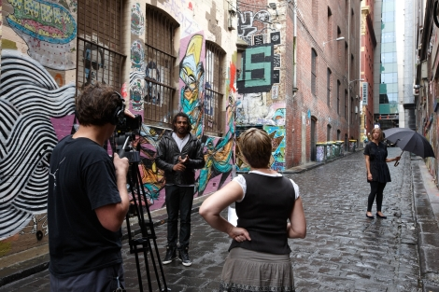
This statement is quite complex and draws on feelings of uncertain belonging and identity as a white Australian and the forceful colonisation of Aboriginal lands. She only tentatively claims her Australianness as someone who was born in Australia, who is white and of European ancestry, hedging this by saying ‘technically I guess’. She then comments that the portrayal of the white man on the tram as racist offended her and then immediately switches and explains that it makes her feel embarrassed. For her, his representation as ‘Australian’, read as white and Anglo, trumps her ability to call herself Australian without having this identity associated with being racist. She feels misunderstood and wants her anti-racist attitudes to be better represented in the exhibition. Although there are examples of this such as anti-racist protest material and imagery, this is perhaps not made explicit enough.
Heritier Lumumba, being filmed talking about ‘Difference’ and ‘Belonging’ for the Identity: Yours, Mine, Ours Exhibition
Source – Museum Victoria

In response to ‘Welcome’, April associates the feeling of being stared at and judged as something people who immigrate to Australia must feel. She said:
‘And it just kind of puts it into perspective that the looks people give you can really make a difference like these people just looking at you make you feel guilty for just standing here and I’m not even an immigrant. I’m an Australian girl just watching this video and it even makes me feel guilty just standing here.’ (Bayside Video Diary)

She switches the guilt from empathising with the unfair feeling of guilt from the perspective of being an ethnic minority and immigrant to Australia to being white Australian and feeling guilty. She implies that because she is white Australian, she shouldn’t feel guilty for being there but that the unusual feeling of being unwelcome compelled her to feel guilty. Later in a focus group, April reiterated her feelings, which were confirmed by other students:
I: ‘Did you feel a sense of being confronted when you were watching the tram simulation in the Museum?

F: I felt kind of guilty in a way. It was confronting ‘cause that man’s kind of obviously depicted as an Australian and ‘cause everyone else like the viewpoint to the people that were more multicultural, it was kind of like stereotypical of white Anglo-Saxon and he was the one being the racist and I don’t know I found it was kind of like a bad reflection, it makes you feel kind of guilty ‘cause he’s kind of reflecting you …

I: Okay ...

F: … if you know what I mean?

I: … as an Anglo-Saxon person?

F: Yeah.

I: Yeah.

F: So it’s kind of making it out like that that’s what we’re all like which isn’t true.

I: Mm-hm. Yeah. So you thought maybe it was a bit unfair to represent them … that … or ?

F: Yeah, I don’t know where I’m going with this, I’m not quite sure what my point was.

I: Oh, well, you said you felt a bit guilty that …

F: Oh, yeah. Yeah, that’s what it was. That will do.
[…]

M: Yeah, exactly what [female student] said.

It’s just … I kind of felt like it was a bad representation of Anglo-Saxon …

F: Mm, you feel kind of bad ‘cause you’re classed as one of them and he’s a prejudiced wanker.’ (Bayside, T2FG)

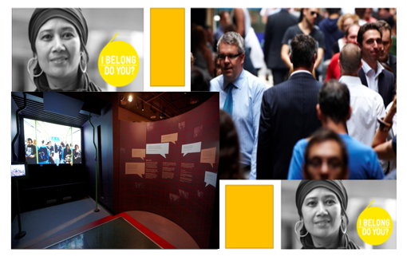
Similar to Karen’s feelings, the guilt and embarrassment of seeing their face reflected in another white face in a racist situation triggered negative feelings of unfair representation. However, the students did not connect this feeling of being unfairly portrayed with unfair stereotypical minority representations that are symptomatic of structural racism.
All Images from Identity: Yours, Mine, Ours Exhibition and Website
Source – Museum Victoria

6.3 What did we learn?
The multi-sensory storytelling medium provides opportunities for:
- Direct engagement with personal stories, artefacts and images which invite students to confront and reflect on their own feelings about identity, belonging and racism.
- Physical interaction with the displays, such as picking up an audio handset and hearing someone on the other end talk about what happened to them and how those experiences made them feel. The students did not just read about people, they felt connected to real people by hearing and seeing people from diverse backgrounds talk about their experiences growing up in Australia.

- Deeper connections that enabled a sense of civic responsibility. The intimate and interactive nature of this engagement ‘got under their skin’ and, through a familiar connection (e.g. talking on an audio handset), they could also begin to go a bit deeper by becoming open to the other person’s experience.
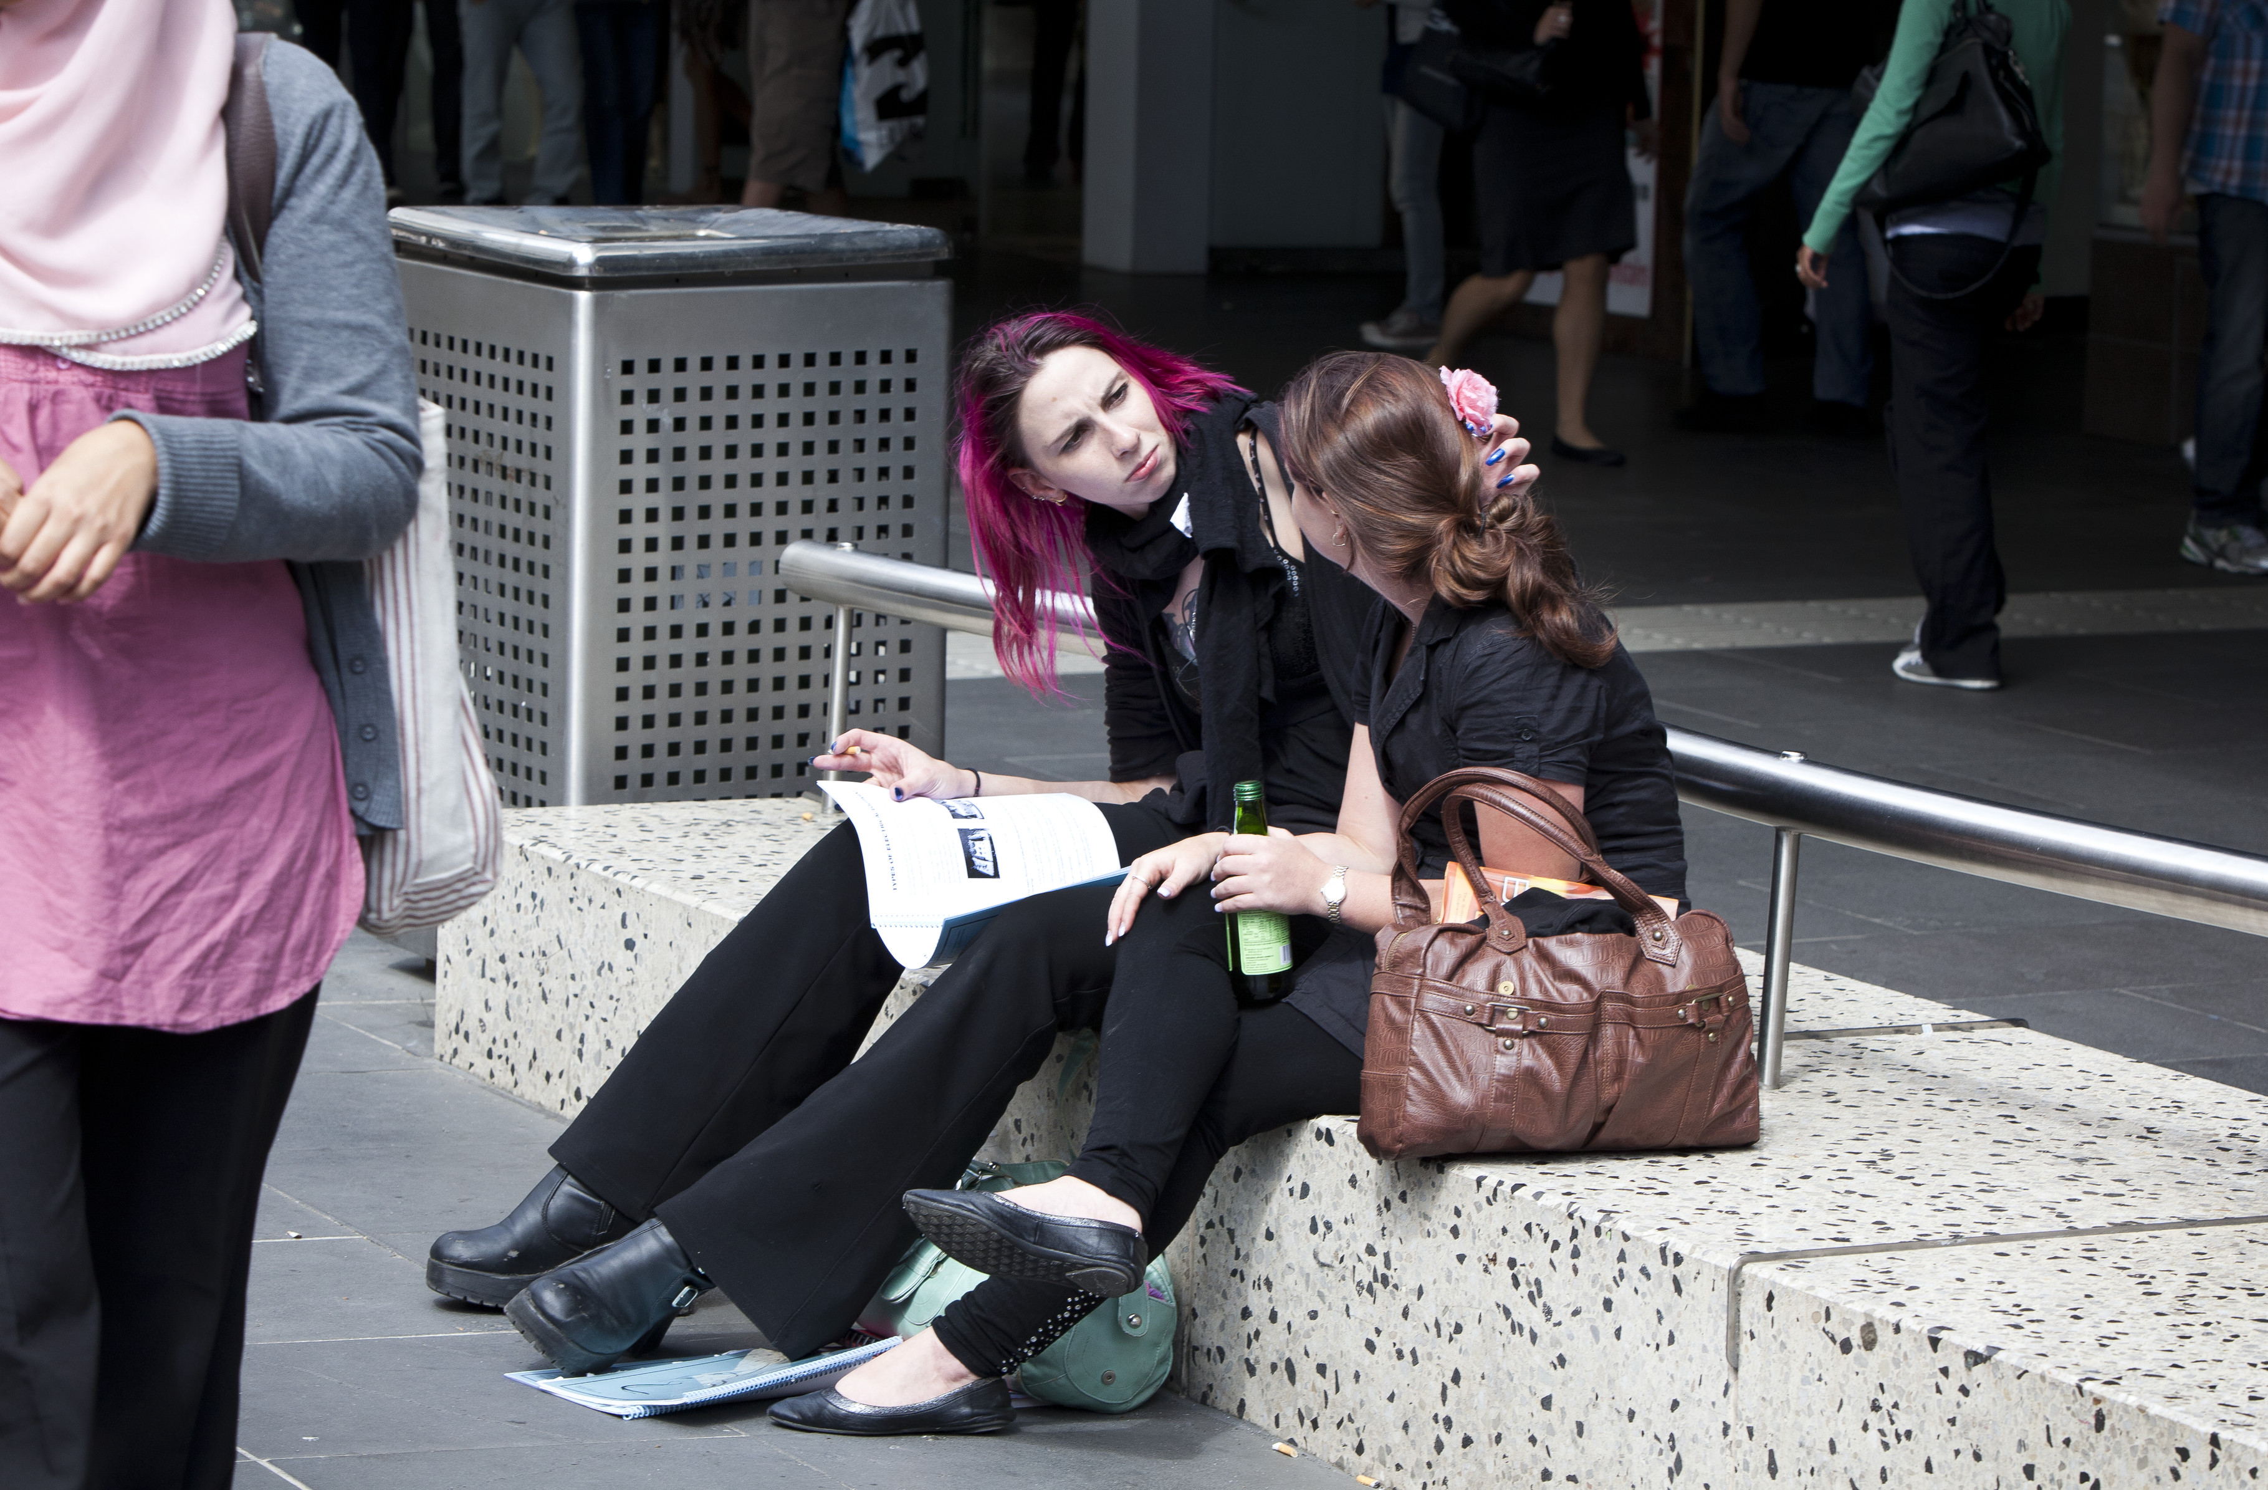

A city conversation
Source – Museum Victoria

7. Research Theme 4: Living IYMO

The IYMO exhibition helped the students to think about their own and other people’s experiences of belonging, which included difficulties belonging and factors that supported a sense of belonging. Racism was identified as a major exclusionary barrier to belonging.

7.1 Experiences of belonging: Family, friends, social acceptance
Students mainly discussed having close friends and close relationships with family as contributing to their sense of belonging. It was important to have not just friends but people who they really know and who really know them.
F: ‘And like your best friends, close friends.’ (Harford T2FG2 2013)
‘So when I came to school in Year 10 and I first came to school and my English not really good and lived by my own life, no friends… but I had met a group of friend in my EAL [English as an Additional Language] class and now I belong to them. Every break I play with them.’ (Minh, Kensington T2NarrIntv)
‘With my friends and stuff, we all like to learn about each other's background and we try to cope with it [racism] and help each other.’ (Rashed, Kensington T2NarrIntv)

As demonstrated by Rashed’s comment, friends also provided support for coping with experiences of racism.
Students also talked about how it was important to feel accepted by others, both people who they identify with (in-group) and others who they do not necessarily identify with (out-group). For example, the students at Hartville, who were mainly Turkish and Muslim, talked about a shared belonging:
Male 1: ‘Like a group, like we have a group where we fit in.’
Male 2: ‘Our friendship group is like where we fit in our identities, like our culture and all that.’ (Hartville T2FG)

Others such as Tuyen, an international student at Kensington, also talked about people who helped her to feel welcome even though they did not know each other.
‘But the people on the street used to smile [at] me even if I don’t know them. That’s really nice you know when I first came here it was like, ‘Why do they smile at me?’ But that’s really cute. And I walk on the road and if I see strangers I smile [at] them first.’ (Tuyen, Kensington T2NarrIntv).

Some of the international students at Kensington College found it difficult to belong and found solace among people who looked like them. For example, Ary’s experience, described below, evokes both isolation and a sense of inclusion.
‘My experience was when I first came here all I see is people with blonde hair with also Australian accents and when I arrived in Australia that’s what I see. But when the first couple of day I was only inside the house but then I got to Springvale where I see a lot of Asian peoples and stuff, I start to feel like I’m home, I start to feel like there’s people that are like me, they all have the same story and when I’m in the exhibition I can tell that it’s not only me who facing this loneliness or alienation alone. There’s trillions of people, billions of people around the world facing ... and in Australia there’s a lot of people [who] are facing the same way so that’s how I feel.’ (Ary, Kensington T2NarrIntv)

When Ary first came to Australia from Cambodia, she could only feel the differences between herself and others based on appearance, language and accent. She found initial comfort among people who looked like her and who spoke the same language. Her experience at the exhibition expanded her individual experience by seeing that others have also experienced similar feelings of loneliness and alienation. For students who had difficulties feeling a sense of belonging, particularly for recent international students such as Ary, it was important for them to know that they were not alone. The exhibition provided this affirmation of their individual experiences and expanded it to broader social issues that impede a sense of belonging such as racism.

7.2 Difficulties for belonging: Racism
Overall, racism was a major barrier to students’ experiences of belonging in Australia and was identified by both majority and minority students as a serious impediment to getting along and living together in Australian society.

7.2.1 Prevalence of racism
In Australia, national-level findings (n=12,512) from the ‘Challenging Racism Project’ survey (2001-2008) found that over 85% of respondents acknowledged that racial prejudice exists in Australia (Dunn & Nelson, 2011) and 44% also identified specific cultural groups that they felt did not fit into Australian society including people with Muslim, Middle Eastern and Asian backgrounds (Nelson, Dunn, & Paradies, 2011 ). National findings from the five Scanlon Social Cohesion surveys (Markus, 2010; Markus, 2011; Markus, 2012; Markus & Arnup, 2009; Markus & Dharmalingam, 2007) found that around 25-30% of respondents disagreed with ‘the proposition that ‘accepting immigrants from many different countries makes Australia stronger’…with 8-11% indicating ‘strong disagreement’’ (Markus, 2014, p. 16). Furthermore, in the three surveys conducted from 2010 to 2012, 20% and 26% of respondents were negative or very negative toward Lebanese immigrants and Iraqi immigrants, respectively (Markus, 2014, p. 16). In terms of reported prevalence of racism, findings from the Foundation for Young Australians survey found that 75% of students (n=698) reported being exposed to, or involved in, racism (Mansouri, Jenkins, Morgan, & Taouk, 2009). Additionally, compared to Catholic schools (54%), students reported significantly higher levels of racism experiences at government schools in both inner (77%) and outer regions (78%) (Mansouri et al., 2009). Finally, in another study involving 263 students (82% primary and 17% secondary), 22% experienced ‘at least one form of direct racism every day’ and 48% reported vicarious racism, ‘at least one form of racism experienced by other students’ every day (Priest, Perry, Ferdinand, Paradies, & Kelaher, 2014, p. 1677).
Students from minority backgrounds and students from majority backgrounds who lived in ethnically diverse areas reported more experiences of racism and knowledge about both subtle and blatant forms of racism than students who lived in white majority areas with low ethnic diversity. The museum exhibition helped students from white backgrounds to understand how often racism happens and also the impact that it has on people who experience it as targets.
F: ‘Sort of like made me see how we ... like how often racism happens, and how many different forms it takes.
I: Okay. So that was new maybe for people to think about?
F: Yeah, like it happens really often and stuff.’ (Harford, T2FG2 2013)
Students reported numerous experiences of racism as a target, as a bystander and sometimes as a perpetrator. Supporting the adult responses from the ‘Challenging Racism’ survey, students mainly talked about racism aimed toward people from Asian and Middle Eastern backgrounds. For students living in areas with people from African backgrounds, there were also reports of vicarious racism (i.e., racism experienced by family or friends which is either witnessed or otherwise impacts on an individual).
Overall, the racism discussions were mainly prompted by the ‘Welcome’ video installation and the tram simulation. ‘Welcome’ helped students to recall experiences when people made assumptions about them based on race or more general stereotypes while the tram simulation generated in-depth discussion about experiences of racism. The tram simulation was particularly powerful because of the way it described the same situation from different perspectives. This helped students relate to the experience, whether it was from the position of the target, perpetrator or bystander. The following sections describes these different perspectives.

7.2.2 Racism from the targets’ perspectives
Students from racial and ethnic minority backgrounds described experiences when they were targets of racism. During a focus group three months after their museum visit, one of the Kensington students recalled an experience at school:
M: ‘I had talked to my friend too, like a guy in recess, like he did something or he said something on me like I’m Asian or something, yeah, and I talked to my friend and he said, ‘Don't worry, ignore them’. (Kensington T3FG)

Samin talked about her family’s experiences when they first came to Australia. She said, ‘And um when I came, my background, my parents are Muslims so when I came to the country um I was, I started from year 5 at school and people sometimes used to you know stereotype, Muslim terrorists and all that’ (Harford T2NarrIntv 2013). Fahim at Hartville College also recalled an experience when he was speaking in Turkish on the bus and it reminded him of the tram simulation at the museum:
M: ‘One example was there was a video of a person staring at someone in the train or the bus, I can’t remember.

I: Yeah, the tram.

M: Yeah in the tram, where the guy's staring at the other guy.

I: Yeah the darker skinned guy.

M: Yeah, yeah, that's sort of like ... I sort of knew how that guy was feeling 'cause some people stare like that at our people, at Turkish people and stuff, when we'd be speaking Turkish in public. I know it might be rude to speak Turkish but sometimes you just need to, you know, and people sometimes stare what are they saying and…’ (Fahim, Hartville, T2NarrIntv)
The student could identify with the experience of the black man on the tram who was talking on the phone in a language other than English and the white man’s racist behaviour toward him. Similarly, the student felt that people might stare at him and behave negatively toward him for speaking Turkish. Even though it is not inherently ‘rude’ to speak in any language, he felt that this might be people’s perception of him when they stare at him for speaking Turkish.
In addition to interpersonal racism, students at Hartville College described experiences of racism that impacted their opportunity to get a job. They described experiences of racism between minority ethnic groups, demonstrating that racism needs to be understood beyond a black/white dichotomy (Paradies, 2006).
M: ‘Yeah, like, I don’t know if it relates, but I applied for a job at Coles, but I didn’t get the job ‘til six months.
I: Yeah.
M: The only way I got in was by a friend’s recommendation to the boss, so he knows him, but that boss would only hire mostly his own culture and …
I: Really?
M: … his friends, so that … he was from Afghanistan and he would only hire his Afghan friends. But, yeah …
I: Because you’re not … you haven’t got an Afghani background.
M: Yeah, so he only … the way he got me, and I met him was by my friend.’ (Hartville T2FG)
Another student recalled a similar experience applying for a job:

M: ‘I remember I was applying at Charcoal Chicken … and then I remember I gave my resume in and then I was talking to the manager and he was … I think he was Asian and I was talking to him and then I gave my resume in … as soon as I walked out … we were talking for 15 minutes, as soon as I walked out, he rips up the resume and just chucks it in the bin.

I: Yeah. Wow.

M: And then I’m like, we were still in the store walking out and he just rips it and just chucks it in the bin.

I: Why do you think he did that?

M: I don’t know, I was confused, my mate’s like, he just chucked it out.

M: Probably skin colour.

I: You reckon?

M: Yeah.’ (Hartville, T2FG)

Students also talked about subtle forms of racism that seemed obvious to them but were harder to easily call out as examples of racism because of their more covert nature.
M: ‘Walking into shopping centres.

I: Yeah. Can you explain that?

M: It’s like when sometimes people stare at you. (Hartville T2FG)

M: Yeah, it reminds me of the things that have happened to me before. Like I was once the victim like there was one, like a bus driver maybe, for some reason he didn't stop for us, he just, like, went straight, and I think that's to do with racism.’ (Kensington T2FG Year 11 2013)

7.2.3 Vicarious racism
Students who were mainly white described everyday experiences of racism that they overheard or witnessed in everyday life as bystanders rather than as targets of racism. Students at Harford College talked about racism toward ‘Asians’ in Springvale where there is a high percentage of people who were born in Vietnam (22% of the population) (based on statistics from the Australian 2011 Census, see Australian Bureau of Statistics, 2014).
I: ‘Has anyone else had … does anyone else have any examples from them or their friends who might have experienced anything similar to the tram?
F: No.
M: Where was that, sorry?
F: Oh, when you go to like … when you go to Springvale station and you see some people, people like ‘oh Asians’. I can't say it without laughing ‘cause it’s so mean, but you just see some people who sit there just like ‘oh, Asians everywhere’.
I: You’ve heard them say that out loud?
F: Yeah, ‘I just feel like, oh, they’re everywhere’.
M: Oh no, you just see like amongst conversation, like especially…
F: [mimicking people she has overheard] ‘Oh, they’re everywhere, they’re all over Springvale; they’re just everywhere, aren’t they?’
M: Like you … yeah, you just hear racism … I don’t know you just always hear like it’s not anything you remember because it’s always just like stupid little comments made. Like if you’re on the train coming back from the city after work hours and it’s packed, there’s always people making stupid little comments like that amongst friends and stuff.
F: Yeah.
M: Yeah, it can just get really uncomfortable especially when you can see that other person’s understood what they’ve said.
F: Yeah.’ (Harford T3FG1, 2013)
The last student rationalised that racism was worse if the target person could understand what was said about them. Overall, for these students, racist commentary had become so normalised that it almost becomes part of the background noise, ‘not anything you remember’.
Students who were witnesses to racism on a daily basis seemed more able to identify subtle forms of exclusionary behaviours or attitudes as racist. For example, students at Wellview and Harford understood that not sitting next to someone was an example of racist behaviour as well as the ways racial and ethnic groups are segregated on public transport.
F: ‘It wasn’t so much like not sitting next to the person but more like if you ... you’ve just seen the way that a person reacts to the different culture, they roll their eyes and they’ll whisper something to their friend…’ (Harford T2FG1 2013)
F: ‘Well you go on a bus and you see a lot of like ... I don’t know, it’s weird, it’s like you see people sitting near each other and they’re like split up into groups. If you pay really close attention you’ll see like the white kids at the back and it might sound racist but the black kid is kind of in the middle and grouped together and you barely see two different people in different like colours and stuff sitting next to each other.’ (Wellview T2FG1)
A student at Bayside College recognised the racist ‘Full!’ t-shirt and connected it to racist bumper stickers she has seen in the area where she lives:
‘Full!’ t-shirt: ‘I think this exhibit here is kind of interesting because if you look at the sign. I don’t know if you can read it…cause I see a lot of cars driving around with these stickers on here. It just kind of shows the racism that people have without even realizing like they think they are protecting their country but really they’re just hurting others, which this one really speaks to me, but it’s kind of sad at the same time.’ (April, Bayside Video Diary)

She felt that despite the intention of the stickers, it nevertheless communicates a racist message that ends up hurting people rather than doing anything productive. This supports research about how Australians identify racism, which included intent as one of the factors (Walton, Priest, & Paradies, 2013). However, the study participants agreed that regardless of intent, if the racialised speech act or behaviour hurts people or has a negative impact, then it is racist.
A student at Harford College recalled an experience at a major department store during which she was favoured as a white person over three women of African backgrounds who were denied service.
F1: ‘... yeah, I was ... these three African women were in front of me and there was this old Australian [white] woman and she had a free counter and she wouldn’t let them come but she would let me, yeah.
F2: Wow.
F1: Yeah.
F2: She worked there?
F1: Yeah, she was working there and I was ... I had more stuff so it would have been easier just for them and they were buying like I think it was a magazine and some gum and she would not let ... she would not serve them.
F2: Did they come up to her and she ...
F1: Yeah, and then she went no, and then like she motioned to me to come forward and the girls I don’t think they really realised what’s happening, maybe they thought she was busy, yeah, and then, yeah.’ (Harford T2FG2 2013)
While the student talked about this experience, the focus group dynamics shifted and another student took the position of facilitator and prompted her peer to clarify what happened. The student who was allowed to cut in front of the other women was complicit in that she did not say anything to the sales assistant or to the other women. Comparatively, another student at the same school in a different focus group tried to challenge a racist experience at her workplace (as described in Section 8 Activating IYMO).
Students tended not to talk about themselves as perpetrators but freely discussed people close to them acting as perpetrators, particularly older family members. For example, a student at Harford College talked about her great-grandma’s racist attitudes and behaviours:
F: ‘Cause it’s like my great-grandma … her husband, my granddad, he fought in World War 2, so she’s very racist. Yeah. Very racist. I got so upset once, we were in a restaurant and she just wouldn’t shut up about her opinions and she kept talking and talking and I just wanted to cry. I was so upset, I just … I stormed out of the restaurant and my parents said don’t, you know … but I got so mad and I couldn’t deal with her. She was being too racist, I couldn’t handle it. But she’s racist towards Vietnamese, everyone who’s not white.’ (Harford T2FG 2014)

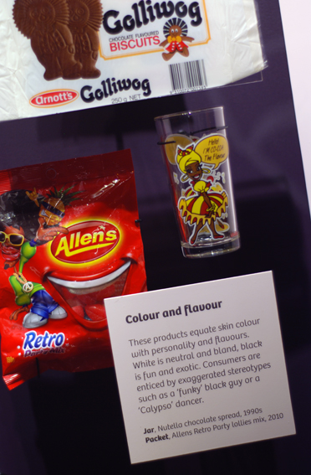
Three months later, students recalled other racist things they had heard family members say. Again, the ‘Full!’ t-shirt sparked conversation:
F1: ‘… I think of that f-off, we’re full shirt and I don’t …
F2: My dad actually has a top that says that and I don’t let him wear that anymore. It’s …
I: Did you tell him not to wear it?
F2: Yeah. He bought it in Queensland. And like my parents are from Australia and they’re always saying ‘Oh, people from other countries shouldn’t come here, we’re getting rid of the whole Australian thing’. But me and my sister …
‘Pop Culture’ - Display Case
Identity: yours, mine, ours Exhibition
Source – Museum Victoria
F1: Your parents are worse than my dad. My dad’s like that even though he’s got a different background, like it doesn’t make sense. So is my mum. But they think they’re more Australian than anyone else.’ (Harford T3FG 2014)

7.3 What did we learn?
In-body, interactive exhibition experiences which focus on race-based discrimination, encourage students to:
- Find affirmation in shared experiences of loneliness and alienation and realise that these experiences are not unique to them.
- Engage in deep discussions and self-reflection about issues and experiences of racism (as victims and bystanders), particularly via the presentation of multiple perspectives which provoke empathetic responses.

8. Research Theme 5: Talking identity

In terms of talking about ‘identity’, students generally found it problematic as a term for describing themselves. This was more difficult for white students who did not feel they had a clear identity or one that was different enough to describe. Students at majority white schools talked about how they did not feel they could call themselves Australian despite identifying as Australian because ‘everyone is Australian’, implying that being Australian includes people who do not have white Anglo backgrounds like themselves. Conversely, students from ethnic minority backgrounds were more readily able to describe their identity in ethnic or cultural terms due to ethnic-racial socialisation experiences that supported ethnic/cultural pride and social affirmation of their ethnic, cultural or religious background. It may also be the case that they felt compelled to talk about their identity in terms of ‘multicultural difference’ due to racialised social expectations in Australian society that mark them as ‘culturally different’ as well as the racialising nature of racist experiences themselves. For both white and ethnic minority students, there was resistance toward defining a static ethnic or cultural identity for themselves. The following sections explore these tensions and moments of resistance in relation to how students talk about identity.

8.1 ‘Having’ ethnicity or culture
White Anglo students tended to resist categorising themselves in terms of ethnicity or culture and instead described themselves in terms of individual personality traits or physical characteristics. At Bayside College, one of the students in the focus group joked that her cultural background is ‘chill’ and then commented that she does not have ‘much of a cultural background’ because her grandmother is from England.
I: ‘Yeah, so how would you describe your backgrounds?
F: Chill (all chuckling).
I: How would you describe your cultural background or your family background or your social background?
F: Chill.
I: Chill, yeah?
F: I don’t really have that much of a cultural background. My grandma’s from England, that’s about the most exciting thing I’ve got… It's not really much of a background.’ (Bayside, T2FG)

On the one hand, this describes what Perry (2001) found conducting research at a majority white high school in the United States, which was that white students perceived their identity as ‘cultureless’. This idea of being without culture ‘suggests that one is either ‘normal’ and ‘simply human’ (a standard of individualism to which others should strive) or beyond culture or ‘post cultural’ (therefore, developmentally advanced’) (Perry, 2001, p. 59). This is problematic in the sense that this demonstrates a lack of awareness about how one’s worldview is shaped by cultural socialisation as well as how particular social and cultural practices are normalised and maintained through complex power relations. However, it also demonstrates broader societal approaches to cultural diversity. Conservative and celebratory multicultural approaches tend to reify ethnic and cultural boundaries, which are then collapsed into ideas about ‘race’ so that social perceptions of people’s ethnic and cultural identities are literally contained by their racialised bodies. For example, those who are perceived as ‘white’ are positioned as ‘normal’ and representative of the dominant cultural group and so do not ‘have’ a marked ethnicity or culture whereas those who are ‘not white’ do have marked ethnic or cultural identities.
Sociology classes at the secondary school level have a unit on ‘Culture and Ethnicity’. One of the study areas focuses on Aboriginal Australian cultures and the second study area focuses on ethnicity and Australia’s migration history. The intent is to show that everyone ‘has ethnicity’ and that this can be ‘hybrid’ or multiple. However, this was not always supported by the broader social and cultural context in which the students live, particularly those living in majority white communities such as the students at Bayside College. Even for white students who went to schools with high ethnic diversity, the question of whether or not they really ‘have an ethnicity’ was still raised. For white Anglo students at Harford College, a school that includes students who speak over 50 different languages, feeling like they don’t belong to an ‘ethnic group’ was a key issue. For example, Laura described this:
‘I live the Australian culture but I don’t really attach myself to any sort of culture or ethnic group as such. So it reminded me how sort of out of place sometimes I’ll feel but it doesn’t really faze me. I don’t know. I’m not really the type of person that really has to be in a large ethnic group. I’d prefer to just have my friends and my family, whoever they may be for me. A different type of background, that doesn’t matter.’ (Laura, Sc1 T2NarrIntv 2014)
There are clearly issues with the lack of understanding about how Anglo culture is normalised in an Australian context so that it becomes ubiquitous rather than bounded as ‘different’. However, at the same time, the students’ resistance to identity categories also suggests that identity is not experienced in monolithic terms as a static and contained ‘ethnic’ or ‘cultural’ identity. Instead, it supports the understanding that ethnicity, culture and identity are relational, dynamic and situated (Eriksen, 2002). For example, later on in the narrative interview, Laura reflected on the Passport Room and the stories she read about people trying to negotiate their cultural background with their new life in Australia. She was able to use cultural relativism to think about how she might be more aware of her ‘Australian ethnicity’ in a different cultural context.
‘I guess in that sense it did make me feel like I do have more of an ethnicity than I believed as I previously said. I didn’t feel like I had any but when you think about it, if I did go to another country and it was completely different I could only understand really then how much of an ethnicity I have and the differences between others. It would be able to make it distinct thing in my mind of what the Australian ethnicity is…’ (Laura, Sc1 T2NarrIntv)

Likewise, students at Woodlane College discussed how it is hard to know what it means to have a particular ethnic or cultural background when you are a member of the majority group. They also suggested that they might become more aware of the cultural nuances that have informed their particular worldview by travelling to a different country (e.g. Fechter, 2005). The following discussion was prompted by the interview questions, ‘What does it mean to belong in Australian? What does it mean to be Australian?’:
Student 1: ‘But then I guess it’s hard because I’ve never like lived in another country. I’ve never experienced another culture so I don’t know, if I were to go to another country, would I feel like I belong more to that country than I did in Australia.’

Student 2: : ‘I don’t really know, I guess like how do you feel to be like acknowledged as an Australian, like especially because I’ve never left the country or like really experienced other cultures so deeply that you don’t really know like anything else…like you only know how you live like each day. It’s not really like, ‘oh I feel different because I know I’m Australian’.’

Student 1: ‘Yeah you can’t acknowledge what you don’t understand.
Student 3: Yeah and I guess that’s what the exhibition is trying to teach you about and I think it did do that, trying to get you to understand like other cultures and I guess trying to make you like think to yourself and ask each other, what um, how do you feel about your country and like what defines you as to be an Australian.’

Student 1: ‘I, when I was younger, I didn’t really understand that Australia that we really had our own culture because I always thought that it was kind of a mixed culture because there were so many like different people and different cultures in Australia that I always thought that…we just, until you kind of learn about when you’re older that we, that there are different cultures and that we do have our own culture and it is different to other cultures you don’t really notice that, you don’t really notice what it is to be Australian until you really like learn about other cultures and then you can learn more about your own culture and that’s what the exhibition does and helps you with.’ (Woodlane T2FG)

The students were trying to understand why it is they do not feel ‘different’ or feel like they have a culture as white Anglo students in Australia. Their discussion shows that they were beginning to understand how normalised their cultural background is in Australia and the need for reflexivity to understand what makes their everyday practices, ideas and behaviours culturally specific.

8.2 Contested identities
Compared to white Anglo students, students from ethnic minority backgrounds, who were racialised as ‘non-white’, were ‘seen’ to unquestionably have ethnicity. Racial and ethnic minority students were also more likely to identify an ethnic background when talking about their identity. This was probably influenced to some extent by the topics of the interview/focus group and the learning points on ethnicity in the classroom. However, more broadly, Australian multiculturalism focuses on embracing ethnic or cultural identity and also belonging to the Australian nation or ‘unity in diversity’ (Hage, 2008). Public displays of multiculturalism focus on ethnic and cultural ‘difference’ made visible through various events such as cultural festivals that focus on food, dress and performance.
Students enjoyed seeing their cultural heritage reflected back to them in the exhibition. For example, in his video diary, Matai talked about his Pacific Islander background in response to a display about food and what is considered ‘weird’ in some places is also normal. He said, ‘We do eat kind of weird food I would say but you know, it’s part of my culture. It’s what I eat, it’s really nice’. He continued to read the display, which talked about taking pride in your family’s traditions. He added, ‘You know cause I go to church I get taught how to make food and stuff so I’m always proud of what culture I’m in’. He then panned down to other images about how people in different cultures prepare their food and reflected, ‘We’re actually not that different as you see, how they make the food it’s pretty much how [we] make the food’. Other students also identified cultural similarities to their own cultural practices. For example, Cezmi and Fahim, two students from Turkish backgrounds, commented on the similarities between the Greek shadow puppets in the exhibition and the puppets they had in Turkey:
‘Another familiar sight, the shadow puppets. We had a lot of them in Turkey and growing up, we used to watch performances of the shadow puppets. Seeing that in the immigration museum it’s a familiar sight, I love it’ (Hartville, Cezmi & Fahim Video Diary)
Although students expressed pride in their ethnic or cultural background, the pressure to have an ethnicity, read as ‘non-white’ and ‘non-Anglo’ meant that students were also pigeonholed and defined by their look or speech. In response to what identity and belonging means, Tuyen, an international student, explained:
‘Because like I say like ... I’m Vietnamese here but then identity isn’t only about the ethnic, it’s about like in [my] class here, my identity is a student but when I go home to ... according to my little brother, I am the sister.’ (Tuyen Kensington T2NarrIntv)
On the other hand, students who could ‘pass’ as white, such as some of the Turkish and Muslim students at Hartville and Harford Colleges, had to explain and justify their ‘difference’ when people told them that they do not ‘look Turkish’ or ‘look Muslim’. A student at Harford explained, ‘I’m like half Australian and half Turkish and like Turkey … it’s not really considered to be an Islamic country so whenever I say I’m Muslim, people are like, ‘Oh, but you don’t look it’. It’s like what we do, it’s not nationality’ (Harford, ClassA T2FG1). Fahim also talked about his experiences speaking Turkish and then speaking English and the different perceptions people have of him. During his video diary, he filmed the audio handsets and read out the text, ‘What we say and how we say it’. He reflected on this:
‘This makes me feel, it reminds me of where I’ll be speaking Turkish in front of Australian people and they would look at me and like, ‘What are these guys saying?’ Then I start speaking English and I have that Australian accent on me because I was born here [and] they’ve got the more happy face towards me, they see me as someone they know.’ (Cezmi & Fahim, Hartville Video Diary)
Interestingly, although a focus on hybrid identities (i.e., being both Turkish and Australian) is meant to be ‘inclusive’, the pressure to identify as Australian as a national identity in addition to a specific ethnic identity mandates having a hybrid or multiple identity rather than being about how someone chooses to identify. There were students in this study that preferred not to identify as Australian, which contradicted the hyphenated ‘hybridised’ identity imagined by others such as school staff. Again, speaking about how he experiences his identity, Fahim explained:
‘I guess I could see myself more as a Turkish person than an Australian person even though I was born here and that's only because my parents have given me the privileges of going to Turkey to visit my family and stuff and to go and love the country that my background is, Turkey. And I'm encouraged to speak Turkish at home and I'm actually glad that my parents have encouraged me to speak Turkish ‘cause it's made me really fluent in the language. I'm very fluent in the language…But even though I still feel that, how I see it, I'm Turkish but I still feel that English is my first language. I feel more comfortable when I'm speaking English.’ (Fahim, Hartville T2NarrIntv)

Comparatively, the school principal felt that seeing oneself as only Turkish was a ‘narrow’ approach to identity. The principal explained:
‘And even on my first few days kids were saying oh you know, they’d come and introduce themselves and say, ‘So are you Turkish?’ No, I’m not Turkish…And I said to them, ‘So what are you?’, and they said, ‘Oh we’re Turkish’ and I said, ‘So where were you born?’ [The students said], ‘Oh here, in Australia’. But you’re Turkish. And they had this idea that you couldn’t be an Australian of Turkish heritage or Australian/Turk or Turkish/Australian or whatever. They had this very narrow view of their identity. We’re Turks.’ (Principal, Hartville interview)
The students’ claim to identity was questioned and critiqued rather than attempting to understand why they might not identify as Turkish-Australian. It also places the emphasis on the individual to identify as Australian rather than focusing on barriers to belonging as Australian such as racism and representations of Australian identity as white and Anglo. Moreover, this student-teacher exchange communicates a moralistic view that a hybridised understanding of identity is more open-minded compared to how students understand their sense of self that may sit outside of a hybrid identity paradigm.
A student at Harford College also noticed that people do not always identify as Australian and recognised that it is up to the individual how they ‘label themselves’ rather than directing how others should identify:

‘But some people from other countries don’t like labelling themselves as Australian. I know a few people, they from Europe and stuff, like Serbia, and they’re no, we’re not Australian, we’re Serbian. They don’t like labelling themselves as that, so definitely don’t think they’re Australian as much as people that were born here. So it depends on how they label themselves.’ (Harford T2FG 2014)

One of the teachers at Harford initially insisted that one of his students who has a Serbian background was really Serbian Australian rather than just Serbian but then learnt about different cultural interpretations of national identity. He described his interactions with this student:
‘I give him a little bit of a hard time, like just joking, but you know he is Australian born but if you say to him what nationality are you he’ll say he’s Serbian and, you know, I’ve sort of quizzed him on that and I’ve just said, ‘Well, are you not Australian?’ and then he’ll sort of say, ‘Oh well yeah, you know’, and I’ll say, ‘Well, are you Serbian Australian?’ and he’d say, ‘Yeah, that’s what I am’ and I’d say, ‘Well, wouldn’t you sort of, you know, say that you … are Australian Serbian, you know, like you live in Australia, you were born in Australia, your friends are Australian and you have an Australian accent, you go to school’ and he sort of says, ‘Yeah, but no my father’s Serbian so I’m Serbian and that’s a cultural thing as well so, you know, as … and I didn’t know this, [the student] actually explained this to me, that Serbians will just go by their father’s nationality, or as he understands it, I haven’t really looked into it, he could be slightly mistaken but, you know, his father is Serbian and therefore he is Serbian.’ (Harford, Teacher interview)
Another important factor when understanding issues of identity and belonging is the problem of social exclusion. In terms of students’ everyday lives, ethnic minority students may not identify as Australian or feel they could identify as Australian, especially if ‘being Australian’ and being recognised as Australian continues to be associated predominantly with a white Anglo identity and speaking English. Furthermore, the pressure for ethnic minority students to have a ‘hybrid identity’ can have the unintentional effect of viewing non-hybrid identities as a threat to ‘unity in diversity’. In this case, students who contest ‘hybrid identities’ are potentially perceived as ‘having too much ethnicity’. Students at Wellview College expressed these views, emphasising that not identifying or assimilating to ‘Australian culture’ was a negative thing. The other students in the focus group agreed with what one of the students said:
‘Yeah. I don’t know, people that don’t ... or like it’s good that they keep their own culture but they don’t really go for ... with the Australian culture either, like they basically stay in their little culture and they have their family and it’s their culture but if they’re go ... like living in Australia and stuff then they should really bring some aspects of Australian culture into their [culture].’ (Wellview T2FG1)
This criticism focuses on perceived individual responsibility to ‘fit in’, which overlooks systemic barriers to inclusion. If the idea of ‘unity’ is not something that ethnic minority students experience in their everyday lives or if it is constantly being challenged, then feeling able to identify as Australian may be unattainable particularly if their belonging and claims to an Australian identity are disrupted by experiences of systematic exclusion such as racism.

8.3 What did we learn?
Presenting an exhibition on complex and challenging concepts such as ‘personal identity’ pushes students and teachers to:
- Engage with their assumptions about their own identity (or perceived lack thereof) and attempt to articulate their reflections of either lived experience or through relational observations.
- Reflect on conventional understandings (whether spoken or unspoken) of identity ‘hybridity’, demonstrating the importance of legitimising individual expressions of identity, whether singular or multiple.
- Encounter the perceived absence of personal identification of ‘Anglo’ as an ethnicity when considering cultural diversity in Australia.
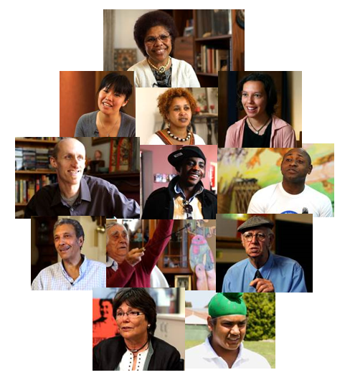

9. Research Theme 6: Activating IYMO
‘Belonging’ Videos – Identity: Yours, Mine, Ours Exhibition
Source – Museum Victoria

This section explores how students conceptualised and identified racism. This is followed by a discussion of bystander anti-racism in terms of students’ experiences and conditions that influenced whether or not they took action when witnessing interpersonal racism. The tram simulation was central to the students’ discussions because the video helped them to think about racism from different perspectives. They then connected these perspectives to their own experiences at school and around their neighbourhood.

9.1 Identifying racism
Students identified racism more readily when behaviours were overt, aggressive and derogatory or seemed to focus unnecessarily on someone’s racial background, especially in a negative way. For example, students were uncertain about objects that were presented as racist in the exhibition but for them, were more ambiguous. These included examples of historical racism (e.g., golliwogs) and cultural appropriation (e.g., Orientalism in commercial products). Students tended to dismiss accusations of racism as being too ‘politically correct’, especially when they did not understand the historical or social context of particular objects and the reasons why they might be considered racist.
However, they also talked about examples of more subtle forms of racism. The racist incident featured in the tram simulation generated the most conversation about how to identify racism and whether or not someone would act and why. The tram simulation aimed to facilitate conversations by including touch screen options that allowed the viewer to re-watch the incident through the eyes of the target, perpetrator and two different bystanders.
During the tram scenario, most students agreed that the white man was being racist toward the black man by not sitting next to him. However, they also felt that because he did not say anything explicitly racist, it was potentially ambiguous and thus more open to interpretation. Students at Hartville College such as Cezmi, also talked about how the ambiguity of subtle racism would affect their readiness to say something as an anti-racist bystander.
In a Hartville focus group conducted two weeks after the students attended the exhibition, the students agreed that the man’s actions indicated his racist attitude. They said, ‘So this one man that was the racism (sic) one, came in and refused to sit next to the dark skinned man, but he … I forgot, I don’t think he spoke to him, but his actions, you could see and you could tell that he was racist (Hartville T2FG). Similarly, in a Hartville narrative interview, Cezmi talked about how he can identify racism by the feeling he gets when it is happening, ‘You can sense that, when someone’s looking at someone else, it’s just like, they don’t say it but they’re … you can see in their attitude…It’s against that person’ (Hartville T2NarrIntv). Although Cezmi could identify subtler forms of racism such as this example, he felt it would be difficult to speak up about it because the behaviour was not explicit. He explained, ‘With me it’s, I wouldn’t want to, I mean like accuse someone on their actual…on the way they look at someone else. It’s more once they’ve said something, then you can move on and do something else to stop that’ (T2NarrIntv). Because of the subtlety, there might be a lower perceived likelihood that others would support him if he spoke out against the racist behaviour.

9.2 Bystander anti-racism
This section discusses students’ experiences of interpersonal and systemic racism in terms of their role as a bystander; including factors they used to decide whether or not to act against racism. This is referred to as bystander anti-racism, which can be defined as:
‘Action taken by a person or persons (not directly involved as a target or perpetrator) to speak out about or to seek to engage others in responding (either directly or indirectly, immediately or at a later time) against interpersonal or systemic racism.’ (Nelson, Dunn, & Paradies, 2011, p. 265)
As discussed in the previous section, being able to identify racism and the extent to which other bystanders might interpret the interaction as racism were important precursors to other decisions about whether or not to take bystander action. For example, recalling the tram scenario during a focus group discussion, a student at Wellview College questioned whether the act of staring at someone could be interpreted as racist. Interpreting someone’s behaviour in the absence of explicit racist speech affected the decision to confidently name something as racist through the act of speaking up against it. The student explained, ‘The guy who’s staring might be thinking of something else and you don’t want to go up there and punch him and realise he’s not actually going to be racist to that guy and you’d be like, I’ve just made a complete idiot of myself’ (Wellview T2FG2). In this instance, the student interpreted the ‘staring’ behaviour as a potential precursor to doing something racist. Therefore, the act of calling the behaviour out as racist or potentially racist would be publically shaming if the student wrongly interpreted the situation. The student’s difficulty interpreting particular situations as racist as well as the potential for a lack of public support or even worse, public shaming or backlash, were key factors when deciding whether or not to take anti-racist action.
Other factors included fear of retaliation or escalation, lack of confidence or discomfort with confrontation, perceived ability to effect positive change, extent to which the racist behaviour contradicts personal values and level of familiarity with the people involved. These factors are supported by a review of bystander anti-racism literature (Nelson et al., 2011) and research on how people identify and frame everyday racism (Walton et al., 2013). The following scenarios that the students described provide examples of the different ways they approached racist incidents and why they decided to act or not.
The students at Kensington College explained how strong emotions can get in the way of thinking clearly about what to say or do in a particular situation. They explained that they might initially feel angry and then wish later that they had done something differently in a calmer state:
M: ‘It might not be that hard, just when you're on the spot to get your decision but afterward it might be a regret…

F: Yeah, of what you would say at the time, yeah.

M: True.

F: Like when you're pissed off.

M: Yeah.

F: Like, angry.

M: You should have done something differently.

F: Yeah, when you're angry and ...

M: Instead of staying calm.

F: When you're calm and stuff and you think about what you said, like oh, I should've done that. (Chuckling)

M: Yeah.

F: Yeah. I agree with that (chuckling).’ (Kensington Sc4 T3FG 2013)

Other students who felt more comfortable with confrontation and felt strongly about the injustice of particular racist incidents said that their strong feelings would make them feel that they needed to or should act. Whether or not they actually took action depended on if they felt taking action would put them in personal physical danger or might escalate the situation.
Female 1: ‘Well, because if people are going to be that hostile verbally then you sort of don’t really know what they’re going to do physically if you do stand up to them especially if it is something they feel strongly about.
Female 2: Especially, it’s such a touchy situation, yeah, especially in like these areas, yeah.’ (Harford T3FG 2013).

These students felt that if someone could be so openly hostile in a public place toward a stranger, then the person could easily turn on them. Therefore, the perpetrator’s strong feelings might outweigh the bystander’s feelings about what was happening and prevent the bystander from acting. Conversely, when the situation was perceived to be fairly non-threatening to the bystander, the students felt they would be more inclined to act. In the following example, a student at Harford College described a racist incident that happened at his workplace. In addition to the other factors previously mentioned, the student was also in a slightly higher position of authority as an employee than the perpetrator who was a customer, not his boss or a more senior colleague. He described an interaction he had with a female customer who alerted him to other shoppers of black African backgrounds. The following focus group excerpt describes how the student handled the situation with the customer:
M: ‘Yeah, I was in … a lady at work was trying to tell me to watch out for Sudos in my store because they can't be trusted. And I was like they’re fine, they’re just shopping. She was like (putting on ocker accent) ‘Oh no, take it from me, love’. I was like, ‘I think they’re fine, madam’…Yeah, she was like, ‘just watch them, keep an eye on them’. [I said], ‘No, it’ll be cool, they’re fine’.

I: So did you speak up? Did you say something to her?

M: I just made the point I wasn’t … I just made it like we’ve never had an issue in that, we’ve never experienced anything else, like ‘No, we’re fine like …’
I: Was this woman your boss or a customer?

M: A customer. At the time, she mentioned it she was like ‘I’m just letting you know those boys over there look like they’re up to something’ and at first she just said it without any racial reference. Oh, just I listened and I was like, ‘Oh yeah, thanks for letting me know’. And then once I was putting her sale through and started talking to her she just made a few comments that and I don’t know it just got really uncomfortable and there were other people there at the next counter that heard her as well and if I just kind of argued it would look bad on my workplace if I wasn’t to say something or just bad in general. So I was just like oh no, we’re fine, like we’ve never had any problems. You’d expect it from … we get it from the people we wouldn’t expect. I’m like you know people who are grandmas stealing, she’s like, ‘Oh, okay, well, yeah, you know I’m just saying some stuff’. I was like, ‘Oh, no, we’re cool, thanks’.

I: How hard did you … was it to decide what to do?

M: Not at all ‘cause I don’t have a problem other nationalities so it wasn’t a thing for me personally to decide whether to say it or whether that’s actually what I felt but I wasn’t just saying it for my work like I honestly believed what I was saying so it wasn’t too hard.’ (Harford T3FG1 2013)
In this particular situation, the student kept the situation from escalating by acknowledging what the customer said to him but not assuming it was racist in the first instance. In fact, he supported what the customer was saying by affirming her observation and not challenging it. When the customer persisted with her observation and made more explicit racialised comments about the other shoppers, he explained to her that they have never had any problems in the past and did not expect that they would based on previous experiences. He challenged her racist stereotype by giving a counterexample about the store having previous issues with older women, ‘grandmas’, stealing items. This resulted in the customer backing down and trying to neutralize her own observations as if it were merely an observation rather than a racist assumption about people’s behaviour based on skin colour. He explained that he felt confident challenging the customer’s comments because he felt strongly about his own views, which conflicted with the woman’s espoused racist views.
Overall, the students agreed that racism was unacceptable. However, they often felt unable to take a stand against racism because they were afraid of potential repercussions (e.g., physical harm), were uncomfortable with confrontation or were worried they might incorrectly identify racism. They also expressed regret when they did not take action but felt that they should have.

9.3 What did we learn?
Presenting a variety of forms of racism (both subtle and overt) and ways to experience that racism in exhibitions provokes students to:
- Explore conflicting responses in discussions about what constitutes a racist artefact or act.
- Place themselves in a real-life situation and challenge themselves as to how they might act (or not) as an anti-racism bystander.
- Question what might be appropriate action to take as an anti-racism bystander.
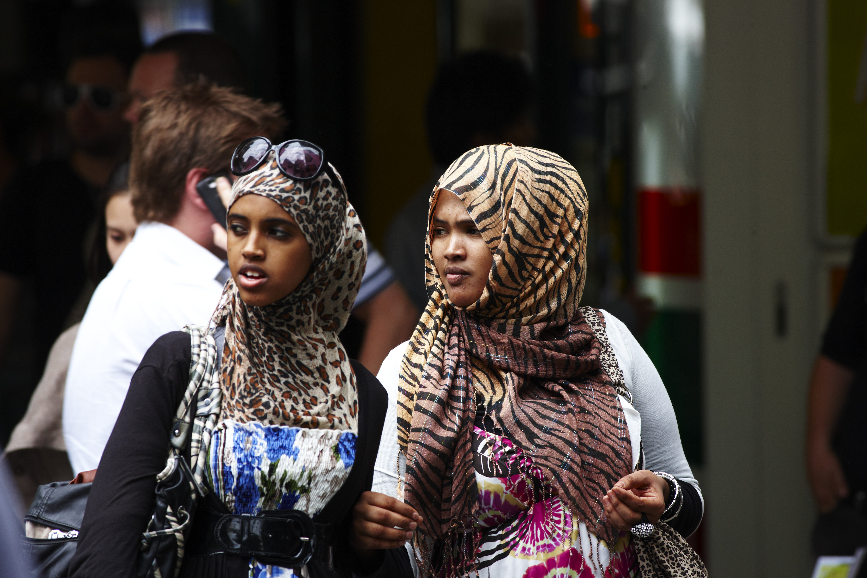

People in Melbourne
Source – Museum Victoria

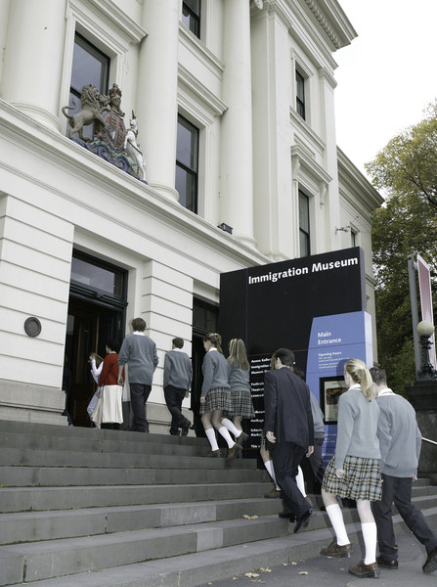
10. Research Theme 7: Teaching IYMO

This section examines teachers’ experiences of IYMO in relation to self-reflection together with examples of teaching and learning practice resulting from IYMO as well as school-level factors in relation to talking about cultural diversity and racism. A total of five interviews were conducted with six teachers at five of the six schools involved in the evaluation. One interview was a joint interview as two teachers’ preferred to be interviewed at the same time due to school time constraints. Both teachers were from a white Anglo Australian background. Of the six teachers interviewed, four were Anglo Australian, one was Greek Australian and one was born in Australia but her parents were from an ethnic minority background (did not specify).
Immigration Museum
Source – Museum Victoria

10.1 Teachers’ experiences at IYMO
Overall, when asked, teachers did not talk extensively about their experiences at the IYMO exhibition because they said they were mostly preoccupied with supervising the students and making sure that the students were engaged. However, the teachers made some reflective comments that related to their own racial, ethnic or cultural background. A few also said the IYMO exhibition helped them to reflect on what their students’ experiences might be like as a racial minority living in Australia.
The teachers’ experience of the exhibition was that it was valuable because of the diverse stories that were based on people’s actual experiences and the personal approach the museum used to understand immigration, identity and racism. Helen said that she could relate to some of the stories ‘from a personal level’ because she is a ‘child of immigrants’ (Bayside Interview). Other teachers said that the tram simulation had the most impact on them. As someone who has experienced racism directed toward her as an ethnic minority in Australia, Mandy felt that the tram simulation was an ‘an eye-opener’. She explained:
‘It was confronting…it just made me feel uncomfortable because it made me think while I was watching and the kids were pressing you know the responses for each person, it made me think, ‘Oh, would I be ... would I have the guts to stand up and say something if somebody said that?’ Or, ‘Did you know exclude other people because of their race or what have you on public transport?’’ (Kensington, Teacher Interview)

Learning about a racist incident from different perspectives helped her to reflect on whether she would do anything as a bystander if confronted with a similar situation or if she had ever acted as the perpetrator by excluding people because of their race. Lynette (Wellview), who is from an Anglo Australian background, said that the exhibition overall helped her ‘have more of an appreciation for what it would be like to migrate to Australia’. She continued by reflecting on her own identity, ‘Being from a very Anglo Australian family I haven’t had to deal with a lot of what you see in that one [the tram]’. Without explicitly mentioning it as such, she also touched on the privilege she holds as a white Anglo person living in Australia:
‘Not that I’m racist in any way but I just ... it just hadn’t occurred to me that sometimes people might feel like that and I guess I don’t catch public transport all that often so I don’t see that sort of thing happen. Oh that sounds really dumb but ... yeah, I guess it’s improved my understanding of what kids in my classroom might be dealing with as well on a day-to-day basis, [and students in] other year levels as well.’

For Lynette, the tram simulation allowed her to immerse herself in a situation that she had only conceptually understood. Listening to how someone feels during and after a racist incident as the target opened her mind to what it might feel like for that to happen. She admitted it might sound ‘really dumb’ to other people. However, she does not come across this kind of interpersonal racism in her everyday life and so had never stopped to think about it happening to other people and what that experience is like. She was able to link the racism the man of African background experienced on the tram with what it might be for some of her students from a racial minority background.
Although Lynette and the other teacher in the joint interview, Fiona, felt that the exhibition did a good job of providing ‘lots of insight into other people that have come to Australia and how they’ve then fitted their culture into us, us as in Australian’ (Fiona) and ‘about identity of other cultures’ (Lynette), they didn’t feel that there was much ‘talk about what is an Australian’ (Fiona) or ‘Australian identity as such’ (Lynette). This echoes some of the comments from other white Anglo students who did not feel that their identity as ‘Australian’ was included in the exhibition in a way that was diverse. They felt that the exhibition mainly portrayed white Australians’ identity as inherently racist. As Lynette commented, ‘I think the others ... who others think we are, I think that was covered but it made us look very … not welcoming. A lot of it showed us just as being racist as a culture ourselves, an Australian’. They felt that ‘Australian culture’ was represented as simply ‘being racist’.
Throughout the discussion, teachers referred to themselves as Australian as ‘we’ and ‘us’, which they felt was overlooked compared to a focus on the identity of people from ‘other’ cultures. Although Lynette identified herself as Anglo Australian earlier in the interview, during this discussion about Australian culture, Lynette and Fiona did not specifically talk about their identity as ‘Australian’ in terms of being linked to an Anglo cultural background. Instead, ‘Anglo’ was implied when using the word ‘Australian’. For example, Lynette talked about the commercial products section saying she didn’t think the products were ‘seen as being racist…from an Australian point of view’ and therefore, the text about the history of the products didn’t provide a counter-explanation about why they might not have been considered racist. In relation to this, she reflected, ‘I don’t think it does show our identity but it does show identity of a lot of other cultures and how ... certainly how we accept other cultures but not ... not us’. Fiona added that the exhibition does not talk about ‘what Australia is’ and suggested there could be more specific information about what belonging means in Australia, ‘X, Y and Z’ (Wellview, Teacher joint interview).
Overall the teachers, as white Anglo Australians, did not feel that their identities were part of the multicultural immigration story that was presented in the exhibition. For them, multicultural was presented as being about ‘other cultures’ and ‘Anglo’ Australian culture was only presented as being ‘racist’. Although there were examples of ‘Anglo’ Australians talking about their stories and their sense of belonging (e.g., specific Belonging videos, Australian accent audio handsets, community videos) and in various artefacts around the exhibition, their impression was that the representation of ‘Anglo’ Australians was limited. Eve (Hartville) did not talk about the exhibition in terms of her own identity. However, at the start of the interview in the context of what it is like working at a school where the majority of students are not ‘Anglo’ Australian, she talked about her experiences as a student going to school where she was one of very few white Anglo students. She said:
‘Most people were migrant background. So it makes being a migrant background the dominant culture, even though they’re lots of different cultures. They dominate ‘cause they all have other languages and other holidays and cool stuff and then there’s just like me that only speaks English and doesn’t have anything exciting.’

Eve’s sentiments that she has a cultural background that is not exciting and feeling excluded because it was more common for people to have a ‘migrant background’ (read as non-Anglo) is something that is common among people from the dominant culture in Australian and other Western multicultural societies (Perry, 2001; Zevallos, 2005). Based on research among young women of Latin American and Turkish migrant backgrounds living in Australia, Zevallos (2005) found that these women ‘saw themselves as Australian, but their view of traditional Australian culture as ‘cultureless’’ complicated their understanding of ‘what exactly constitutes the uniquely Australian aspects of this culture’ (p. 44). This view of ‘Australian identity’ as ‘cultureless’ or the difficulty identifying cultural aspects of ‘Australian identity can be partly
explained by the dominant normativity of Anglo Australian culture throughout Australian society (Forrest & Dunn, 2006). This has also been observed in other settler colonial countries where the dominant culture is Anglo. Based on an ethnographic study among high school students in the United States, Perry (2001) found that the white American high school students perceived themselves to be ‘cultureless’. In countries such as the United States and Australia, due to the invisibility of whiteness and the dominance and denial of white privilege (Dunn & Nelson, 2011), the issue of feeling overlooked or ‘forgotten’ in the midst of multicultural diversity is an issue that needs to be critically engaged with when talking about cultural identity and multiculturalism.

10.2 Teaching and learning practice in the classroom
The IYMO exhibition was used mainly as a resource to refer to when discussing themes of identity, belonging and racism rather than as a source for creating new lesson plans or new activities. In this sense, teachers already recognised the value of IYMO before attending the exhibition and so the visit fit into their existing lesson plans for the units they were teaching. As discussed in Section 3, the perceived value of IYMO was enhanced after they attended the exhibition because the audio-visual interactive format and approach to presenting a diverse range of identities and issues of belonging exceeded their expectations. Therefore, IYMO was valued as a shared experience that the teachers could refer to, and as a resource that the teachers and students could use after their visit, especially the on-line material.
One of the activities that the sociology classes (3 classes at 3 schools) used was a student-led project that involved researching an ethnic group in Australia. This activity is one of the suggested assessments outlined in the VCE Sociology Assessment Handbook (2011). Visiting the Immigration Museum is also a recommended activity. Therefore, the teachers already knew that there was a link to talking about ethnicity and visiting the Immigration Museum. From the teachers’ perspectives, what they didn’t expect is how well it would complement their teaching in terms of providing an immersive interactive experience for the students to learn about people’s personal stories of identity, belonging and racism.
For the VCE sociology ethnicity project, the students interviewed people from different ethnic backgrounds about their experiences in Australia. The students at all three schools were told to research an ethnic group different from their own. However, one student at Woodlane decided to interview people from her own family anyway because she didn’t know much about her German background. She interviewed her grandmother’s sister and learned so many things she had never known before. She said that halfway through World War II, when her uncle came to Australia to seek refuge, he was put in a camp for ten years because the Australian government thought he was a spy. She was shocked to realise this had happened to a family member and that the camp was nearby to where she lives now. She said her family had never brought it up before and she said, ‘I think it [hearing about her uncle’s story] actually changed my perspective … well made … not changed, kind of made my perspective of asylum seekers a little bit more clearer, that they don’t really deserve to be locked up. So, yeah, it did open up a couple more ideas that I maybe hadn’t or wouldn’t have got the chance to think about’ (Woodlane T3FG).
At Kensington College, the students had to produce a written piece in any form that used their experience at the exhibition and the exhibition on-line material to reflect on ‘Identity and Belonging’, one of four themes in their senior-level subject, English as an Additional Language (EAL). They were asked to think about ‘who they are, where do they belong and not only themselves but what about your neighbour? What about other people in your class or other people in the school or you know the guy that lives down the end of the road’ (Kensington Teacher Interview). The teachers were not the only ones who felt more capable thinking through complex concepts of identity and belonging. The exhibition experience also had an impact on the students’ perceived capabilities. Ary talked about the essay she wrote for the assessment task:
‘We were writing an essay about identity and belonging where we have a picture of belonging and we have to see that picture and try to write in the essay. Before I visit that exhibition I can only write half a page and it wasn’t that good but after I visit, give me the picture I can write you another couple of pages. That’s how I feel, yeah, I feel comfortable.’ (Kensington T3 Narr Intv)

Through her experience at the exhibition, she was able to form a ‘picture’ of what identity and belonging mean in a more concrete, felt way. She was able to relate to the issues she was studying through the personal experience of learning about other people’s stories and reflecting on her own experiences.
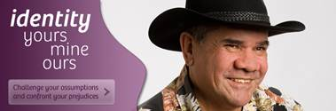
Eve at Hartville College also expressed the value of the personal experience and the ‘real-life’ feel of the museum exhibition. In terms of the on-line content, she said while they won’t go to the museum again next term, they’ll use the website for their unit on Identity and Belonging. Similarly, the classes at Wellview College only used the on-line content when it came up in class or just referenced the visit in classroom discussions. The teachers did not use the exhibition material in an integrated way and saw it more as a resource that they could draw on if needed. The experience itself, going to the exhibition and encountering personal stories about difference and belonging, was perceived as more valuable because it was something they could draw on as a shared experience. Nevertheless, since all the students in the classes did not visit the museum, the teachers noted that it was sometimes difficult to draw on their experiences there because not everyone attended. This was the case for the classes at Wellview. One of the teachers at this school used the on-line material to inform other students about what they were talking about and noted that this was particularly helpful.
Website banner, featuring Pat Dodson , Identity: yours, mine, ours Exhibition
Source: Museum Victoria
However, whether or not the teachers used the exhibition materials in further class activities or assessment tasks was not necessarily as important as the boost the exhibition experience gave to teachers’ perceived professional capability. Some noted that understanding more about the complexity of people’s experiences of identity and belonging helped them to feel more capable teaching about those issues to the students. As Lynette reflected, ‘I was probably confident before but I think it’s given more information that ... I don’t know if it boosts the confidence but it certainly makes what you’re saying at least in your own head a lot more credible’ (Wellview, Teacher Joint interview). Mandy at Kensington had a lot of teaching experience (over 10 years) and already felt pretty confident talking about identity and belonging. However, she said that going to the exhibition provided a ‘practical’ side to teaching those concepts in a way that was less abstract.
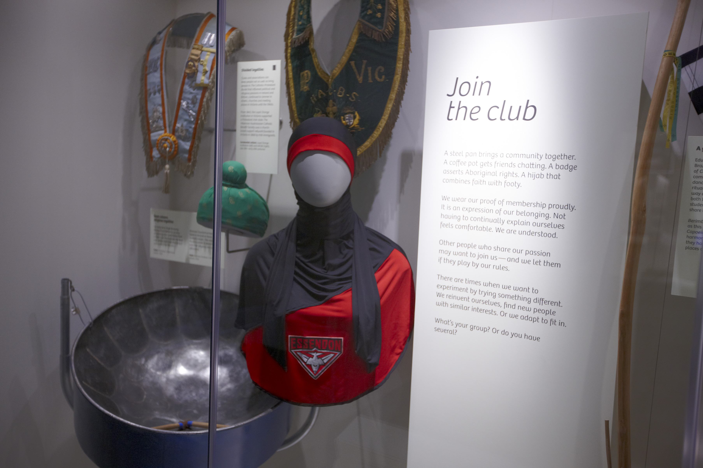
‘I think ... ‘cause in the classroom if I say okay, who are you? Tell me you know tell me about yourself, tell me about your background you know where do you belong or tell me a little bit about the country where you’re from? What do you think about or what’s your first impressions of you know life in Australia or how have you been treated by people here? It’s just ... it’s not a practical application. But with the exhibition we were able to apply it practically.’
Essendon Football Club Hijab
Identity: yours, mine, ours Exhibition
Source – Museum Victoria
Overall, the teachers felt the exhibition visit enlivened their teaching and provided a stronger connection to the concepts they were learning in class by drawing on how these are experienced by actual people in everyday life. This provided an entry point for students to begin reflecting on their own experiences.

10.3 School support for talking about cultural diversity and racism
Teachers, principals and students identified a number of factors that influenced the extent to which issues of cultural diversity and racism were considered important and whether or not they were included and supported in a school context. These factors included student demographics, whole school support, curriculum support and appropriate resources.

10.3.1 Student demographics
A key factor identified at all five schools was student demographics. At Woodlane and Bayside, two schools with a majority white Anglo student population (Australian Curriculum Assessment and Reporting Authority, 2015), the teachers and students explained that topics of racial, ethnic or cultural diversity and racism are not at the forefront of discussions because they didn’t think racism happened at their school.
‘I think because we ... our students ... that we aren’t that diverse so it’s not to say that we should be more or anything but we’re not exposed to that. We’re not exposed to the ... like with some other schools that might have a lot of different cultures within them but we don’t sort of have that racism sort of that might occur with you know ethnic groups within the school so in terms of trying to promote ethnicity in that regard we don’t really sort of focus on that.’ (Bayside Teacher Interview)

In other words, because of the low level of racial and ethnic diversity, they felt that race did not matter so much in their school context. Since racism was not perceived to be a problem within the school, the teachers did not focus on racism in classroom discussions. When the students went to the exhibition, however, they were most interested in the parts of the exhibition that talked about racism and about addressing racism and challenging stereotypes. As previously mentioned, the tram simulation was of particular interest because it gave students and teachers the space to consider a racist incident from the point of view of the target, perpetrator and bystanders.
The teacher at Bayside also thought that because the students did not have many personal interactions with people from different racial, ethnic or cultural backgrounds that they would not be able to talk about diversity and racism. She compared this to her perception of other schools with higher levels of racial, ethnic and cultural diversity. She reasoned, ‘Maybe because they [students at other schools] are more exposed to it, the diversity within their school, that they can ... the kids themselves can talk about their own experiences whereas here they can’t really’ (Bayside Teacher Interview). The issue of student demographics and the lack of interpersonal encounters with people from different backgrounds certainly influences the extent to which students think about or understand the social significance of race and issues of racism as well as whether or not they have reflected on their own racial, ethnic or cultural background. However, simply being from a school with higher levels of racial, ethnic or cultural diversity does not mean that the students will have a more in-depth understanding of these issues. For example, Wellview College has a high percentage of students from a language background other than English (LOTE) at 45%. However, there was the assumption that white Anglo students don’t have an ethnic background. As Lynette commented:
‘Again, you get a greater appreciation when you don’t have an ethnic background yourself as such of the trials and what other people have gone through to come here. Because even though some of our kids’ll have said, ‘Yeah you know I’m from Sudan’ or something, they might have come when they were one or two and they still ... they identify as Australian, they don’t identify as anything else. So it does give us a greater understanding that hopefully you can portray and give back to the kids too.’ (Wellview Teacher Joint Interview)

Here Lynette highlights a few important issues. First, is the feeling that if you are white and Anglo Australian, then you don’t have an ethnic background ‘as such’. However, if white Anglo Australians simply identify as Australian, then as she mentions, so might students who are perceived to have a different background (e.g., Sudanese background) and yet they might still only identify as Australian.
Furthermore, students at a majority white Anglo school might be aware that racism happens (i.e., through the media, after-school activities, at home) but not have the support or knowledge to think through the complexities of racism when they experience it, either directly as a target, vicariously or as someone being racist toward someone else (regardless of intent). For example, April at Bayside College talked about how she sees racist bumper stickers in her area all the time. Another student, Sandra said she is frequently exposed to students saying racist things at school:
‘I think everyone can agree that they have come across racist people in their lives, especially in this school I won’t lie about it there are a lot of racist people, there’s a lot of comments thrown around because there’s no-one to hear them, there’s no-one to stand up for themselves because we’ve just got no-one here and so there’s no-one to stand up and say, no, you’re wrong or anything like that, it’s just another comment just thrown around the courtyard.’ (Sandra, Bayside, T2NarrIntv)

Therefore, although the students might not look visibly ‘different’, issues of race, ethnicity and culture are still relevant to them and when given the opportunity, they are interested in learning more.

10.3.2 Whole school support
Another key issue that was identified was the perception of school support for talking about and addressing racism and supporting positive intercultural relations.
In a focus group discussion at Woodlane, the three white Anglo students began by discussing how during a different excursion in Melbourne, another school group targeted them as being from ‘the country’ because the whole school group was white. Then, they reflected on the student demographics at their school and acknowledged that it is not completely white and there are students from different racial and ethnic backgrounds. At first, they rationalised that the ‘other’ students excluded themselves from the white Anglo students but then upon further reflection, began to question this assumption. One student explained:
‘This guy came to our table and I think he said it as a joke, but it kind of stuck with me and he said, I know you guys are from the country because you’re the only all white table at this place. And it kind of resonated with me and I was realising when I came back, oh my God, we don’t have that many people from different ethnicities, or we do and they separate themselves… [Second student: Yeah]…from the rest of us.’ (Woodlane T3FG)

At first, a second student agreed with the first student’s reasoning. However, the third student challenged this a bit and said, ‘I think the school separates them as well’. This student went on to say that there is a designated space for students who speak a language other than English to go to. She said other students are not allowed to go in because they do not speak another language. When asked where the room is, they said it was on the other side of campus and now that most of the classes have moved into the new part of campus, the LOTE room is still in the old section and is housed in a demountable. The students reasoned that the room is helpful for the students because their English is not strong and that this is the way for the school to help them. However, they also said that as a result, there are not any opportunities to get to know each other, especially now that they are physically separated from them on opposite sides of the school. One student said, ‘Some people are probably like….they’re not mean to them…’. Another student agreed and said it’s not that they are mean to the other students, but that ‘we don’t get the chance to know them’. They acknowledged, ‘We don’t take it upon ourselves to be like, ‘Hi, my name’s Penny. How’s it going?’’ but then also stressed that ‘It’s hard to talk to them because we’re already isolated from them, seeing as we’re in different areas, they have their own room and, yeah’ (Woodlane T3FG).
Comparatively, at Harford College where 40% of students are from a LOTE background, diversity is perceived as normal. In a focus group, one student explained, ‘We’re from a pretty multicultural area as it is so it’s not saying that really needs to be hidden or it’s just kind of general conversation to ask, ‘Oh, what’s your background’’ (Harford T2FG1 2013). Other students agreed that being asked where you are from is normal and people do not mind responding. They explained that there is a ‘massive multicultural day where everyone present[s] their own culture and stuff like that. We kind of need to know ‘cause it’s so relevant to us’. The students said that it is relevant because it is ‘easier’ just asking each other as a way to make sense of the super diversity at their school. However, at the same time, based on observations at one of the annual multicultural days and a conversation with the sociology teacher just before the interview, the Anglo students were not as included on the day or did not feel included. For instance, they were not sure what ‘national costume’ they should wear to represent their culture so they just wore Ugg boots and flannel shirts. During the activities, the white Anglo boys stood on the periphery of the schoolyard far back from the stage where the main activities were taking place. During the teacher interview, the sociology teacher explained that the area is very multicultural but it is also predominantly working class. He explained:
‘…With the Afghan and the African diaspora that happened, it’s confronting for a lot of these [Anglo] kids, or particularly for their parents, to see an influx of Africans and to see, you know, an influx of black faces, an influx of Middle Eastern faces, an influx of Asian faces or something, and there’s a bit of that racism.’ (Harford Teacher Interview)

Similar to the teacher’s comments at Wellview, it is possible the Anglo students also do not feel they have a racial, ethnic or cultural background that is significant enough to be included as part of the multicultural diversity at their school. At predominantly white Anglo schools like Bayside and Woodlane, the students feel that, due to a lack of diversity, their school doesn’t value the need to address racism or support intercultural contact / understanding amongst the students. As Sandra commented ‘The school just doesn't… apart from this class especially sociology, no-one’s really shown what it’s like [e.g., being from a different cultural background or being a refugee] apart from this class, the school doesn’t really understand (Bayside T2NarrIntv). Therefore, there is a desire amongst at least some of the students to understand more about what it means to live in a multicultural country but beyond the abstract idea of it, they have not had the opportunity to understand what that is like on an experiential level. Their visit to the museum exhibition helped the students experience this by learning about issues of identity, belonging and racism from the personal stories of people from different backgrounds.
At Hartville, the principal stressed that it is important to have open communication among all staff when it comes to talking about and working through issues of cultural and religious diversity and racism. She said rather than letting comments slide among students or teachers, that their policy is to help the students think through their comments through ‘subtle corrections’. She said, ‘You have to correct them. You can’t allow them to just go’ (Hartville Principal Interview). She added that ‘a lot of the time, it’s just about raising awareness of what it is [racism and stereotyping]...and talking about it and challenging it…’Cause if you let it go, you’re seen as condoning it’. The principal explained that if something happens in the classroom in the presence of a classroom teacher, then, they will also involve the religious education teachers so that ‘everybody [is] sort of pushing in the same direction’ (Hartville Principal Interview). Finally, the teachers try to model their behaviour to the students. The principal said that staff is ‘very multicultural too and that’s really helped because it breaks down the racist things because the kids see the teachers all getting along with each other and it doesn’t matter whether you know, what colour you are, what faith you are, what nationality you are’. By getting all the staff on board with clear goals in mind, there was a concerted effort to reinforce that racism is unacceptable and the reasons for this. Rather than shutting it down, the students were encouraged to think through why they held particular stereotypes and why acting on those stereotypes in the form of racist attitudes or behaviour was unacceptable. Nevertheless, she also stressed, ‘one of the biggest barriers is getting the adults, sometimes the parents, to change their views and opinions’ (Hartville Principal Interview). Despite all of the school’s efforts, the principal at Hartville stressed that if the parents were taking a different approach at home and reinforcing racist attitudes, then it was difficult for the school to counter that. This view is supported by recent research showing an association between parental and child attitudes (Degner & Dalege, 2013; Jugerta, Eckstein, Beelmann, & Noack, in press; Meeusen & Dhont, in press; Miklikowska, in press).

10.3.3 Curriculum and resources
A third factor identified by teachers and principals was the importance of curriculum support and appropriate classroom resources and signage around the school that demonstrates support for cultural diversity. At Harford, there is a strong VCAL program given the school’s strong vocational focus, but the sociology teacher did not feel there was enough space for a strong VCE humanities program. The teacher explained that the principal is always supportive of his ideas and said that their involvement in this evaluation project demonstrates this. However, in terms of an ‘on-going’ humanities program with clear and structured pathways for sociology from Year 10 to Year 12, he said that they struggle to get the student numbers and to keep the sociology classes running at each year level. He teaches a unit on multiculturalism for VCAL literacy subject but said it was difficult because there is no dedicated curriculum so it is just a once-off ‘when it’s like well multiculturalism is an issue every day’ (Harford Teacher Interview). At the same time, the principal identified curriculum pressures and the difficulty of staying on top of every issue in a ‘crowded environment’ (Harford Principal Interview). She said that ‘at the senior secondary level [students are] focused on their VCE or their VCAL and you’ve got to somehow push and pull your day to make sure that you fit all this stuff in’. In addition to being time poor and having to ‘teach the million things that they’ve [government] put into the curriculum that we’re meant to be teaching’, she also identified limited financial resources as a barrier to doing more and meeting the demands that schools face on a daily basis.
Comparatively, at Wellview, the teachers said that the value of VCAL is the flexibility in the curriculum. When asked whether they thought it was feasible to incorporate topics from the exhibition into the curriculum and in the classroom, the teachers said:
‘For us it’s quite easy because we’re ... our curriculum is so flexible that whatever the kids come up with when we do our debrief and our discussion at the end we can run with. You can’t do that in mainstream curriculum, you’re really bound by what needs to be done so from our point of view, VCAL, it’s great.’ (Wellview Teacher joint interview)

From their perspective, it is important for the curriculum to be flexible and from the teacher’s perspective at Harford, there also needs to be a supportive and structured curriculum with clear pathways for students.

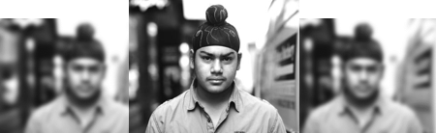
At Hartville, the principal identified the need for schools to have more up-to-date resources such as posters and textbooks that reflect contemporary Australian diversity. She said that they have signage welcoming people to the school in different languages but that there also needs to be more subtle forms of inclusion. For example, she said, ‘It would be nice to have, you know, some Muhammads and Islas and Ailas and Aishers… just to have a bit of diversity…because again it’s that subtleness’ (Hartville, Principal Interview). Rather than just having a multicultural day as a once-off or only supporting cultural diversity in explicit and celebratory ways, the principal suggested that it is important to incorporate support for diversity in a way that also normalises it across the school. At the same time, the principal and school staff recognise that racism needs to be treated explicitly and talked about openly rather than brushing it to the side.
Avi Singh Portrait
Source – Museum Victoria

10.3 What did we learn?
Taking a complex, cross-disciplinary topic and presenting it through both personal stories and real-life simulations (both in-gallery and online) provides teachers with:
- Ways to reflect on their own previously unrecognised personal experiences relating to identity and racism, as well as those of their students.
- Opportunities for immersion in scenarios only formerly understood in a conceptual or intellectual way.
- Space to encounter representations of identity, and how this impacts on what they bring to teaching topics relating to identity and diversity.
- An invaluable value-adding resource for existing lesson plans that has lasting use post-exhibition visit, particularly due to strong online materials.
- A series of valuable shared experiences with students (personal stories and ‘real-life scenarios’) for ongoing class discussion on various curricular themes.
- A heightened awareness of social and cultural issues needing discussion in their schools (by teachers and students) not previously considered relevant or necessary.
- A boost to their acknowledged professional capability and confidence to teach complex subjects.

11. Impacts of IYMO

This section discusses students’ reported impact of the IYMO exhibition on their perspectives, attitudes and approaches toward racial, ethnic and cultural diversity and issues of racism. The first part describes the development of the survey (items and constructs), provides a summary of the participant data and then discusses the reasons why there were not significant statistical changes in the students’ attitudes. The survey findings are supported by a discussion of the qualitative data.

11.1 Survey background
A student survey was developed to evaluate changes in perceptions, attitudes and approaches toward racial, ethnic and cultural diversity as a result of visiting the IYMO exhibition at the Immigration Museum. Due to a lack of age-appropriate measures for school-aged students, we adapted items from other surveys and designed additional items based on constructs grounded in the theoretical literature. We also included questions to understand the broader context of young people’s friendships with people from different racial, ethnic and cultural backgrounds. Finally, based on findings that demonstrate strong associations between racism and health across all age groups (Paradies, 2006; Paradies et al., 2015; Priest et al., 2013), we included psychosocial health measures and a general health item. The following outlines the survey constructs that formed the theoretical basis for items from other surveys, which were used in their original form or adapted for the purpose of this survey and the Australian context.
The 49-item student survey included 12 demographic items, which asked about age, gender, school year, racial/ethnic/cultural background, birth country, parents’ birth country, length of time living in Australia and other countries including age at arrival/departure, languages spoken, religious identification and religiosity (in terms of religious salience). The remaining 37 items measured attitudes, perspectives and approaches toward diversity as well as peer intergroup contact, ethnic identity and health. Key constructs measured included: feeling relaxed around people from different racial/ethnic groups (n=1) (Dunn, 2001), empathy (n=1) (Davis, 1980), internal (n=1) /external (n=3) motivation to respond without prejudice (Green, Adams, & Turner, 1988; Molina & Wittig, 2006; Plant & Devine, 1998), ideological stances in relation to diversity, including colour-blindness (n=1) (VicHealth, 2014), assimilation (n=2) (Ferdinand et al., 2013; Montreuil & Bourhis, 2001), system justification (n=2) (Kay & Jost, 2003), symbolic threat (n=1) (VicHealth, 2014), realistic threat (n=1) (Ferdinand et al., 2013) and social desirability (n=3) (Crowne & Marlowe, 1960).
To understand the broader context in relation to students’ attitudes, other items examined peer intergroup contact (n=2) (Ferdinand et al., 2013; Henry & Hardin, 2006), social connectedness (n=3) (Bond et al., 2007), experiences of racism (n=3) (Australian Bureau of Statistics, 2008) and an ethnic identity scale (n=6) (Phinney & Ong, 2007). The ethnic identity scale was adapted from the Multigroup Ethnic Identity Measure-Revised (Phinney & Ong, 2007). Finally, based on the extensive literature about the mental and physical health impacts of racism (Paradies et al., 2015) and particularly among children and young people (Priest et al., 2013), students were asked about their health using the K6 scale (Kessler et al., 2010) and one item measuring positive self-rated health (SF1) from the SF-36 Health Survey (Ware & Gandek, 1998). See Appendix 2 for more detail on survey items and sources.
In total, across five schools, there were 80 students who completed Time 1 (T1) surveys approximately two weeks before their exhibition visit. Across six schools, there were 98 students who completed Time 2 (T2) surveys approximately two weeks after their exhibition visit, and 85 students who completed Time 3 (T3) surveys approximately three months post-visit.

11.2 A discussion of survey findings in relation to qualitative findings
The small sample size limited the statistical survey analysis. Additionally, the short intervention (time spent in the museum) is likely to contribute to the lack of change across the three months of follow-up. In terms of exposure to an intervention (or ‘dose’), the students only visited the exhibition once and the time they spent in the exhibition ranged from 30 minutes to 1 hour depending on the school’s schedule. The following discussion provides rich qualitative evidence that speak to some of the ‘null’ findings in the survey data. However, as discussed in Section 10.4.4, there are also significant changes identified by other students in the qualitative data, which the survey data could not capture.
First, some students at Bayside and Wellview felt that they already had a high level of respect and acceptance of people from different racial, ethnic or cultural backgrounds before visiting the exhibition. At Bayside, some of the students said that they already have respect for people and that they do not feel they need to go beyond that:
F1: ‘I honestly like even after the exhibition I still feel the same, I’m still respectful, I’m still … I haven’t really had any … like my whole family is a bit racist and whatnot and I’m just sitting there going well, this is … but I’m still not going to change my ways, I’m not going to … I have respect for everybody but other than that…

I: How about other people, similar?

M1: Yeah, I’m pretty similar to [female student] like if you show respect … if a person shows you respect, you show them respect no matter what colour their skin is or what race they … or religion they believe in or anything like that. (Bayside T3FG)

F2: Yeah, throughout our lives we’ll probably encounter most of it but, I don’t know, you know basically what’s right, what’s wrong, what not to do, what to do and then just kind learn from that.

M1: And I think it all … it really comes back to the way that … like your parents’ influence on you. I think a lot of us have been raised with that whole respect those who respect you and that type of attitude.’ (Bayside T3FG)

For these students, interacting with people from different backgrounds was just a matter of basic respect they feel they should have toward anyone, whether or not they are different to them. Likewise, at Wellview, a student said nothing surprised her because she already ‘respects tons of different things from everywhere’ (Wellview T2FG2). During a focus group three months later, another student said that because she was ‘pretty mellow with it all before anyway…I didn’t really change anything’ to which another female student agreed saying, ‘Same here’. A male student added, ‘It didn’t really change me ‘cause I’m always made to like people from other religions and stuff, so, I just went away the same’ (Wellview T3FG2). For these students, the message that they should respect people from different religious or cultural backgrounds was not something new to them. They remained at the level of understanding that there are expectations that they act without prejudice toward other people.
Other students felt that they already knew a lot of what was in the exhibition so in that sense, it did not surprise them or change their views of what they already knew. As a student at Harford said, ‘We were all aware of that stuff, we learnt some ... we learned a bit more about it’ (Harford, Class A, T2FG2 2013). In a different focus group, other students also said simply, ‘We’re just aware of it’. They compared themselves to students who ‘aren’t a part of this class…and they just don’t, like I will notice things that they are kind of just like, ‘Oh, yeah, whatever’’ (Harford, Class A, T3FG1 2013). Another student gave a hypothetical example of someone not in their class saying, ‘There’s some ethnic down at the milk bar’, to which she said, ‘Like everyone’s ethnic…and if you try and explain that to someone, they’re kind of like…they don’t get it’ (Harford, Class A, T3FG1 2013). For these students, the visit was mainly about a heightened awareness of what they already knew.
For some students at Kensington who have personally experienced racism or knew that racism happens quite often, parts of the exhibition about racism were not new to them. As one Kensington student said, ‘To be frankly honest, it didn’t really change me ‘cause before I went there, I actually realised that racism has been going on a lot’ (Kensington T3FG). He also felt that the exhibition showed that people’s racist attitudes are difficult to change and reasoned that ‘it’s difficult to be erased or changed ‘cause if you’re born with racism…if you’re racist from the start…you’re already racist [and] it’s likely that you will be always racist. It’s gotta be hard to change’ (Kensington T3FG). For this student, the examples in the exhibition of people being racist toward other people (e.g., tram simulation) or racist artefacts (e.g., ‘we’re full t-shirt’) reinforced his view that people will always be racist. However, another student argued that it might not change for everyone but ‘sometimes it can change…it can be a challenge for anyone’ (Kensington T3FG).
In terms of challenging assumptions, some students at Kensington said that they agreed the exhibit aims to make people more aware of the assumptions they make about each other and that it achieved this. However, one student also said they think that it only did this ‘for a short amount of time’ because for him, he ‘remember for like a month but after that…kind of forget’ (Kensington T3FG). Another student agreed saying, ‘It just wakes you like a bit, but then it turns back into your normal way and behave normally’ (Kensington T3FG). However, another student did not wholly agree with the other students saying, ‘Sometimes, but like, every day is not the same, things happen different[ly]…so you kind of can relate to that’ (Kensington T3FG). Another student said it changed ‘for some certain things, yes, but not all of them, obviously’ (Kensington T3FG).
Overall, due to the complex and varied impact that the exhibition had on students as well as other factors such as a relatively small sample size, the survey data did not yield strong results whereas the qualitative data provided a richer understanding of the students’ experiences.

11.4 Discussion of IYMO impacts
Although there were null findings in the survey data, the qualitative data demonstrate that the museum exhibition helped to build knowledge and challenge previous assumptions about cultural diversity, to develop a heightened awareness about one’s own identity and sense of belonging through perspective-taking and reflexivity and to begin to develop a more critical understanding of racism. The students could also readily relate to people’s personal stories and everyday artefacts that were presented in the exhibition in a way that was accessible to them. This practical everyday context helped students to think of ways they might be able to challenge their thinking and for some, to be more aware of their behaviours in terms of how they interact with people from different backgrounds in their everyday lives. Therefore, although there were null survey findings, the qualitative findings illustrate the subjective impact the experience in the exhibition had on the students and the ways through which the immersive and interpersonal approach of the exhibition helped to facilitate this.

11.4.1 Knowledge acquisition
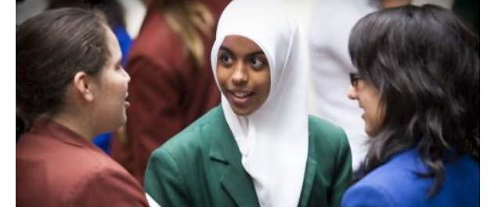
A key aspect of intercultural understanding is building knowledge as a precursor to challenging prejudicial assumptions and providing counter-stereotypes. At one level, students talked about the visit as a ‘useful’ place where they could acquire information about people from different cultural backgrounds. As Samin commented, ‘It is a very useful and a good environment for people to enhance their knowledge of different cultures [and] enhance their knowledge of migration’ (Harford Class B, T2Narr Intv 2013). Ary, a student at Kensington, found that the extra knowledge boosted her confidence when completing her essay on identity and belonging. She said, ‘I want to say that the Immigration Museum is really awesome’ because ‘when I went to the exhibition, I see a lot of story of other people and when we come to write essay of identity and belonging, I can include those people…I feel more confident in studying because I have more experience and I have a lot of idea and knowledge…after I read and visit the exhibition’ (Ary, Kensington T2NarrIntv). As an international student from Cambodia, Ary found it challenging to understand the Australian multicultural context and difficult to grasp abstract ideas about identity and belonging. Through the personal stories in the exhibition, these concepts came to life and she felt more confident completing her assignment.
Conversations about big ideas
Image: Singing Bowl Media
Source: Museum Victoria

For students who were already familiar with the idea of Australia as a multicultural society, the depth of knowledge that they acquired in the museum provided a critical layer that they previously had not considered or been exposed to. At Harford, Jordan explained that up until Year 12, his knowledge of Australian history had been ‘very basic and not as in-depth as this year’ (Harford Class A, T3NarrIntv 2013). In the exhibition and in his sociology class, it was the first time he heard about the Immigration Restriction Act (commonly known as the ‘White Australia Policy’), which limited immigration to people from Britain and later included people from other European countries. In a separate focus group, other students in the class echoed his sentiments saying, ‘Immigration in itself, I think after this class, we’ve all got a different view on it….When we went there [the Immigration Museum], we saw identity…so I think we just know a bit more about it now so we’re not going to be as ignorant’ (Harford Class A, T3FG2 2013). Not only did they learn about immigration in a more in-depth way, they also ‘saw identity’ – the personal stories made it more real for them. Similarly at Woodlane, the students reflected, it ‘helped us all…we can now talk about it more, have more knowledge on it so we can talk about it in a deeper context’ (Woodlane T3FG). The students’ comments reflect the teachers’ thoughts about the exhibition (Section 9), which were mainly that it helped to enliven discussions and provided an interpersonal connection to the broader issues they were learning about in class.
Another key issue that students highlighted repeatedly was the heightened awareness and deeper understanding they had about racism. On a conceptual level, most of them knew that racism exists in Australia. However, for people who had never experienced racism directly or had never been the target of racism, the exhibition, particularly the tram simulation, allowed them to understand what it feels like as well as knowledge to think through different perspectives. For instance, some of the students at Harford did not realise ‘how often racism happens and how many different forms it takes’ (Harford, Class A, T2FG2 2013). In a different focus group (same class/school), the students talked about understanding a racist situation in more depth, not just that it occurs. One student reflected:
‘You know about racism and stuff before you went to it [the exhibition] but then yeah, you just kind of … especially with the [tram simulation] like I watched all of them [different people on the tram’s perspectives about the incident] and I’m like okay, you could see all, everyone’s opinion and what they were thinking or how they were feeling. So it was just… I don’t know, it was just more understanding like you go deeper into the situation. So instead of just seeing.’ (Harford ClassA, T2FG1 2013)

Instead of just being present and seeing the racism occurring vicariously as a bystander, the student described how she learnt about what people were thinking as well as how they were feeling. Similarly, the following year, a student in a different class at the same school explained that it gave ‘a bit more insight into what people feel like when they’ve come here from other countries. Didn’t really know much about that… Like immigration and that sort of stuff… How hard it is for them’ (Harford, Class B, T3FG 2014). Another student in the same focus group agreed saying ‘Because…we haven’t experienced that kind of prejudice by other people, so I felt that way too. Like it kind of made you understand how other people feel’ (Harford, ClassB, T3FG 2014). A student at Kensington also described the feeling he had watching racism happening and how it affected the people on the tram, but especially the target. He said:
‘I knew that racism exists but seeing…it shows like I didn't know that the impact of being racist is so much. Like, say I went there to a place that was like a tram and they… like racism was going on and I always know that racism is a bad thing but seeing it myself, I feel it's really, really bad, like I really feel so sorry for the people that get, like, intimidated, it's really bad for them… I knew that it exists before but seeing that; it makes me feel even more so awful for them.’ (Kensington, Year 11 T2FG)

This student is from a racial and ethnic minority background, but as an international high school student, he had not had many experiences in Australia interacting with people outside the group of international students he had classes with at school and had not yet experienced racism outside of school. For him, seeing it happen and observing the impact it had on someone who could very well be him in a similar situation made him feel bad for the other person. Overall, it was clearly important for the students to be able to feel what others could be feeling in situations that they had not directly experienced themselves. This was something that simply learning about racism at school or seeing it happen in everyday life could not fully capture. The simulated environment of racism in the tram along with the deeper contextual knowledge provided by people’s voices talking about how they felt as it was happening also drew the students into the scenario. They became another person caught in the moment as the racist incident unfolded.

11.4.2 Challenging assumptions
The in-depth knowledge and personal stories the students acquired at the exhibition helped provide a starting point to begin challenging their assumptions. In terms of developing intercultural understanding, acquiring knowledge is necessary but not sufficient to address prejudice. As Allport stated in relation to his oft-cited work on intergroup contact theory, ‘the teaching of correct information does not automatically change prejudice; but it may in the long run help’ (1954, p. 486). The knowledge and the conceptual framework that students develop can provide an organising structure for thinking about new information and countering false beliefs the students may have held previously (Walton et al., 2013). Although knowledge acquisition is important and valuable, it is also vital to provide ‘interactive and experiential spaces in which an understanding of self and one’s own culture is developed in relation to an understanding of people from other cultures’ (Walton et al., 2013, p. 182). In other words, the process of intercultural understanding occurs through experience and is not simply a cognitive process (Dovidio, Gaertner, & Kawakami, 2003).
For students who have had very little to no meaningful experience interacting with people from different racial, ethnic or cultural backgrounds, the exhibition provided that contrasting point of reference through which they could compare their own experiences with that of others. Moreover, the exhibition provided a supportive affective space that acted as an entry point through which students could consider their own feelings and those of the people they were listening to, watching or reading about. Through audio-visual displays and real-life props like phones the students could pick up, the students were also immersed in such a way that they could feel like they were interacting with the people on an intersubjective level. The students could empathise with people’s different experiences, particularly of racism. A few students described the value of learning more about racism from different people’s perspectives:
F1: ‘Sometimes you don’t put yourself in someone else’s shoes like another ethnicity or whatever it was just like…

F2: It’s easier to empathise.

F1: Yeah, I put myself in another person’s shoes like someone that’s not my race and stuff. Some people cop racism all the time and … just by their looks and stuff. It opens up your eyes, yeah, it really opens up your eyes.’ (Harford Class A T3FG1 2013)

Laura, a student in the following year at the same school, was struck by a story about Vera, a woman of South African heritage whose physical appearance is Asian and is ‘labeled as an Asian person…merely ‘cause of her eyes and skin colour and stuff’ but she only knows what it’s like to live in Australia. Laura reflected, ‘That was really interesting ‘cause it made me feel, not sorry but it made me feel like a little bit more like I was in their shoes, which I like to empathise with people, but yeah I usually don’t really think of things like that. I usually think of it in my own position’ (Laura, Harford ClassB T2NarrIntv 2014). The fact that they were actual people’s stories and not fabricated or presented as a hypothetical situation in a textbook or classroom exercise made it more real for the student.
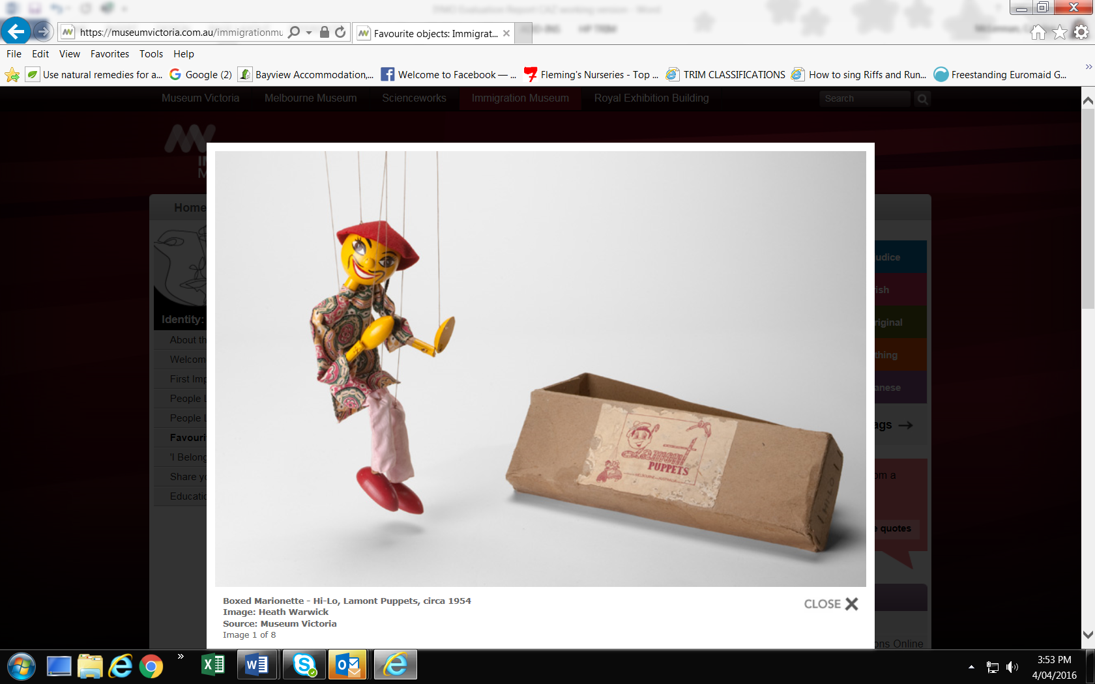
Likewise, the knowledge that they acquired that was different to what they had previously known or had taken for granted also facilitated a shift in the way students viewed issues such as racism. A few students openly said that they had been taught to have racist attitudes toward other people. However, their experience at the museum exhibition shifted those attitudes a bit. She explained, ‘Well I was
Boxed Marionette - Hi-Lo, Lamont Puppets, circa 1954
Identity: Yours, Mine, Ours Exhibition
Source: Museum Victoria

brought up in a racist family so it was kind of weird going there [to the exhibition] and stuff. Like I don’t ... I’m not racist that much but I was brought up like that so it was kind of weird but yeah, it did kind of change my opinion of other people’ (Wellview T2FG1). When asked to give an example, she said it was through the ‘phone calls and people explaining their stories and stuff. They’re just normal people’. This realisation that ‘they’re just normal people’ was facilitated by the mode through which they heard those stories. It was the physical act of picking up a phone and engaging in a normal everyday activity and listening to someone’s voice on the other end that the perceived ‘difference’ formed by her racist attitudes became humanised and normalised. Similarly, in a different focus group and in a different class at the same school, another student admitted to being racist. While the other student said she’s ‘not racist that much’, this student was different and said, ‘I am very racist. I was brought up that way’ (Wellview T3FG2). She went on to say, ‘It actually kind of hit me across the head a few times, when we were in the museum. But yeah, I guess it changed my opinion a bit’. While her description of the exhibition hitting her over the head suggests that she knew the exhibition was meant to deliver a particular message of acceptance toward cultural diversity, she also admitted that it might have changed her opinion ‘a bit’. Even a small admission by someone who openly admits that they are very racist is a significant shift, particularly after just one museum visit. She continued with, ‘I don’t like people in general, but I guess treating them fairly is a good thing’ (Wellview T3FG2). Through her sense of fairness, she could reason that it was good to treat people fairly even though she might see them as different to her.
These sentiments were echoed by some of the students at Bayside and Woodlane. Students at Woodlane agreed that the exhibition ‘opened you up to being more tolerant…I think that’s what the museum really did really well. It was more about accepting people for who they are, not what race or what anything they are’ (Woodlane T3FG). At Bayside, Gail commented on the ‘Fear of a Brown Planet’ video showing comedians, Nazeem Hussein and Aamer Rahman. She said hearing them talk about their experiences being checked for bombs at the airport every time they fly helped her to think twice about how people who look like them are perceived and treated. She explained:
‘Oh, it kind of just opens up your eyes to the fact that … for example with all the Taliban and all that kind of stuff some of the people over there are just as scared about it as we are and they’re coming over here not to bring that stuff over here but to escape it as well as us. So it kind of makes you realise that just because they’re from a different culture, it doesn’t mean that they’re the same as all the terrorists and that kind of stuff.’ (Bayside T2NarrIntv).
She reasoned that people who are fleeing countries where they are being persecuted by fundamentalist groups like the Taliban are ‘just as scared about it as we are’ and so depicting everyone who people think resemble the terrorists portrayed in the media is unfair and inaccurate.
Three months after their visit, the students could not always remember specific content in the exhibition but what stuck with them was the ‘felt’ experience of being there. Parts of the exhibition that tapped into this affective dimension such as the tram simulation, and emotional stories that challenged or resonated with the students, were the most memorable aspects of the exhibition and were what they discussed in the three-month follow-up interviews and focus groups. For example, a student at Woodlane said, ‘I can’t really remember what it was, I couldn’t tell you. Yeah. But there was like … there was people's stories, they had little brief paragraphs of a person, I remember reading them… I couldn’t tell you what they were about, but I do remember having like, ‘Oh yeah, I understand what that person’s talking about’’ (Woodlane T3FG).

11.4.3 Reflexivity
There was some indication of reflexivity, particularly by students who took the time to critically reflect on what they learnt about in relation to their own experiences, either at the exhibition or in their own time. Reflexivity can be broadly defined as a process of critical self-reflection through which someone becomes aware of their own subject-position within a particular cultural framework and in turn, how this positioning influences and shapes how they view and behave in the world (Kleinsasser, 2000; Schwandt, 1997). For some students, it stopped at learning about other people whereas for other students, perspective-taking and empathy moved toward reflexivity. This tended to happen when there was a personal and felt connection to the people’s stories in the exhibition as well as meaning-making about how those stories relate to their own lives in terms of similarities or differences. Three months after the museum visit, Laura reflected in a narrative interview about her experience watching the tram simulation. She said, ‘I had more personal connections with this and that’s why it’s stayed with me so long and I can still remember it now and yeah, it was more something that I can bring out and put into real life’ (Harford Class B, T3 NarrIntv 2014). The felt connection to parts of the exhibition resulted in a longer lasting impression than knowledge acquisition alone could have achieved. She could also relate what she saw to what she sees in everyday life.
Through audio-visual media and emotive real-life personal stories, the exhibition space provided an affective experience, that is, an emotional and physical or sensuous experience (Mazzarella, 2009). When students could relate to or felt touched by people’s stories, there was potential for the students to engage in critical reflexivity. For example, Sandra felt particularly affected by the stories of people’s hardships fleeing their countries to seek asylum in Australia. She said it took a while for her to process what she had learnt and felt. She described her moment of realisation:
‘In the museum, the day of the museum, it kind of took me ‘til that night when I was sitting down to actually take in everything I’d heard and just it hit me really hard because you don’t really … you sit there and you’ve got a shelter, you’ve got the light, you’ve got the TV, you’ve got the heater, you’ve got the food in front of you and then you’re still thinking about all these stories and you realise that there’s people at the exact same moment they’re sitting in mud with no food, no water, no clothes, they’re sitting in freezing cold weather and it’s sad that it takes a museum to make people realise that.’ (Sandra, Bayside T2NarrIntv)

During the narrative interview, she was quite emotional about it and used evocative phrases to express how much of an impact it had on her (e.g., ‘it hit me really hard’). Even though it was ‘just’ a visit to a museum, the visit and the way she felt at the museum and the things she learnt left an impression on her. She felt upset that ‘it takes a museum to make people realise that’. Although this may be interpreted as simply feeling sorry for asylum seekers, the knowledge of what it is like combined with a strong personal realisation moved her to think about her own life in a way she had not done before she went to the museum. Laura at Harford also recognised the museum’s impact on her, particularly while she was watching the ‘Welcome’ installation in the entryway. She said it made her feel what it is like ‘maybe if I went to another country’, in terms of feeling different and regarded with suspicion. She explained further, ‘‘Cause a lot of people that would go to the museum like me who’s never been to another country before, we don’t really know how it would feel. So we would just think, it’s not really that big of a deal but in actual fact, the projection showed me it actually would be a big deal…’ (Laura, Harford, Class B, T2NarrIntv 2014). Because Australia is familiar to her and it is all she knows, she had not really considered how difficult living in Australia could be for someone who has come from another country. On a cognitive level, she knew people had difficulties, but the experience of being made to feel ‘different’ even just momentarily made her ‘get’ what she knew through the affective experience of the ‘Welcome’ installation.
For students who recognised themselves in people’s stories, the emotional and bodily reaction to those stories brought up their own memories and experiences. Stories of racism and bullying experiences and the feelings those brought up in relation to their own experiences made a particular impression on the students. While Laura, as a white Anglo person, experienced ‘Welcome’ as a way to feel what it is like to be perceived as ‘different’, Tuyen, an international student from Vietnam who had lived in Australia for three years recalled an experience of being excluded at school while she was watching ‘Welcome’.
‘Oh yeah, I remember in Year 10 ... like I’m the only Asian in the class... and then people ... I think, because people, they just group into their ... I mean they just play with their friends and no one care about me. And like when I came to ask them to join a group and then they [were] like, ‘oh’. There’s no response, and then yeah, it’s like the way when I saw the hallway like people…staring at you like ... not really staring, they didn’t really stare at me but you know the way they look at us like not really friendly.’ (Tuyen, Kensington, T3NarrIntv)

The visceral experience of ‘Welcome’ brought up a previous experience when she had a similar feeling. A similar experience happened to Matai, a student with a Pacific Islander background at Wellview. While he was filming his video diary, he read out the introductory panel in the ‘Children’s Games’ section. The panel brings up bullying at school and asks the viewer, ‘Were you called names at school? Were you the bully?’. In response to this, he reflected:
‘Well when I was growing up as a child the playground was pretty, very unique because it takes me back to the days when I was younger and I used to have a lisp and kids used to pick on me and it actually really hurt my feelings and yeah it just goes to show that this part of the museum brings back some bad memories but it teaches you a lesson.’ (Matai, Wellview Class B, VD)

For Matai, coming across this part of the exhibition resonated with his own experiences being treated poorly because of his lisp. Seeing the display brought up bad memories for him but he also recognised that it was trying to teach people a lesson about the impact their actions can have on people and the fact that it happens among young children. Tamati, a Maori student at Harford, said that the experience that most affected him in the exhibition was the tram simulation. He said, ‘It was of a dark skinned person…no-one would sit by him because there was the colour of his skin and I’ve only picked that out because I’ve been through it myself and yeah just got to see what happens and the situations’ (Tamati, Harford, ClassB T2NarrIntv 2014). Tamati could readily identify with the target of racism in the video but also felt that he could reflect on his own experience by listening to how other people with different perspectives feel when racism happens. Finally, at Hartville, male Muslim students could relate to the story heard through the audio handsets about the difficulty getting a job if your name is ‘too different’. One student explained, ‘‘Cause a person’s name was Indian, they didn’t accept it, but when she changed it, she got called back straight away. Probably that because we’re Islamic’. The other students agreed saying ‘So everyone will get knocked back’ when going for job interviews (Hartville T3FG).
For other students, this affective experience remained at the level of learning about other people and their experiences. For example, a female student explained, ‘Just more aware that things that aren’t offensive to us are offensive to other people. But we don’t realise that. (Wellview T3FG1). As these students explain below, they did not feel personally connected to the stories:
F1: ‘But I didn’t really feel like I left like I knew myself better or anything, just average, like I learnt; I learnt about the stuff but it didn’t affect me personally….

M1: Yeah, it was really educational but I … it wasn’t anything like …

F1: It didn’t change your life.

M1: … it wasn’t personally for me, I thought about some … I learnt about other people’s experiences.

M2: Yeah.

F2: The same.

Interviewer: Mm-hm. The same?

F3: Yeah.’ (Harford, Class A, T3FG1 2013)
For these students, their museum visit was ‘educational’ rather than something that affected them personally. In a second focus group with different students at the same school and the same class, one of the students also talked about how she felt she only learned about different cultures and ethnicities rather than reflecting on her own identity.

Interviewer: ‘Did you think differently about identity?
F: Not really, I just didn’t … ‘cause I’m Australian I don’t really have like a, I guess, a different culture so I saw how other people identify how it’s … how their ethnicity is so important in their identity. I: Yeah?
F: Yeah.’ (Harford Class A, T3FG2)

As previously discussed in section 9.1, some of the white Anglo teachers and students did not feel that Anglo Australian identity was fully explored in the exhibition. They also felt that the exhibition taught them a lot about ‘other’ people but not about ‘us’ as ‘Australians’, read as white and Anglo. The white Anglo student’s comment above suggests that she could not see herself as coming from a ‘different culture’ and so from her perspective, the exhibition was all about ‘different cultures’, which did not include her. As a result, she did not feel a personal connection to the stories she read in the exhibition because she could not see herself reflected in those stories.
Other students at Woodlane explained why it can be difficult to have a personal connection to the stories they read about of people from different cultural backgrounds.
F1: ‘But then I guess it’s hard because I’ve never like lived in another country. I’ve never experienced another culture so I don’t know, if I were to go to another country, would I feel like I belong more to that country than I did in Australia.

F2: I don’t really know, I guess like how do you feel to be like acknowledged as an Australian, like especially because I’ve never left the country or like really experienced other cultures so deeply that you don’t really know like anything else…like you only know how you live like each day. It’s not really like, ‘oh I feel different because I know I’m Australian’.

F1: Yeah you can’t acknowledge what you don’t understand.’ (Woodlane T2FG)

These students went deeper into the issue of critical reflexivity. They acknowledged that it was difficult to be reflexive if they did not have experiences where they were perceived as different or could feel what it is like to experience their own cultural background as Anglo Australian as different from another cultural background. They talked about this in terms of not ‘really know[ing] like anything else’ because they are so immersed in their own way of living. Because they come from a majority Anglo cultural background, which is completely normalised in Australian society, and live in an area that is predominantly white and Anglo, they do not know what it means to ‘feel different’.

The exhibition tried to facilitate this by displaying provocative questions in each section, which asked the visitor to reflect on their own identity and belonging. However, as one Woodlane student said in a focus group three months after their visit, ‘You would have had to have sat down and made yourself think about who you were’ (Woodlane T3FG). This would have required the space and time to reflect on those questions, which was difficult to do within a tightly scheduled school field trip. However, this comment also suggests that the parts of the section that asked the visitor to reflect on their own identity were not presented in the same engaging audio-visual format that other parts of the exhibition about other people’s diverse stories were presented. The students would have just read the question and then moved on to the next section if they did not deliberately take the time to reflect on what the question was asking. For example, in some of the video diaries, the students read out the text and the questions and then took time to think about what it meant for them. As the same Woodlane student explained, ‘The way they [the stories in the exhibition] were set out, it was very much like this is this person’s story and this is what they think and you had to walk away from that and then go, ‘Okay, so what does … who am I and what’s my story?’’ (Woodlane T3FG). Nevertheless, if students took the time to think deeply about their own ‘story’, there was certainly potential for a stronger impact as evident by the previous students’ personal reflections described earlier in this section.

11.4.4 Behavioural change
As discussed in the survey section, there were null findings in the survey data. In addition to the previous reasons mentioned such as a high self-reported baseline level of openness and acceptance toward diversity and the relatively low sample size, the complexity of experiences, particularly around such broad and contested issues such as identity and belonging, are difficult to quantify and measure. Instead, the multi-method qualitative approach that this evaluation used was able to capture rich data about what the students experienced in the exhibition and the impact it had on them. As evidenced by the students’ experiences, the museum exhibition was not simply an informational exercise to increase literacy and comprehension levels. In addition to the new knowledge that the students acquired, it was also an affective experience which brought up memories, lived experiences and emotions about a range of issues raised in the exhibition. The audio-visual experience and the interactive elements (e.g., ‘Welcome’ video installation, Tram simulation, audio handsets, ‘First Impressions’ touch table and ‘People Like Me’ touch screens) created a subjective and at times, intersubjective experience through which the students personally connected with the people whose stories they read, heard and felt. In addition to the impacts described above (e.g., challenging assumptions through perspective-taking and empathy, and reflexivity), the students also identified incremental but significant changes in their behaviours and attitudes toward people who may be perceived to be different to them. This section describes some of those reported changes.
The majority of changes were discussed by students at Harford. This may be due to the super-diversity (Vertovec, 2007) at the school as well as the way the students talked about diversity as just a normal everyday thing that they experience all the time rather than something they have to intentionally ‘explore’. For these students, racial, ethnic and cultural diversity is embedded in their lives at school and in their community rather than being a conceptual exercise. During a focus group, one of the students explained that she is more ‘patient with people’:
F1: ‘It makes me feel more patient with people. No, like if they don’t know the …

F2: Tolerant?

M1: Tolerant.

F1: … no, patient …

F3: ‘No, patient’ (playfully mimicking the other student)

F1: … because like if I see someone and they’re like not … if I’m just kind of annoyed with them they don’t know how to speak English properly or something like that, I just think at least they’re trying, they’re trying to assimilate but before I’d just be like, ‘Oh my god, learn English’ but now I’m kind of like, ‘Oh, that’s okay’.

F1: Does that make sense?

F2 and F3: Yeah, yeah.’ (Harford Class A, T3FG1 2013)

When the interviewer asked if anyone else had any other experiences they wanted to talk about, another student also talked about feeling more patient. She explained, ‘I just come to an understanding of things, you know, that you can't pressure them to try to learn English’ (Harford Class A, T3FG1 2013). Throughout the focus group, the students were teasing each other in a friendly manner. In this focus group interaction, when the student who explained she felt more ‘patient’, the other students playfully teased her but then when she asked if it makes sense, they agreed with her. One of the other girls agreed saying, ‘I just come to an understanding of things, you know, that you can't pressure them to try to learn English’ (Harford Class A, T3FG1 2013). The student who insisted on using the word ‘patient’ rejected the male student’s suggestion that she meant ‘tolerant’. Tolerance is a term that has been criticised for an approach that merely ‘puts up with difference’ rather than truly accepting people on their terms (Paradies, in press). Here, the student was not claiming she had changed her attitudes enough to fully accept people as they are. However, she did insist that she is more ‘patient’ with people (rather than ‘tolerant’). Patience is a more neutral term than tolerance and, in the student’s example, reflects increased openness and understanding toward people she thinks are trying to speak English. She still holds to the belief that people should ‘assimilate’ but has taken a moment to reflect that maybe she should not expect people to just speak English like her straight away. This is a small concession but at the same time, is significant given how entrenched racist attitudes can be.
Similarly, the following year with a different class at the same school, the students were asked if there’s anything they do or think about differently since they attended the exhibition three months ago. One student said, ‘Not as quick to like make assumptions’. When asked to give an example, she prefaced her reason by saying, ‘Well like not saying I’m…like I was racist or something’ and then continued with, ‘but [I’m] not as quick to make assumptions about different ethnic groups, that kind of, you know, like stereotypes and stuff…not like racist ones’ (Harford Class B, T3FG 2014). She wanted to make it clear that she was not saying she was racist but at the same time, acknowledged that she held stereotypes of people that were challenged as a result of what she experienced at the exhibition. For students at Kensington, ‘Welcome’ brought their attention to the assumptions they make about people based on their appearance or bodily expressions. One student said that what changed for him is the ‘way you look at other people from other backgrounds… Before that, you might think that people are really happy and stuff, [but] you don't know what's behind them…so need to have some respect’ (Kensington T3FG). Another student agreed saying, ‘We don’t really know what’s going on….We need to like learn to understand that everyone has problems and like yeah, where they’re coming from and stuff’ (Kensington T3FG). Students at Woodlane also connected what they learnt at the museum with ways to apply it in their everyday life. One student said the information in the museum was useful because ‘you can take it with you and you can use it in your life experiences and stuff. If you encounter a person you already have that understanding and you don’t have to…’. Another student finished the other student’s sentence with, ‘and you don’t have to judge’ (Woodlane T3FG). Through these examples, the students expressed heightened awareness about the stereotypes they have about other people and suggest they are more likely to question those assumptions rather than immediately assuming that their view of other people is always correct.
Some students also mentioned other examples of how they have or plan to challenge racism in everyday life. This mainly centred on bystander anti-racism. A focus group at Harford discussed how racism plays out in their lives and things they do now that question racism when they see it happening. One student explained that she never ‘had kind of racist views or anything like that’ but when she sees other people ‘say that kind of stuff in front of me, even though they’re not saying anything to anyone else, like I feel uncomfortable now’ (Harford, Class B T3FG 2014). She continued by explaining that now that she has more knowledge about racism and the impact it has on people she feels, ‘more like I can be disapproving towards it when someone’s making fun of like Islam or, you know, different culture. Like I just, I don’t just let them say that now’ (Harford, Class B T3FG 2014). Because she feels uncomfortable, she does not feel she can just let racist things slip by without speaking up about it. Another student then gave an example of how since the exhibition she’s spoken up about racism in her family. She mentioned that her dad bought a ‘fuck off, we’re full’ t-shirt that is associated with racist anti-immigration views and was displayed in the exhibition. She said, ‘My dad actually has a top that says that and I don’t let him wear that anymore’. She said her parents are ‘always saying, ‘Oh, people from other countries shouldn’t come here. We’re getting rid of the whole Australian thing’’ (Harford Class B, T3FG 2014). The students expressed how they have become more aware of the way people use racist attitudes against people in ways that are not fair.
Students at other schools also said they are more likely to help someone if someone is being racially abused. A Wellview student said, ‘If I saw someone being racist on public transport, I’d probably help aid the person being abused or attacked’ (Wellview T3FG1). At Hartville, the students also explained what they would do:
M: ‘The way you speak to people.

I: Yeah? How do you think it’s changed?

M: Like, some … you have … sometimes you think before you say something ‘cause it might hurt someone.
I: Mm-hm.

M: It might be racist.

M: The way … maybe like, if someone else is getting bullied or … about their racial or ethnic group …

M: …you jump in.

M: … you could help.

M: Yeah.

M: There was the example of our teacher when we were on the train.’ (Hartville T3FG)

These students explained that on the way back from their excursion to the museum, there was a racist incident on the train and their teacher spoke up against it. They mentioned this incident in the focus group as an example demonstrating that they can also do something about it if they see something. Similarly, Rashed, a student at Kensington, talked about the tram simulation example of the woman on the tram getting up to sit next to the man who was being unfairly targeted because of his skin colour and for speaking in another language. He said, ‘I liked how the woman stood up for the man and did what was right, it really inspired me and stuff’ (Rashed, Kensington T2NarrIntv). Seeing examples of people taking action and how they went about it gave the students more confidence to know what they could do in a similar situation.

11.5 What did we learn?
Acknowledging the limitations of the survey findings (due to the small sample size), the richness of the qualitative data, and the breadth and degree of exhibition impact on students, it can be concluded that:
- Exhibition experiences offering strong immersive and interpersonal opportunities can build knowledge, challenge assumptions and heighten personal awareness through self-reflection.
- The contracted nature of school visits require exhibitions provide high-impact moments of interaction to deliver the key content.
- Students with little to no meaningful interactions with culturally and socially diverse people, and experiences of racism, can have a higher learning threshold, potentially increasing the overt exhibition impact.
- Student and teacher learnings from exhibitions can range from a more detached, ‘educational’ experience, to more practical, ‘lived’ understandings through simulated and human interactivity.
- It is the ‘felt’ experience that primarily remains with students and teachers (immersion, emotional stories), enabling a degree of reflexivity, and/or moments of painful recognition.
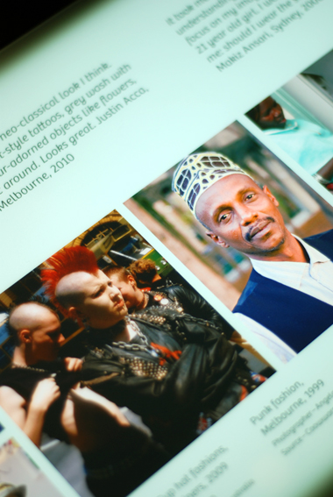
Graphic ‘What I Wear’
Identity: yours, mine, ours Exhibition
Source- Museum Victoria

12. School Exhibition Feedback: Highlights and Improvements

This section outlines what the students and some of the teachers’ felt were the main highlights of the exhibition as well as suggested changes to improve the exhibition experience. Their perspectives are discussed in relation to format and environment, educational approach and content.

12.1 Format
Overall, all of the students and teachers who participated in the evaluation commended the exhibition’s format in terms of the interactive and interpersonal focus through the use of audio-visual displays. The exhibition material engaged the students because ‘it wasn’t just reading. There were things that you could watch, things that you could listen to and that you could take a part in (Woodlane T2FG). Students said that the touch table did not always work and for them and because this interactive element was an essential feature of their exhibition experience, they said that it was important that the technology worked. As a Bayside student commented, ‘I liked the way it was set up the way that you could just … it’s so interactive that you can just look at some amazing stuff in there and for the screens that do work you can touch them and just … and like the computers and stuff… it was just … I really enjoyed it’ (Bayside T2FG).
At one level, the audio-visual format appealed to the students because it was more engaging than just reading text. However, it was not simply about the audio-visual for the sake of it. The students were adamant that the audio-visual format provided a unique experience through which they could feel like they were listening to an actual person rather than an audio-visual display of a person. The format brought them into a space in which they could momentarily feel like they were having a one-on-one interaction with another person. Sandra explained how she felt when she was listening to the stories:
‘And so it wasn’t just like an overview of what people go through it was a specific person talking to you about what had happened to them and it just made it a whole lot more real when you could see their face and you could see … you could hear their voice and you could see pictures of their family back in Vietnam when they were all together… even though they weren’t actually there but it was still … it still felt like a one-on-one experience with them because they were just … they were opening up so much, they didn’t leave out anything they just told you their whole story like they wanted us to know what they went through.’ (Sandra, Bayside T2NarrIntv)

The students also enjoyed the audio handsets. Even though there was not a fancy display, the simple act of picking up a familiar object like a telephone and putting it up to their ear and listening to someone tell them their story in a way that no one else could hear, created an intimate one-on-one experience. Rather than just reading about someone, the story came to life through the sound of a person’s voice telling their own story directly to the listener. These students all expressed similar feelings about the hand set experience:

‘I feel like I’m talking ... listening to those people telling a real story. And the telephone also make me feel like I’m talking to that person so like we’re sharing experience. Like a lot of stuff make me feel like I’m so connected to those people even though it’s just manmade.’ (Ary, Kensington T2NarrIntv)

‘Just like that whole listening to some of the stories. And that phone, I loved the phone… you’d pick up the phone and just press a button and you could like have a conversation with someone, I found that pretty cool.’ (Male student, Bayside T3FG)

‘These kinds of interactive phone things are very good. They allow, I don’t know, to connect more than reading the other stuff.’ (Adam, Lakeland VD)

The students also highlighted the touch table as another interactive feature they enjoyed in the exhibition:
‘It was a while ago. The only moment I remember from the museum was…like with touch table. I heard each story or background, but each of them had a really, really touching story about what they were and how they were affected by other people when they saw them.’ (Joel, Wellview T3NarrIntv)

‘Now we’re in the first portion and you touch the face and touch the bubbles. [taping the white Australian boy]. Man, I feel like I’m talking to him for real. This is cool.’ (Ary, Kensington VD)

Touch table – ‘I think this very good that its hands on because people like hands-on things and they get to touch it and hear what people are saying and their stories.’ (Elise, Wellview VD)

The students described having to physically touch the table to activate someone’s story. It engaged their senses – seeing, hearing, and feeling – and through this experience, as Adam expressed, they were also ‘touched’ by the stories they heard.
In a way, by using their bodies to directly engage with the exhibition displays, students became part of the exhibition through the physicality of picking up an object or touching a screen in order to interact with someone’s story. For the exhibition to come to life, it required their presence and willingness to reach out and physically interact with the displays. Minh is an international student from Vietnam. He compared his IYMO exhibition experience to his previous museum experiences in Vietnam:
‘Yeah, you can touch and you can feel and stuff but in my country you can’t do that. You just look, walk past, walk past you can, you know. Last time I went on an excursion with my school to walk and look and can’t even read the information and like here you can read and you can do everything you want, yeah.’ (Minh, Kensington T2NarrIntv)

Rather than just being a passing observer, students like Minh, became entangled in other people’s stories. They had to stop and figure out how to interact with the displays in order to interact with the people’s stories.
Another example of how the students experienced the exhibition as a sensorial bodily experience was the tram simulation. One student at Woodlane said that even though they were watching a video, it was not the same experience as watching a video on YouTube. She said, ‘It was a lot more different to do the tram thing than just like watching a video on YouTube about it. It was much more submersive [sic] to actually watch that… to be almost like listening and watching it than just watch[ing] a YouTube video’ (Woodlane T2FG) Another student in the same focus group also explained why it was so powerful. She said, ‘It was very confronting and I guess you wouldn’t get an experience like that in the classroom [compared] to where you’re in a room and you can’t really be distracted by anything else’ (Woodlane T2FG). This student made the distinction between being in a classroom or school environment where there are many distractions and being in the exhibition space where they were momentarily suspended in time to focus solely on listening to someone else’s story. For her, it was confronting because there were no other distractions and it as just her and another person having an interpersonal experience.
Finally, the teachers also reiterated the students’ feelings about the importance of being able to physically touch and engage with the exhibition in a way that brought the stories to life.
‘[Students] having to sit and read things and it’s kind of like oh yeah, I’ll quickly read the next bit you know whereas the more audio-visual sort of stuff, that sort of stuck a bit more into their minds as well, I believe.’ (Bayside TeacherIntv)

‘I just thought it was really good to have different items in there like .. and different interactive devices and things like you could pick up a telephone and …the touch screens, you can touch a screen and you know different bubbles of information and people talking will come up. The interaction of you actually being ... the simulation of being on that bus with those people, that was a really good ... I think that was probably one of the most powerful things because it put it into a day-to-day scenario that the kids face. This happens everyday. And what do you do? And so I think that that was probably one of the most standoutish thing that the kids took away.’ (Kensington TeacherIntv)

The first teacher emphasized that the interactive format of the exhibition meant that the experience ‘stuck a bit more’ with the students. Rather than simply using their eyes to read about someone, the exhibition engaged their senses to more fully interact with another person’s story, thus creating a lasting tactile impression and a more memorable experience. The second teacher also described the significance of being able to physically interact with the exhibition as a ‘powerful’ experience that brought it back to the ‘day-to-day’.
Given these highlights, the suggested changes focused on including more of what was good about the exhibition, namely more audio-visual content. For example, students at Wellview suggested:
‘Maybe bigger and add more into it or something, like more props … hands on things.’ (Wellview T3FG1)

‘Probably like … more hands on things ‘cause if a kid went there they’d probably be a little bit bored because a lot of words written on the walls but if there was more hands-on things he might be more engaged into the topic at hand.’ (Wellview T2FG2)

Some students also felt it would be good if there was more space. This included ‘more seats at the tram’ (Harford Class B, T2FG 2014) and more space in the Passport room because ‘it was packed’ and some students skipped over it (Harford Class A, T2FG1 2013). Students also suggested including ‘another computer in that Passport room’ (Wellview T2FG2).
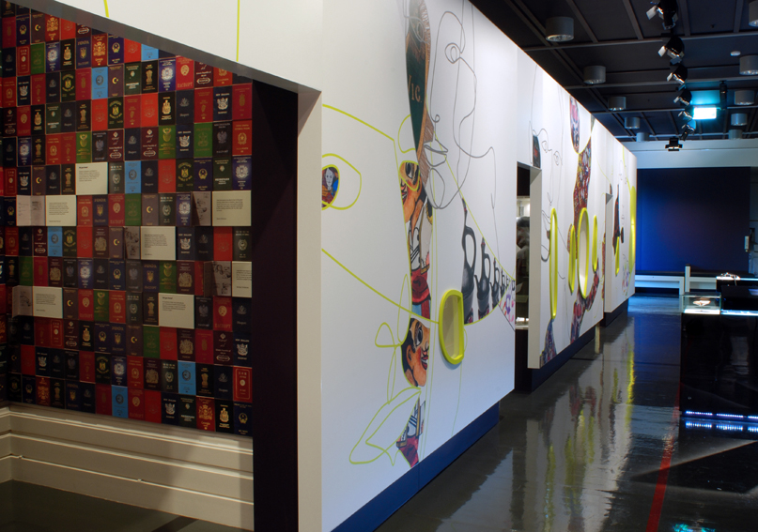
In terms of access, another student suggested it would be good to have more visual material for people whose first language is not English. She said, ‘it would be hard for them to understand 'cause they cannot ... they can't read or understand, so I reckon more visual stuff would be good for them, so in that way they can get the sense of ... Australia's multiculturalism’ (Samin, Harford ClassA, T3NarrIntv 2013).
Entrance to Passport Room
Identity: Yours, Mine, Ours Exhibition
Source – Museum Victoria

12.2 Educational approach
This section on the exhibition’s educational approach mainly focuses on the exhibition booklet that was used for classes that booked a staff-led session. All classes in this evaluation booked a staff-led session. There were mixed views about using the booklets in the exhibition as well as the length of time spent in the staff-led sessions compared to the time spent in the exhibition. Some of the students found the education session and booklet helpful because the session provided an understanding of ‘key details to look out for or what to expect’ (Tamati, Harford Class B, T2NarrIntv 2014) and the booklet provided a more structured way to guide them through the exhibition. For example, Laura at Harford said the education session ‘good…because it put our minds into the position of where we’re going into and…what we should be thinking about and paying attention to’ (Laura, Harford Class B, T2NarrIntv 2014). Because the students did not know what to expect beyond the fact that it was related to their study (see Section 3), Laura also said, ‘It was just opening our minds up to expect a lot of different things and that there are some things in here that might make you feel different ways…It was a nice preparation for the museum and it put everybody on the same level’ (Laura, Harford Class B, T2NarrIntv 2014). In terms of the booklet, Sandra at Bayside said that it ‘encouraged us to look more deeply into the things that were there’ (Sandra, Bayside T3NarrIntv). For her, she felt the book helped because it made her ‘pay more attention to what was actually going on’ (Sandra, Bayside T3NarrIntv). Similarly, the teacher at Hartville said she thought it was ‘really cleverly done…[because] if you do it like the booklet [says] you start in the ‘Welcome’ hallway and then you come through each section so it leads you through, which I like’ (Hartville TeacherIntv).
However, students and teachers also felt that the education session could be slightly revised in terms of the amount of time it took relative to the overall time the school had at the museum. Some also preferred to have a shorter education session that was more focused, rather than talking about issues the students had already learnt about in class or that were too broad to be specifically relevant to the IYMO exhibition. For example, the teacher at Hartville said she wished the session was ‘more tailored’ because her Year 12 students had not done VCE history since Year 10 and the history lesson that the staff member gave beginning with the First Fleet and the gold rush was too broad for their focus which was on identity and belonging and so ‘wasn’t relevant to our kids’ (Hartville TeacherIntv).
Some students also mentioned they preferred to spend more time in the exhibition as well as more time focused on engaging with the exhibition displays rather than being distracted by answering questions in the booklet. As a student at Harford explained, ‘We did the first bit [the education session] and then we did the middle [IYMO exhibition] with our booklets and stuff but I really didn’t want to sit there and fill out the booklets, I kind of just wanted to touch all the stuff for a while’ (Harford Class A, T3FG1 2013). Given one of the key evaluation findings is the importance and value of the interactive and immersive environment that the exhibition creates, some students felt that the booklets hindered their ability to fully engage with the displays. The students enjoyed the exhibition because it enlivened what they learnt in the classroom at school. One Bayside student recommended that the museum ‘make it all fun, not just sitting in the classroom’ (Bayside T3FG).
The teachers’ comments at Wellview reiterated these points. They also felt that that the booklet limited what the students engaged with because they were just focused on answering the questions. She said, ‘In reality, the kids are looking at the question sheet going I need to answer that so I’ll find that bit and I’ll answer it, it’s not ... so if it’s not there they’re not going to go and read it and ... unless they’re really into it like some of our kids were’ (Wellview Teacher Joint Interview). The teachers suggested that if there are going to be booklets, that they should include questions that encourage self-reflection such as, ‘How does this make you feel? Rather than you know, just go to the touch screens and tell me one story. I think it should be really about the students’ (Wellview Teacher Joint Interview). When the booklet asks to relate an issue back to the students’ personal experiences, it mainly focuses on people the students have encountered rather than critically thinking about their own attitudes or behaviours. For example, one of the questions in first impressions asks, ‘What assumptions are commonly made about a person’s identity based on their name? Use examples from your key text or personal experience’. It may be partly the way the questions I worded that the students do not fully understand that they could think about assumptions they’ve made about other people and why. Instead, it could just be some experience they have had that does not necessarily focus on the students themselves. The exhibition introductory panels for each section do ask provocative questions to help the students think about their own identity and sense of belonging. However, if they were trying to fill out the booklets, then they might not have felt they had time to read the panels and think about those questions as well as the questions in the booklet.

12.3 Content
Finally, in terms of exhibition content, the students felt the exhibition had the right approach in terms of providing personal stories and interesting artefacts. They just wished there were even more stories and more artefacts. For example, at Wellview, the students said, ‘I would keep everything the same, but just incorporate [more] stuff’ and ‘Just add…make it bigger…and add new things to it’ (Wellview T2FG2). Students at Harford and Wellview suggested the museum could include ‘more cultural backgrounds’ (Harford Class B, T2FG 2014) and ‘more people with different identities’ (Wellview T2FG1). Jordan at Harford suggested, ‘Also that Anglo-Saxon type and also Aboriginal and I just wished there had been more European, Middle Eastern, South American…to show their sort of stories of how they came to Australia or the reason why they came to Australia’ (Jordan, Harford Class A T2NarrIntv 2013).
A few other suggestions included school specific content, recent objects from the past few years and more explanation. During a focus group, students at Kensington said that they felt the exhibition mostly talked about ‘issues that happen outside of school so they might include…something in the school as well’ (male student 1). They agreed that it would be good to show ‘problems [that] happen around the schools’ (male student 2) and ‘maybe like something to do with international students or someone who just arrived and started school and how they’re finding it’ (female student) (Kensington T3FG). Some students at Wellview said they see stuff like the racist t-shirt that was displayed a lot where they live and suggested ‘they should put more stuff ‘cause there are heaps more of those [kinds of things]’ (Wellview T3FG2). Finally, some students at Bayside and Wellview thought there more explanation in certain parts of the exhibition would have been helpful. For example, some Bayside students suggested there could be more explanation in the commercial products section that asked students to think about why certain objects are considered racist. They did not understand why certain objects, such as the Golliwogs and Creole biscuits could be considered racist and rationalised that it was just being overly politically correct. One student said, ‘For example, the Golliwogs and stuff, they had the thing that said what a Golliwog was but it didn’t really explain the significance behind the meaning there...I think I wanted things a bit more explanation as to the significance behind it’ (Bayside T2FG). Rachel at Wellview wanted to know more about ‘people’s experiences…in-depth’ because she wanted to know more about a story about people whose family had gone through immense hardship on their way to Australia (Rachel, Wellview T2NarrIntv). Finally, another student at Wellview wanted to know more about ‘how to deal with racism’ (Wellview T2FG1).

12.4 Suggested Exhibition Improvements
More prominence to ‘Anglo’ identities: Although there was content about Anglo identities in the exhibition, to the Anglo students and teachers, this was not prominent. A suggestion for new content would be to include an audio-visual display about becoming aware of their positionality as white and Anglo and becoming aware of white privilege. This could be in the form of an Anglo youth talking about their journey from considering themselves ‘cultureless’ to understanding their positionality and privilege.
Enhancing the immersive museum experience: Students commented that the ‘Identity booklet’, while useful, was difficult to fill out while at the same time, fully experiencing the exhibition in an immersive sense. Due to limited time in the exhibition, the ‘Identity booklet’ might be more useful if it is reframed as an activity they can do at school using the on-line material, if needed.
The students also suggested more instructive signage would be helpful. For example, the students said that it was not always immediately obvious what they had to do at the touch table. Some suggested there could be a display panel to alert them to the interactive feature with instructions about what they should do. Although most understood what they had to do, because the interactive displays were so integral to the exhibition experience, it would be useful to consider including more signage to provide some guidance.
More space and time to encourage self-reflection: Students felt the audio-visual content and format was the most engaging at both cognitive and affective levels. The majority of explicit self-reflection prompts were written on the introductory panels for each section. It would be helpful if these prompts were worked into an audio-visual display that guides students through a reflexive process (e.g., the suggestion under recommendation #1).
Additionally, due to the students’ strong feelings and emotions about complex topics of identity, belonging and racism, it would be worth considering including a post-exhibition debrief session for students as part of their visit.
Providing a detailed classroom resource package: To support teachers to build on students’ key learnings from the exhibition experience, a detailed curriculum resource that can be implemented in the classroom would be useful. This could include activities that would facilitate an interpersonal and interactive learning style, which was simulated through the exhibition displays.
More in-depth explanation of commercial products to address ‘political correctness’: Additional explanation of the commercial products such as the Golliwogs, Redheads matchsticks and Creole Creams would support the students to understand the reasons why they were included. These products weren’t immediately recognisable as racist. Clearer distinction between sexism and racism also needs to be made with students wondering why the Redheads matchsticks were racist. It could be useful to have an audio-visual of someone talking about why it is offensive to them and/or an academic talking about the racist history of the terms involved, rather than defaulting to ‘political correctness’.
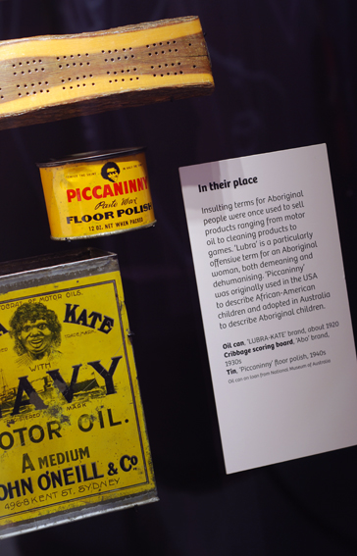

‘Cultural Stereotypes’ Display Case
Identity: yours, mine, ours Exhibition
Source – Museum Victoria

13. Appendices

Appendix 1 Qualitative Methods (schedules and prompts):

1. Student focus group schedule

1.1 T2 Student focus group schedule
(Two weeks after attending the IYMO exhibition)

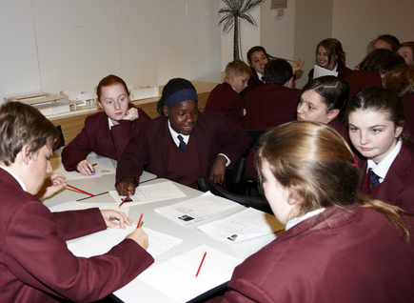
Intro: It’s been a few weeks since you visited the Identity exhibition at the Immigration Museum. Today, we’ll discuss some key topics from the exhibition about identity, belonging and racism. We’re interested in everyone’s thoughts and experiences to help us evaluate the exhibition. That means that what you say is really important because it will help the museum know what to change or keep the same.
Students Education Program at Immigration Museum
Source – Museum Victoria

Before we start, it’s important to remember a few things. First, everything you say will be kept private. Only we (the researchers) will have access to the recordings. So in publications or conference papers, we’ll remove your names and use pseudonyms so that no one will be able to connect your name to what you say. Finally, as you know, it’s important to respect each other’s opinions. It’s okay to disagree because you’ll have different ideas and different experiences, but we just need to remember to be respectful. Okay, does anyone have any questions?

Ask everyone’s names for the recording.

1) Intro questions
- Why do you think your teacher organised for you to visit IYMO (Identity: Yours, Mine, Ours)?
- What did you expect to find out?

On the website, the museum says that the exhibit is ‘about identity – who we are, who others think we are, and what it means to belong and not belong in Australia’.
- What do you think of this? Do you think it achieved this?

2) Your experience
‘Welcome’ installation (feeling welcome – belonging/not belonging)
Intro: At the start of the exhibition, there was a screen at the end of the corridor with images of people. Some of them looked friendly and some looked unfriendly.

- What did you think when you saw it?
- Was there anything that surprised you?
- Was there anything that you found challenging?
- Are there any particular situations or events that come to mind?

First Impressions touch table display (stereotypes and assumptions)
Intro: This part of the exhibit was about snap judgments or assumptions we all make about other people based on how they look, what they wear, the way they talk, what they eat, who they’re with and so on.

- Did the videos help you think about stereotypes or assumptions?
- Was there anything that surprised you?
- Was there anything that you found challenging?
- Are there any particular situations or events that come to mind? (e.g. from your experiences or people you know)

Passport room and citizenship test (Australian national identity and cultural diversity)
Intro: In the Passport Room, you were invited to do an Australian citizenship test. The citizenship test asks a set of questions in order to prove Australian knowledge to be an Australian citizen.

- What does being Australian mean to you?
- Can someone be more or less Australian? Do you think this is OK?
- Are there any particular situations or events that come to mind? (e.g. from your experiences or people you know)

Tram simulation (racism and bystander action)
If needed: To recap, the scenario involved a White Anglo man getting on the tram and refusing to sit next to a young man with darker skin. You could watch the scenario from the perspectives of different people on the tram: as bystanders, as the target of racism and as the perpetrator of racism.

- Was there anything that surprised you?
- Was there anything that you found challenging?
- Are there any particular situations or events that come to mind? (e.g. from your experiences or people you know)
- Did watching the scenario help you think about how you would react if you were in a similar situation?
- Did you do or say something?
- How easy or hard is it to decide what to do?

Standing up (taking action)
Intro: At the end of the exhibit, there was a room with a computer where you could leave a comment and your handprint.

- Did anyone do this? If so, what was your key message to others? If you did not leave a comment, what key message would you give?
- Did the exhibition inspire you to learn more? If so, what did you most want to learn more about?

Final thoughts
- Was there anything you would change?
- What would you definitely keep the same?

1.2 T3 Student focus group schedule
(Three months after attending the IYMO exhibition)

Intro: It’s been about three months since you visited the Identity exhibition at the Immigration Museum. Today, we’ll discuss some key topics from the exhibition about identity, belonging and racism. We’re interested in everyone’s thoughts and experiences to help us evaluate the exhibition. That means that what you say is really important because it will help the museum know what to change or keep the same.

Before we start, it’s important to remember a few things. First, everything you say will be kept private. Only we (the researchers) will have access to the recordings. In publications, we remove your names and use pseudonyms so that no one will be able to connect your name to what you say. Finally, as you know, it’s important to respect each other’s opinions. It’s okay to disagree because you’ll have different ideas and different experiences, but we just need to remember to be respectful. Okay, does anyone have any questions?

Ask everyone’s names for the recording.

1) Intro
- Why do you think your teacher organised for you to visit IYMO (Identity: Yours, Mine, Ours)?

On the website, the museum says that the exhibit is ‘about identity – who we are, who others think we are, and what it means to belong and not belong in Australia’.
- What do you think of this? Do you think it achieved this?
- Have you been back to the IYMO exhibition or looked at the IYMO materials on-line since your class visit?
2) Changes
- Since your visit, have you talked more about what you learnt with anyone? (e.g. had discussions with friends, posted opinions on social media sites, etc.).
Are there any particular situations or events that come to mind? (e.g. from your experiences or people you know)

- Now that it’s been three months since you attended the exhibition, is there anything that you do or think about differently? (e.g. in relation to thinking about cultural diversity)?

Are there any particular situations or events that come to mind? (e.g. from your experiences or people you know)

- The exhibition aimed to help people become more aware about the assumptions people make about each other. Do you think it achieved this?

Are there any particular situations or events that come to mind? (e.g. from your experiences or people you know)

- Since attending the IYMO exhibition, have you witnessed something like the tram video?
  - Are there any particular situations or events that come to mind? (e.g. from your experiences or people you know)
  - Did you do or say something? Why or why not?
  - How easy or hard did you find it to decide what to do?
- Do you think you will continue to explore issues raised in the IYMO exhibition? In what ways?

2. Student narrative interview prompts:
(written by Dr Philipp Schorch)

First stage: Please tell me about your visit to the ‘Identity’ exhibition at the Immigration Museum. Begin wherever you like, I will just listen and will not interrupt. I am interested in your perspective and story, and will only record the interview and take some notes for after you have finished telling me about the exhibition experiences of importance to you.

Second stage: Elaboration (Prompts: Are there any particular situations, events, displays or objects which come up to mind?)

Third stage: How did you experience the cultures of Australia at the exhibition?
How did you experience the religions of Australia at the exhibition?
What role did the education program in this regard?
How does your experience of the exhibition relate to other museum experiences in Australia?

Follow-Up Narrative Interviews:

First stage: Please tell me about your past visit to the ‘Identity’ exhibition at the Immigration Museum. Begin wherever you like, I will just listen and will not interrupt. I am interested in your perspective and story, and will only record the interview and take some notes for after you have finished telling me about the exhibition experiences of importance to you.

Second stage: Elaboration (Prompts: Are there any particular situations, events, displays or objects which come up to mind?)

Third stage: How did you experience the cultures of Australia at the exhibition?
How did you experience the religions of Australia at the exhibition?
What role did the education program in this regard?
How does your experience of the exhibition relate to other museum experiences in Australia?

3. Student video diary prompt:
We’d like you to help us evaluate the exhibit by documenting your experience. While you’re walking through the exhibit, use the iPads to talk about what you’re seeing/thinking: things that interest you or surprise you, something you’d like to know more about. Something might remind you of your own experience or someone you know. You can talk about that too. We’d like to know ‘why’ you’re recording certain objects. Record as much or as little as you like. You can stop and start the video by pressing the record button. We’ll wait for you at the exit where you can return the iPads to us and also receive $20 to thank you for helping us with our evaluation.

4. Teacher interview schedule:
About the exhibition and your experience:
It’s been a few weeks since you and your students visited the Identity exhibition at the Immigration Museum. Today, we’ll discuss some key topics from the exhibition about identity, belonging and racism as well as how appropriate you felt the material was for the classroom. We’re interested in your thoughts and experiences to help us evaluate the exhibition. First we’ll discuss your experiences at the exhibition. Then, we’ll discuss the exhibition in relation to teaching and learning practice.
1) Intro questions
- Please tell me why you decided to take your students to visit IYMO (Identity: Yours, Mine, Ours)?
- On the website, the museum says that the exhibit is ‘about identity – who we are, who others think we are, and what it means to belong and not belong in Australia’.
  - What do you think of this? Do you think it achieved this?
2) Your experience
Please tell me about your experience during your IYMO visit. (Note: Allow the teacher to discuss what they remember)
If needed, can use these prompts:
- What part of the exhibition was most interesting to you?
- Was there anything that surprised you?
- Was there anything that you found challenging?
If needed, can use these prompts for the different IYMO sections as teacher discusses them:
‘Welcome’ installation (feeling welcome – belonging/not belonging)
[If needed: At the start of the exhibition, there was a screen at the end of the corridor with images of people. Some of them looked friendly and some looked unfriendly.]
- What did you think when you saw it?
- Are there any particular situations or events that come to mind?
- Was there anything that surprised you?
- Was there anything that you found challenging?
First Impressions touch table display (stereotypes and assumptions)
[If needed: This part of the exhibit was about snap judgments or assumptions we all make about other people based on how they look, what they wear, the way they talk, what they eat, who they’re with and so on.]
- Did the videos help you think about stereotypes or assumptions?
- Are there any particular situations or events that come to mind? (e.g. from your experiences or people you know)
- Was there anything that surprised you?
- Was there anything that you found challenging?
Passport room and citizenship test (Australian national identity and cultural diversity)
[If needed: In the Passport Room, you were invited to do an Australian citizenship test. The citizenship test asks a set of questions in order to prove Australian knowledge to be an Australian citizen.]
- What does being Australian mean to you?
- Can someone be more or less Australian? Do you think this is OK?
- Are there any particular situations or events that come to mind? (e.g. from your experiences or people you know)
Tram simulation (racism and bystander action)
[If needed: To recap, the scenario involved a White Anglo man getting on the tram and refusing to sit next to a young man with darker skin. You could watch the scenario from the perspectives of different people on the tram: as bystanders, as the target of racism and as the perpetrator of racism.]
- Did watching the scenario help you think about how you would react if you were in a similar situation?
- Are there any particular situations or events that come to mind? (e.g. from your experiences or people you know)
- Did you do or say something?
- How easy or hard is it to decide what to do?
Standing up
[If needed: At the end of the exhibit, there was a room with a computer where you could leave a comment and your handprint]
- Did you do this? If so, what was your key message to others? If you did not leave a comment, what key message would you give?
- Did the exhibition inspire you to learn more? If so, what did you most want to learn more about?
Final thoughts
- Was there anything you would change?
- What would you definitely keep the same?
3) Teaching practice
- Have you used anything like the IYMO exhibit material in your classroom before your visit?
- Since your visit, have you used any of the on-line material from the IYMO exhibit in your classroom?
- How appropriate do you feel the IYMO exhibition material is for secondary school students?
- How appropriate do you feel the IYMO exhibition material (including the on-line material) is for using in your classroom?
- How feasible do you think it is to incorporate topics raised in the IYMO exhibition in your classroom/in the curriculum?
- What do you think would help make it more feasible to use in your classroom/in the curriculum?
- If it came up, how confident do you feel talking about issues related to cultural diversity and racism in your classroom? Is this the same or different to your confidence before visiting IYMO?
- Since your visit, have you sought out other sources to learn more about cultural diversity, identity and belonging? (Prompts: e.g. other media, professional development opportunities)
- Since your visit, have you talked more about what you learnt with anyone? (e.g. had discussions with friends, with other teachers, posted opinions on social media sites, etc.).

5. Principal interview schedule:
Intro: This interview will help us to better understand school culture and demographics, policy and practice in regards to promoting and supporting cultural diversity in the school and curriculum.

- What does your school do to support learning about cultural diversity? (Prompt: for example, curriculum, programs, activities, community visits, etc.). What’s working well? Is there anything you’d like to change?

- Is there anything your school does to support teachers to have conversations about racial, ethnic, cultural or religious diversity with their students?

- Is there anything your school does to support students to have conversations about racial, ethnic, cultural or religious diversity (e.g. with other students)?

- How do you think schools can promote learning about racial, ethnic cultural or religious diversity amongst staff? Among parents? Among students?

- Is there anything your school does to teach or talk to students about understanding/addressing racism?

- How are teachers supported to talk about or address racism in a school/classroom context?

- How are students supported to talk about or address racism in a school/classroom context?

- What kinds of support do you feel is needed to help schools promote acceptance of diversity and to understand/address racism?

- How appropriate do you feel it is to promote acceptance toward diversity and address racism/promote anti-racism strategies in your school’s curriculum? At different year levels?

- How feasible do you feel it is to promote acceptance toward diversity and address racism/promote anti-racism strategies in your school’s curriculum?

6. Museum staff interview/focus group schedule:
Intro: This interview/focus group will help us to better understand the intended impact of the exhibit on attitudes and behaviours towards race, cultural diversity, identity and belonging as well as broader context of museum policy and practice.

Exhibition origins and vision:
- First, could each of you briefly describe your role and involvement with IYMO?
- How did the idea for the IYMO exhibition originate?
  - What was the social, cultural, political context at the time?
  - Was anything particularly influential in the design and aims of the exhibition? (e.g., community groups, government bodies, policies, other institutions, local/global events, campaigns)
  - Were state and national curriculum documents taken into account in designing IYMO? If so, what do you see as the benefits and limitations of this?
- What was your overall vision and aims for IYMO originally?
  - Has this changed? How/why?
- In designing IYMO, who did you imagine as your target audience?
- What was your approach to cultural diversity in the exhibition?
- What was your approach to issues of racism and belonging?
- Can you talk me through your intentions for each of the three sections of the exhibit? (First impressions, People like me & People like them)? (Including selection of fonts, language, graphics, narratives, sounds etc.)
Exhibition educational approach:
- What was the thinking behind the IYMO education program?
  - Could you please tell me about the pink IYMO booklet (e.g., how it was developed, its purpose, intended outcomes)?
  - What are the key ideas you are trying to get across during the IYMO education session and tour?
- How do you intend IYMO materials to be used in the classroom?
Exhibition impacts:
- What do you think the impact of the exhibition has been? (e.g., on young people, teachers, specific community groups, general community?
- What do you think the impact of the IMYO education program has been on students and teachers?
- In the first 2 years of the exhibition, do you feel IYMO has met your goals/museum goals? Do you feel it has had the intended effect on people?
- Is there anything else you’d like to add?

Appendix 2: IYMO Student Survey items by construct

IYMO Museum Project: Summary of constructs by survey item (students)

Code
CRQ=Challenging Racism Questionnaire (Dunn et al. 2001)
EQ=Empathy Questionnaire (Davis 1980)
Outgroup Contact (Henry & Hardin 2006)
HCAS=Host Community Acculturation Scale (Montreuil & Bourhis 2001)
ISS=Institutional Support Subscale, Molina & Witting 2006 - Adapted from School Interracial Climate Scale in order to assess classroom climate (Green, Adams & Turner 1988)
K6=Kessler-6 (Kessler et al. 2010)
LEAD=Localities Embracing and Accepting Diversity Survey (Ferdinand et al. 2013)
MEIM-R= Multigroup Ethnic Identity Measure-Revised (Phinney & Ong 2007)
MRWP=Motivation to Respond Without Prejudice scale (Plant & Devine 1998)
MTT1= More than Tolerance (2006 survey)
Social Connectedness=Bond et al. 2007 - Adapted from Interview Schedule for Social Interaction (Henderson et al. 1980)
SDS=Marlowe-Crowne Social Desirability Scale (Crowne & Marlowe 1960)
SF1=Item from the SF-36 Short Form Health Survey (Ware & Gandek 1998)
VARCD=Victorian Attitudes to Race and Cultural Diversity (this is a revision of MTT1) 2013. (VicHealth 2014)
A=Adapted survey item
R=Reverse coded

Relaxed with difference | 13 | I am relaxed around people from other racial and ethnic groups. _{CRQ -A (also used in LEAD)}
Empathy | 15 | I feel quite upset when I see people from other racial and ethnic groups having problems. _{EQ-A}
External motivation to respond without prejudice | 14  16  27 | My friends expect me to treat people from other racial and ethnic groups fairly. _{MRWP-A (also used in LEAD)}  Adults expect me to treat people from other racial and ethnic groups fairly. _{MRWP-A (also used in LEAD)}  Teachers want us to be friends with students from other racial and ethnic groups. _{ISS-A (also used in LEAD-A}
Internal Motivation to respond without prejudice | 24 | It is important to me that I treat people from different racial and ethnic groups fairly. _{MRWP (also used in VARCD-A)}
System justification | 17  22 | Australia is a fair place for all ethnic groups. (theoretical basis using Kay & Jost, 2003)  Everyone in Australia gets a ‘fair go’. (theoretical basis using Kay & Jost, 2003)
Social desirability | 19  21  26 | There have been occasions when I took advantage of someone. _{SDS-A}  I sometimes feel resentful when I don’t get my own way. _{SDS-A (also used in VARCD-A)}  I sometimes try to get even rather than forgive and forget. _{SDS-A (also used in VARCD)}
Assimilation | 18  23 | People from racial or ethnic minority groups should adopt mainstream Australian culture. _{LEAD}  People from racial or ethnic groups should retain their culture. _{(REVERSE-CODED) HCAS-A}
Colour-blindness | 20 | We shouldn’t talk about racial or ethnic differences. _{(VARCD)}
Realistic threat | 25 | Racial and ethnic minority groups get more from this country than they contribute. _{LEAD-A}
Symbolic threat | 28 | Australia is weakened by people from racial and ethnic minority groups maintaining their cultural beliefs and values. _{MTT1-A}
Peer Intergroup contact | 29  30 | How many of your friends are from other racial or ethnic groups? Outgroup Contact (also used in LEAD-A)  How many of your CLOSE friends are from other racial or ethnic groups? Outgroup Contact (also used in LEAD-A)
Social connectedness | 31  32  33 | In your friendship group, do you have someone to talk to? Social Connectedness (Bond et al. 2007)  In your friendship group do you have someone to depend on when angry or upset? Social Connectedness (Bond et al. 2007)  In your friendship group do you have someone who could be trusted with private feelings and thoughts? Social Connectedness (Bond et al. 2007)
Experiences of racism | 34  35  36 | In the last 12 months how often have you been treated unfairly because of your racial or ethnic background? _{NATSISS-A}  In the last 12 months how often have you witnessed someone else from your own racial or ethnic background treated unfairly because of their racial or ethnic background? _{NATSISS-A}  In the last 12 months how often have you witnessed someone from another racial or ethnic background treated unfairly because of their racial or ethnic background?
Ethnic identity | 37  38  39  40  41  42 | I have spent time trying to find out more about my racial/ethnic/cultural group, such as its history, traditions, and customs.  _{MEIM Revised – A}  I have a strong sense of belonging to my own racial/ethnic/cultural group. _{MEIM Revised – A}  I understand pretty well what my racial/ethnic/cultural group membership means to me. _{MEIM Revised –A}  I have often done things that will help me understand my racial/ethnic/cultural background better. _{MEIM Revised – A}  I have often talked to other people in order to learn more about my racial/ethnic/cultural group_{. MEIM Revised – A}  I feel a strong attachment towards my own racial/ethnic/cultural group. _{MEIM Revised – A}
Psychological Distress | 43  44  45  46  47  48 | How often did you feel so depressed that nothing could cheer you up? _{K6}  How often did you feel nervous? _{K6}  How often did you feel restless or fidgety? _{K6}  How often did you feel hopeless? _{K6}  How often did you feel that everything was an effort? _{K6}  How often did you feel worthless? _{K6}
General Health | 49 | In general would you say your health is: (excellent, very good, fair, poor) SF-1 from the SF-36 Health Survey

14. References

Allport, G. (1954). The nature of prejudice. Reading, MA: Addison-Wesley.
Australian Bureau of Statistics. (2008). Population Characteristics, Aboriginal and Torres Strait Islander Australians, 2006 (ABS Cat. No. 4713.0). Retrieved from Canberra:
Australian Bureau of Statistics. (2008). National Aboriginal and Torres Strait Islander Social Survey (NATSISS) (Cat. No. 4714.0). Retrieved from http://www.abs.gov.au/ausstats/abs@.nsf/Latestproducts/4720.0Main%20Features22008?opendocument&tabname=Summary&prodno=4720.0&issue=2008&num=&view
Australian Bureau of Statistics. (2014, 13 March 2014). Australian Social Trends. Retrieved from http://www.abs.gov.au/ausstats/abs@.nsf/Lookup/4102.0main+features102014
Australian Curriculum Assessment and Reporting Authority. (2015). My School. Retrieved from http://www.myschool.edu.au/
Bates, C. (2013). Video diaries: Audio-visual research methods and the elusive body. Visual Studies, 28, 29-37.
Bond, L., Butler, H., Thomas, L., Carlin, J., Glover, S., Bowes, G., & Patton, G. (2007). Social and school connectedness in early secondary school as predictors of late teenage substance use, mental health, and academic outcomes. J Adolesc Health, 40(4), 357.e359-318. Retrieved from <Go to ISI>://MEDLINE:17367730
Charmaz, K. (1996). Grounded theory. In J. A. Smith, R. Harré, & L. Van Langenhove (Eds.), Rethinking methods in psychology (pp. 27-49). London: Sage.
Charmaz, K. (2014). Constructing grounded theory (2nd ed.). London: Sage.
Chesterman, J., & Galligan, B. (1997). Citizens without rights: Aborigines and Australian citizenship. Melbourne: Cambridge University Press.
Clifford, J. (2010). Introduction: Partial Truths Writing Culture: The Poetics and Politics of Ethnography. Berkeley, CA: University of California Press.
Crawford, A. (2013, 27 May). Adam Goodes 'gutted' by racial slur but wants AFL fan educated. ABC News. Retrieved from http://www.abc.net.au/news/2013-05-25/goodes-gutted-but-places-no-blame/4712772
Crowne, D. P., & Marlowe, D. (1960). A new scale fo social desirability independent of psychopathology. Journal of Consulting Psychology, 24(4), 349-354.
Davis, M. H. (1980). A Multidimensional Approach to Individual Differences in Empathy. Catalog of Selected Documents in Psychology, 10, 85.
Degner, J., & Dalege, J. (2013). The apple does not fall far from the tree, or does it? A meta-analysis of parent–child similarity in intergroup attitudes Psychological Bulletin, 139(6), 1270-1304.
Dovidio, J. F., Gaertner, S. L., & Kawakami, K. (2003). Intergroup contact: The past, present, and the future. Group Processes and Intergroup Relations, 6, 5-21.
Dunn, K. (2001). Challenging Racism Project 2001 Survey. Retrieved from http://www.uws.edu.au/__data/assets/pdf_file/0011/77384/DunnQuestionnaire2001.pdf
Dunn, K., & Nelson, J. K. (2011). Challenging the Public Denial of Racism for a Deeper Multiculturalism. Journal of Intercultural Studies, 32(6 ), 587-602.
Eriksen, T. H. (2002). Ethnicity and Nationalism (2nd ed.). London: Pluto Press.
Essed, P. (1991). Understanding Everyday Racism: An Interdisciplinary Theory. Newbury Park: Sage.
Fechter, A. M. (2005). The 'Other' stares back: experiencing whiteness in Jakarta. Ethnography, 6(1), 87-104.
Ferdinand, A., Trenerry, B., Perry, R., Priest, N., Paradies, Y., & Kelaher, M. (2013). Localities Embracing and Accepting Diversity (LEAD): Tool Development Report: VicHealth.
Forrest, J., & Dunn, K. (2006). 'Core' culture hegemony and multiculturalism: Perceptions of the privileged position of Australians with British backgrounds. Ethnicities, 6(2), 203-230.
Green, C. W., Adams, A. M., & Turner, C. W. (1988). Development and validation of the school interracial climate scale. American Journal of Community Psychology, 16, 241-259.
Guillemin, M., & Drew, S. (2010). Questions of process in participant-generated visual methodologies. Visual Studies, 25(2), 175-188.
Hage, G. (2008). Analysing Multiculturalism Today. In T. Bennett & J. Frow (Eds.), The SAGE Handbook of Cultural Analysis (pp. 488–509). London: Sage.
Henderson, S, Duncan-Jones, P., Byrne, DG., & Scott, R. (1980). Measuring social relationships: The interview schedule for social interaction. Psychological Medicine 10, pp. 723-734.
Henry, P. J., & Hardin, C. D. (2006). The contact hypothesis revisited: status bias in the reduction of implicit prejudice in the United States and Lebanon. Psychol Sci., 17(10), 862-868.
Hewstone, M., & Brown, R. (1986). Contact is not enough: An intergroup perspective on theHenry, PJ & Hardin CD. (2006). The contact hypothesis revisited: Status bias in the reduction of implicit prejudice in the United States and Lebanon. Psychological Science 17(10), pp. 862-868.
Jugerta, P., Eckstein, K., Beelmann, A., & Noack, P. (in press). Parents’ influence on the development of their children’s ethnic intergroup attitudes: a longitudinal analysis from middle childhood to early adolescence. European Journal of Developmental Psychology.
Kay, A. C., & Jost, J. T. (2003). Complementary justice: effects of’ poor but happy’ and’ poor but honest’ stereotype exemplars on system justification and implicit activation of the justice motive. Journal of personality and social psychology, 85(5), 823.
Kessler, R. C., Green, J. G., Gruber, M. J., Sampson, N. A., Bromet, E., Cuitan, M., . . . Zaslavsky, A. M. (2010). Screening for serious mental illness in the general population with the K6 screening scale: Results from the WHO World Mental Health (WMH) survey initiative. International Journal of Methods in Psychiatric Research, 19, 4-22.
Kleinsasser, A. M. (2000). Researchers, Reflexivity, and Good Data: Writing to Unlearn. Theory Into Practice, 39(3), 155-162.
Kowal, E. (2012 ). Stigma and suffering: white anti-racist identities in northern Australia. Postcolonial Studies, 15(1), 5-21.
Kowal, E., Franklin, H., & Paradies, Y. (2013). Reflexive antiracism: A novel approach to diversity training. Ethnicities, 13 (3), 316–337.
Lensmire, T. J., McManimon, S. K., Dockter Tierney, J., Lee-Nichols, M. E., Casey, Z. A., Lensmire, A., & Davis, B. N. (2013). McIntosh as Synecdoche: How Teacher Education's Focus on White Privilege Undermines Antiracism. Harvard Educational Review, 83(3), 410-431. Retrieved from http://www.metapress.com/content/35054H14L8230574
MacDougall, C., & Baum, F. (1997). The Devil's Advocate: A Strategy to Avoid Groupthink and Stimulate Discussion in Focus Groups. Qualitative Health Research, 7(4), 532-541.
McFadzean, M. (2012) Exhibiting Controversy at Melbourne’s Immigration Museum.
Melbourne Historical Journal, 40, 5-19
Mansouri, F., Jenkins, L., Morgan, L., & Taouk, M. (2009). The Impact of Racism upon the Health and Wellbeing of Young Australians Retrieved from Melbourne:
Marcus, G. E., & Fischer, M. M. J. (1999). Anthropology as cultural critique: An experimental moment in the human sciences (2nd ed.). Chicago: University of Chicago Press.
Markus, A. (2010). Mapping social cohesion: The Scanlon Foundation surveys summary report 2010. Retrieved from Melbourne:
Markus, A. (2011). Mapping Social Cohesion: the Scanlon Foundation surveys 2011 summary report. Retrieved from
Markus, A. (2012). Mapping Social Cohesion: the Scalon Foundation national report. Retrieved from Melbourne:
Markus, A. (2013). Mapping social cohesion: the scanlon foundation surveys national report 2013. Retrieved from Melbourne:
Markus, A. (2014). Attitudes to immigration and cultural diversity in Australia. Journal of Sociology, 50(1), 10-22. doi:10.1177/1440783314522188
Markus, A., & Arnup, J. (2009). Mapping social cohesion: The Scanlon Foundation surveys full report 2009. Retrieved from Melbourne:
Markus, A., & Dharmalingam, A. (2007). Mapping Social Cohesion: The 2007 Scanlon Foundation Surveys. Retrieved from Clayton: http://scanlonfoundation.org.au/research/surveys/
Mazzarella, W. (2009). Affect: What is it good for? In S. Dube (Ed.), Enchantments of modernity: Empire, nation, globalization (pp. 291-309). Abingdon: Routledge.
Meeusen, C., & Dhont, K. (in press). Parent–Child Similarity in Common and Specific Components of Prejudice: The Role of Ideological Attitudes and Political Discussion. European Journal of Personality.
Miklikowska, M. (in press). Like parent, like child? Development of prejudice and tolerance towards immigrants. . British Journal of Psychology.
Molina, L. E., & Wittig, M. A. (2006). Relative Importance of Contact Conditions in Explaining Prejudice Reduction in a Classroom Context: Separate and Equal? Journal of Social Issues, 62(3), 489-509.
Monahan, M. J. (2014). The concept of privilege: a critical appraisal. South African Journal of Philosophy, 33(1), 73-83.
Montreuil, A., & Bourhis, R. Y. (2001). Majority acculturation orientations toward ‘valued’ and ‘devalued’ immigrants. Journal of Cross-Cultural Psychology, 32(6 ), 698-719.
Museum Victoria. (2015a). Customs History. Retrieved from http://museumvictoria.com.au/immigrationmuseum/discoverycentre/old-customs-house/customs-history/
Museum Victoria. (2015b). Identity: yours, mine, ours. Retrieved from http://museumvictoria.com.au/immigrationmuseum/discoverycentre/identity/
Museum Victoria. (2015c). Old Customs House - Melbourne. Retrieved from http://museumvictoria.com.au/immigrationmuseum/discoverycentre/old-customs-house/the-building/
Museum Victoria. (2015d). Packet - Nigger boy steel wool soap pads, circa 1950s. Retrieved from http://museumvictoria.com.au/collections/items/1371261/packet-nigger-boy-steel-wool-soap-pads-circa-1950s
Nelson, J., Dunn, K., & Paradies, Y. (2011). Bystander Anti-Racism: A Review of the Literature. Analyses of Social Issues and Public Policy, 11(1), 263-284.
Nelson, J., Dunn, K., & Paradies, Y. (2011 ). Australian racism and anti-racism: links to morbidity and belonging. In F. Mansouri & M. Lobo (Eds.), Migration, Citizenship and Intercultural Relations: Looking Through the Lens of Social Inclusion? (pp. 159-176). Farnham, Surrey: Ashgate.
Paradies, Y. (2006). A systematic review of empirical research on self-reported racism and health. Int J Epidemiol., 35(4), 888-901.
Paradies, Y. (in press). Whither anti-racism? . Ethnic and Racial Studies.
Paradies, Y., Ben, J., Denson, N., Elias, A., Priest, N., Pieterse, A., . . . Gee, G. (2015). Racism as a Determinant of Health: A Systematic Review and Meta-Analysis. PLoS One, 10(9), e0138511. doi:10.1371/journal.pone.0138511
Paradies, Y., Franklin, H., & Kowal, E. (2013). Development of the Reflexive Antiracism Scale – Indigenous. Equality, Diversity and Inclusion: An International Journal, 32(4), 348-373.
Perry, P. (2001). White Means Never Having to Say You’re Ethnic: White Youth and the Construction of ‘Cultureless’ Identities. Journal of Contemporary Ethnography, 30, 56-91. doi:10.1177/089124101030001002
Personal identity in contemporary Australia: Exhibition concept brief. (2009). Museum Victoria. Melbourne.
Phinney, J. S., & Ong, A. D. (2007). Conceptualization and Measurement of Ethnic Identity: Current Status and Future Directions. Jounrla of Counseling Psychology, 54(3), 271-281.
Plant, E. A., & Devine, P. G. (1998). Internal and External Motivation to Respond Without Prejudice. Journal of personality and social psychology, 75(3), 811-832.
Priest, N., Paradies, Y., Trenerry, B., Truong, M., Karlsen, S., & Kelly, Y. (2013). A systematic review of studies examining the relationship between reported racism and health and wellbeing for children and young people. Social Science and Medicine, 95, 115-127.
Priest, N., Perry, R., Ferdinand, A., Paradies, Y., & Kelaher, M. (2014). Experiences of Racism, Racial/ Ethnic Attitudes, Motivated Fairness and Mental Health Outcomes Among Primary and Secondary School Students. Journal of Youth and Adolescence, 43, 1672-1687.
Priest, N., Walton, J., White, F., Kowal, E., Fox, B., & Paradies, Y. (2014). ‘You are not born being racist, are you?’ Discussing racism with primary aged-children. Race Ethnicity and Education, Accepted
Rabiee, F. (2004). Focus group interview and data analysis. Proceedings of the Nutrition Society, 63, 655-660.
Sandell, R. (2007). Museums, prejudice and the reframing of difference. London and New York: Routledge.
Sandell, R. (Ed.) (2002). Museums, Society, Inequality. London: Routledge.
Sawrikar, P., & Katz, I. (2010). ‘Only White People can be Racist’ What does Power have to with Prejudice? Cosmopolitan Civil Societies Journal, 2(1).
Schorch, P. (2014). Cultural feelings and the making of meaning. International Journal of Heritage Studies, 20(1), 22-35.
Schorch, P. (in press). Museum encounters and narrative engagements. In A. Witcomb & K. Message (Eds.), Museum theory: an expanded field. Malden, MA and Oxford: Blackwell.
Schorch, P., Walton, J., Priest, N., & Paradies, Y. (2015). Encountering the ‘Other’: Interpreting Student Experiences of a Multi-Sensory Museum Exhibition. Journal of Intercultural Studies, 36(2), 221-240. doi:10.1080/07256868.2015.1008432
Schwandt, T. A. (1997). Qualitative inquiry: A dictionary of terms. Thousand Oaks, CA: Sage Publications.
Szekeres, V. (2002). Representing diversity and challenging racism: The migration museum. In S. Watson (Ed.), Museums and their communities (pp. 234–243). London: Routledge.
Vertovec, S. (2007). Super-Diversity and Its Implications. Ethnic and Racial Studies, 30(6), 1024-1054.
VicHealth. (2014). Findings from the 2013 survey of Victorians' attitudes to race and cultural diversity. Retrieved from Melbourne, Australia:
Victorian Curriculum and Assessment Authority. (2011). Sociology: Victorian Certificate of Education Study Design. Retrieved from Melbourne:
Walton, J., Priest, N., Kowal, E., Brickwood, K., Fox, B., White, F., & Paradies, Y. (2014). Talking culture? Egalitarianism, color-blindness and racism in Australian elementary schools. Teaching and Teacher Education, 39(112–122).
Walton, J., Priest, N., & Paradies, Y. (2013). Identifying and developing effective approaches to foster intercultural understanding in schools. Intercultural Education 24(3).
Ware, J. E., & Gandek, B. (1998). Overview of the SF-36 Health Survey and the International Quality of Life Assessment (IQOLA) Project. Journal of Clinical Epidemiology, 51, 903-912.
Wengraf, T. (2001). Qualitative research interviewing: Biographical narrative and semi-structured methods. London: Sage.
Willis, K., Green, J., Daly, J., Williamson, L., & Bandyopadhyay, M. ( 2009). Perils and possibilities: achieving best evidence from focus groups in public health research. Australian and New Zealand Journal of Public Health, 33(2), 131-136.
Witcomb, A. (2009). Migration, Social Cohesion and Cultural Diversity ‒ Can Museums move beyond Pluralism? Humanities Research, 15(2), 49-66.
Zevallos, Z. (2005). 'It's Like We're Their Culture': Second-generation Migrant Women Discuss Australian Culture. People and Place, 13(2), 41-49.

In other countries, a tram could also be referred to as a ‘streetcar’ or ‘trolley’.
Pseudonyms are used for all school names and participants.
Pseudonyms are used for all students and schools. Only participants who participated in individual interviews and video diaries have been given a pseudonym.
In this report, Pasifika refers to people who identify with and whose family lineage is connected to the Pacific Islands of Melanesia, Micronesia and Polynesia.
For purposes of anonymity, the exact country is not identified.
‘Sudos’ is slang for people with a Sudanese background but is also used to refer generically to people from different African backgrounds.
According to the MySchool Australian government website, Bayside had 4% of students with a language background other than English and Woodlane had 5%. In terms of percentage of Indigenous students, Bayside had 3% and Woodlane had 6%.
VCAL refers to Victorian Certificate of Applied Learning.
VCE refers to Victorian Certificate of Education

