My Visit to the Immigration Museum

This book belongs to:
_____________________________________________________

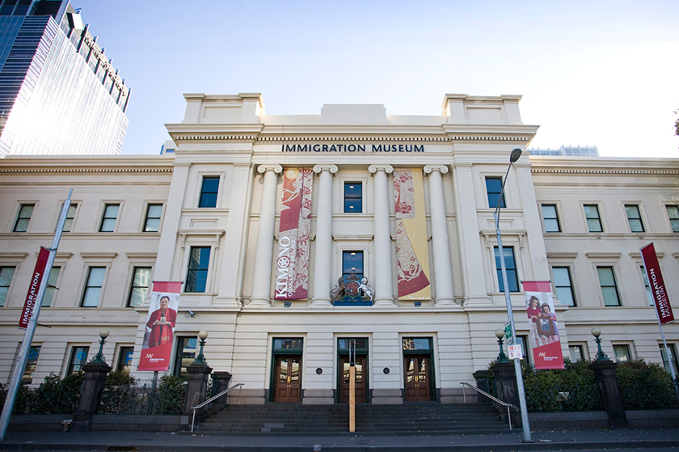

I am going to visit the Immigration Museum.
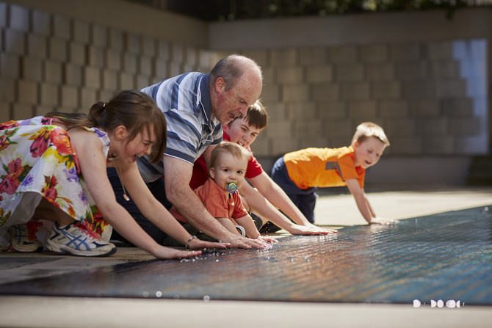

I will see lots of different things in the museum. I will see other people there too.
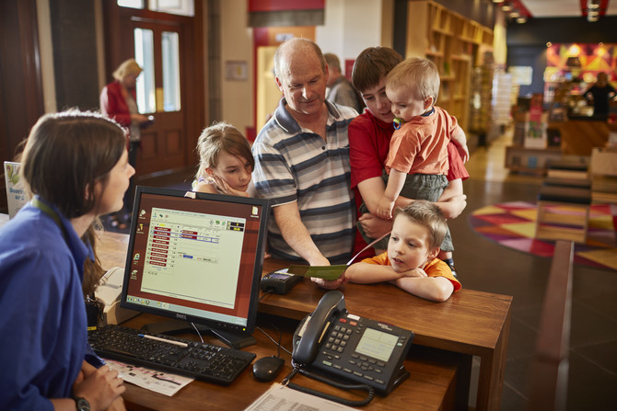

I might have to wait while my adult buys a ticket.
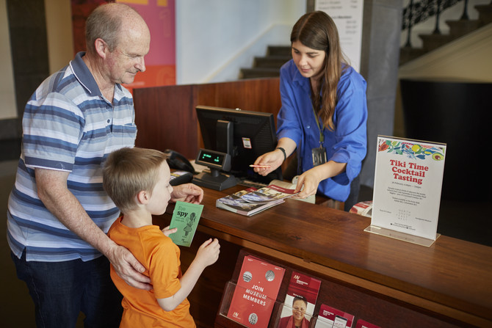

I will get a map and an activity booklet.
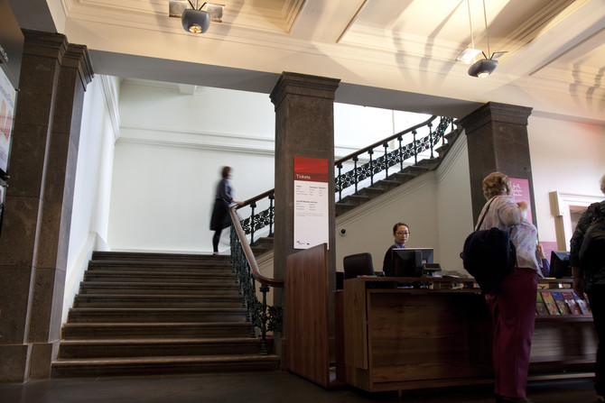

I might use the big stairs.
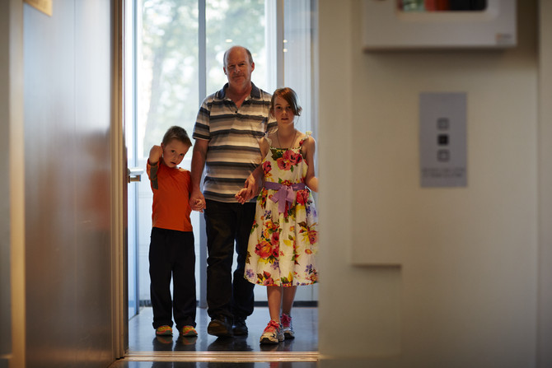

I might use the lift. The lift has a window and I can see outside. I will see that we are going up or down and I will know that I am safe.
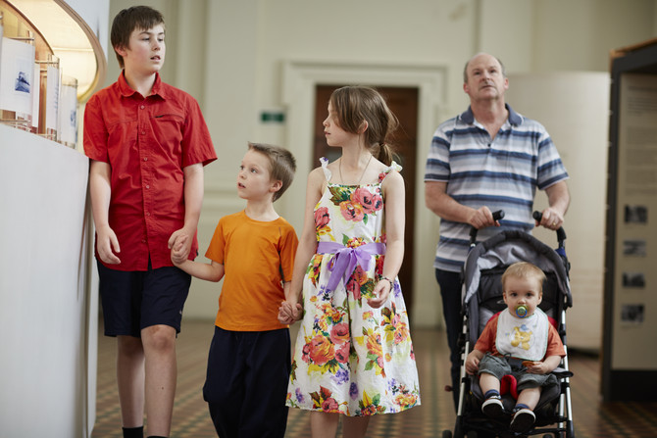

I will walk with my adult in the museum.
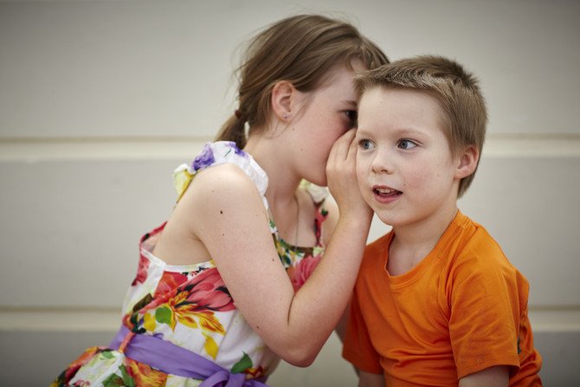

I will use my quiet voice in the museum.
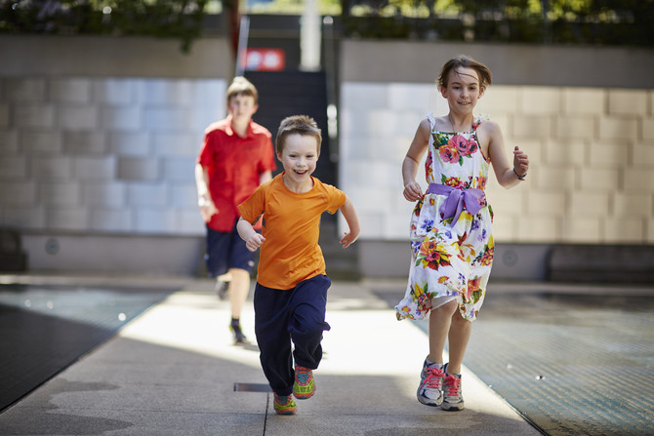

If I need to run around, my adult can take me to the courtyard. I will stay inside the gates.
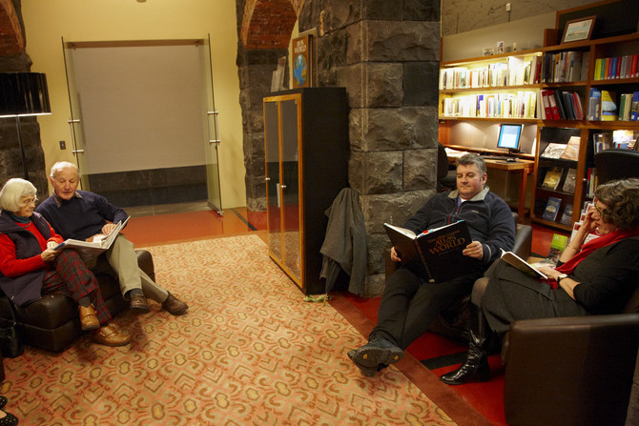

If I need a break, my adult can take me to the Discovery Centre. It is a quiet place with books to look at.
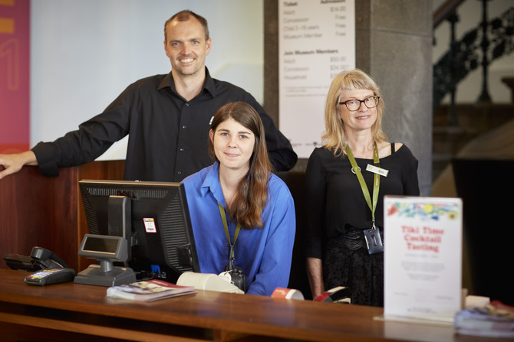

If I get lost I can ask a museum staff member for help. Museum staff members wear coloured straps around their necks.
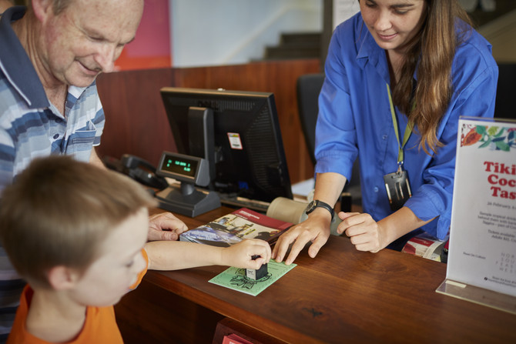

I can go to the ticket desk and get a stamp on my activity book.
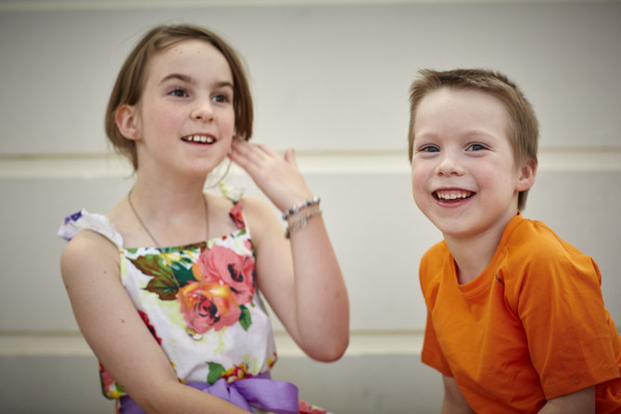

Going to the Immigration Museum will be fun.

