My School Visit to the Immigration Museum
This book belongs to:

_____________________________________________________

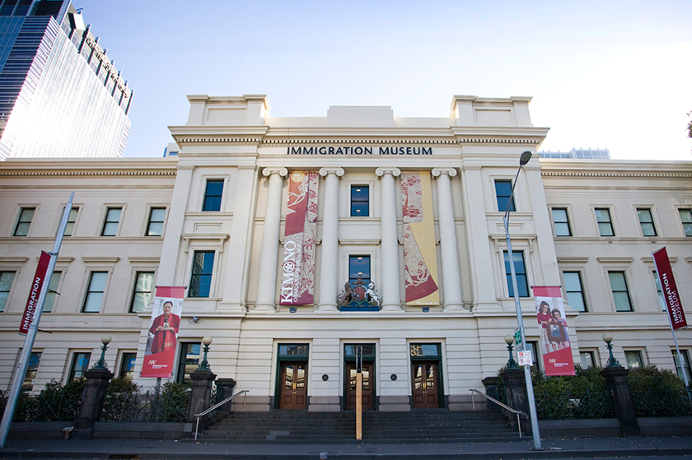

What is the Immigration Museum?
The Immigration Museum is a place with lots of information about Australia’s immigration history. There are lots of big and small things on display. I can find out why some people move to Australia from other countries. I can look, listen and learn at the museum.
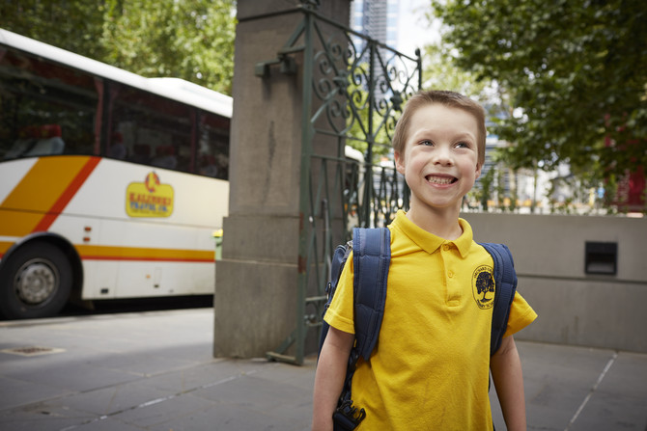

Arriving at the museum
I will arrive at the museum with my teacher and school group. We will go through a big gate at the back of the building.
I will have to wait with my teacher and school group in the courtyard before going inside the museum. That’s okay because I can talk to my classmates or look at the things around me. I will stay inside the gates near my school group.
If I need to go to the toilet, my teacher will show me where the toilet is. I will go to the toilet and wash my hands afterwards. Then I will go back to the courtyard where my school group is waiting.
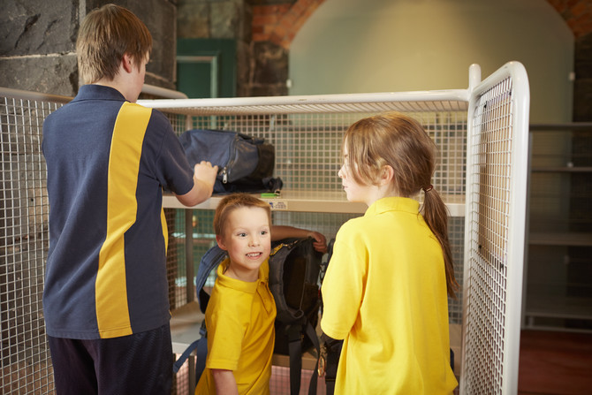

Going into the museum
My teacher will tell my school group when it’s time to go inside. A museum staff member will come and show my school group where to go. We will go into a room with glass walls and it might be noisy.
Then we will go into a room with walls made of stone and I will put my bag on a big metal trolley. The museum staff member will put the trolley away so I know my bag and all the things inside it are safe. I will get my bag back when my museum visit is finished.
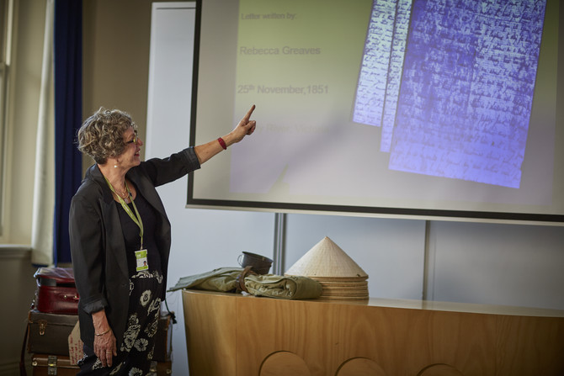

Special booked programs
My school group will go into the education room for a special session with a museum teacher. I will sit down on a blue mat or a chair. The museum teacher will talk to my school group. By listening to the museum teacher, I can learn more about people who have moved to Australia from other countries. I will sit as still as I can and I will not interrupt the person speaking. I can put my hand up if I want to answer a question. I might help unpack suitcases that have things inside them.
The museum teacher will give all the students an activity to do in the rest of the museum. If I need help with the activity, I can ask an adult.
We will go into small groups to look at the museum. I will stay with my group and we will look at the museum together. The adult with my group has a map and knows where to go.
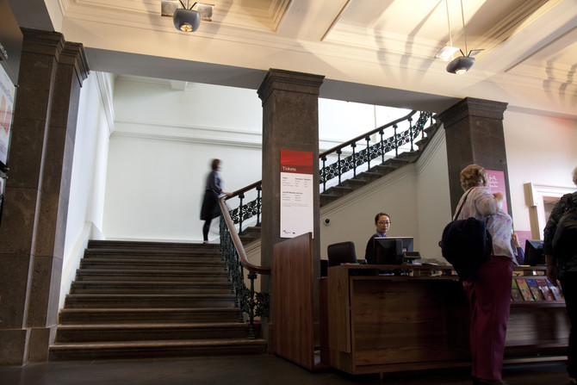

Stairs at the museum
My school group will use a big staircase with a high ceiling. I will walk slowly on the stairs, because walking slowly is the safest way. If I want to, I can hold onto the railing or touch the wall.

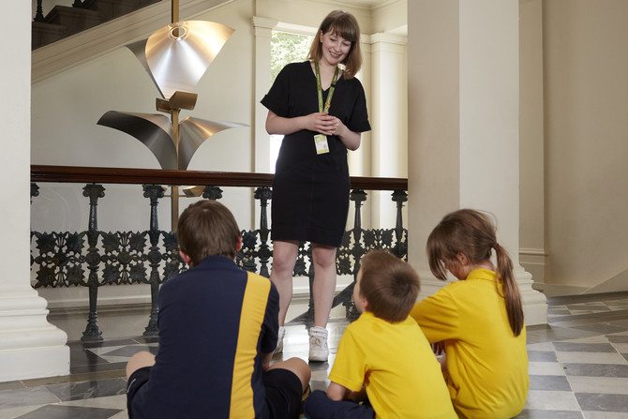

Inside the museum
I will sit on the floor with my school group and a museum staff member will talk to us. By listening to the museum staff member, I can learn more about the museum. I will sit as still as I can and I will not interrupt the person speaking. I can put my hand up if I want to answer a question. Then, the museum staff member will give all the students an activity to do. If I need help with the activity, I can ask an adult.
We will go into small groups to look at the museum. I will stay with my group and we will look at the museum together. The adult with my group has a map and knows where to go.
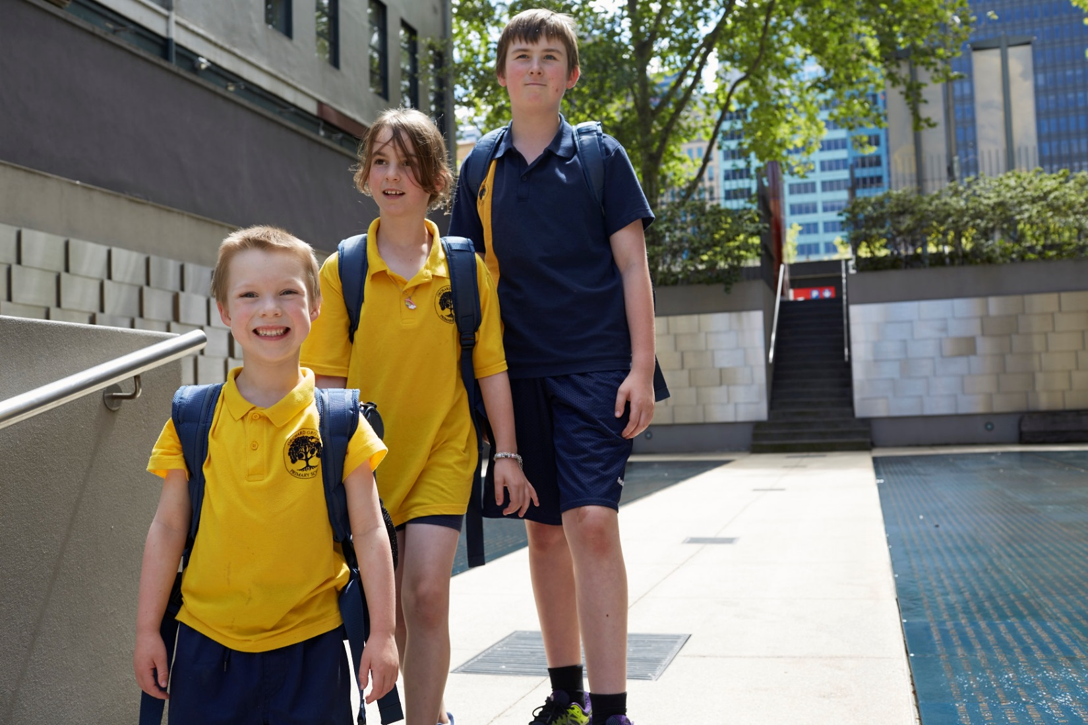

Different spaces at the museum
The Immigration Museum is a special building and inside it looks and feels different from home or school. Some rooms might be big or small. Some rooms might be dark or bright.
I will hear lots of different sounds at the Immigration Museum. I might hear music, people talking and animal noises.
If I don’t like being in an area, I will tell an adult and we can go out of the area together. Some areas I will enjoy more than others and that is okay.
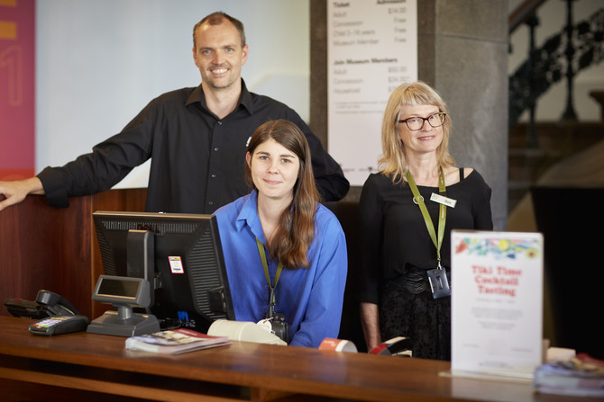

Staff at the museum
Many people visit the Immigration Museum and many people work there too. If I get lost, a museum staff member can help me. They wear tags on coloured straps around their necks.
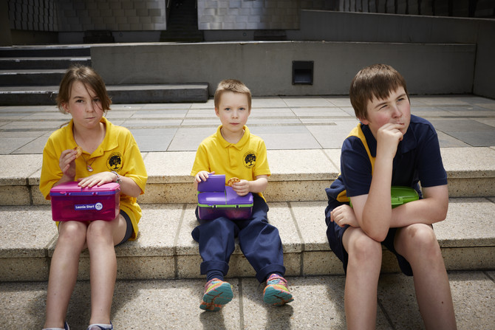

Food and eating at the museum
When it is time to eat, I will go with my school group to eat outside. If it is raining, my school group might eat in the room with glass walls. I will not eat inside the museum unless my teacher tells me I can.
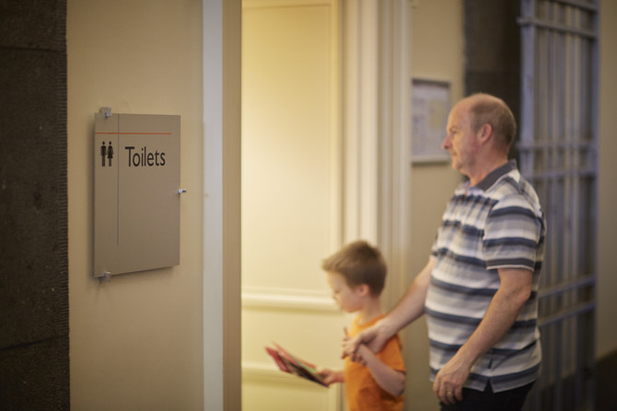

Toilets at the museum
If I need to go to the toilet I will ask my adult to take me there. There might be other people in the toilet, too. When I am finished using the toilet, I will wash my hands.
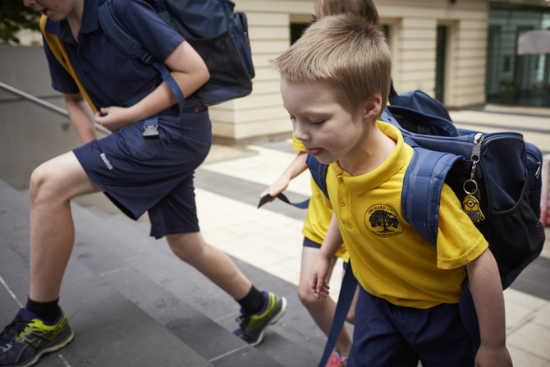

Leaving the museum
After we have done all of the things that my teacher has planned, my school group will walk down the stairs. I might go to the toilet or have a drink of water if I need to.
We will all go to collect our bags and I will wait while the museum staff member gets the trolley. I might need to wait while other students get their bags, but I will get my bag before we leave. After I have collected my bag, I will go with my school group and we will leave the Immigration Museum together.
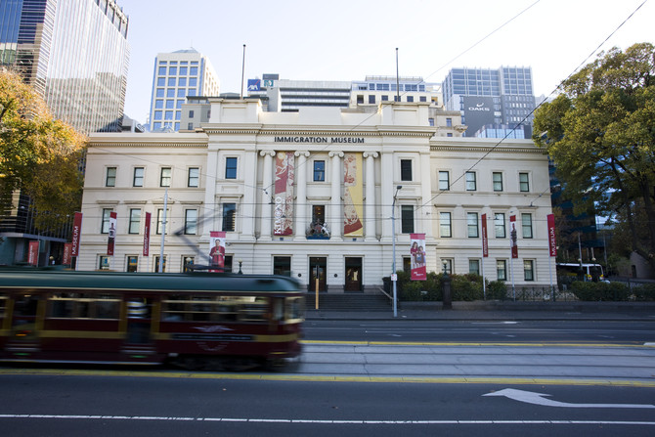

Important things to remember at the museum
When I am at the Immigration Museum I must remember to:
Stay with my school group
Speak with my quiet voice, even though it might be noisy
Take turns with other people
Wait patiently when I have to line up
Only touch objects I am told that I am allowed to

