SOCIAL STORY FOR OLDER CHILDREN

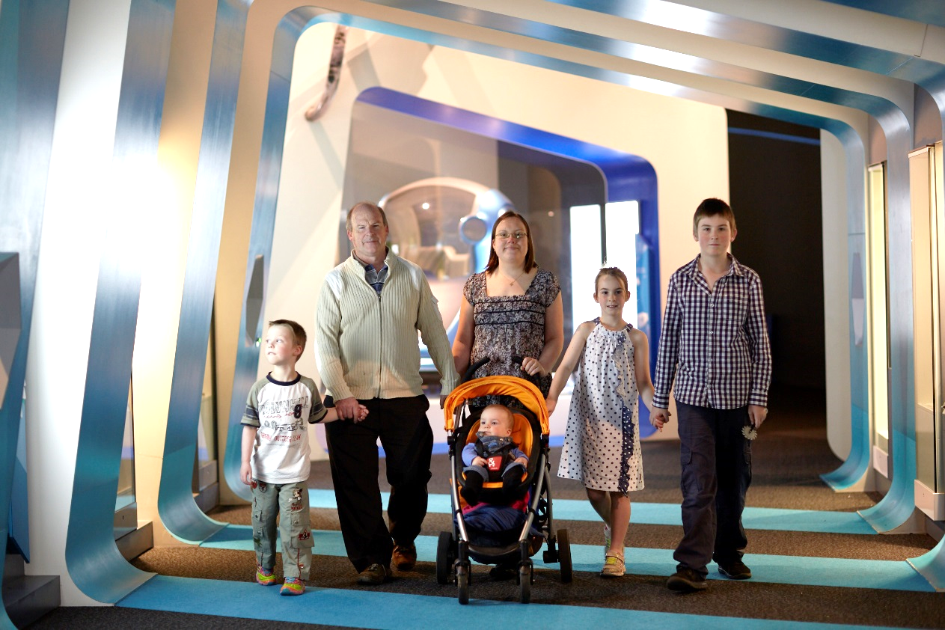

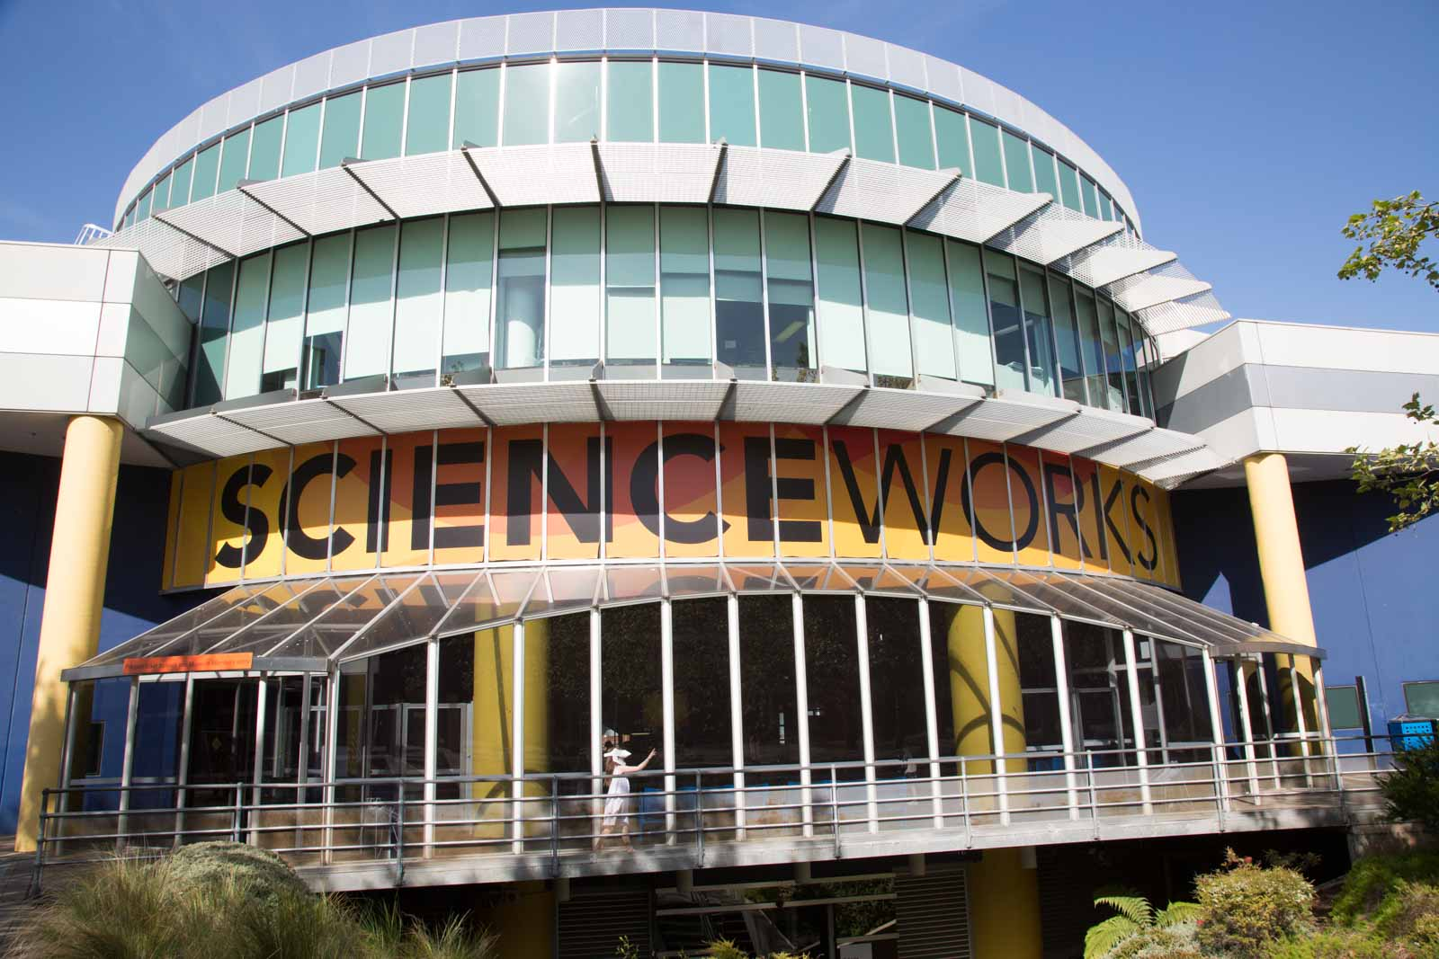

What is Scienceworks?
I am going to Scienceworks museum. I can explore and learn all about science and technology of the past, present and future.

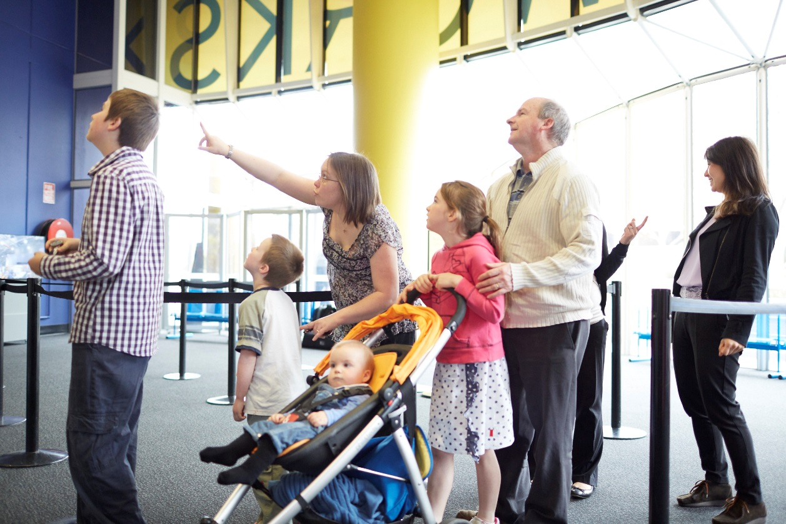

Getting tickets
I will enter the museum through automatic sliding doors. The air conditioning above the doors may blow down on me.
I might need to wait in line with my family to buy tickets. We can use this time to decide if we want to buy extra tickets to see any shows or special exhibitions.

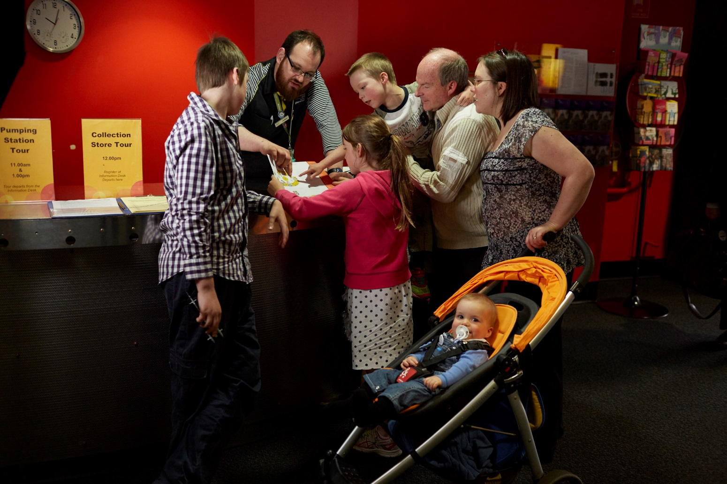

Finding out what we can do at Scienceworks
I can get a map of Scienceworks and find out what I can see and do.
I can store my bag at the information desk, and when it’s time to leave I can pick my bag up.
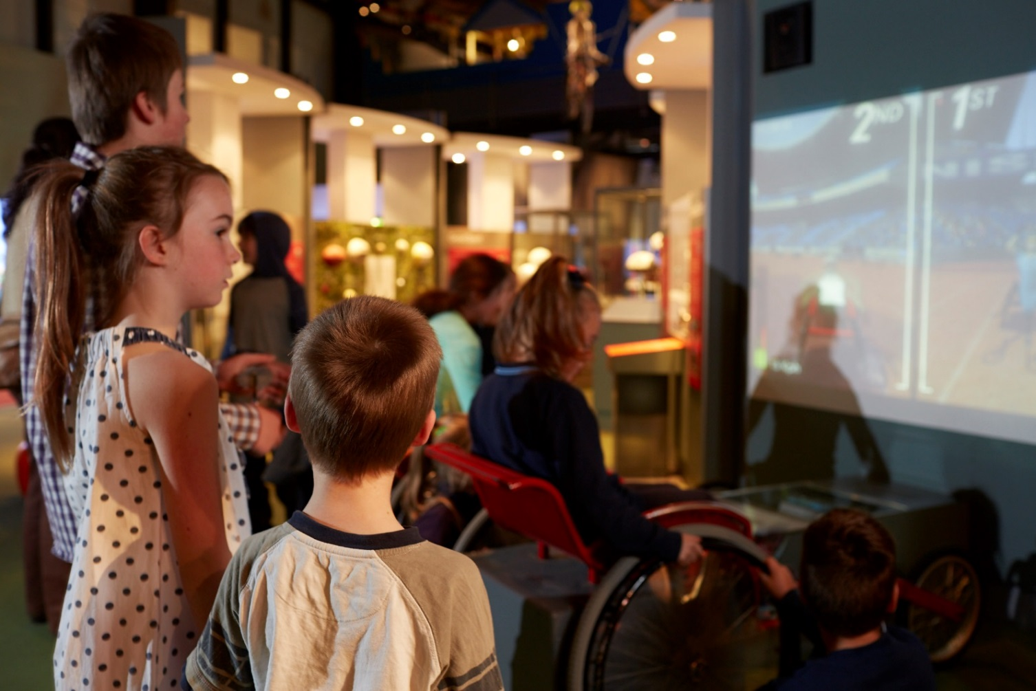

Exploring Scienceworks
There are lots of exhibitions to visit at Scienceworks.
Sometimes there are lots of people and it can be noisy.
I might need to wait in line to see things, touch things and do things at Scienceworks. I might not have time to see everything.
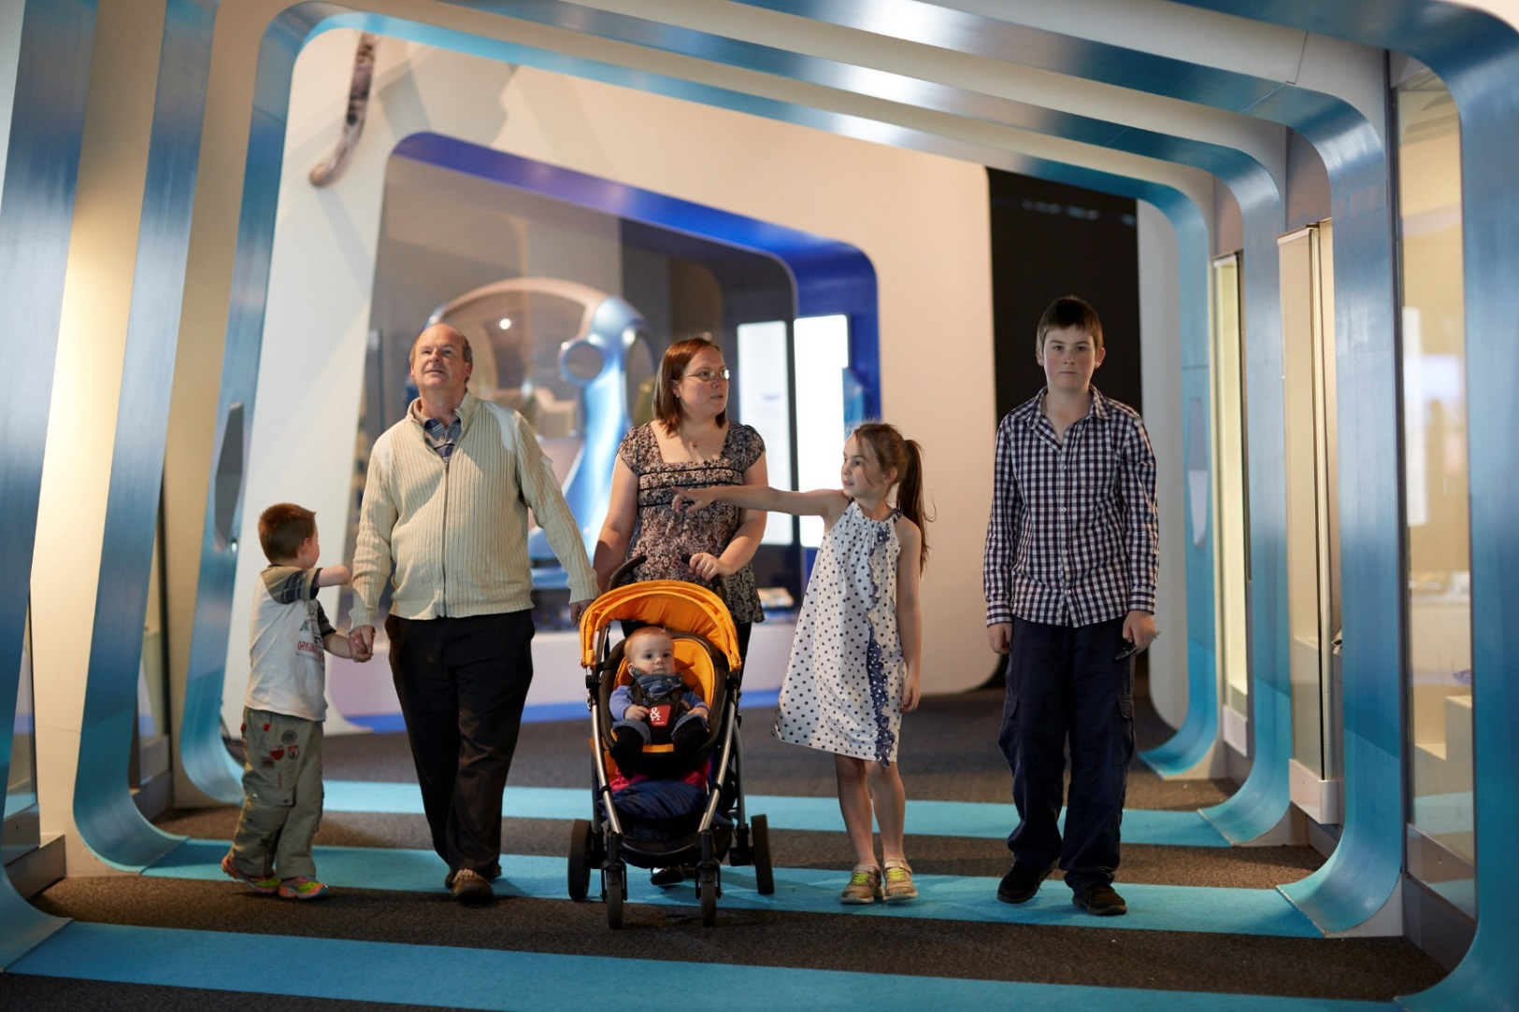

Staying with my family
It can be exciting at Scienceworks. I will do my best to stay calm, speak in a quiet voice and walk inside the museum.
I will stay with my family while I am visiting Scienceworks
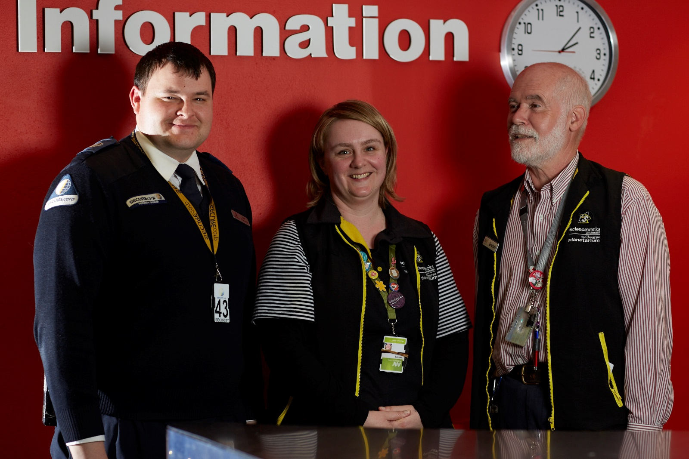

Staff who can help
If I am lost or have a question, staff at Scienceworks can help me. They wear uniforms and straps around their neck.


Quiet spaces
There are quiet places at Scienceworks where I can relax with my family. I can find these on the Sensory Map.

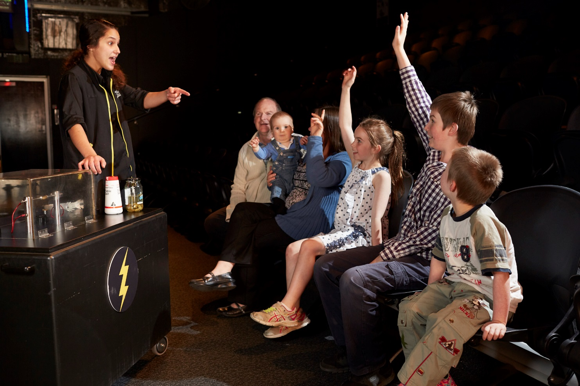

Seeing a show
I might see a special show in the planetarium, lightning theatre or amphitheatre. There may be a lot of people, loud noises and it may be dark. I might feel a bit scared but it will be okay because I will be with my family.
I will stay in my seat to watch and learn. If I put my hand up when asked, I may get chosen to answer questions or come to the front as a helper. If I have more questions, I can talk to the presenter after the show is over.
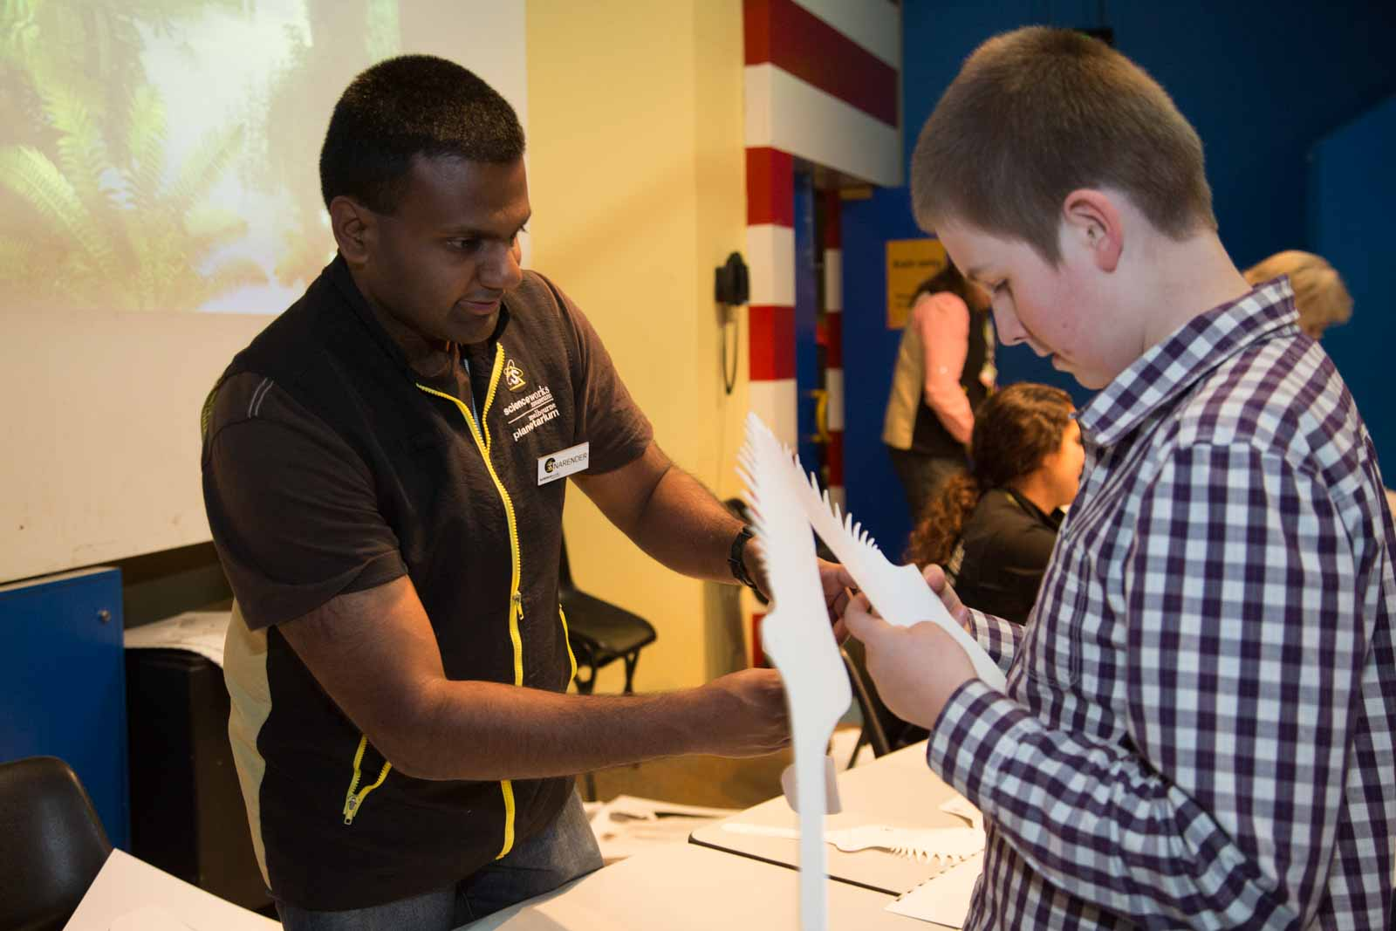

Activities at Scienceworks
Sometimes there are activities at Scienceworks. I might make something or do an experiment. I will listen and follow instructions by Scienceworks staff. My family can help me with this activity.

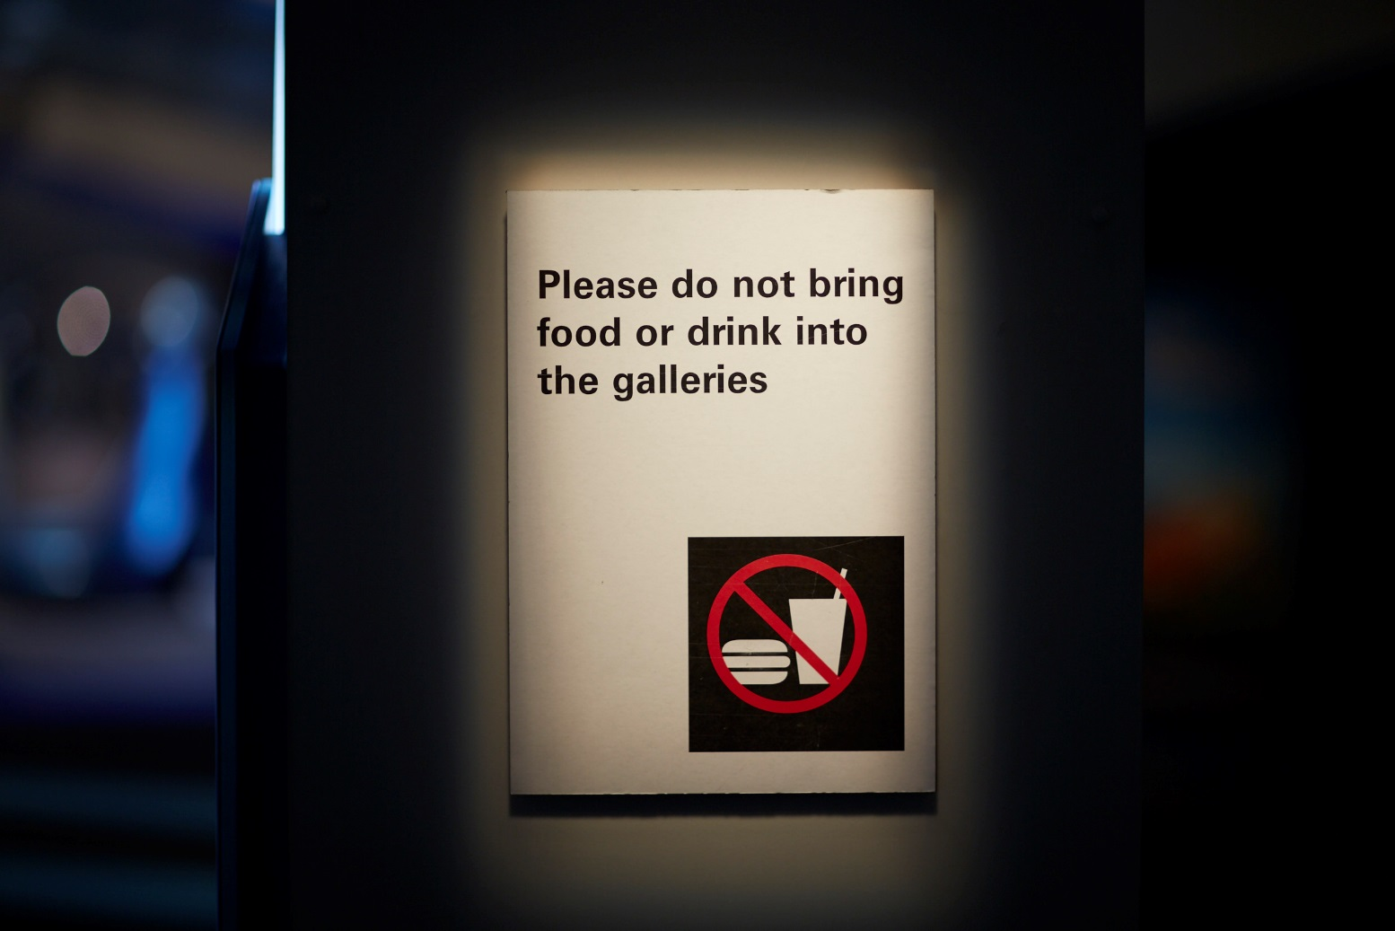

Food and eating at Scienceworks
There are special areas where I can eat and drink at Scienceworks. Food and drink are not allowed in the galleries.
If we bring food from home, I can eat it anywhere outside, in the foyer area or on the lower ground floor.
There is a café at Scienceworks. If we want to buy food, I might need to line up. The café may be busy inside.

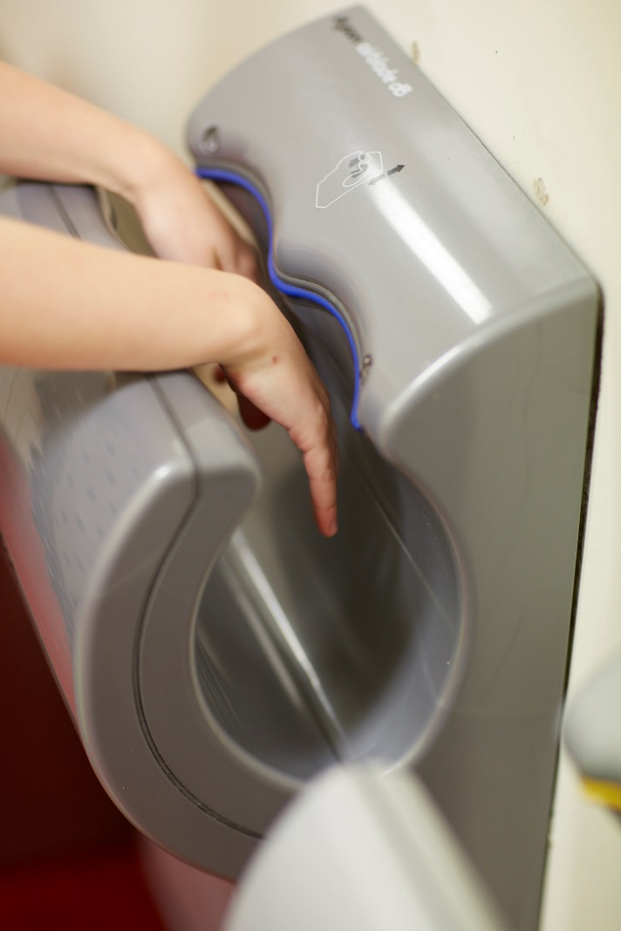

Toilets at Scienceworks
To find a toilet, I can look for signs, check the map or ask a staff member.
The hand dryers are noisy but they dry hands fast.

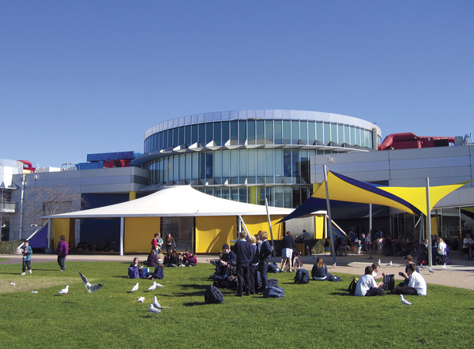

Outside spaces
Outside, I can sit on the grass with my family and other families and explore the playgrounds.
I can see the sundial outside the Planetarium or walk down to the Pumping Station.

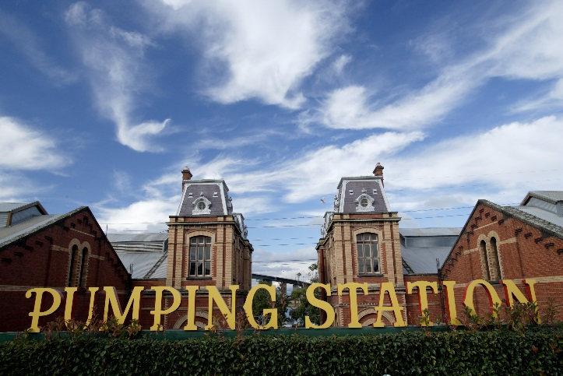

Spotswood Pumping Station
The Pumping Station is an old building that used to pump sewerage. I can explore the Pumping Station and old steam engines with my family. Sometimes it can be dark and smell strange.
I can enter at the yellow doors and go down the long ramp to the Boiler House. I can also get there using the stairs to the right of the Pumping Station sign.

