Sensory Friendly Road to Zero
At Melbourne Museum
SOCIAL STORY FOR SCHOOL VISITS

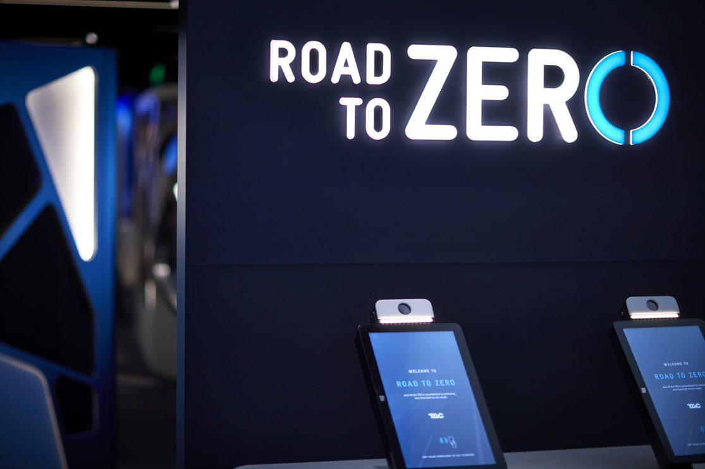

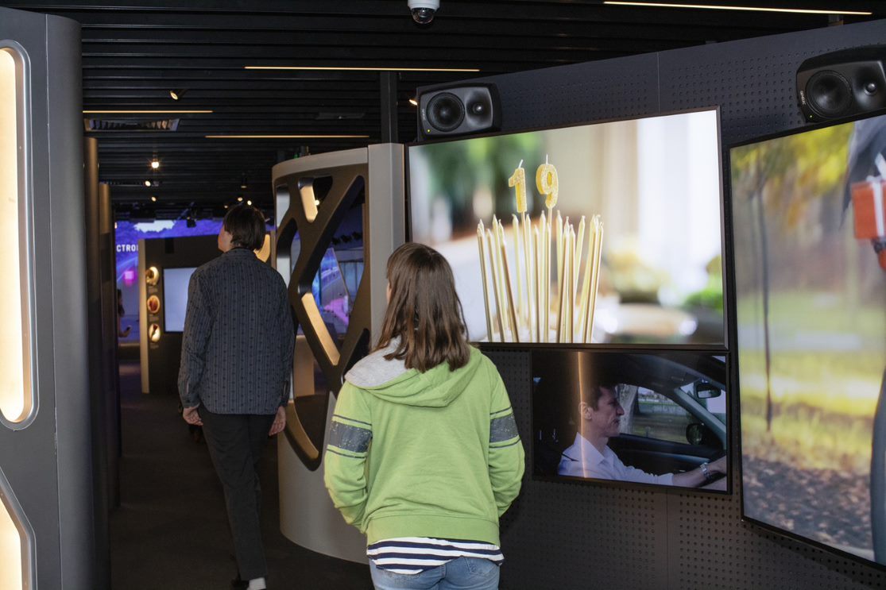
What is Road to Zero?
I am going to the Road to Zero learning centre at Melbourne Museum. At Road to Zero I will explore and learn about road safety. My visit will include a look around the Road to Zero exhibition called the Experience Space, and a lesson in a classroom with a Road to Zero teacher.
There will be many screens with images and sounds. These will explain how people can stay safe when using the roads. I will be safe. I can look, listen and learn at Road to Zero. I will tell my teacher if I need some quiet time.
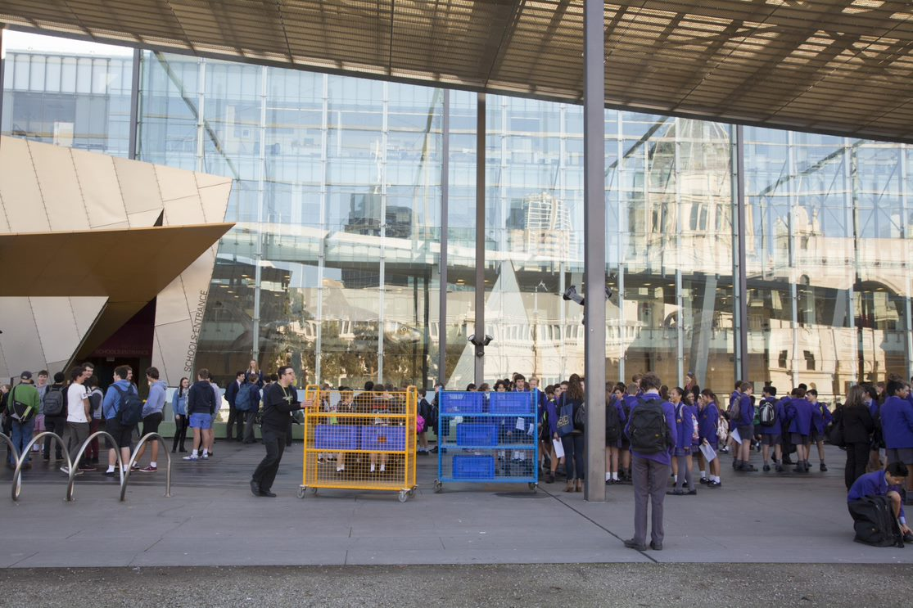
Arriving at Road to Zero
Before I enter the museum, my teacher will go inside the school’s entrance to get the program for the day. The class may have to wait outside.
My bag will be put on a trolley so that I don’t have to carry it around the museum. Someone will look after it and my things will be safe. I will get my bag back later.
I will stay with my class as someone who works at the museum takes us inside.
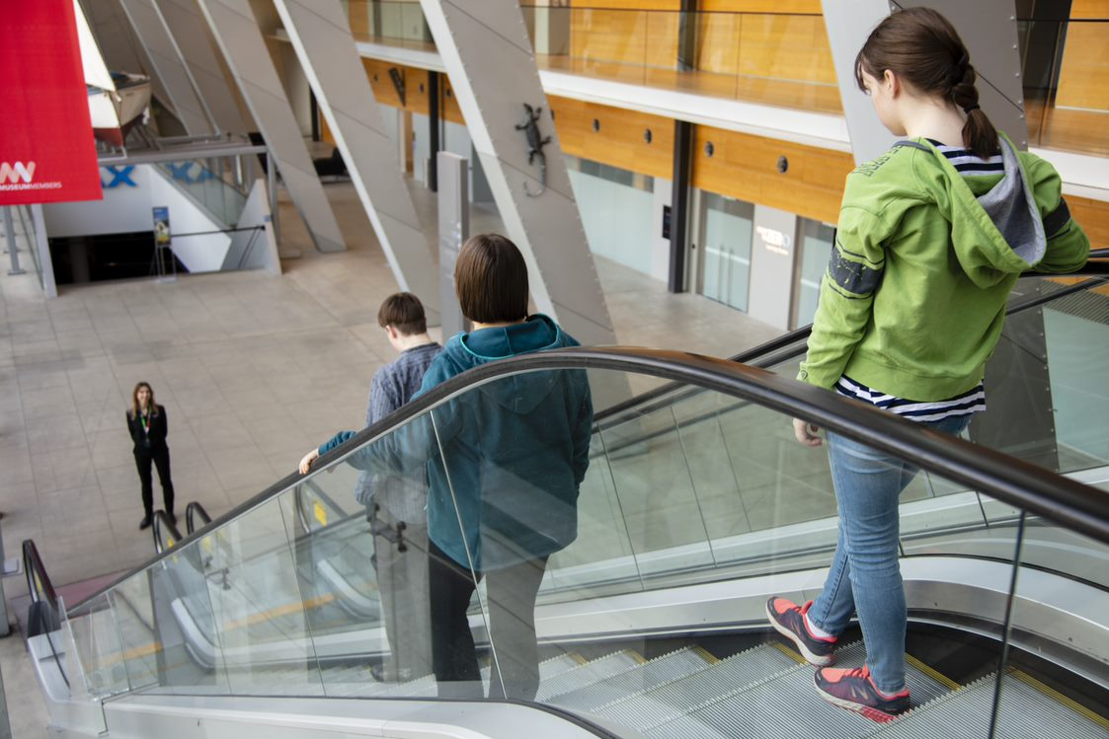
Going into the museum to the Road to Zero learning centre
I will go through big glass doors into the museum. The museum is a big building with large open spaces.
I will then go down the escalators to get to Road to Zero. I will stay with my teacher and group as I go on the escalators, and I will hold on to the rail.
A Road to Zero teacher will meet us at the bottom of the escalators and tell us where to go.
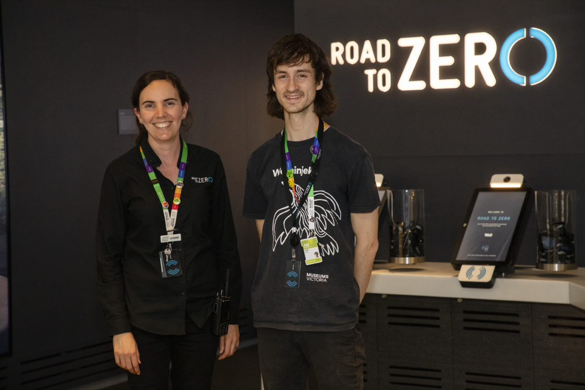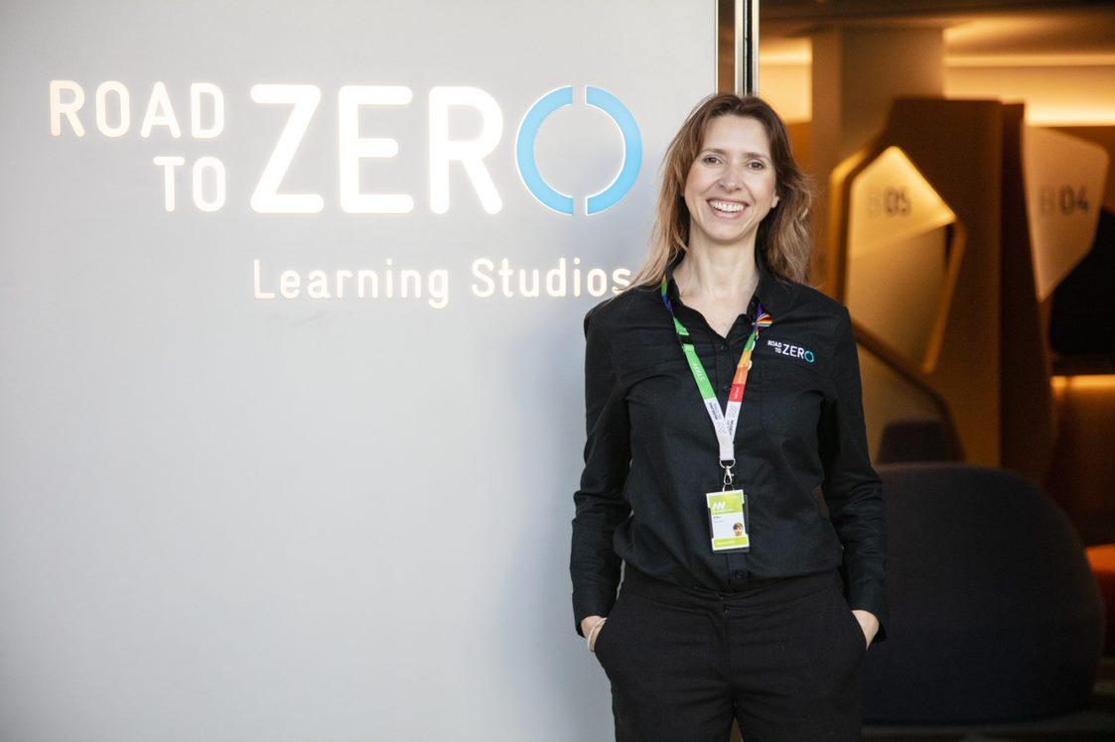
Staff at Road to Zero
A Road to Zero teacher will be with my group when we are in the exhibition and during the classroom lesson. There are also lots of other staff at the museum that I can get help from. Road to Zero and museum staff are easy to see because they wear black shirts and have coloured lanyards around their neck.
I can ask these people for help if I get lost.

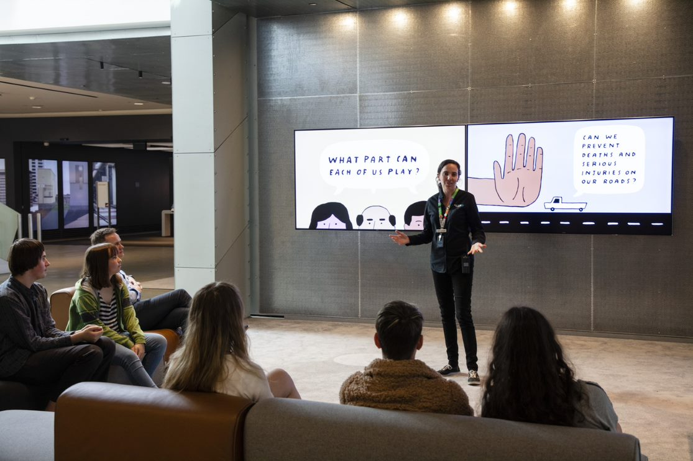
What will I be doing at Road to Zero?
There are three main spaces at Road to Zero. My teacher knows what we are going to do and when. I will be at Road to Zero for about 2 and a half hours.
I will not be able to eat or drink in any of these spaces, but there will be a break time when I might have a snack or my lunch, and go to the toilet. My teacher will tell the class when this will be.
In the lounge area, I will sit and listen to the Road to Zero teacher for about 15 minutes. I will see a short video, and I might answer some questions.
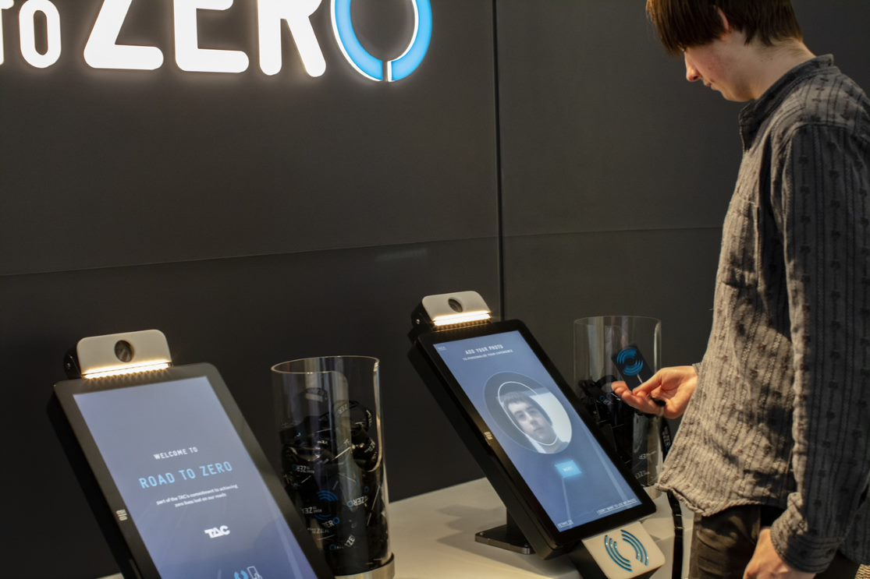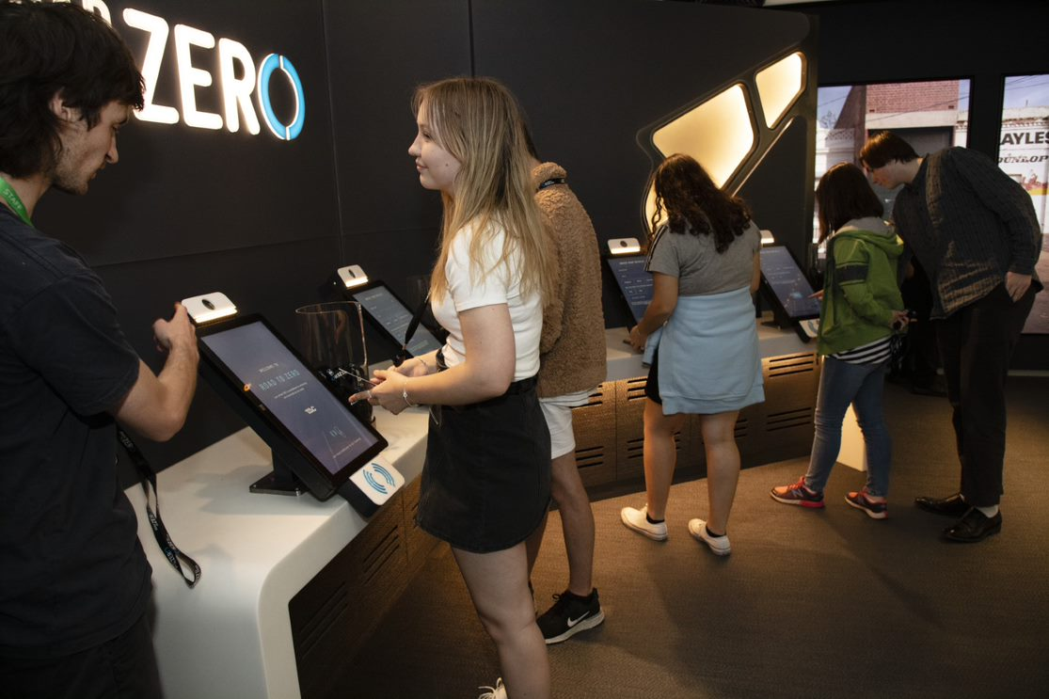
Logging in to the Experience Space
My class will spend about 30 minutes exploring the Road to Zero exhibition.
I will get my own lanyard with a card, and will use this to enter my details into a computer, including my email address. My personal details will be safe. My teacher, or the museum staff, can help me log in.
I will wear the lanyard while at Road to Zero.
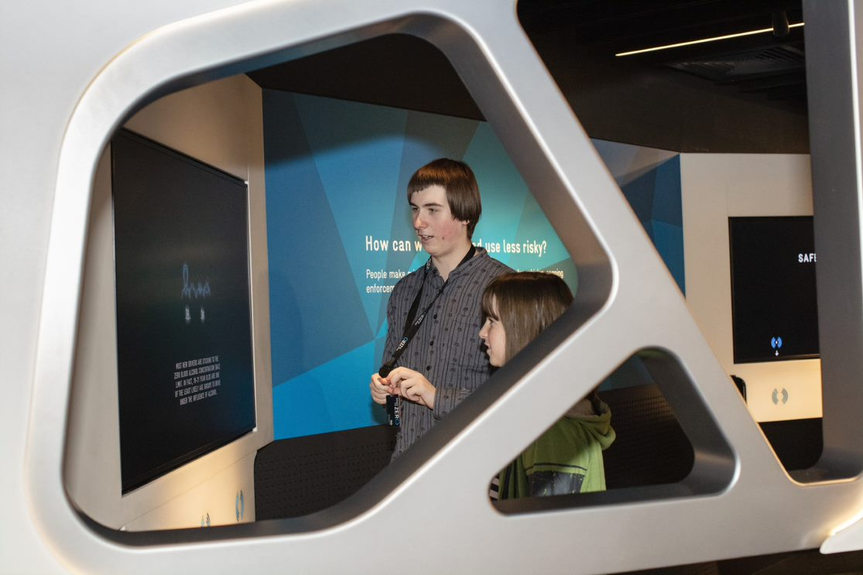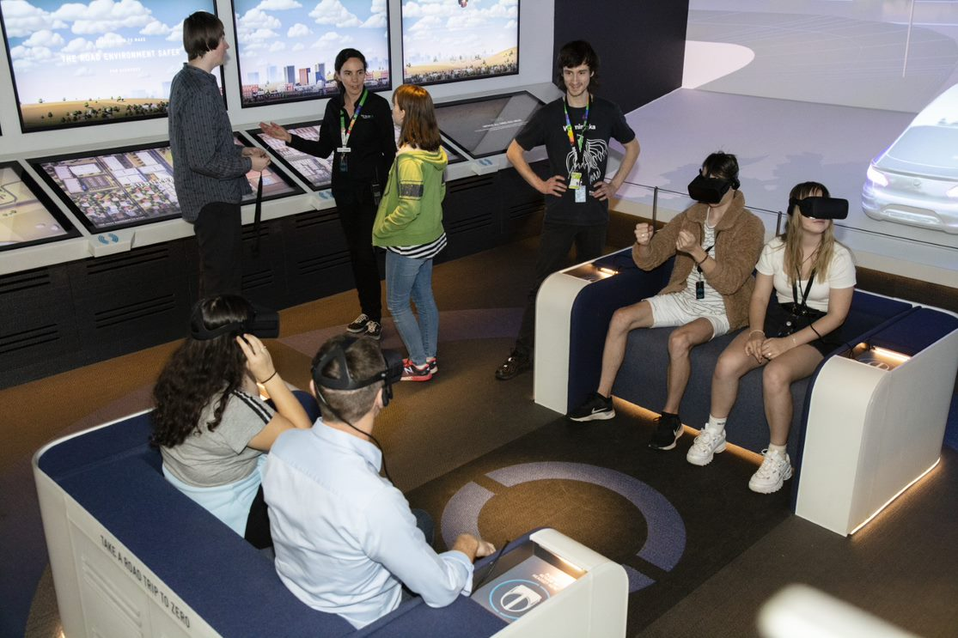
Exploring the Experience Space
In the exhibition there are some dark spaces, some light spaces, and some smaller spaces I can walk into to do activities. My teacher will be able to see me the whole time.
There are different technologies in this space. I can touch big screens to interact with them. If I do the virtual reality activity, I will wear goggles on my head. I do not have to do anything that makes me feel uncomfortable, but everything will be fun.
It may be busy at times and I might have to wait to do some activities.
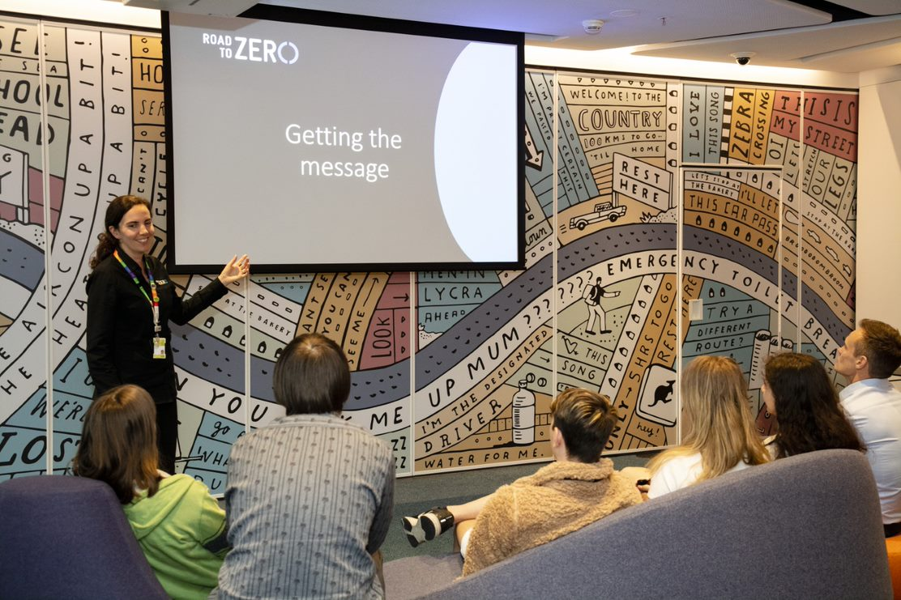
The Learning Studios
My class will have a lesson and someone from Road to Zero will talk to us. I will get to sit down on comfortable couches and listen to the person talking. I can put my hand up if I want to ask questions or if I have an answer to a question.
I will work in a group with my classmates to do an activity on touch table computers.
The doors to the classroom will be closed. If I need to leave I can ask my teacher.
The program will be 75 minutes.
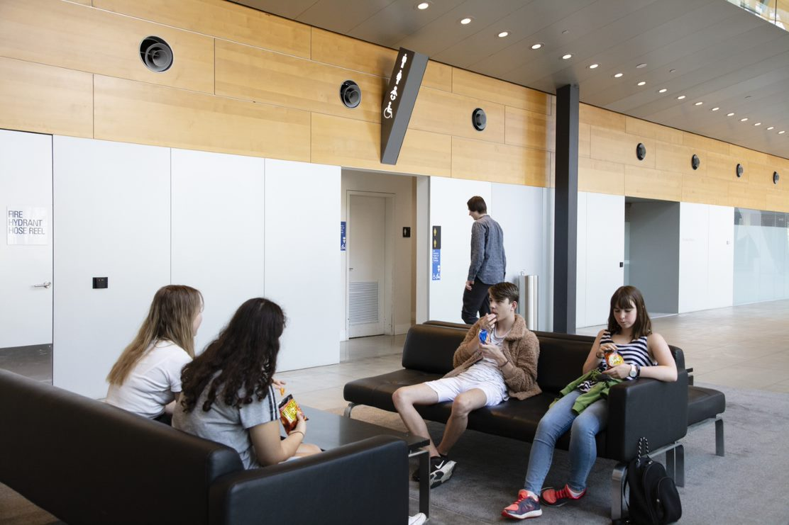
Breaks and eating at the museum
I will have a chance to have a break. My teacher will tell me when I can eat and when I can get my food from my bag. We might have a break inside or outside the museum. I need to listen to my teacher’s instructions so I know when I need to finish the break and re-join my class.
There are lots of bathrooms in the museum. There might be other people in the bathroom too. There are hand dryers in the bathrooms. Some people use them after they wash their hands, but I do not have to use them.
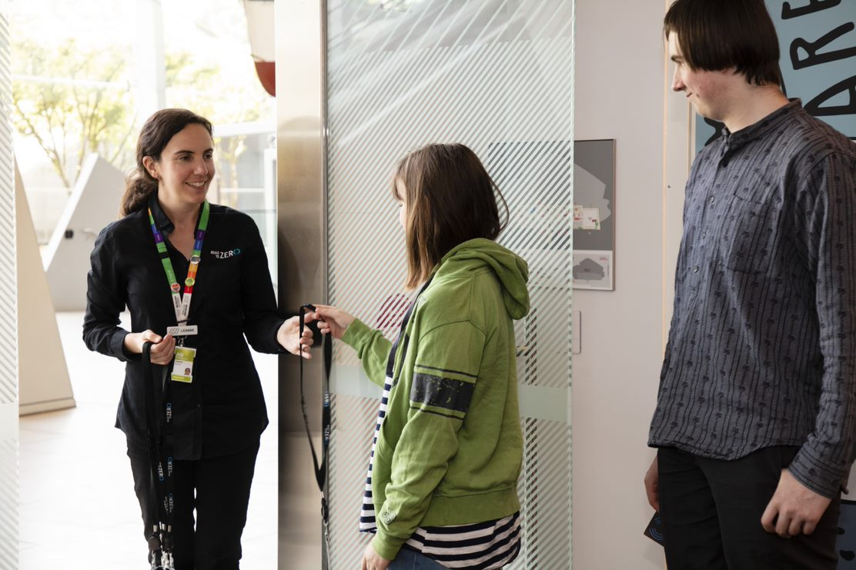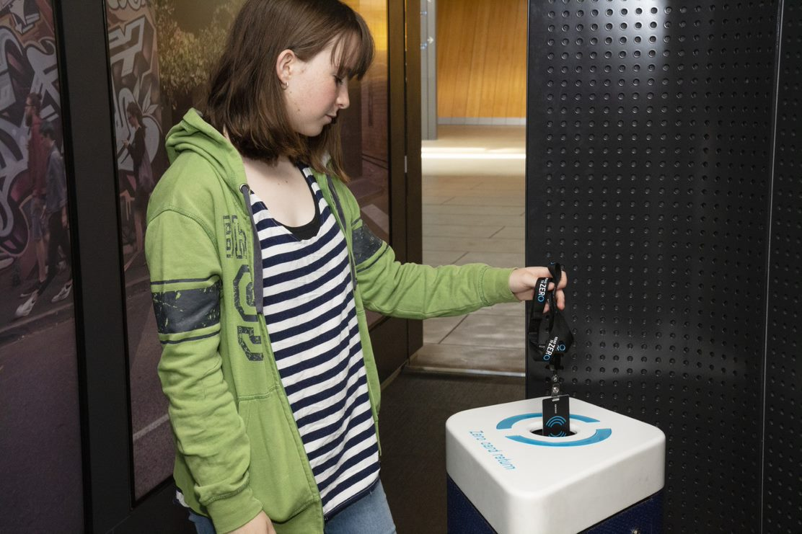
Leaving
Before I leave Road to Zero I will return my lanyard.
After we have done all the things that our teacher has planned, we will go to collect our bags from the school’s entrance.
My work will be emailed to me so I can look at it back at school.

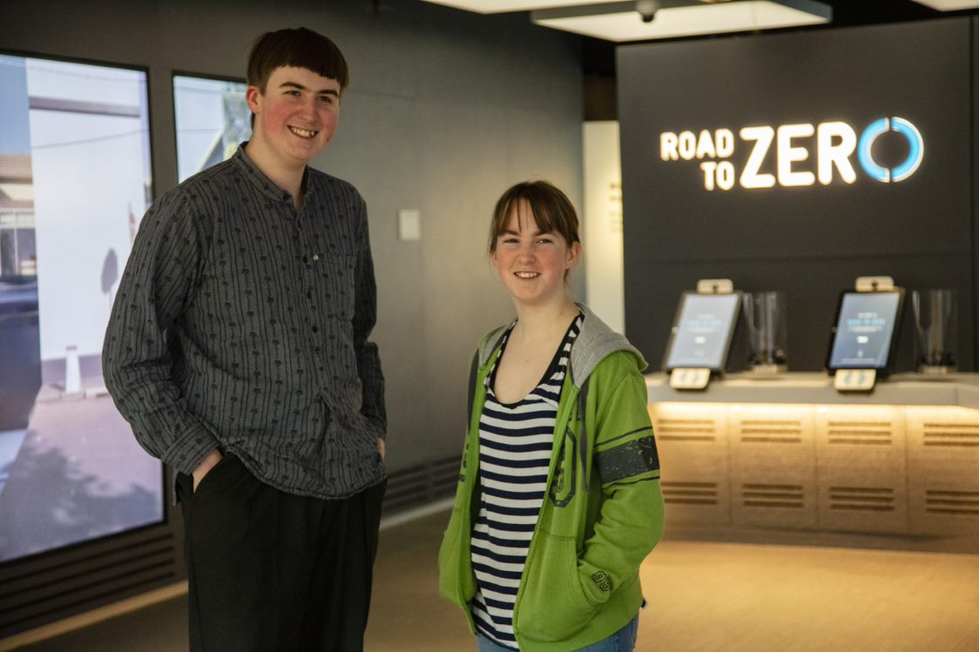
When I visit Road to Zero at Melbourne Museum I must remember to:
- Follow the adult who is leading my group
- Stay close to my group
- Walk and not run
- Speak with my quiet voice, even though it may be noisy
- Take turns with other people
- Wait patiently when I have to line up

