Pauline Gandel Children’s Gallery at Melbourne Museum
Social Story for families with young children

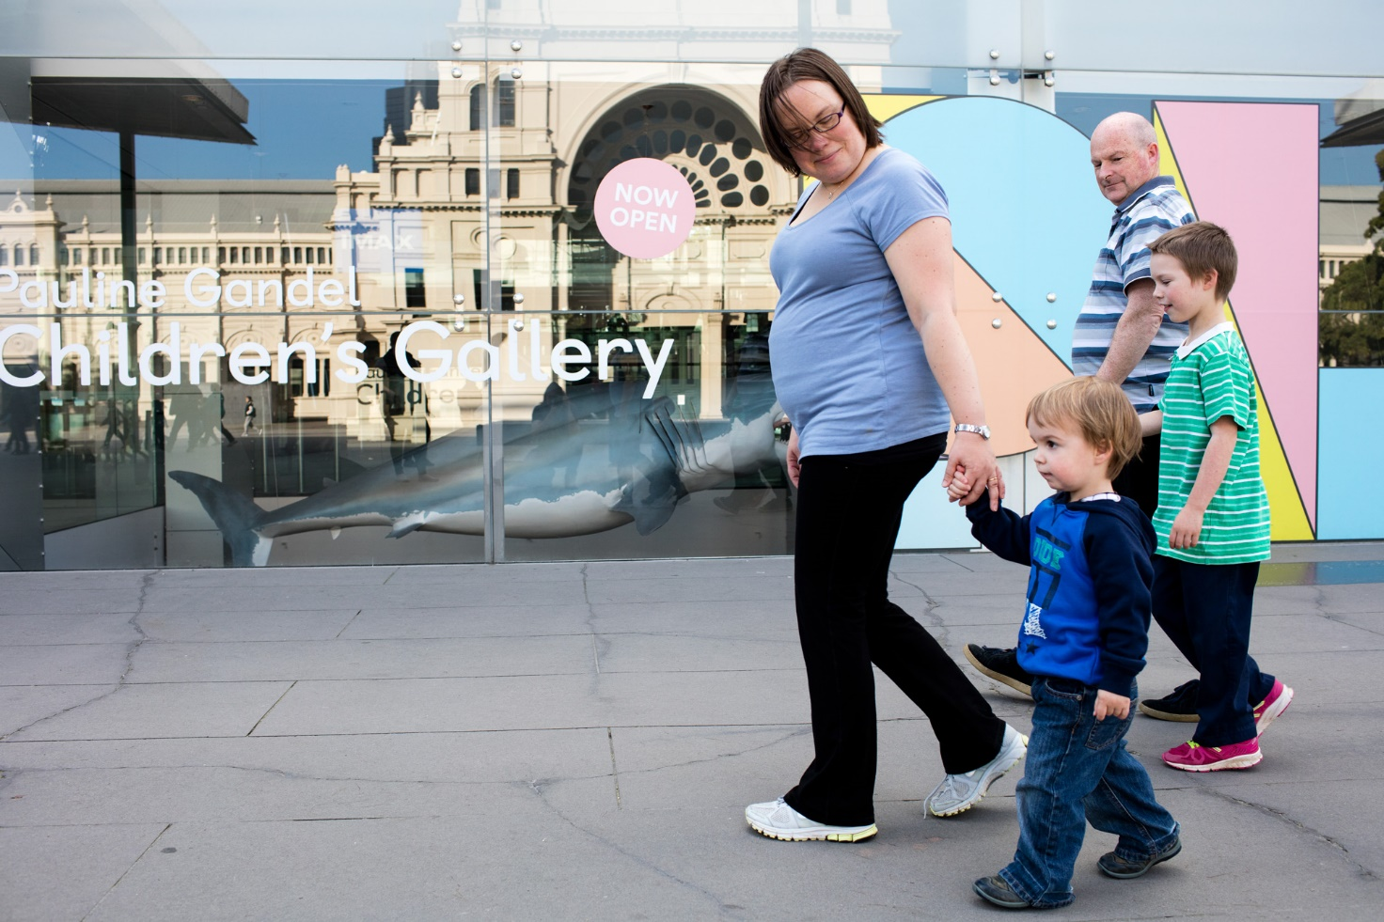
I am going to visit the Children’s Gallery at Melbourne Museum.
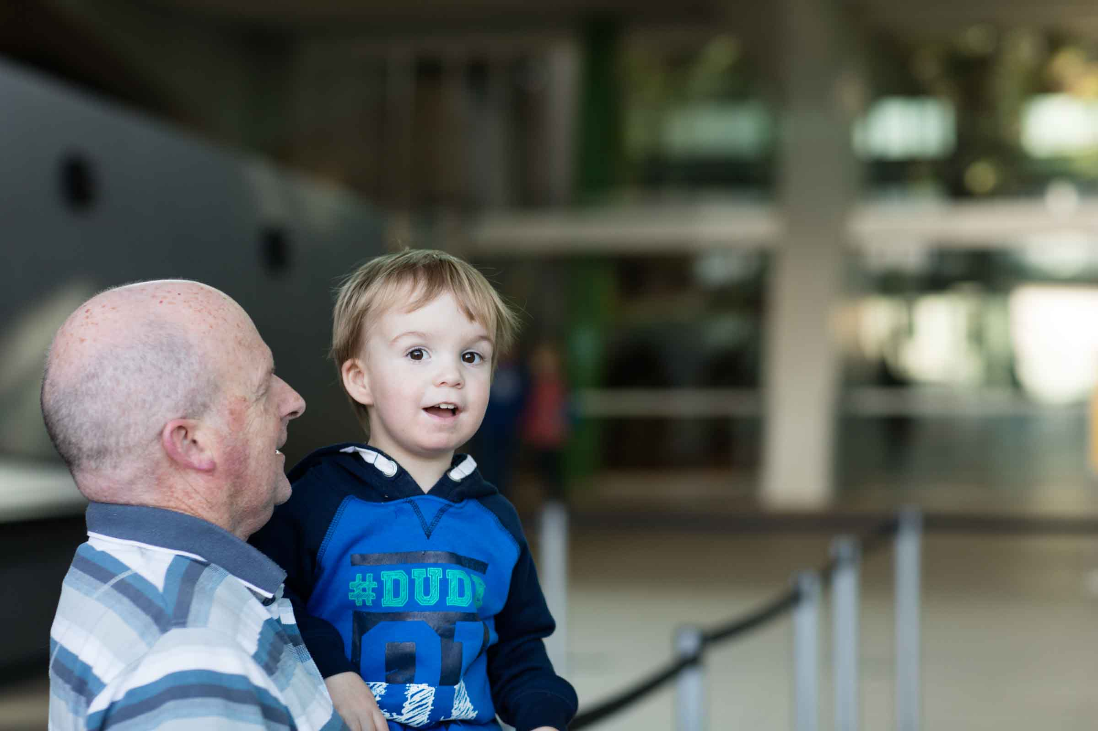
I will see, hear and do many different things during my visit.
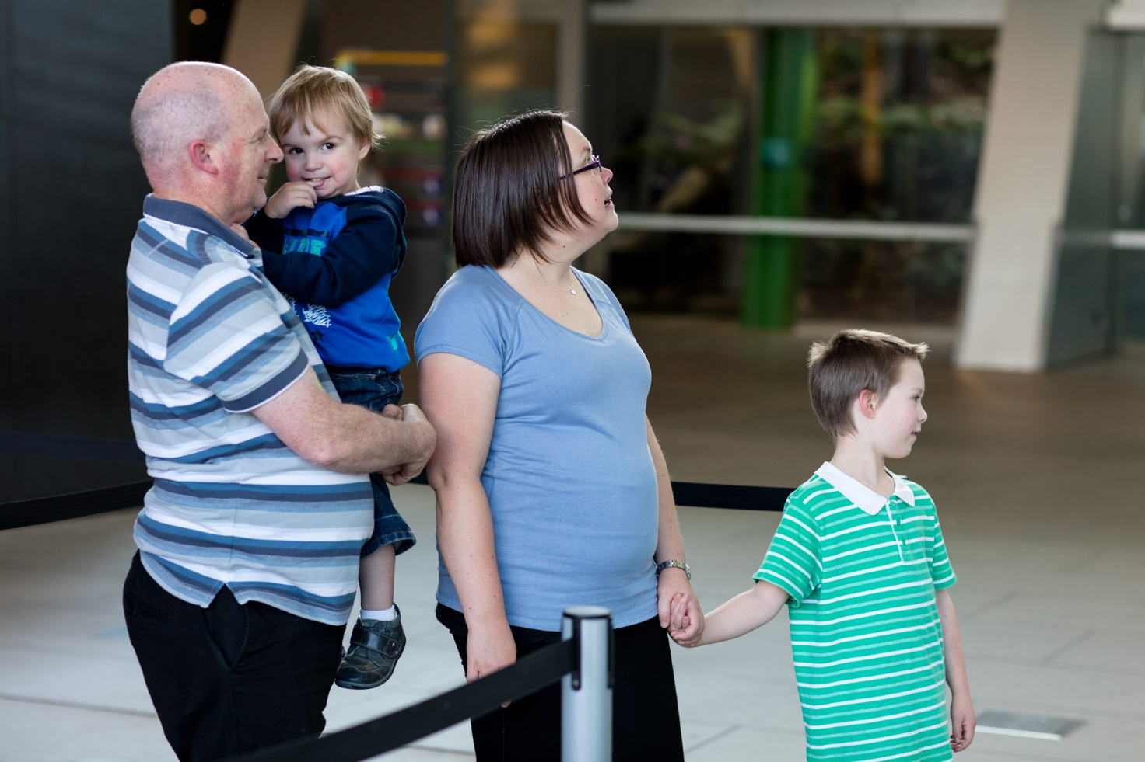
I might have to wait with an adult to buy the tickets to go inside the museum.
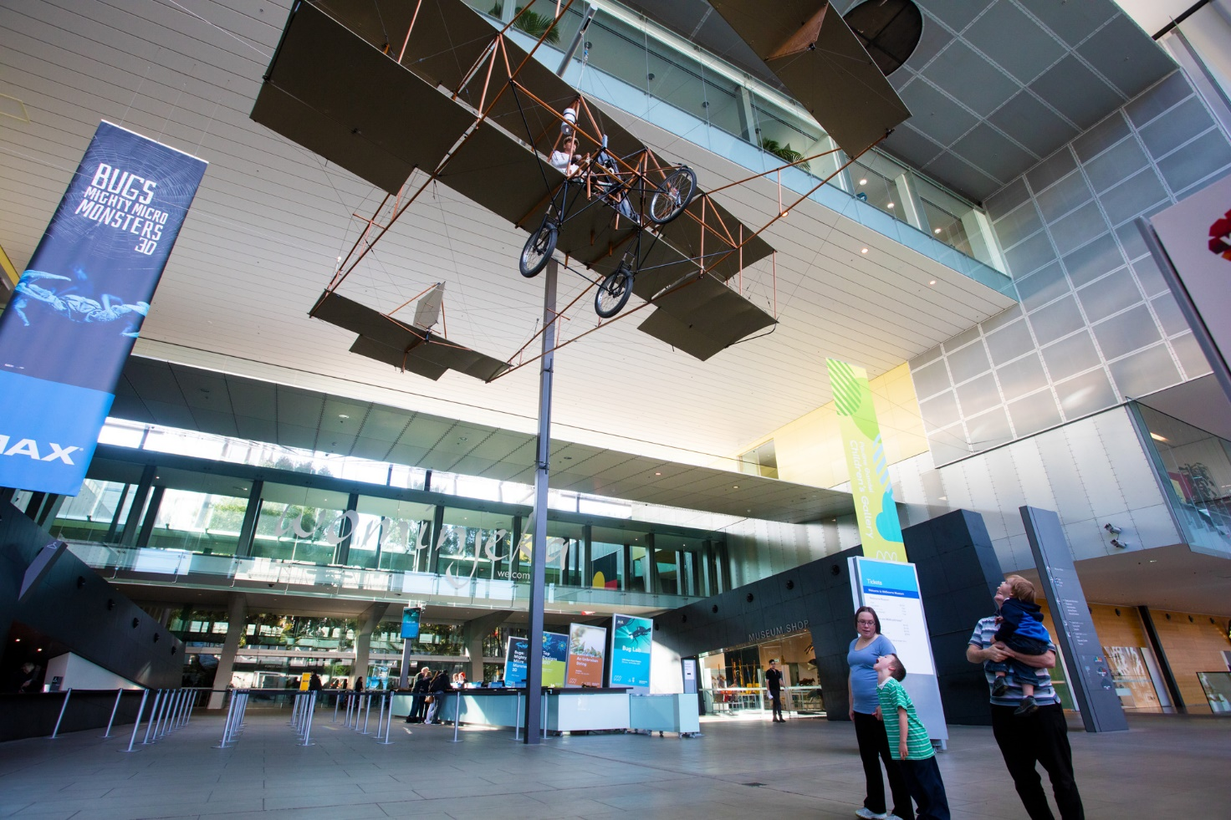
I will see lots of things hanging from the roof. They will not fall down.
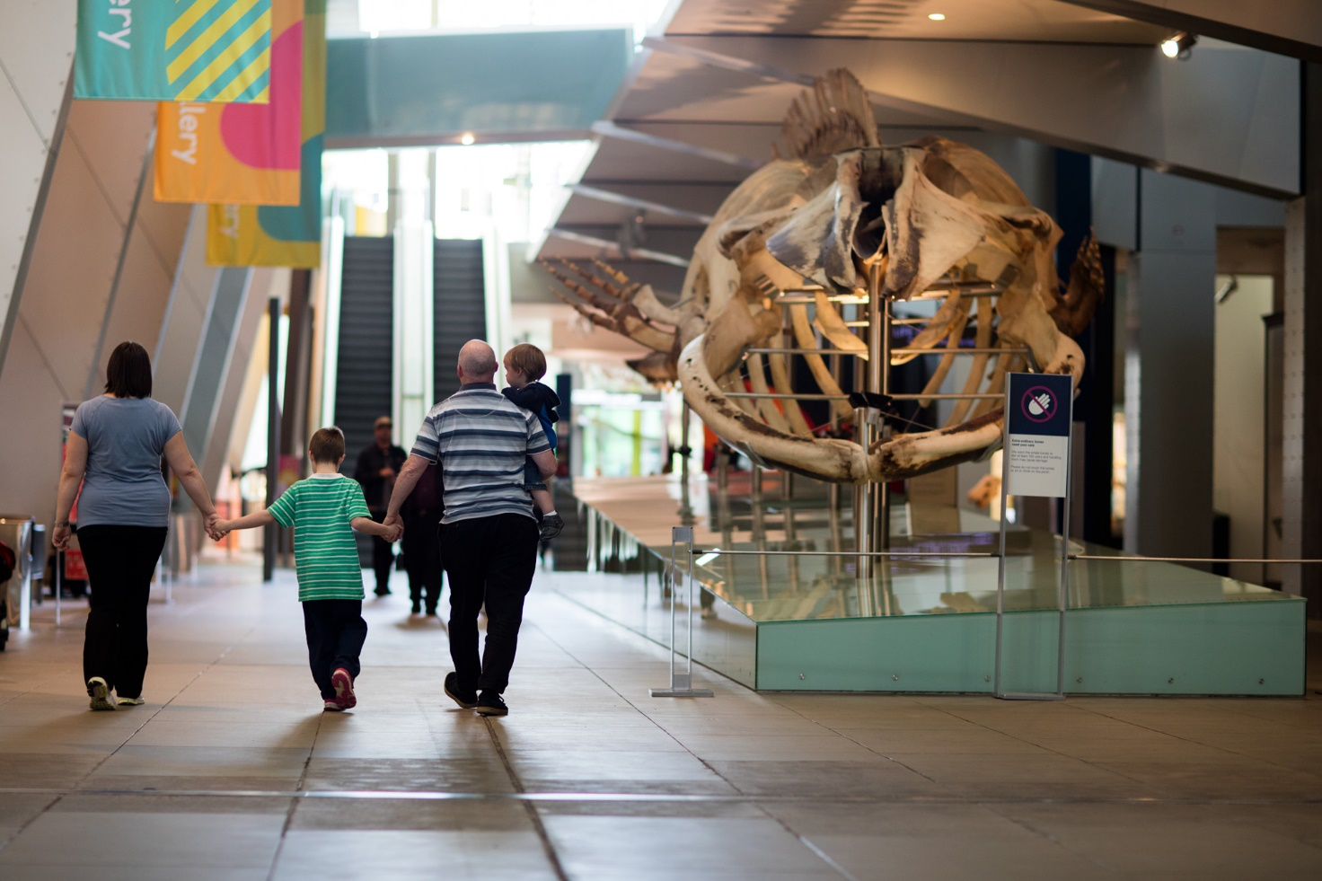
To get to the Children’s Gallery I will walk past the very big Pygmy Blue Whale skeleton.
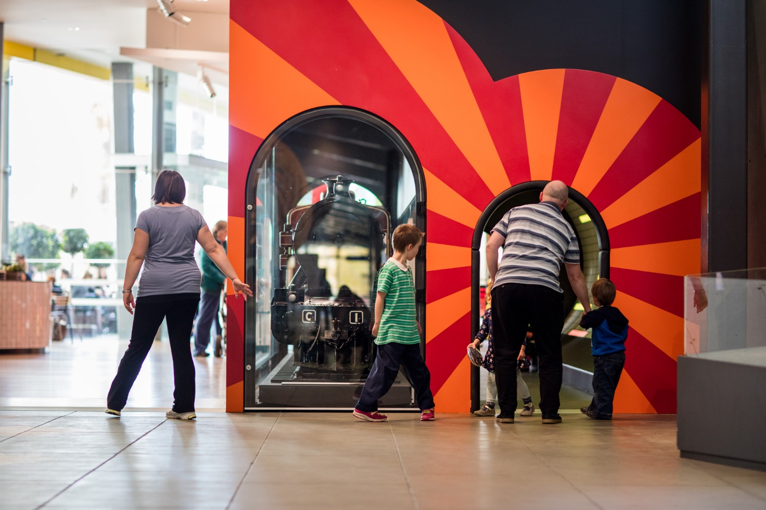
I will see a train at the entrance to the Children’s Gallery.
I can go into the tunnel next to the train or walk around the outside of the train.
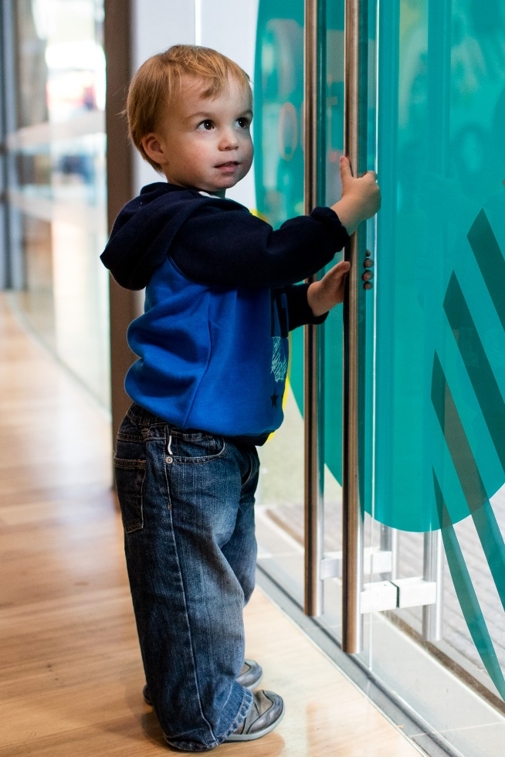
There are indoor and outdoor areas in the Children’s Gallery.
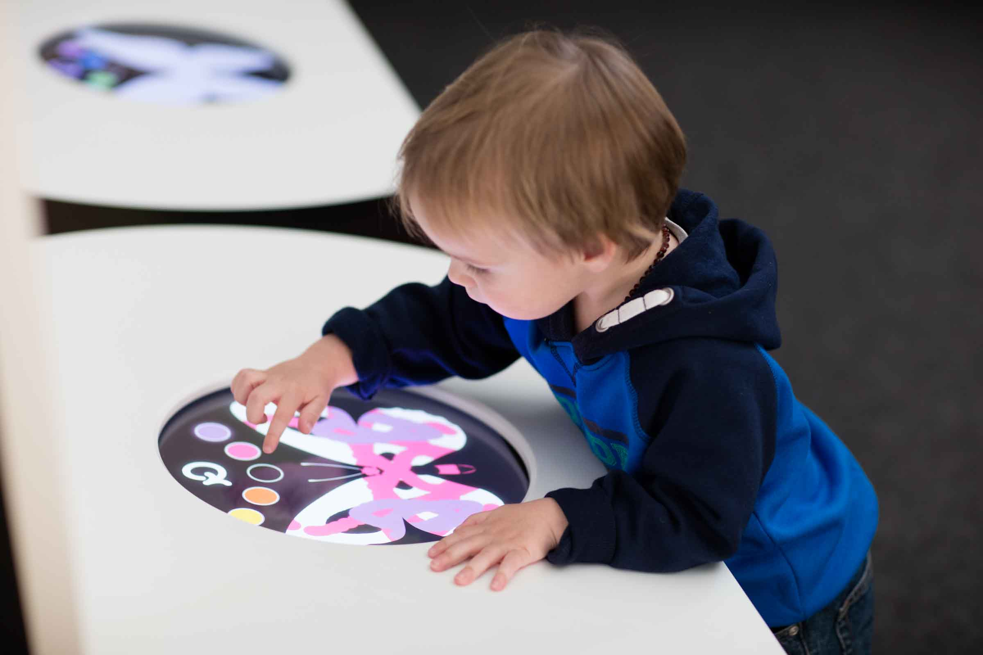
I can touch different things. They might light up or make a noise.
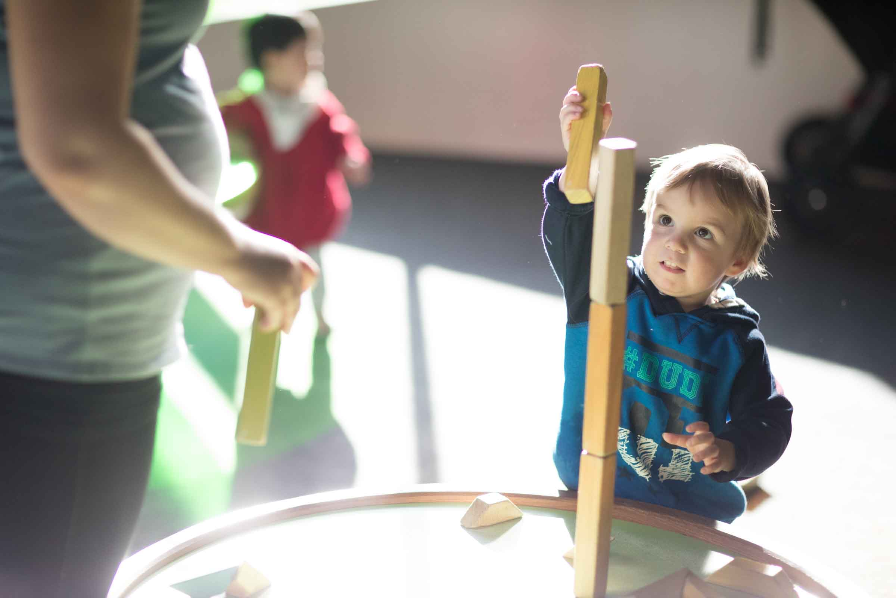
I can play with toys, games and shapes that I see and also read books.
I will take turns with other people.
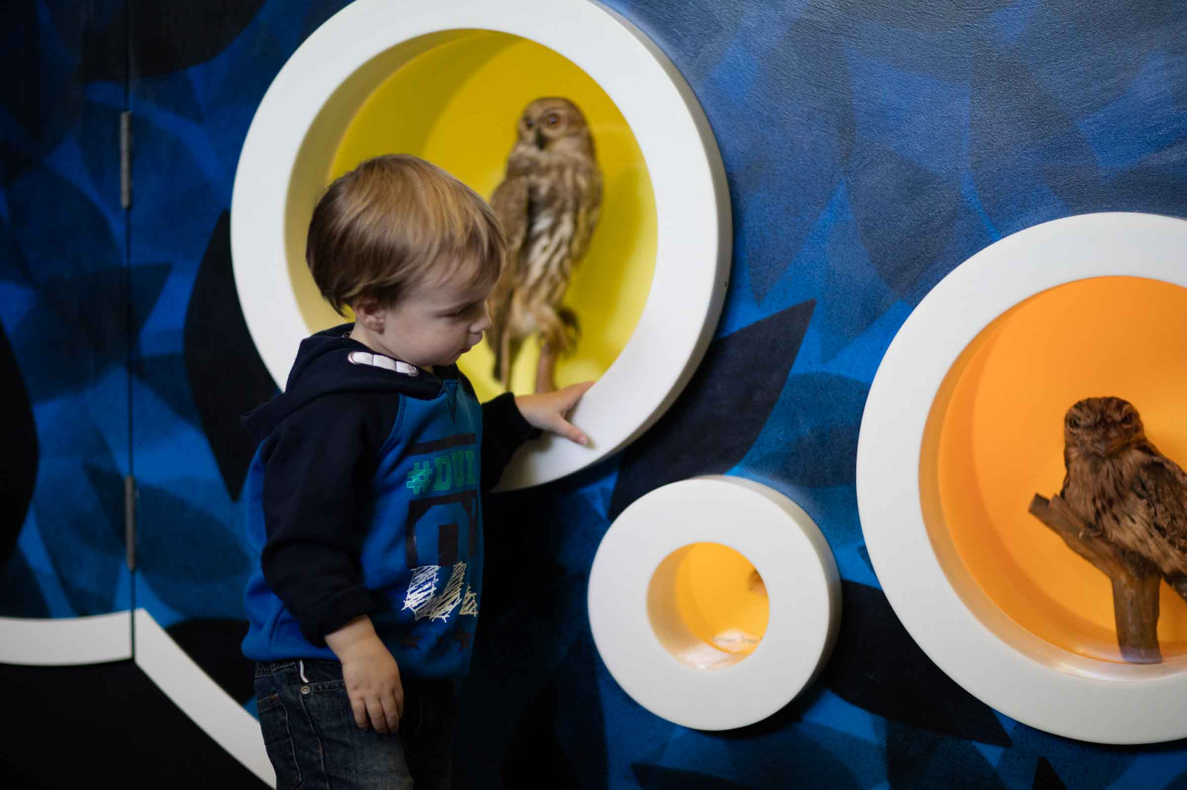
I will see and hear big and small animals.
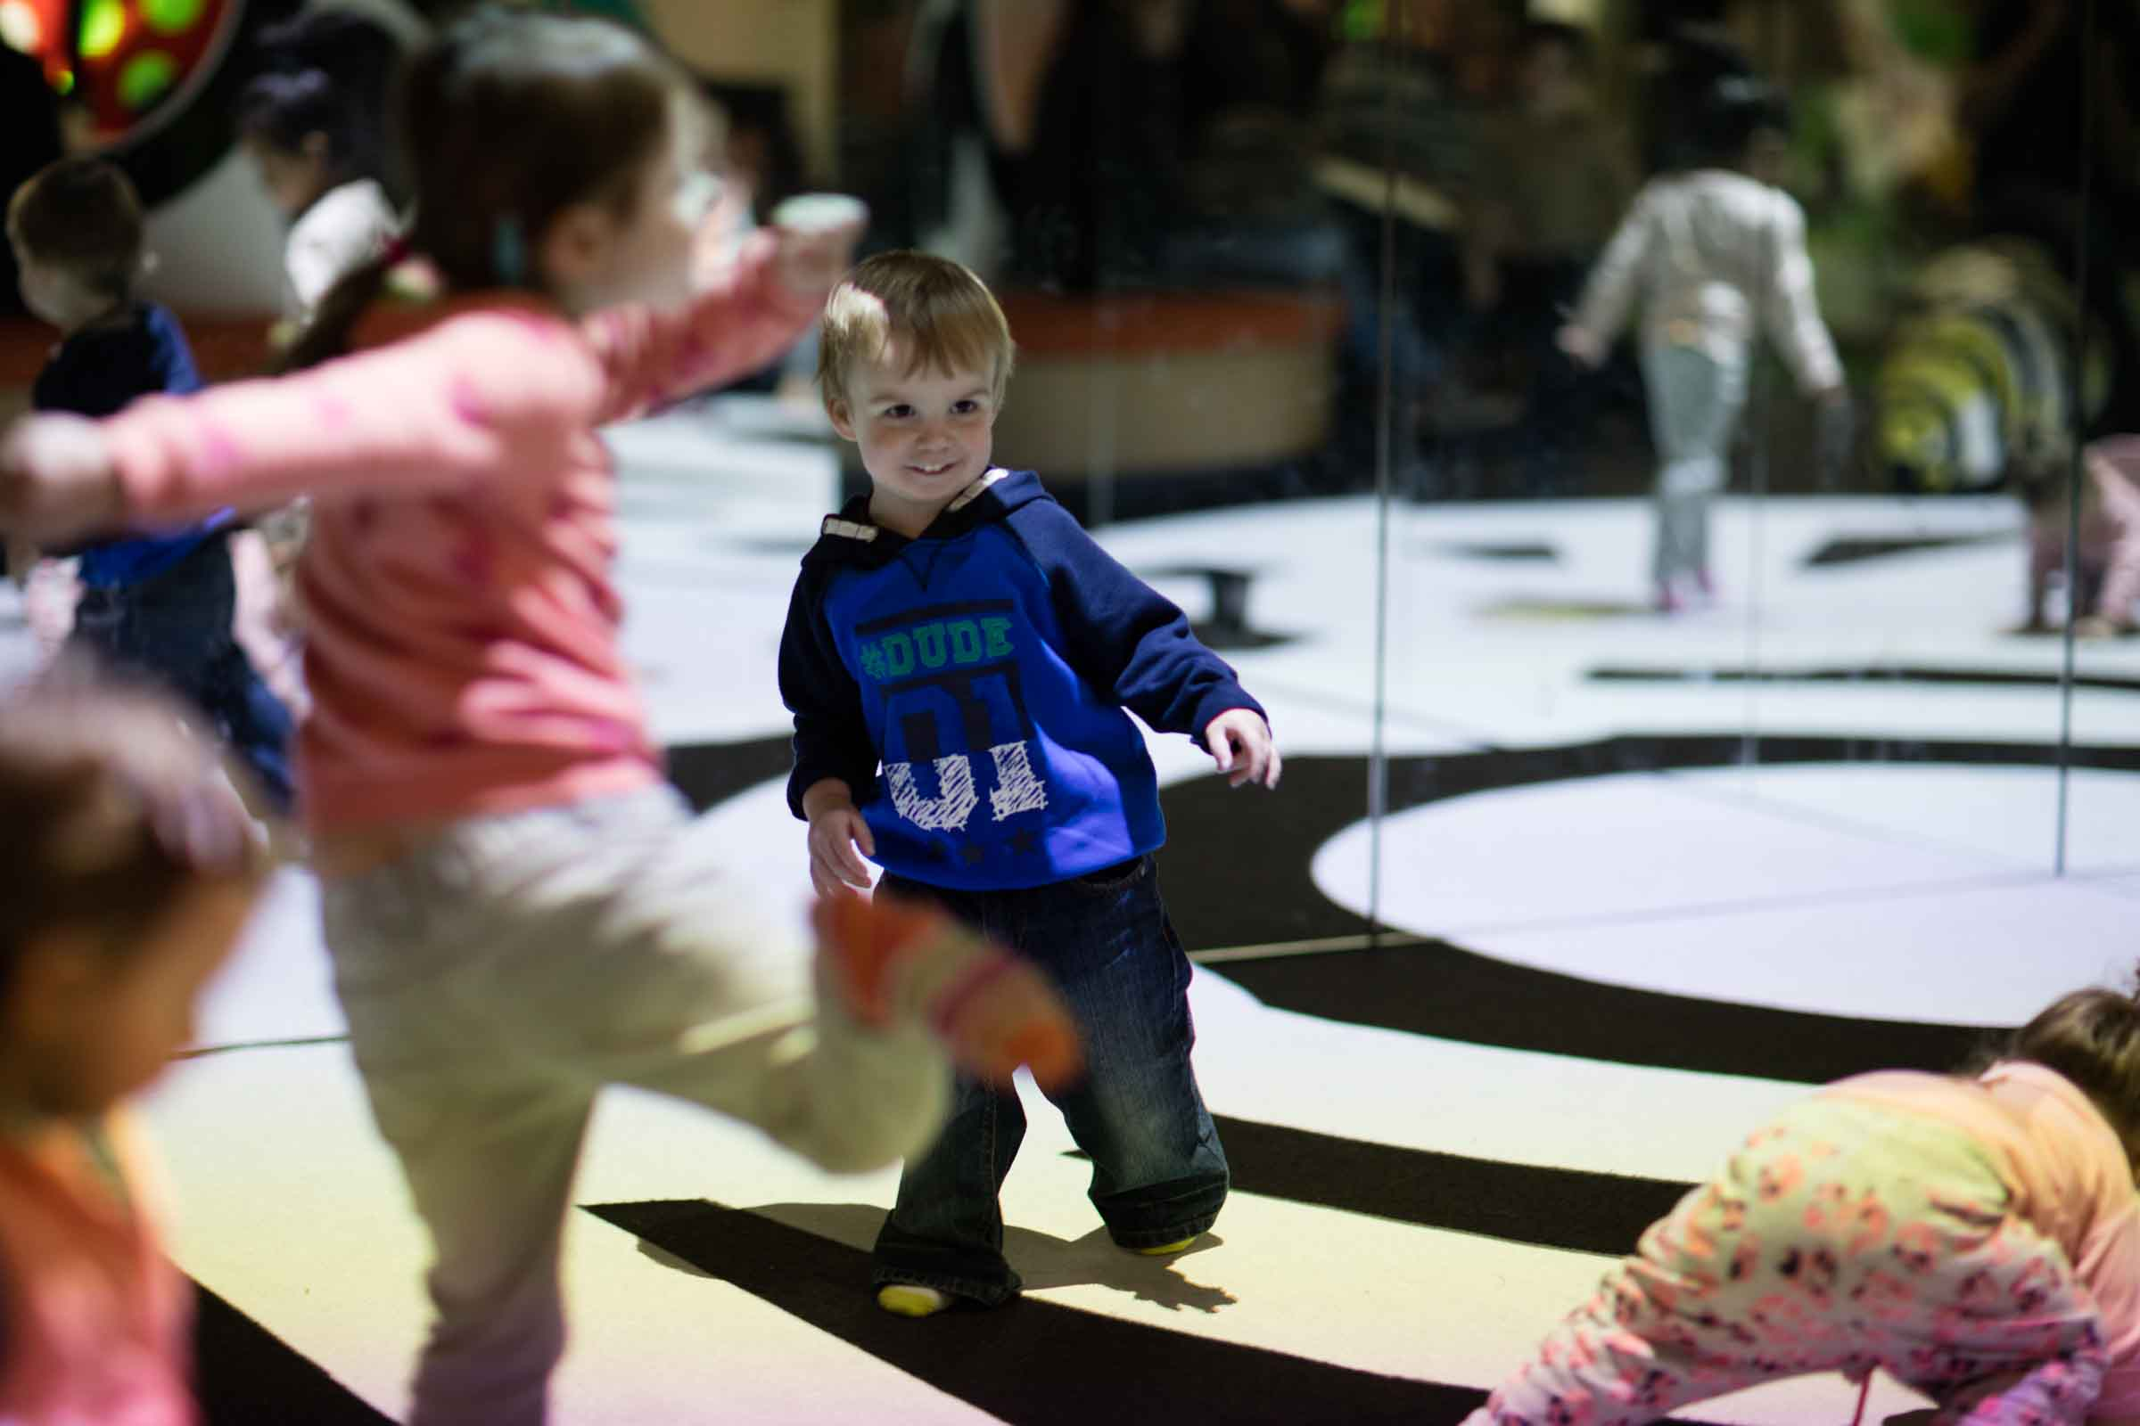
I can move and dance in the special sound and light area with mirrors.
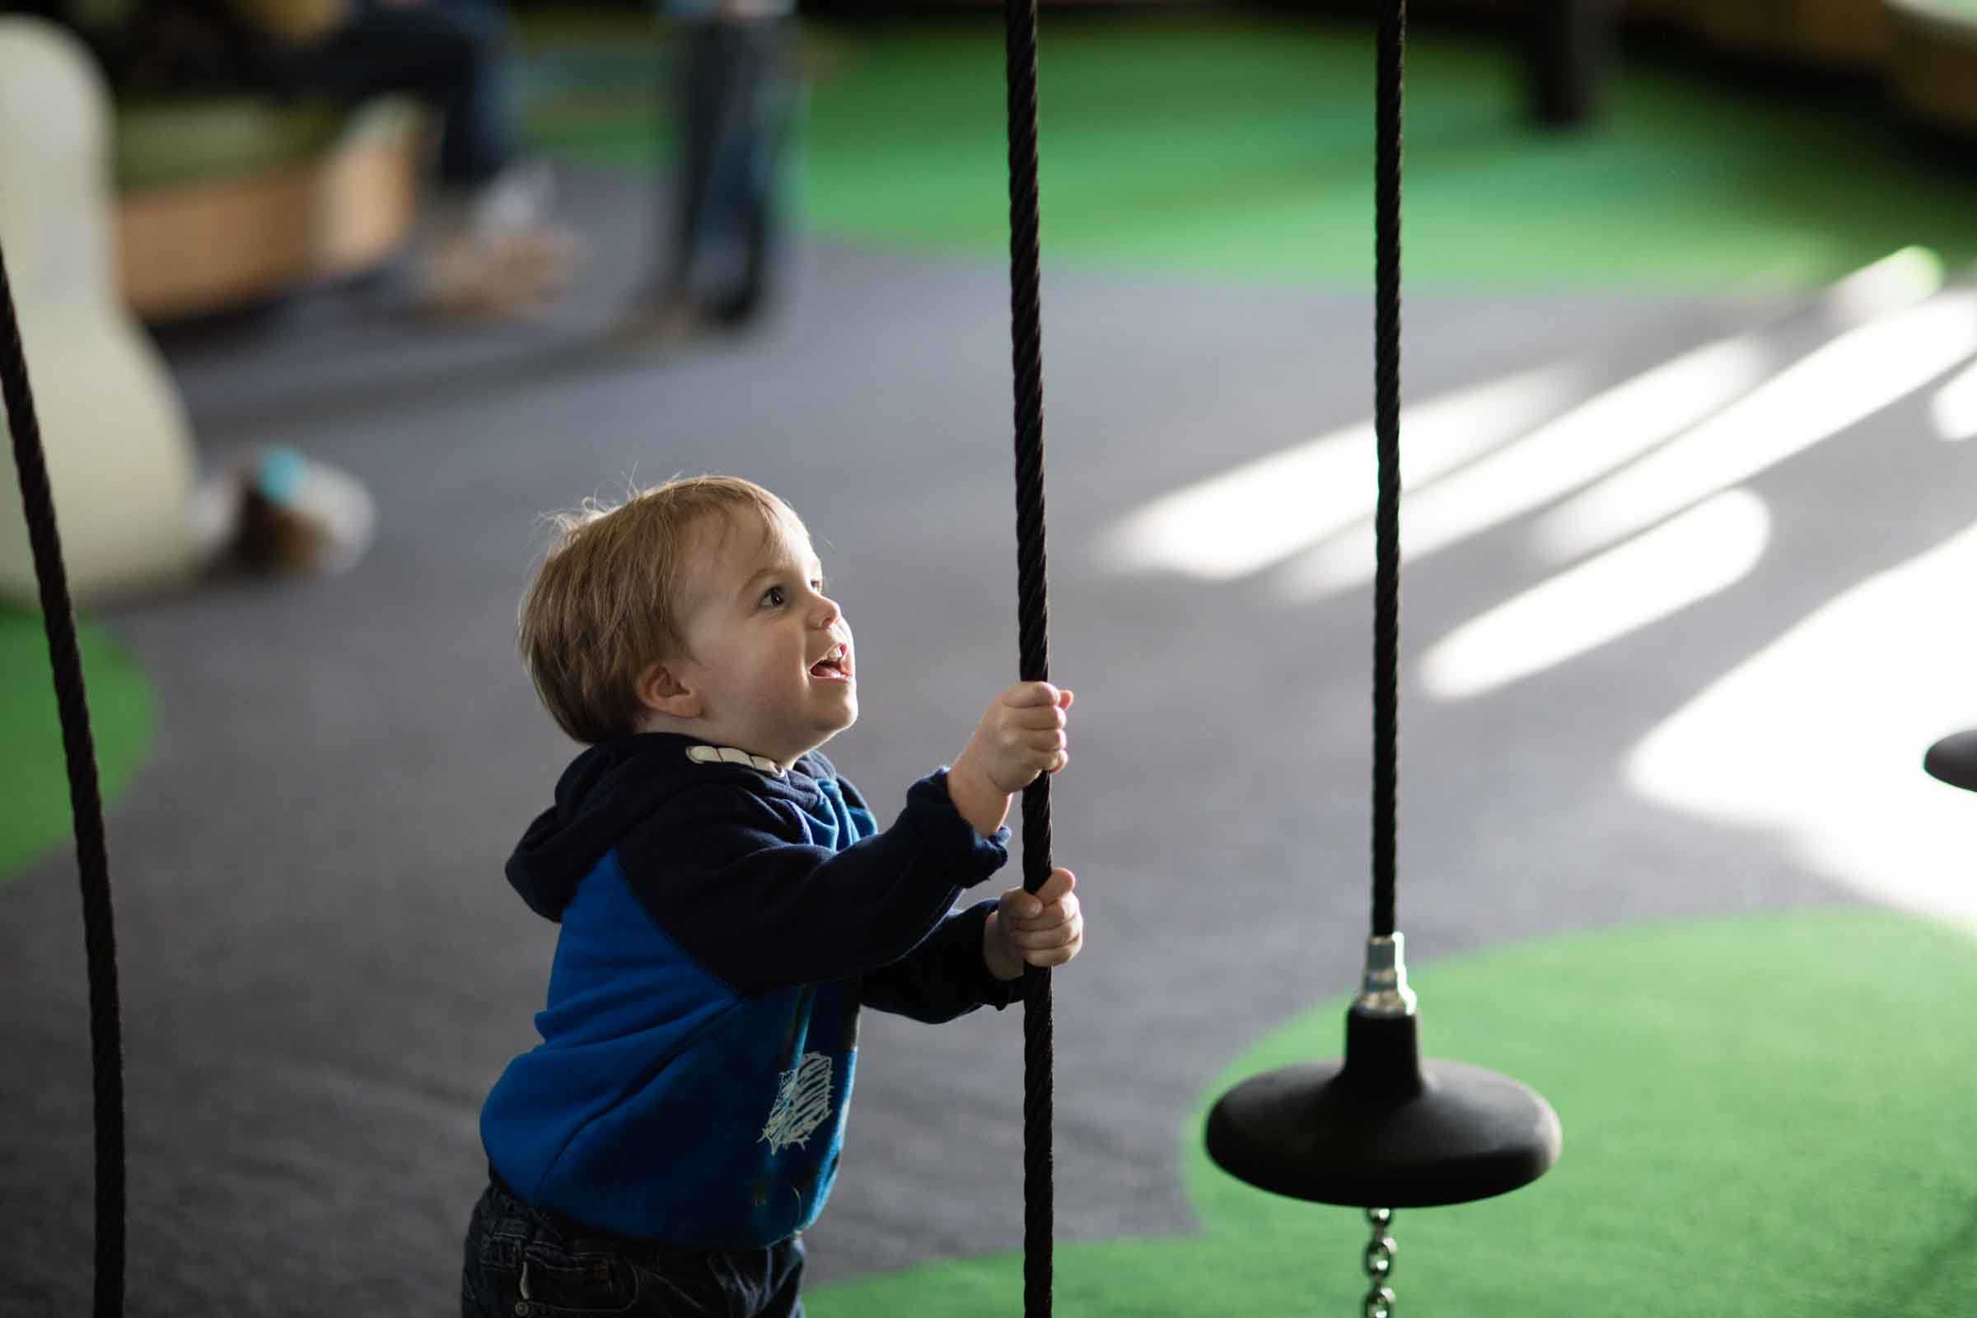
I can play with long ropes.

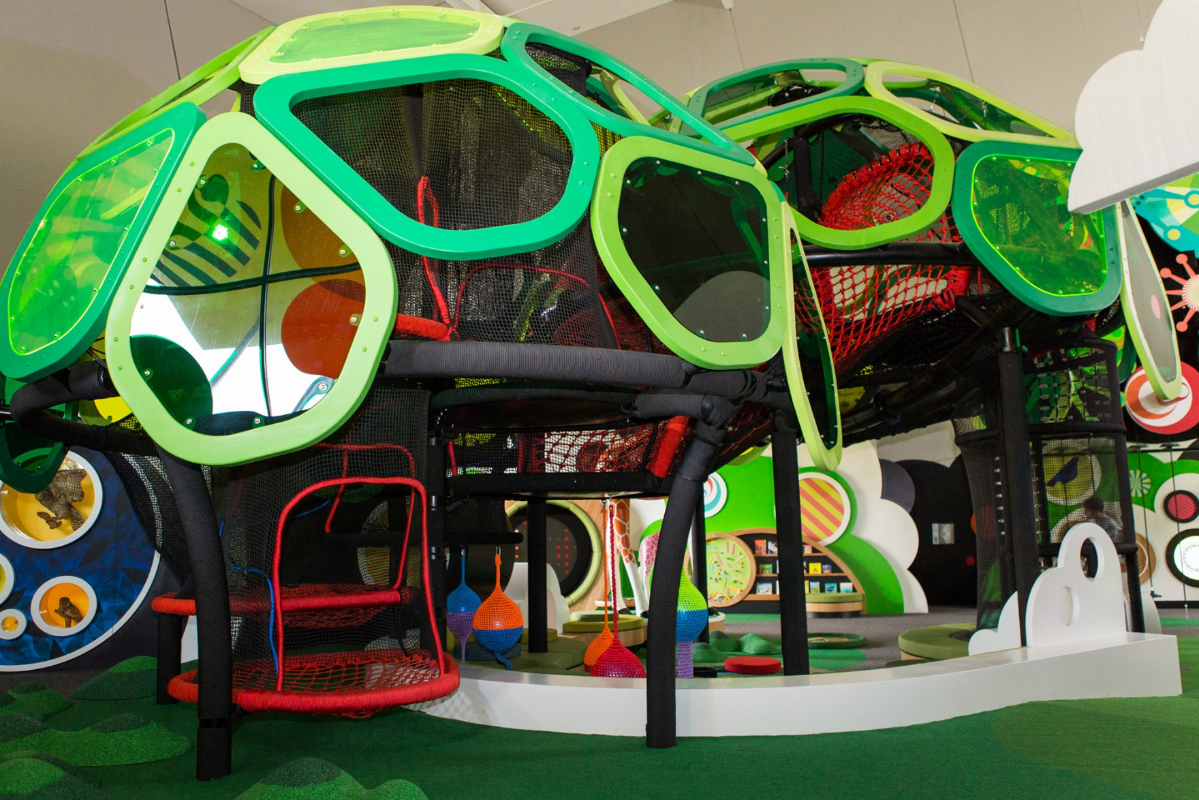
I can climb in the big net. I will be safe and will not fall.
There might be lots of other children in the net too.
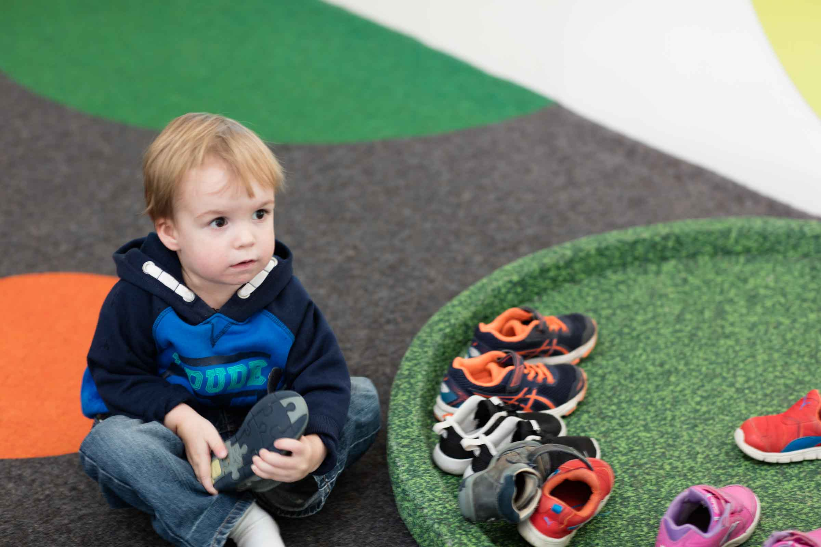
I can take my shoes off to climb in the big net.

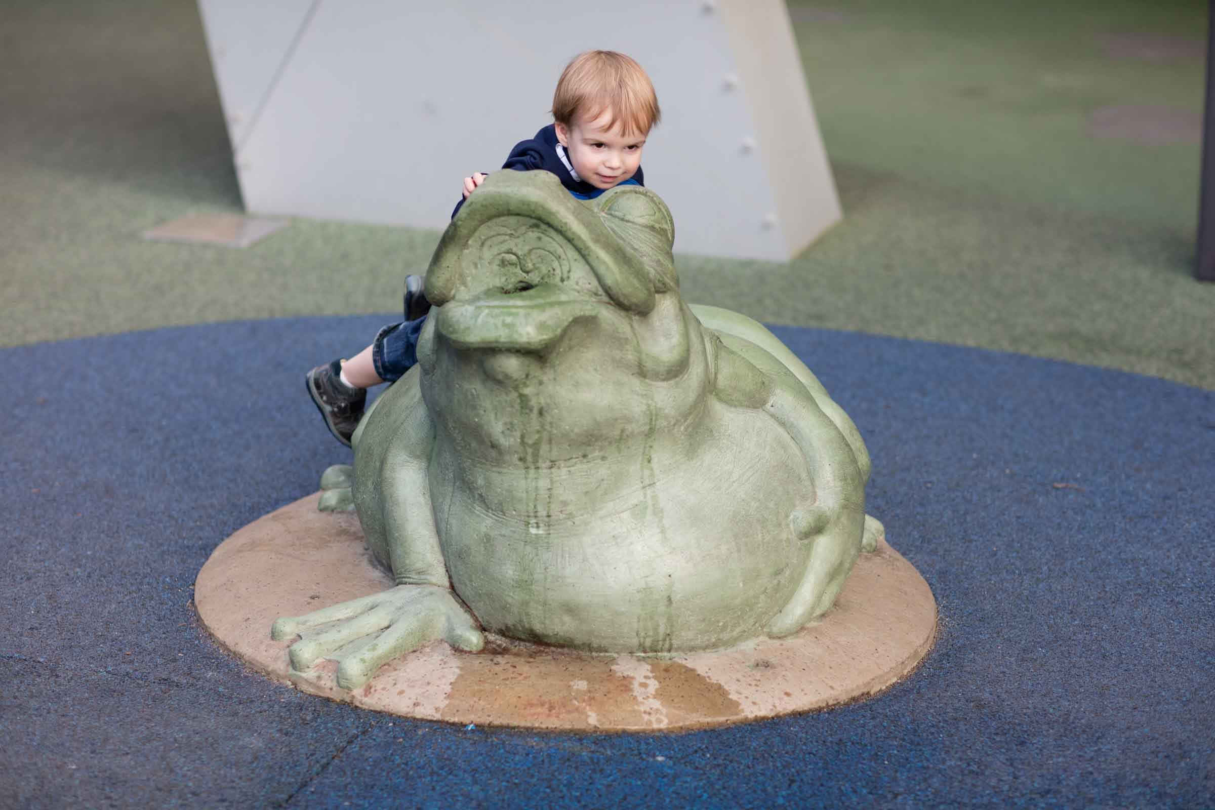
There are frog sculptures near a wet play area.
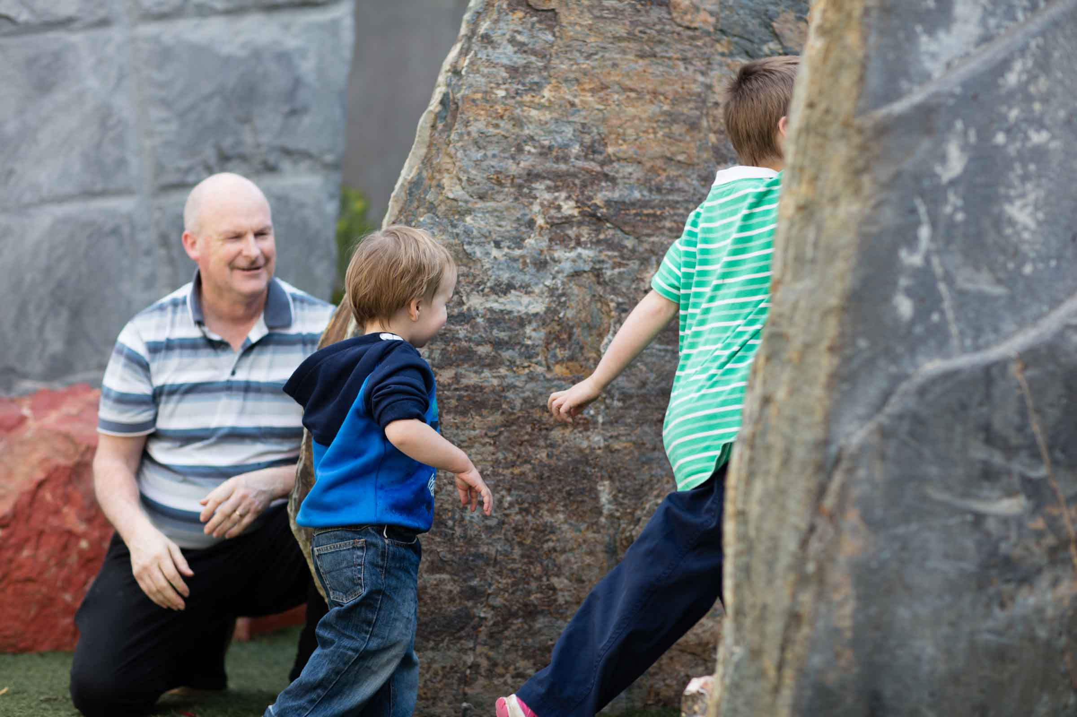
I can explore the garden and see big rocks.
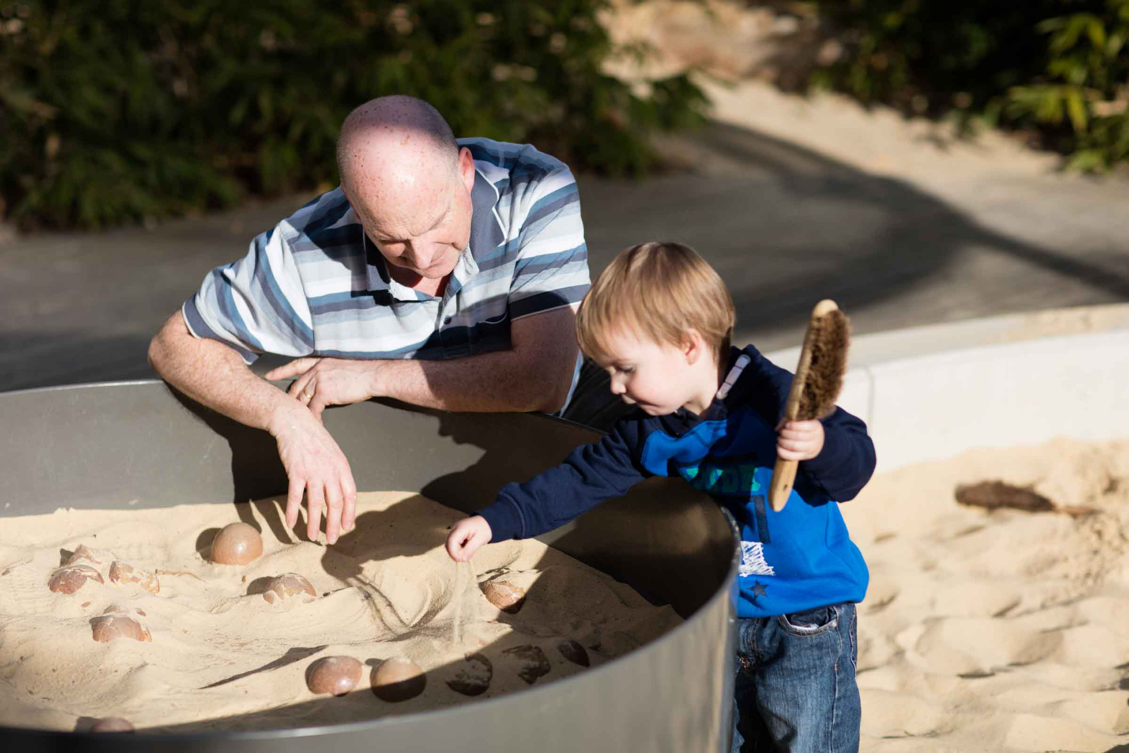
I can dig for dinosaur bones in a big sand pit.
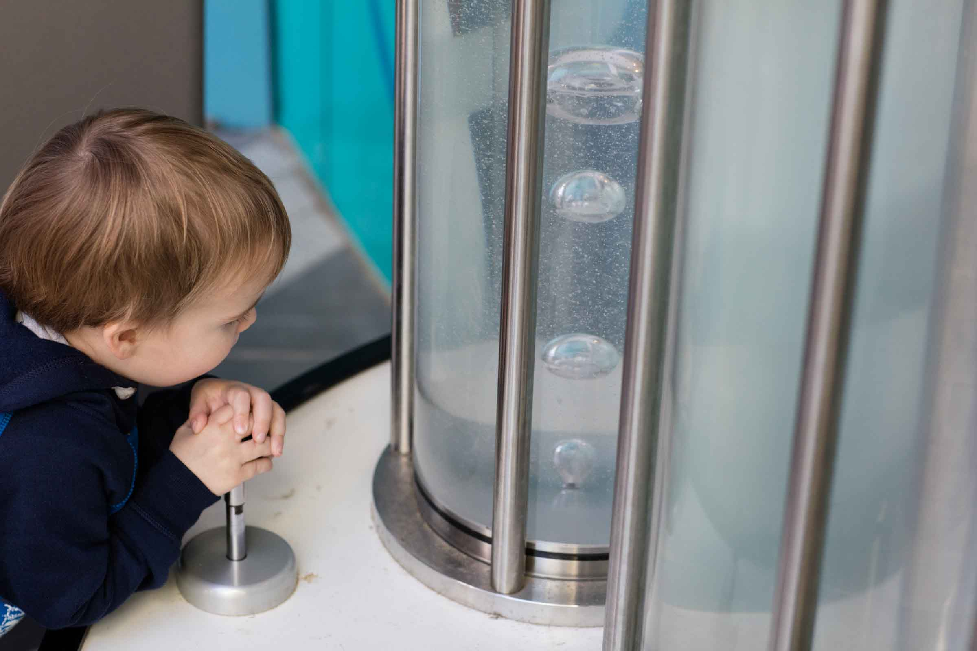
I can make bubbles by pushing a ball up and down.

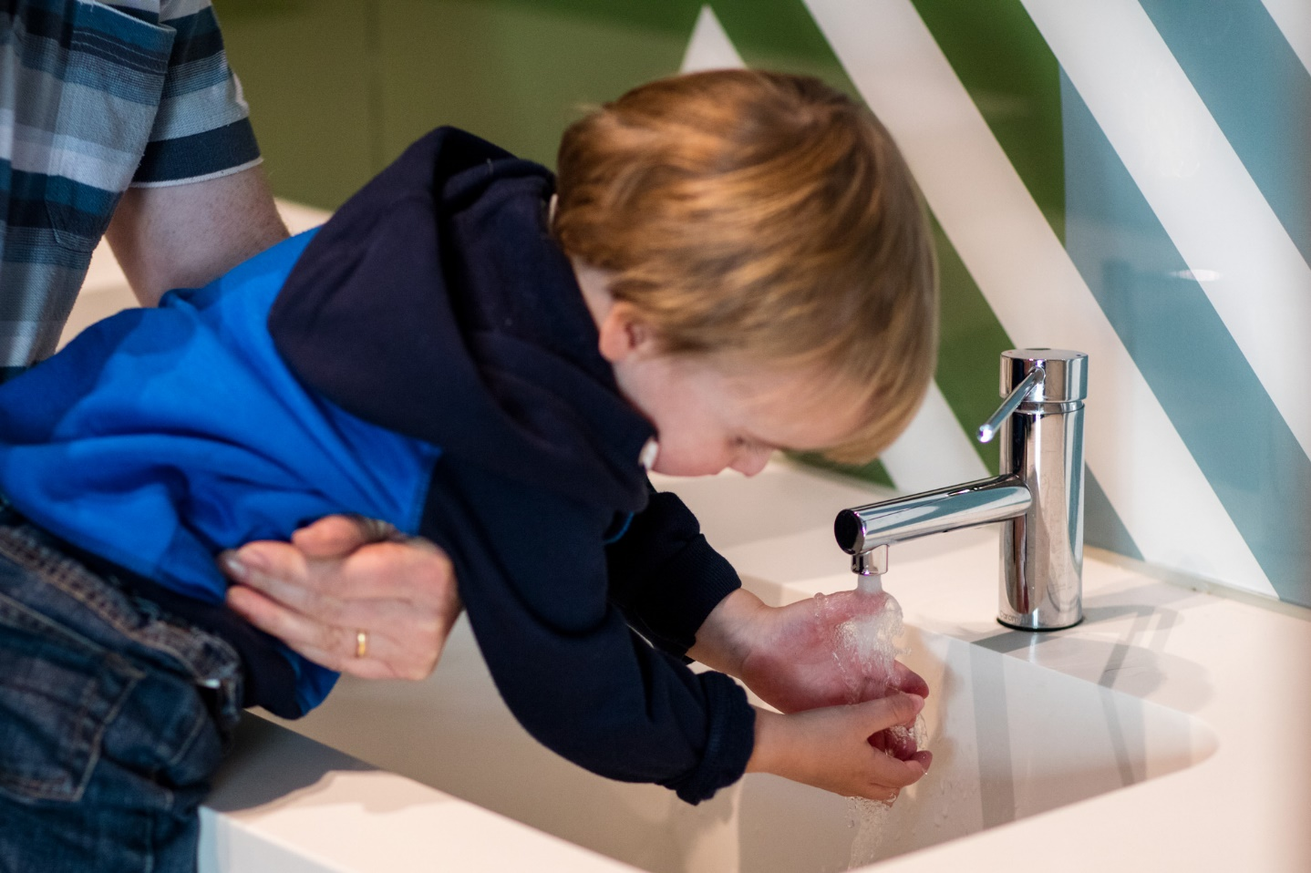
There are hand dryers in the toilet. Some people use them after they wash their hands.
I do not have to use them.
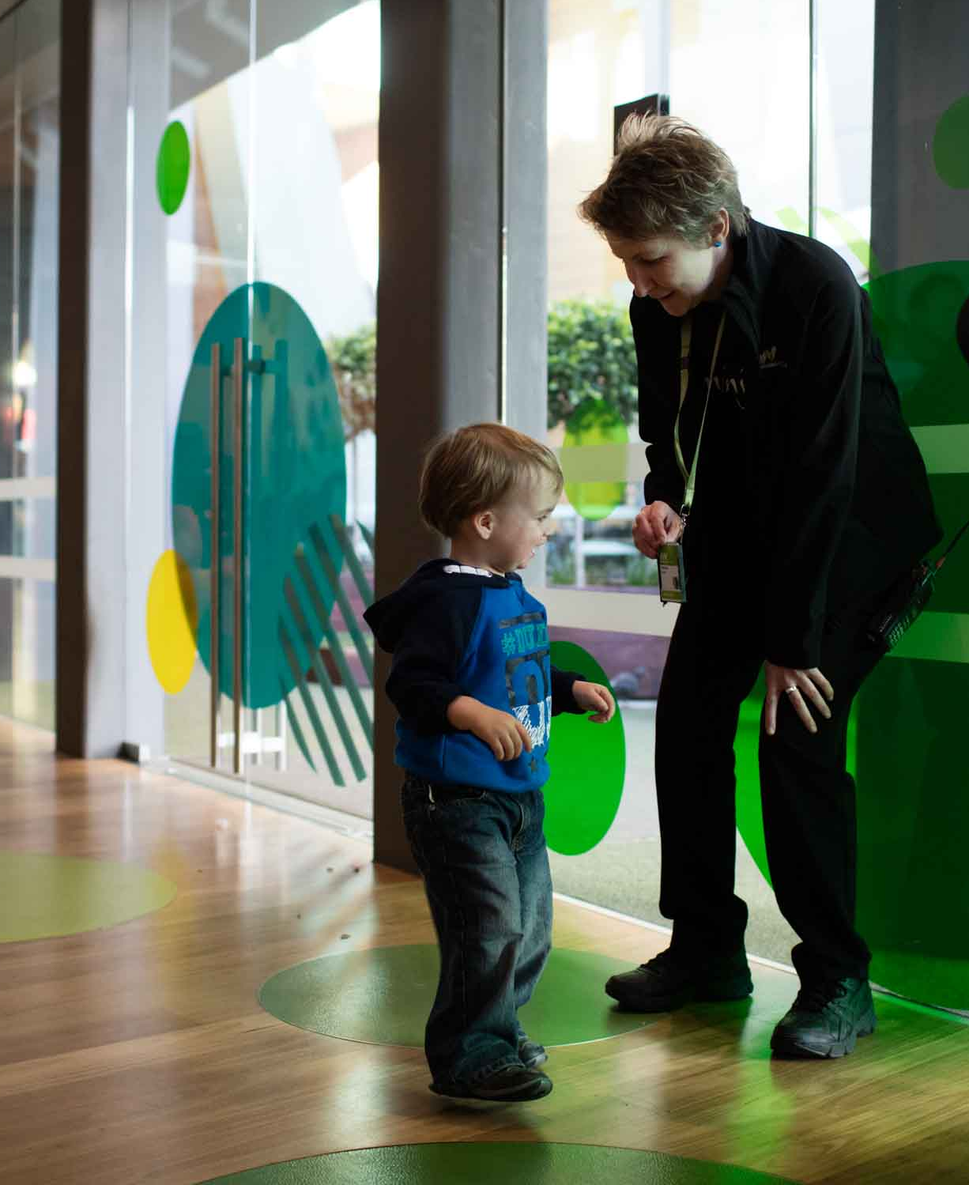
If I get lost I can ask a museum staff member for help.
Staff wear coloured straps around their necks.
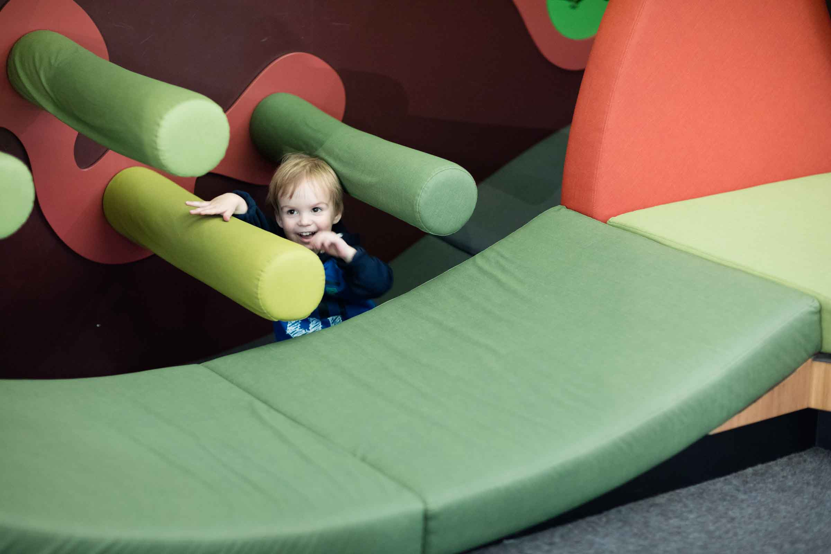
Going to the Children’s Gallery at the museum will be fun.

